Beyond the Multiplex

Interim Findings Report - October 2019

Introduction 1
Purpose of this report: 1
Executive Summary 2
Specialised film and audience development in the UK 4
Socio-cultural index: identifying the profiles of film audiences 7
Audience member film-watching experiences and practices 10
Examining audience consumption patterns through time 14
How audiences interpret specialised films 18
Conclusion 20
Appendices: 21
Appendix 1: Outline of work packages (WPs) 21
Appendix 2: Project outputs to date 22
Appendix 3: Survey respondent identified genres: 24
Appendix 4: Film titles used to provide ‘clips’ for the film-elicitation groups: 25

Introduction

Purpose of this report
This report sets out interim findings across Beyond the Multiplex work packages 1 to 7. As the project enters its third and final year, all data have been collected, and analysis is well underway within each work package. As we carry out those analyses, we are writing up our findings as a precursor to a more holistic and integrated cross-work package analysis. A set of relevant outputs have also been produced (see Appendix 2) with more planned for the immediate future. This includes meetings where we have presented the project to external stakeholders to engage with the wider film community.

Overall, Beyond the Multiplex seeks to address two main research questions:

- How to enable a wider range of audiences to participate in a more diverse film culture that embraces the wealth of films beyond the mainstream;
- How to optimise the cultural value of engaging with less familiar films (defined as specialised films).

To address the research questions, data from all work packages were assessed through various subsidiary questions, each grouped within four main themes:

- Identifying patterns within contemporary film consumption.
- The meaning of specialised film for audiences, and how those meanings are interpreted.
- Place, venue and events.
- Mapping regional actor responses to change in the distribution of public funds.

To address our research questions through those themes, the project was divided into 11 work packages, of which 6 involved data collection and analysis, with each producing a standalone dataset (see Appendix 1). Within this, quantitative methods provide a broad overview of patterns and trends, while qualitative methods provide insights into how audiences connect and engage with film, what experiences they take away from watching films. Together, the datasets provide a rich set of findings that can be used to inform audience development and explain how the cultural value of film might best be converted into commercial value. Rather than addressing the research aims by combining separate analyses from each work package or dataset, the project employs a computational ontology to assess and explore the relationships between datasets holistically. This involves the development of a graph database and a set of data visualisation and search resources. Towards the end of the project, our 6 research datasets and our data visualisation and search tools will be made publicly available for secondary researchers to use via a dedicated public-facing website.

Executive Summary

Our research has brought together analyses of non-mainstream, specialised film audiences and the context in which they engage with film in four English regions. Specialised film and audience development in the UK is primarily supported by the BFI through national audience programmes and the regional activities of the Film Audience Network made up of a series of regional Film Hubs. The current focus on the development of regional audiences established as a priority by the Film Policy Review Panel in 2012. The BFI has worked to fulfil this objective, primarily through its funding programmes, however several challenges persist. For example, current challenges include the limited access to non-mainstream theatrical film in some regional areas, the under-development of independent distribution in the UK, risk-averse programming, and uncertainty about the role and impact of online streaming.

Despite these challenges, film is still the most popular and widely consumed cultural activity in the UK. In our analysis we have found eight distinct groupings of film taste or preference (based on genre) including one group with a specific taste for art house and foreign language films. We find this group is more likely to contain people who are highly educated, affluent, and urban living. By contrast, we identified a less educated and affluent group that like all types of film - except art house and foreign language ones. We also found that comedy, as a film genre, has the broadest appeal. Overall, we found that educational level and income are the greatest predictors for film genre preferences, but that film taste is not strongly determined by these factors.

Alongside preferences, we examined audience experiences and practices. We found that the meanings people ascribe to watching films varies with genre, medium/screen type, venue type, and/or whom a film is watched with. In this, we identify six distinct audience types, each framed by size (the number of people watched with) and associated with different forms of social interaction. We also considered the relationship between each audience types and their access to film locally. In this, we found large variations in audiences’ level of provision and access to a diverse film culture. This ranges from cities with good provision of a wide range of films, screens, and venue types, through to areas with low provision, where communities have very limited access to theatrical film.

To develop our understanding of regional audiences for specialised film, we undertook a survey to track the film-watching activities of people who engage with specialised film over a six-month period. From this, we can identify patterns in what people watch, how, with whom and what they value about the experience of watching specialised films. Overall, we find that people tend to watch films with others more often than watching alone, irrespective of the screen or medium used, and that audiences place value on the shared experience of film in different contexts. Across the regions, we find that film engagement is valued in similar ways.

We considered how audiences interpret the narratives and visual styles of specialised films. We found that people draw on their life experiences, cultural and media resources, and their own education to make sense of the forms, narratives, storylines, and topics of films. We find that our participants, of any educational level, identify with a range of themes within film narratives at different formal and emotional levels. However, we found that participants relate to films in similar ways through their own life experiences in different ways, e.g. the portrayal of romance and sexual intimacy, the troubles of parenting depicted in different places and cultures, the experience of work, and other experiences expressed through film.

Overall, we find that film is highly valued culturally and socially across the four regions but note that it varies between audience types. For some, watching a film brings a sense of personal wellbeing, while for others it features as a central aspect of their social lives. Meanwhile, some turn to film to build connections with others, or for self-development through learning or being exposed to new experiences. In this, we find that watching films in our regions is a social and cultural activity, that involves negotiation and discussion amongst people to select which films to watch. People value the social aspects of sharing film and being part of an audience as well as the specific cultural value of engaging with films. People often discover specialised film through the recommendations and/or choices of trusted others, ranging from friends, family, and colleagues through to online reviews.

Specialised film and audience development in the UK
Since 2011 the British Film Institute (BFI) has been the lead agency for film audience development in the UK, taking over from the UK Film Council. At the same time funding for the Regional Screen Agencies and the Specialised P&A Fund ceased and the RSAs are replaced by Creative England (which continues to receive a subvention from the BFI for film-related activity). In 2012, The Film Policy Review Panel publish an independent report for DCMS: 'A Future for British Film: It Begins with the Audience…' which re-focussed the BFI remit on audience related funding. Following this the BFI introduced their own definitions of ‘specialised’ film in 2012 and 2014.
In 2012-13 the BFI replaced the Specialised P&A Fund with the ‘BFI Distribution Fund’ (which included 4 strands: 'Big Audience', 'Breakout', 'New Models' and 'Sleepers'). The BFI launched its ‘Audience Fund’ (which also included 4 strands: Film Audience Network (FAN), Programme Development Fund and Film Festivals Fund and Neighbourhood Cinema Fund). The new funding schemes showed the BFI’s priorities towards diversity and innovation in distribution and exhibition funding, as the awards were explicitly intended to help solve specific distribution and exhibition issues. Between 2013-2017, 580 Audience Awards were distributed at a total value of £22,245,354. In the same period, 112 Distribution Awards were awarded at a total cost of £11,123,359. This approach shows a shift in emphasis away from distribution and towards exhibition or ‘audiences’ for the BFI.
launched in 2017, the BFI 2022 strategy prioritised regional devolution and launched eight Film Hubs, typically based at prominent exhibition venues, in January 2018. Three of these were national: Film Hub Scotland, Film Hub Northern Ireland and Film Hub Wales. Four were in the English regions: Film Hub North, Film Hub Midlands, Film Hub South West and Film Hub South East, and one is metropolitan, Film Hub London. At the same time the distribution of small awards (for distribution and exhibition activities) was devolved to the Film Hubs and small awards (for development and production activities) to the BFI Network.
A central aim of the BFI 2022 strategy was to improve under-representation in the screen industries by establishing the BFI Diversity Standards. The Standards apply to production support as well as audience related funding the BFI provides, using the protected characteristics of UK Equality Act 2010 (age, disability, gender reassignment, marriage and civil partnership, pregnancy and maternity, race, religion or belief, sex, sexual orientation) as well as under-representation in relation to regional participation, socioeconomic background and caring responsibilities.
Observations regarding UK Film audience policy 1997 to 2017
- Public funding for film has consistently decreased in real terms from the UK Film Council and BFI eras since 1997.
- The only consistent funding strategy across the UKFC and BFI has been the continued subsidy of specialised film distribution and marketing. This has, however, also been the first casualty when budget cuts are made.
- The BFI has moved away from funding technological development (notably UKFC’s DSN) as digital conversion has neared completion and re-focussed on audience programmes (e.g. FAN, Programme Development and Film Festivals).
- The establishment of the BFI Audience Fund as a rolling annual programme is a significantly different approach from the UKFC era audience initiatives (e.g. DSN, Cinema Equipment, Small Capital Funds) which were 2-3 years in length and typically capital/plant investments.
- The BFI has increasingly demanded innovation in distribution and marketing strategies and builds this into the fabric of its funding programmes (Big Audience, Breakout, New Models, Sleepers).
- The funding available through the RSAs for distribution and exhibition activities determined at a regional level has been substantially reduced with the closure of five of the nice RSAs (Film London, Northern Film & Media, Screen South, Screen Yorkshire remain) and the emergence of Creative England.
- Of all the UKFC and BFI initiatives, supporting specialised film is, perhaps, the most difficult area to subject to strategies of ‘marketisation’ (or neo-liberalism), because such films, by definition, resist this impulse (to a greater or lesser extent). It is, perhaps, not unrelated then, that funding for specialised film has typically been the first casualty of cutbacks at both organisations.
Perspectives on specialised film and audience development
Despite the investments of the UKFC and BFI over 20 years many of the challenges identified by the UKFC in 2002 and the 'Film Policy Review Panel' in 2012 for developing the nationwide audience for specialised films are still concerns. Essentially, there are still many challenges to meeting the Film Policy Review Panel first recommendation that ‘a key goal of public policy for film should be to connect the widest possible range of audiences throughout the UK with the broadest and richest range of British films and films from around the world’. We interviewed 27 representatives from film distribution and exhibition organisations to gain an understanding of their current priorities and challenges. The interviews included senior-management representatives from national cinema support agencies, policymakers, film-funders and distributors, online platform managers, film-programmers, and cinema staff (from both commercial chains and independent cinemas). The key themes and challenges emerging from these interviewed included:
Number of film releases - there has been a rapid rise in the number of films released to cinemas each year (from 369 in 2002 to 966 in 2018, BFI), this was identified as causing several challenges for film programming, film marketing and audience development. It also intensifies questions around what a diverse film culture should look like in the UK and how to ensure the UK wide release of specialised films that are supported with print and advertising expenditure.
Risk taking and comfort zones - for programmers, venues and audiences - a barrier to developing a more diverse film culture was a general sense of a risk-averse approach to programming from venues, either financially risk averse in terms of programming what they thought would guarantee income or culturally risk averse in terms of programming films that they thought audiences would not respond to. There was also the perception that audiences themselves may be risk averse in their choices of films to watch at the cinema - and therefore venues reinforced this. This perpetuates a narrow film culture and there are questions around how the use of data impacts upon this. Support is needed to enable regional organisations to grow, through best practice knowledge sharing. This includes supporting and developing small-scale, volunteer-led, or one-off initiatives, many currently supported by the BFI’s Film Hubs, into sustainable organisations that can build relationships with audiences over time and challenge the risk averse programming culture.
Independent distribution and exhibition underdeveloped nationally - there was a clear sense that film exhibition and distribution in the UK was heavily balanced towards a small number of major companies, and independent small-scale distribution and exhibition in the UK was problematically underdeveloped. In 2018 three cinema operators owned 63% of all UK cinema screens and ten distributors had 95.5% of the market and the other 128 distributors shared the remaining 4.5%, (BFI). Investment needs to be made to challenge the historical and persistent uneven access to diverse theatrical film provision, in the form of alternatives to mainstream, multiplex cinemas in many regional areas. Investment should be made in new screens, new venues and new organisations, especially in areas of low provision and engagement (responding to models such as Arts Council England’s Creative, People and Places scheme for example).
Creating new audiences - The larger commercial cinemas primarily consider customer numbers and experience, rather than how the audience is composed, while independent and publicly funded organisations have a greater focus on audience development and changing the composition of their audiences. Audience development tends to take four approaches that are interrelated, but all are ways to shift or change existing audience patterns. These include demographic led audience development (e.g. young audience, BAME audiences); habit forming audience development (encouraging loyalty and repeat visits); programme led audience development (e.g. politically or artificially engaged programming); and place led audience development (targeting audiences who live in specific geographic areas). Some of the priorities for audience development were: Broadening and growing the loyal but ageing audiences and effectively engaging younger audiences; reaching diverse audiences and non-metropolitan audiences, e.g. those in rural areas. The application of the BFI’s Diversity Standards for audience development could have an important impact on developing new audiences for specialised film so realising the potential of these standards for audiences of all kinds is essential.
Commercial pressure and cultural value - Commercial pressures were seen as a barrier to developing a more diverse film culture - where showing mainstream film, which was backed with large marketing budgets by distributors was identified as the ‘easy’ option, often taken by cinemas, emphasising the cinema as an entertainment and leisure space, rather than a cultural space.
Uncertainty around streaming - Streaming was viewed as both an opportunity and a threat from different perspectives, it provides a broader sense of access to a wider range of film, but questions were raised over its impact upon theatrical film distribution. There was a general sense that the overall impact of streaming on theatrical film was unknown and still in flux - but that films would have distinct and more individual release strategies and approach that encompassed different degrees of theatrical and online releases.

Socio-cultural index: identifying the profiles of film audiences
The socio-cultural index provides an outline of the factors that affect audience formation. It requires the integration of quality of life indices, social, cultural and audience trends, and data relating to film provision and access alongside digital inclusion indicators. For this, we have conducted various analyses on two external datasets:

British Film Institute (2011) Opening our eyes: how film contributes to the culture of the UK - Appendix 4: Cultural consumption survey data. [data collection]. Available at: http://researchdata.gla.ac.uk/id/eprint/853 (Accessed: 19-September-2019).

Department for Culture, Media and Sport (2016) Taking Part: The National Survey of Culture, Leisure and Sport, 2015-2016; Adult and Child Data - SN: 8070. [data collection]. Available at: http://doi.org/10.5255/UKDA-SN-8070-1 (Accessed: 19-September-2019).

In our initial analysis, we found that audiences’ genre preferences can be grouped into five distinct clusters (see Figure 1) based on how commonly two or more genres are preferred by the same survey respondent:
- Arthouse and Foreign Language
- Romance and Romantic-Comedy
- Drama, comedy, action and thriller
- Fantasy and sci-fi
- Classic and documentary
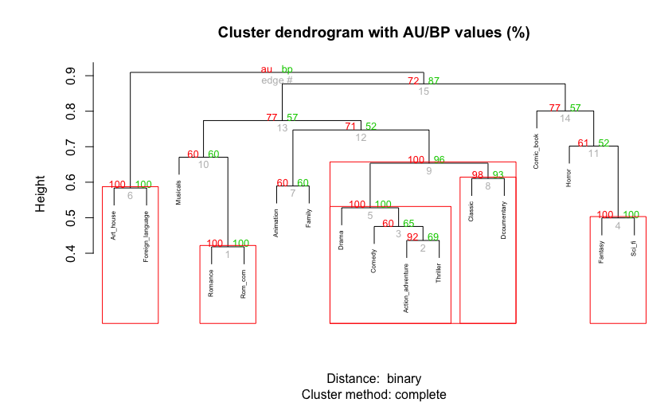
Figure 1: Genre clusters with statistical significance (over 95 is good)
Our initial analysis found that preferences for arthouse and foreign language films were clearly separable from other clusters, while preferences for other genres were less distinct (e.g. action/adventure, comedy, thriller).

Assessing this through more complex analyses we found that film genre preferences fit within 9 distinct classes, listed below in order of occurrence (most to least likely with constituent film genres in brackets):

- Suspense and action (Suspense/thriller; Action/adventure; Comedy; Drama; Sci-fi.)
- Drama documentary (Drama; Documentary; Suspense/thriller);
- Romantic comedy (Romantic comedy; Comedy; Romance);
- Comedy (Comedy);
- Mainstream film (Comedy; Action/adventure; Drama; Suspense/thriller; Sci-fi; Romantic comedies; Family film; Fantasy; Animation; Romance; Classic films; Documentary; Musicals; Horror; Comic book movie;
- Family films (Drama; Family film; Romantic comedy; Romance; Comedy; Musicals; Classic films; Documentary; Suspense/thriller);
- Sci-fi, fantasy and action (Sci-fi; Fantasy; Action/adventure; Comedy; Suspense/thriller; Animation; Comic book movies; Horror;
- Arthouse and Foreign language - (Arthouse films; Drama; Foreign language; Documentary; Classic films; Comedy; Suspense/thriller).
- No Preference

We found preferences for ‘arthouse’ and ‘foreign language’ genre films are distinct (occurring in only the least common class). The people who prefer those genres also like a broad range of more popular genres (e.g. classics, comedy, documentary, drama, and suspense/thrillers). By contrast, people in the most commonly occurring class (Suspense and action) like films in the five most often preferred standalone genres, but not fewer common ones such as arthouse and foreign language. Midway between the most and least commonly occurring classes, we found that people in the ‘Mainstream’ class prefer films from all genres except arthouse and/or foreign language. This identified a division between people who prefer a broad range of film genres (except arthouse and/or foreign language) and people with a more discerning taste, who prefer arthouse and foreign language alongside a narrow set of more popular genres.

Assessing the demographics of people in each class we found that:

- Holding a university degree makes people more likely to be in the ‘arthouse and foreign language’ film latent class group, while people with secondary school educational qualifications are more likely to be in the ‘Comedy’ class.

- Income, in general, has only a small effect on film genre preference, with people in the ‘Drama and documentary’ and ‘No genre preference’ class likely to have an annual household income of less than £30,000 or categories. However, people with an annual household income of £30,000 or more are likely to be in the ‘arthouse and foreign language class.

- Women are more likely to be in the ‘Romantic comedy’ and ‘Family film’ latent classes than any other, while men are more likely to be in the ‘Suspense and action’, ‘Comedy’ and ‘Sci-fi, fantasy and action’ classes.
- People aged 55 or over are substantially more likely to be in the ‘Drama and documentary’ class, while people aged 15 to 24 are more likely to be in the ‘Romantic comedy’ and ‘Comedy’ classes.
- People living in cities are more likely to be members of the ‘arthouse and foreign language’ class than people in suburban or village/rural areas.

Overall, we find that University-educated and urban-dwelling people with a household income of £30,000 per annum or more are likely to prefer arthouse and foreign language film alongside more popular genres. Less educated and/or affluent people also tend to prefer a broad of popular film genres, but dislike art house or foreign language ones. We also find that younger people who are less affluent and have lower educational levels tend to prefer comedy as a standalone genre. As such, we find that education is an important factor in defining film preferences, while other measures fluctuate across classes. For example, age holds more relative weight than household income for some classes and vice versa. Overall, we find that no demographic measure is deterministic. Instead, all measures were found to have a relatively weak effect on film preference, with educational level slightly stronger than others.

Audience member film-watching experiences and practices
Between April 2018 and December 2018, we analysed the 200 interview transcripts generating 4189 Nodes and 925 Relationships. We refined these into 6 key themes:

Theme 1: Audiences:
There are different values placed on being part of an audience (see Theme 4: Values). For some people, it is central to the experience of film-watching as a cultural activity. Others place little or no value on participating in an audience. There are also differing levels of engagement. Some people actively clap or laugh as part of a collective sense of audienceship when watching at the cinema. Meanwhile, others engage with a film at the cinema without any direct interaction with the other people there. Notably this changes with genre, with comedy and horror more likely to evoke an active reaction than documentaries or drama films. Although not all people feel part of an audience when watching films, those who do tend to identify with one of seven audience types:

- An individualised ‘audience of one’ when watching films (whether at the cinema or at home) was held as a profoundly solitary experience;
- Group audiences (of varying sizes) revolve around the sociality and communality. For example, in shared discussion of a new film with a social group, or in watching a film together as a couple, family unit, or with friends;
- Venue-based audiences are based on loyalty and a sense of belonging to a community where the specific film was of less importance than the venue;
- Auditorium-based audiences occur when watching at the cinema, but not elsewhere, with people converging at the same time and place for a collective experience;
- National audiences are based on notions of cultural identity, and often related to senses of decorum or codes of conduct;
- Global audiences occur when people watch culturally significant films at a specific moment, and/or discuss them online;
- Digital audiences revolved around the internet, with people no longer needing to be physically co-present to watch films together. Instead, people can watch simultaneously and discuss films on social media with strangers and people they know. People also people share logins and passwords to video-on demand platforms (VoD’s), often with an awareness that VoD algorithms suggest films based on shared film preferences.

These audience types and the meanings people ascribe to them vary with the genre of film watched, the media or venue used, and whom a film is watched with. In this, audiences do not relate directly to geographical place e.g. administrative wards, or regions – except for national audiences. Instead, people differentiate urban and rural, with specific ‘communities of practice’ constructing local geographies of film consumption based on their level or provision in one of five ways (see Theme 3: Place).

Theme 2: Practices
When people watch films, they do so as part of either an individual or shared practice. Film is a highly popular and accessible cultural form, and film-watching practices are deeply embedded within everyday routines. We also find that digital technologies have brought new ways of watching films and have led to a reconfiguration of existing film consumption practices. This ranges from increased opportunities to binge-watch through to watching part of a film on one medium (e.g. at home on TV) and the rest on another (perhaps on a mobile phone while commuting to work). This type of ‘fragmented viewing’ crosses traditional boundaries between media, screens, and venues.

Alongside individualised practices, people watch films together and discuss them as a shared practice - although not necessarily at the same time or place (e.g. as a digital audience). Meanwhile, others share films to maintain connection with others. For example, one of our participants described buying and sending her sister a DVD of a film they frequently watched together as children as a gift - to reminisce about their shared childhood. Elsewhere, parents’ bond with children over films, and couples use the experience of watching together as a bonding experience when courting. People also share films by judging others based on their film taste, and/or presenting themselves in a specific way through their discussion of film. We also find that films are often watched for education and learning, with the insights they offer increasing empathy and understanding of others. In turn, this allows personal self-development in gaining a greater awareness and knowledge about the lives of people, cultures, and/or countries. Likewise, films are used to mediate teaching, especially on topics that might be uncomfortable (e.g. teaching a child about sex, sexuality, and consent) or that cannot be easily articulated through direct discussion.

Theme 3: Place
In describing how their perceptions of local film provision frames their consumption, people tend to identify five types of place:

- Distinctive film cities (e.g. Manchester, Bristol, Newcastle, and Sheffield) offer a diverse range of films, involving different types of film exhibitors and film related organisations;
- Mainstream multiplex cities (e.g. Sunderland, Leeds, Liverpool and Hull) have population sizes and urban compositions comparable with ‘distinctive’ film cities. However, they offer a narrow range of options, often dominated by commercial multiplex chain cinemas, with independent film limited to small-scale, self-organised, temporary or one-off initiatives;

- Mainstream multiplex towns (e.g. Hartlepool, Middlesbrough, Bournemouth, Doncaster, Durham, Harrogate) have a small number of boutique and commercial cinemas (typically multiplexes) but offer a limited diversity of films beyond small-scale locally organised film events or clubs;
- Distinctive film towns (e.g. Berwick, Hexham, and Keswick) offer a relatively diverse range of films through a small number of often temporally limited venue e.g. film festivals or community hall cinemas supported by volunteers and/or public funding;
- Limited areas (e.g. Whaley) have limited access to film exhibition of any type beyond irregular locally organised film clubs in community venues. These areas are mostly rural, or on the fringe or a city or town requiring travel.

Across those five geographies exhibitors tend to develop a local market with each venue (see WP7) adopting a specific identity, e.g. competing cinemas in distinctive film cities tend to programme and show films in ways that differ, while film festivals in distinctive film towns tend to be ascribed a specific meaning that differentiates them from other festivals. In this, venue-specific audiences work to maintain that meaningfulness.

Theme 4: The value of film
People place differing value on the experience of watching film. For some, going to the cinema is as an enjoyable cultural activity carried out for entertainment purposes – ether as an end unto itself, or as part of a wider set of social activities (often as a group audience). For others, it is about the value of participating in the community of a specific venue-based audience. For both, going to the cinema as an established feature of their everyday cultural lives, from teenage courting rituals to discussion about the latest new release with colleagues. Other people find the socio-political dimension of cinema significant, with film believed to exert an important influence on how people perceive others and how they see their own place in the world. In this, films can instil prejudices, be propagandist, or provide representation for marginalised groups by foregrounding otherwise hidden narratives. As such, film is valued for Its capacity to inform worldviews. At the same time, watching film provides many with a sense of wellbeing - it is able to change a person’s mood, or temporarily detract attention away from everyday life matters, for which people are often willing to travel to another location - especially if they live a ‘limited area’. As a cultural form, film is valued as an educational tool, an art form, and as an easy-to-consume medium (in terms of time and energy) that provides cultural points of reference. People engage with it at differing levels, e.g. a film may be interpreted as entertaining or informative (with or without being culturally enriching), or it can be both. In turn, this highlights the value people place on film for its capacity to entertain, inform, and (re)produce, challenge, and/or effect culture.

Theme 5: Film choice
For some people, choosing to watch films as part of a group audience is central in maintaining a connection with others. For other people, choosing to watch a film is driven by circumstance (e.g. receiving free cinema tickets, or having free time to fill while travelling). People also describe their rationale for choosing to watch films in terms of being entertained, for a sense of catharsis, or even through a sense of duty. In choosing specific film titles, people anticipate new releases, and are often selective - taking time to choose. The latter is often tied to the monetary cost of watching. However, when people describe their rationale for selecting a specific film over others, their reasons range from feeling invested in a need to see the latest blockbuster, holding an interest in the film’s subject-matter, or following the specific actor, director, studio, franchise, or universe in which the film is set. Meanwhile, some people describe being open to taking risks and experimentation, often tying it to loyalty and venue-based audienceship, alongside trust in the programming of a specific cinema. By contrast, when people reject specific films, they often relate it to a threshold of how many films they can watch, or as being steeped in a lack of interest in the topic/subject matter or genre. For others, film rejection is aligned closely to an unwillingness to take risks.

We also find that when people choose or reject films collectively, they do so in various ways. At times, a group audience holds a shared taste in film, at other times a group audience member set of tastes can differ significantly. In negotiating this complexity, people are often unable to agree on films (and as a result do not thus watch any), or they find compromise and/or form a consensus. Other allows people to choose for them, or they set the choice for others. At times, the latter this leads to people being opened to new films they might not have otherwise chosen. In this, sharing films is a way to share and expand personal experience.
Theme 6: Experiences
There is a complex array of film-watching experiences. These range from specific memories or recollections of past film-watching, through to watching at different types of venue and the experience gained from watching films in general. In our analysis, we identify portrayals of emotions being evoked from watching films and how they relate to film genres and attribute, when and where a film is watched - and whom it is watched with. We also identify escapism as key experience gained from watching films. - both in terms of the immersion involved with ‘escaping into’ a film (akin to taking a short holiday) through to escapism being tied to a reprieve or suspension of the mundane tasks that constitute everyday life for a bounded and relatively short period of time. For some people, the escapism film provides takes them away from the stresses of work, while for others watching a film provides a break from parenting, or from dwelling on an illness. In this, film-watching is more than just an entertaining distraction from everyday life, it can change moods and sense of wellbeing. For example, engaging with the content of films can leave people feeling outraged or angry at current affairs. For others, films can be embedded within their emotive sense of self and their development over time.

Examining audience consumption patterns through time
The three-wave survey (conducted over 6 months, each wave spaced 2 months apart) provides detail about how audiences form, the film consumption practices they carry out, and how each audience relates to demographic factors, cultural interests, and the types of film preferred/watched.

In the first wave, the survey gathered N=5,094 responses, with questions focussed on film consumption practices. The second and third waves (n=547, n=317 respectively) focussed on respondents with an interest in specialised film.

Survey wave 1 - Findings:
In our analysis of wave 1 responses, we found little variation between regions on the factors that affect people’s ability to access film, either at the cinema or at other venues (see Q11r1 in Crosstabulations of regions vs. barriers and enabling factors). For example, when asked if access to public transport would affect their likelihood of watching a film, people across all four regions scored highly in the ‘not at all’ category, with the South West slightly higher than others. This disparity disappeared in all other scores for the same question. As such, people consistently find their local level of provision and access to film to be ‘good’ or ‘very good’ across the country.

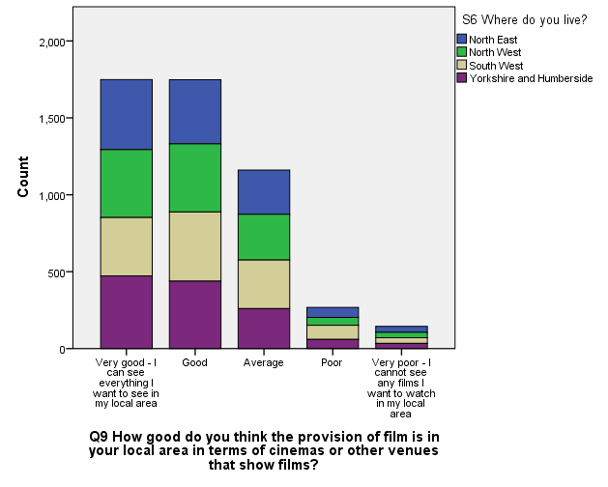
Figure 2: Perceptions of provision per region
Comparing this with the audience types identified in WP4, we found that region has little impact on the audience type that people engage with. As a consistent finding across the four regions, we found that individualised audiences and group audiences based in film clubs and societies are far less common than group audiences composed of family or friends (see Figure 3).

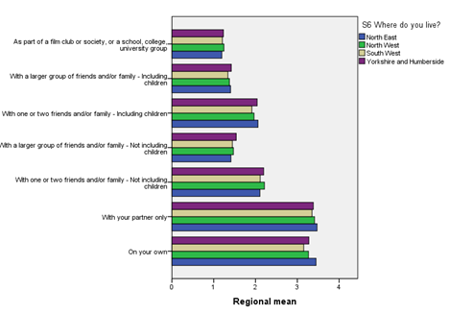
Figure 3: Who respondents watch films within each region
Examining this in terms of respondents’ rationale for watching specific films, we found that people are highly likely to cite ‘entertainment’ or ‘escapism’ as their primary reason. Meanwhile, ‘being challenged’, ‘for ‘learning’, and ‘socialising to spend time with friends and family’ occurred relatively infrequently (see Figure 4).
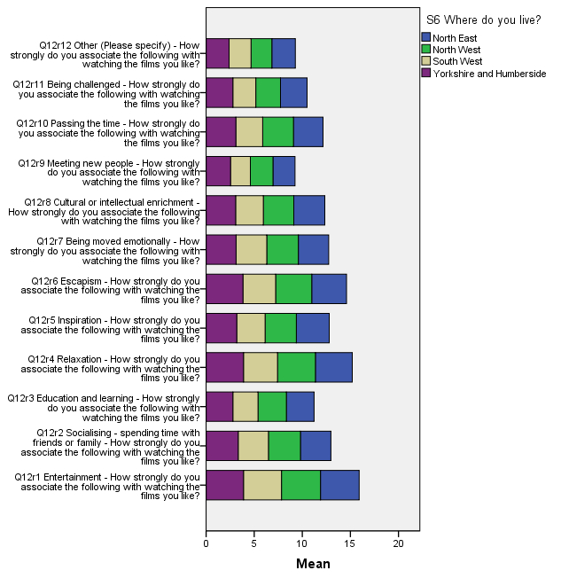
Figure 4: Reason for watching preferred films in each region.

Overall, survey wave 1 findings support those in WP3, leading to an argument that a more discerning taste in films with challenging content is less common than watching popular genres for entertainment. The findings also provide statistical significance to those in other work packages. For example, they support the audience types identified in WP4 by finding that group audiences (watching friends or family) are far more common than individualised ones (watching alone) - a point that suggests film-watching to be primarily a social activity.

Survey waves 2/3 - Findings:
The second and third waves of the survey asked the same set of respondents an identical set of questions, spaced 3 months apart. The questions focussed on their experience of film-watching, and preferences. We found that respondents identified 30 distinct film genres, indicating that people naturally categorise films in ways that differ from the genre listings used with the film industry and by policy-related institutions (see Appendix 3).

To assess how survey responses compared across our four regions, we examined how people find out about films, and in doing so identified a set of patterns that were relatively consistent across the country. Notably, people tend to find out about films by word of mouth (either in person or via social media) more often than they do through advertisements in magazines or newspapers. While this remains relatively consistent across regions, there is some deviation. For example, people living in the North East and Yorkshire and Humber appear slightly more likely to find out about films on a cinema website than people
living elsewhere (see Figure 5).
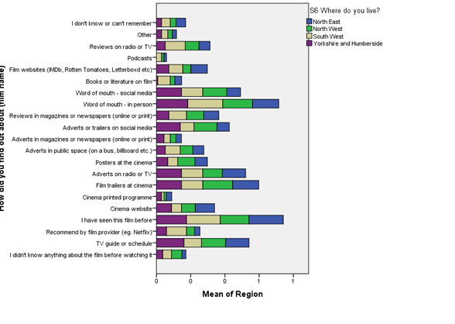
Figure 5: What informs film choice per region.

Overall, our initial analysis of responses to survey waves 2 and 3 supports our analysis of those in wave 1 in several ways. Our analyses across all three-waves finds that:

- Regional location (within the four regions of our study) are not important influences on the way people watch or experience film, e.g. film cultures are relatively similar across the country.
- Watching film as a social activity is far more common than doing so for cultural enrichment, or for learning.
- People tend to find that their local access to film is good or very good, irrespective of the diversity of films on offer within the area.

How audiences interpret specialised films
In our film-elicitation groups, clips were taken from eight recently released British and European independent titles, each screened in UK cinemas between 2016 and 2018 (Appendix 4). Our analysis produced five key findings:

Interpretive Resources
We find that participants draw on a range of interpretive resources to make sense of different types of film. Participants describe the various interpretive resources drawn on to make sense of film, which are; (1) insights and knowledge gained through a person’s own education; (2) cultural resources, where participants drew on other films, current affairs in the news, or other film clips within the session as intertextual reference points to discuss or making sense of a specific scene; (3) life experiences, where past experiences enabled an in-depth understanding of both the content and context of film scene (e.g. working as a mental health nurse or teacher, living abroad, having ‘come out’, or having claimed jobseekers allowance). In combination, these interpretive resources (education, culture, personal ad experience) enable people to relate to, and make sense of films, storylines, and the characters within them. This means audiences will bring different types of resources into interpreting film.

The role of landscape in film interpretation
Participants often discussed the portrayal of landscapes in film. This included both landscapes that were familiar to them (e.g., their local area, or areas previously visited) and those that were unfamiliar (e.g. other countries). Sometimes their portrayal evoked reminiscence amongst participants of past life experiences (holidays, commuting, childhood etc). At other times, it was steeped within an aesthetic enjoyment of the beauty on-screen and connected with the escapism of imagining being there. In terms of sense-making, the portrayal of known places was at times seen as a distraction (e.g. being distracted from the narrative by the film not following the actual geography of the location). Others read the portrayal of landscapes symbolically; both as a metaphor that enabled reflection on a characters’ inner world, and as stimuli that garnered personal reflection on their own location and the memories invested within it. For this, participants often adopted a phenomenological lens when discussing landscapes and/or their connection to characters (a lens that was not present when discussing other aspects of film). In this, participants often described their experience of film scenes in sensory terms, with portrayals of landscape fostering a participatory relationship between viewer and text – notably in an escapist sense of being there or of being transported elsewhere. In either case, the portrayal of landscapes in film were seen to elicit reflection and memory in a way that other film attributes did not.

Engagement with different film aesthetics
Participants valued authentic character-acting and realistic storylines as an effective way to garner empathy, and engagement with characters and the film. In this, authenticity was often assessed through interpretive resources, with specific film clips (at times) felt to purposefully accentuate aspects of reality for effect. For example, several participants drew on their past life experiences of unemployment to describe the portrayal of job centre staff in the ‘I, Daniel Blake’ film clip as heightened; accentuating lived reality to make a point. By drawing on life experiences as a set of interpretive resources, participants tended to engage with realist aesthetics more than any other. That is, the veracity of a filmic depiction was important to participants’ interpretation of the emotional, mental, and psychic status of a character; whether a portrayal of the stark countryside landscapes of farm-life or the claustrophobic space of a job centre. This relationship between the filmic depiction of place, the portrayal of a character, and participants’ interpretation is steeped within the authenticity attributed to the film content. As such, a realist aesthetic was described as important to audiences’ engagement with specialised film.

Universal themes
Across the focus groups, participants identified a set of universal themes, around work, relationships and identity through on-screen portrayals. For example, participants identified with depictions of various relationships that they personally had not experienced by relating them to their own experience. In this, a heterosexual/cis gender participant could relate to subtle moments of romance and sexual intimacy within a homosexual relationship by drawing on their own life experiences of marriage for reference. Meanwhile other participants felt represented through portrayals of their own experiences in on-screen depictions of parenting, even in vastly different contexts, drawing on life experiences of raising their own children.

Engaging with specialised film
In their discussion of what was distinctive about specialised film, participants often described their content as being open to interpretation in a way that mainstream films are not. That is, the formal devices used within mainstream films (e.g. music, colour, tone, framing, panning speed, composition) were felt to direct participants towards a specific interpretation of a film or scene. By engaging with the relatively open format of specialised films, participants were enticed to engage with the film in new ways. For some participants, this was regarded as a positive feature of their film-watching experience; as a way of learning about and connecting with other people and places.

Conclusion
Our findings identify a distinct range of six different types of audiences. As we continue to develop socio-cultural profiles for each audience type, we are refining our understanding of the experiences and practices that make-up each one, and how people might sit within two or more audience types. We also contextualise this against current trends in the policy and industry environments surrounding film. In this, we aim to provide an evidence base which may later be used to inform decisions behind the provision and programming of specialised film for each audience type as market segments.

By exploring how audience members interact with film, and how it relates to their daily lives, we find that the different audience types configure around different experiences, screens, venues and film genres - and that these change with different stages of life. We also find that watching films is a social activity, in which people are often ‘opened up’ or introduced to specialised film by other people (e.g. friends or family); notably through their suggestions and/or recommendations (which may be online or offline) when choosing films. In this, we find that personal recommendations (either in person or via social media) are an important channel for introducing specialised film to audiences that might not otherwise have engaged with them. Although, we note that this should be understood in relation to other marketing strategies. We also find that audiences’ film-watching practices are shaped through levels of access and provision, identifying five different levels of access and provision which range from diverse local film cultures to areas with very limited access to theatrical film.

We are now engaging with stakeholders to co-produce a set of freely available, open access, user-friendly data visualisations and search tools to support audience development. We will also be undertaking Delphi workshops to develop film audience development policy.

Appendix 1: Outline of work packages (WPs)
WP 1 - Development of an ontological data model and graph database to enable us to define, store, and query all datasets across the project in a consistent way. The ontology is being developed iteratively, drawing on analyses from WP’s 2 to 7, with a focus on the coding scheme developed in WP4.

WP 2 - Analysis of 115 trade press, industry reports, policy documents, box office information, and exhibition and distribution materials. The WP sought to identify policy and industry trends surrounding non-mainstream film, producing a qualitatively coded dataset.

WP 3 - Development of a socio-cultural index of the factors that impact audience formation. The index provides a basis for understanding relations between specialised film audiences and the people’s broader patterns of media consumption. The WP has produced several complex statistical analyses combining existing datasets, providing a sound basis for one of our recently published journal articles.

WP 4 - A thematic analysis of 200 semi structured interviews with audience members to understand how people engage with film. The WP gathered rich detail on audience’ viewing practices and experiences, and the meanings people associate with specialised film. WP 4 analysis informed the design of the computational ontology (WP1) and survey questions (WP5). WP4 findings have been drawn on in two submitted journal articles, in several conference presentations, and at meetings with internal and external stakeholders.

WP 5 - Analysis of a three-wave survey to capture detail on audience formation over time, including detail on demographics, cultural interests, types of film watched, watching frequency, location, and types of media used. The survey gathered N=5,094, n=547, n=317 responses (using a diminishing within-group subset sample). The combination of categorical, ordinal, and free-text questions requires statistical modelling and qualitative coding. WP5 findings are currently being used for an in-draft article.

WP 6 - A thematic analysis of 28 semi structured interviews with film policy and industry experts to understand how different release and distribution strategies relate to specialised film. Findings for this WP align with those in WP2, with both identifying a specific pattern of funding distribution in the UK and its influence on specialised film.

WP 7 - A thematic analysis of 16 film-elicitation groups to explore audience member interpretations of the narratives and thematic components of specialised films, in order to understand the relationship between film texts and their contexts of consumption. Findings from this WP have been presented at a seminar and a conference

Appendix 2: Project outputs to date

Forrest, D. (2019) ‘Slightly depressing but beautiful at the same time: National and Regional Imaginaries in Contemporary European Cinemas’, Keynote speech: Place and community colloquium, Sheffield: University of Sheffield, 24-May-2019.

Forrest, D. (2018) ‘Beyond the multiplex: Film elicitations’, This way up 2018, Liverpool: FACT, 5-6-Dec-2018.

Forrest, D., and Hanchard, M. (2019) ‘Through falling in love it’s like he’s seeing this landscape, seeing that beauty: The film worlds of God’s Own Country’, BAFTSS 2019, Birmingham: University of Birmingham, 25-Apr-2019.

Hanchard, M. (2019) Using NVivo to structure a computational ontology, NVivo blog, available at: https://www.qsrinternational.com/nvivo/nvivo-community/the-nvivo-blog/using-nvivo-to-structure-a-computational-ontology (Accessed: 07-Mar-2019)

Hanchard, M. and Merrington, P. (2019) ‘Developing a computational ontology from mixed-methods research: a workflow and its challenges’, Proceedings of the digital humanities congress 2018, Sheffield: University of Sheffield.

Hanchard, M., Merrington, P., Wessels, B., Yates, S. (forthcoming) ‘Understanding British film taste: patterns within film genre preference groups’, Cultural Sociology, np.

Hanchard, M., Merrington, P., Wessels, B., Yates, S. (forthcoming) ‘Exploring contemporary patterns of cultural consumption: offline and online film watching in the UK’, Emerald Digital Gateway: Digital Worlds, np.

Merrington, P. (2019) ‘Beyond the Multiplex: Audiences for Specialised Film in the English Regions’, (Chair) Diagonale: Festival des österreichischen Films, Graz, Austria, 20-Mar-2019.

Merrington, P. (2018) Choice and Diversity in Film, BECTU Freelancers’ Fair 2018, London: Royal Institution, 27-Apr-2018.

Merrington, P. and Hanchard, M. (2018) ‘Using a data ontology to understand the relational dynamics of film audiences’, Digital humanities congress 2018, Sheffield: University of Sheffield, 08-Sep-2018.

Merrington, P., Hanchard, M., Wessels, B., Pidd, M., Rogers, K., Forrest, D., Higson, A., Smits, R., Townsend, N., and Yates, S. (2019) ‘Using a computational ontology and mixed methods in film audience research’, Cultural Trends. DOI: 118-131. DOI: 10.1080/09548963.2019.1617934

Pidd, M. and Rogers, K. (2018) ‘Why Use an Ontology? Mixed Methods Produce Mixed Data’, Talking Humanities blog, Available at:
https://talkinghumanities.blogs.sas.ac.uk/2018/10/18/why-use-an-ontology-mixed-methods-produce-mixed-data/ (Accessed: 07-Mar-2019)

Rana, H. (2018) ‘Watching from the audience’s perspective’, Beyond the Multiplex blog, Available at: https://www.beyondthemultiplex.net/watching-from-the-audiences-perspective/ (Accessed: 07-Mar-2019)

Wessels, B (2018) Beyond the multiplex: A new approach to audience research’, This way up 2018, Liverpool: FACT, 5-6-Dec-2018.

Wessels, B. (2018) ‘Film and audience experiences and participation’, Film Hub South
West members’ Christmas meeting, Bristol: Watershed Cinema, 10-Dec-2019.

Wessels, B. and Hanchard, M. (2019) ‘Using a computational ontology and mixed-methods in conceptualising film audiences’, Chair: International association of media and communications research 2019 (audience research panel), Madrid (Spain): Compultense Universidad Madrid, 07-11-Jul-2019.

Wessels, B., Merrington, P., Hanchard, M. (2019) Beyond the multiplex project presentation with external stakeholders, Museum of Science and Industry: Manchester, 25-Apr-2019.

Wessels, B., Hanchard, M., and Merrington, P. (2019) Beyond the multiplex project presentation with external stakeholders, Creative Scotland: Edinburgh, 18-Apr-2018

Wessels, B., Hanchard, M., and Merrington, P. (2019) Working with mixed methods aided by a computational ontology to address how film audiences form in regional contexts, Sociology Seminar series, Glasgow: University of Glasgow, 20-Feb-2019.
Yates, S., and Hanchard, M. (2019) ’Modelling socio-cultural factors in film genre: Bauman and Goldthorpe’, Liverpool film seminar series, Liverpool: University of Liverpool, 04-Mar-2019 https://www.ljmu.ac.uk/about-us/events/liverpool-film-seminar-professor-simeon-yates

Appendix 3: Survey respondent identified genres:

Survey Wave 2 - Free-text responses to Question 4a on specifying genre type
Action
Adventure
Animation
Biography
Biopic
Chick flick
Children’s
Comedy
Comic Book
Crime
Disney
Documentary
Drama
Family
Fantasy
Hero
Horror
Music
Musical
Romance
Romantic Comedy
Sci-fi
Spy
Superhero
Supernatural
Teenage
Thriller
Unknown
War
Western

Appendix 4: Film titles used to provide ‘clips’ for the film-elicitation groups:

Call Me by Your Name (Luca Guadagnino, 2017)

Dark River (Clio Barnard, 2017)

God’s Own Country (Francis Lee, 2017)

Happy End (Michael Haneke, 2017)

I, Daniel Blake (Ken Loach, 2016)

Loveless (Andrey Zvyagintsev, 2017)

The Eagle Huntress (Otto Bell, 2016)

Things to Come (Mia Hansen-Løve, 2017)

