Data Format
The first tab is called “Test1 – DAQ All”, and relates to the First Test. Columns A, B, C, and D are data sampled at 0.2s, relating to displacement, pressure, temperature, and force. Columns F, G, H, and I have these same data converted to mm, kPa, °C, and N according to the local calibration.
Column L has the corresponding time for all data.
The second tab, “Test2 – DAQ All”, and relates to the Second Test, but is similarly formatted.
The third tab is called “Test1 – Video Gauge Pressure”. The video of the First Test is played from 1’55”, and the position of the pressure needle is recorded every 0.5s afterwards.
The fourth tab is called “Test2 – Video Gauge Pressure”. The video of the Second Test is played from 2’28”, and the position of the pressure needle is recorded every 0.5s afterwards.
The fifth tab is called “Test1 – VGP and Temp”, where VGP means video gauge pressure.
There is a lot of development in this tab. Firstly, the pressure trace from the instruments and the data arising from the pressure gauge in the video (imported into column J) are compared and synchronised by adjusting the value in AD47, which adjusts the offset in the video-domain time values written into column K. This allows us to see that the pressure data has considerable bias – in fact, the sensor is battery-powered and is considered unreliable – but the time offset can easily be set to 58.5s. This is, of course, the time between the start of the formal dataset and the timestamp in the first video corresponding to 1’55”.
Columns J and K (at 0.5s intervals) are therefore not time-synchronised with other data on any given row (at 0.2s intervals). However, by choosing the time vector that corresponds to any desired dataset, plots of any desired dataset can be made in time domain.
Next, video temperature data (in mV, from the left-hand multimeter) is introduced into column E from row 229, starting from the same frame as the video pressure data corresponding to 170s of main dataset time: the point at which the zoomed analysis begins. This is calibrated to a new temperature dataset in column O, which is considered less noisy than the formal trace. Column N is only used as a check when converting video stills to transcribed numerical data.
The video gauge pressure is also considered more reliable, and generally taken forward from this point. Additionally, some noisy force data (mostly due to spark plug operation) is removed from column I.
The sixth tab is called “Test2 – VGP and Temp”, where VGP means video gauge pressure.
Apart from a different time offset of 24.5s between the start of the formal dataset and the start point of the second video, and video temperature data inserted from E117 (80 seconds), this is similar to the previous tab.
The seventh tab is called “Test1 – Propellant Rate”. In this tab, the force data is smoothed by a one second running average (column AF) and the propellant position is converted into a propellant rate.
This is done by first copying the propellant position from column F to column AH. The difference from one cell to the next (an interval of 0.2s) is then calculated in column AI. This is, effectively, consumption per 0.2s.
This data is then multiplied by five, to get a per-second consumption, and subjected to a four-second running average (column AL). The latest second of this running average is then averaged again (column AM) and converted to mm/minute (column AN).
The eighth tab, “Test2 – Propellant Rate”, is similar to the previous tab.
The ninth tab, “Test1 – Propellant as Pressure” simply converts the smoothed force data (column AF) to a pressure (column AR).
The tenth tab, “Test2 – Propellant as Pressure”, is similar to the previous tab.

Frequency Analysis
The PowerSpectrumHann.mat file contains several variables used to construct the power spectra. The process in respect of the First Test is as follows:
rawone is the column on the Excel sheet “Test 1 – Propellant Rate”, from cell AN856, down for the next 255 cells. This start cell is chosen because it corresponds to time 170 in the DataSet Time, which is where the detailed analysis begins.
The frequency analysis is then conducted using this approach.
f = 5/256*(0:127);
w=hann(256); %Windowing line
rawonehann = rawone.*w; %Windowing line
Xhann = fft(rawonehann,256);
Pxxhann = Xhann.*conj(Xhann)/256;
plot(f,Pxxhann(1:128))

[NB – if windowing is not carried out, the variable names –hann are used.]

This approach is set out here:
https://uk.mathworks.com/help/matlab/examples/fft-for-spectral-analysis.html
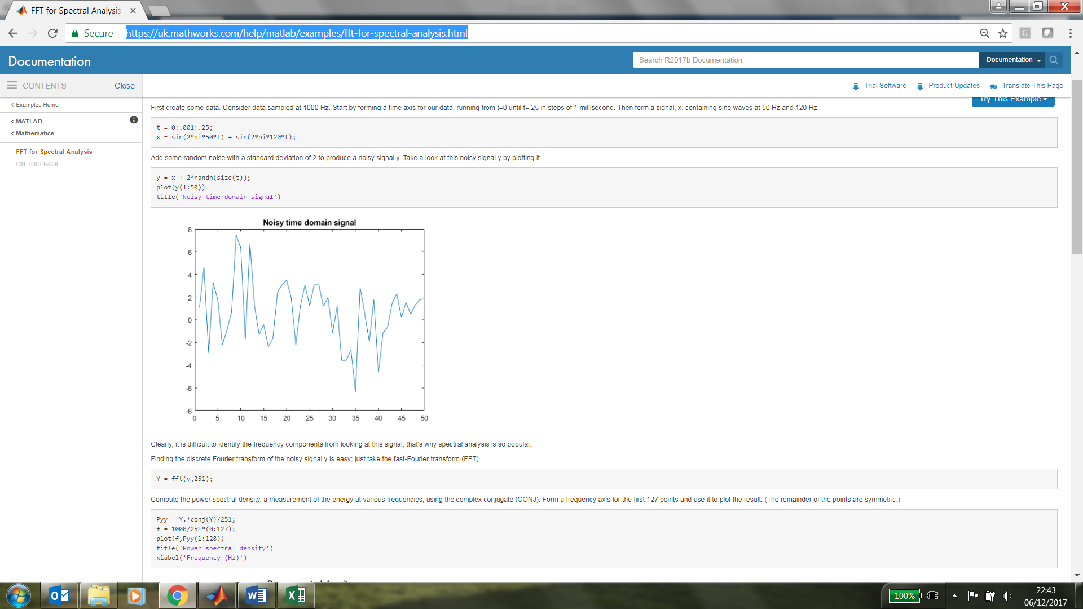

Apart from using cell AN406 in “Test 2 – Propellant Rate” to obtain rawtwo, and using Y for the intermediate steps, the Second Test spectrum is obtained in the same way.

