A re-evaluation of Sn(II) phthalocyanine as a catalyst for the electrosynthesis of ammonia

Michael A. Shipman and Mark D. Symes*
WestCHEM, School of Chemistry, University of Glasgow, Glasgow. G12 8QQ, United Kingdom
*Email: mark.symes@glasgow.ac.uk

Materials and Methods
Materials: Sulfuric acid (95%) was purchased from Fisher. Potassium hydroxide (90%), sodium hydroxide (98-100.5%), phenol (99%), ammonium chloride (99.5%+) and sodium phosphate dibasic (98.5%) were purchased from Sigma Aldrich. Sodium citrate tribasic (99%), tin(II) phthalocyanine, and sodium pentacyanonitrosylferrate(II) (98%) were purchased from Alfa Aesar. Ethanol (100%) and acetone (99%) were purchased from VWR. Propan-2-ol was purchased from Honeywell. All chemical reagents were used as purchased, except for Sn(II) phthalocyanine (see washing procedure below). All aqueous solutions were prepared with ultrapure grade water (18.2 MΩ-cm resistivity), obtained from a Sartorius Arium Comfort combined water system. pH determinations were made with a Hanna HI 9124 waterproof pH meter. Glassy carbon foil substrates (Carbon-Vitreous 3000C (C) foil, 1.0 mm thickness) were obtained from GoodFellow. All other materials were obtained as stated in the text.

Ammonia determination: Ammonia was determined colorimetrically using Scheiner’s indophenol protocol []. Briefly, a 2.5 mL sample of electrolyte was placed in a clean glass sample vial. 1 mL of phenol-nitroprusside buffer and 1.5 mL of alkaline hypochlorite solution were promptly added, the mixture shaken and left in a dark place to develop. After 45 minutes, a UV-vis spectrum was taken, with the value of the absorbance at 635 nm noted. A calibration curve was also established by this procedure, using ammonium chloride diluted to various concentrations over the range 0.04 - 0.20 mg L⁻¹ in 1 M KOH (giving a range of 0.02 – 0.10 mg L⁻¹ after being further diluted by the indophenol test reagents: see Figure 1). UV-Vis spectra were collected in solution using quartz cuvettes on a JASCO V-670 spectrophotometer, unless otherwise noted. The cuvettes were washed successively with acetone and deionized water prior to use. The Sn(II) phthalocyanine complex is essentially insoluble in 1 M KOH, and suspensions of Sn(II) phthalocyanine in 1 M KOH at the loadings we report here do not produce significant absorption at 635 nm.
Figure 1: Calibration curve used to determine ammonia concentrations in solution. Values for the number of moles of ammonia produced in a given experiment were taken from the amount measured in the electrolyte post electrolysis minus that determined to be in solution prior to electrolysis. Pre-electrolysis values were typically around 0.015 mg L⁻¹ in indophenol test samples (and therefore around 0.03 mg L⁻¹ in the electrolyte). Each point in the calibration curve is the average of three separate determinations and the error bars are standard deviations.

Electrochemical methods: Electrochemical studies were performed in a three-electrode configuration using a CH Instruments CHI760D potentiostat. Platinum wire was used as the counter electrode and was washed with acetone and deionized water and then sonicated in ultrapure water before each experiment. An Hg/HgO reference electrode (1 M NaOH, CH Instruments) was used. A glassy carbon foil electrode (2 × 1 cm) was used as the working electrode. The working electrode was polished with 0.5 µm diamond polishing solution and washed with ultrapure water and propan-2-ol prior to use. Three-electrode potentials were converted to the RHE reference scale using E(RHE) = E(Hg/HgO) + 0.140 V + (0.059 × pH) [].
Cyclic voltammetry: Cyclic voltammograms were collected in a single chamber cell at room temperature (20 °C) using a scan rate of 100 mV/s in 1 M KOH. Measurements were compensated for the iR drop and conducted without stirring. The iR test function available on the CH potentiostats uses the general method developed by He and Faulkner [].
Bulk electrolysis: Bulk electrolyses were performed in a three-electrode configuration in single compartment electrochemical cells. Solutions were agitated by gas bubbling (either with nitrogen or argon), at equivalent rates of bubbling through the solutions. Bulk electrolyses were conducted without considering any resistive losses; solution resistances were measured using the iR test function (as for cyclic voltammetry) and were found to be on average 3.7 Ω for a bare 2 × 1 cm carbon foil electrode, and 5.0 Ω for a 2 × 1 cm carbon foil electrode with Sn(II) phthalocyanine deposited on it (see procedure below). At the currents typically passing in these experiments, voltage drops caused by this uncompensated resistance were thus on the order of 1 - 5 mV, and could be neglected.

Washing procedure for the Sn(II) phthalocyanine: 50 mg of Sn(II) phthalocyanine was suspended in 10 mL ultrapure-grade water, and the Sn(II) phthalocyanine then pelleted from this suspension by centrifugation. The supernatant was then decanted and the pellet re-suspended in 10 mL fresh ultrapure-grade water. This process was repeated five times with each 50 mg batch of Sn(II) phthalocyanine. The supernatant solution after each centrifugation was subjected to the indophenol test, giving approximate ammonia concentrations of 0.08 mg L⁻¹ in the first wash supernatant and an average of 0.006 mg L⁻¹ in the supernatant after 3-5 washes. After the fifth wash, the pelleted material was suspended in acetone and re-pelleted by centrifugation (to help remove water) before isolation and drying at elevated temperature to give dry powder. A comparison of the UV-vis spectra of Sn(II) phthalocyanine before and after washing is made in Figure 2A (below). Due to the poor solubility of Sn(II) phthalocyanine in conventional solvents, these spectra are reported in concentrated sulfuric acid, in which Sn(II) phthalocyanine is both reasonably soluble and stable for at least 24 h []. The spectra are in good agreement with those reported for Sn(II) phthalocyanine in the literature [22,]. Meanwhile, the infrared spectrum of the washed Sn(II) phthalocyanine (collected in the solid state on a Shimadzu IRAffinity-1S Fourier Transform Infrared Spectrophotometer) is shown in Figure 2B. The spectrum displays key bands as indicated, which Kroenke and Kenney have shown to be characteristic of Sn(II) phthalocyanine [].
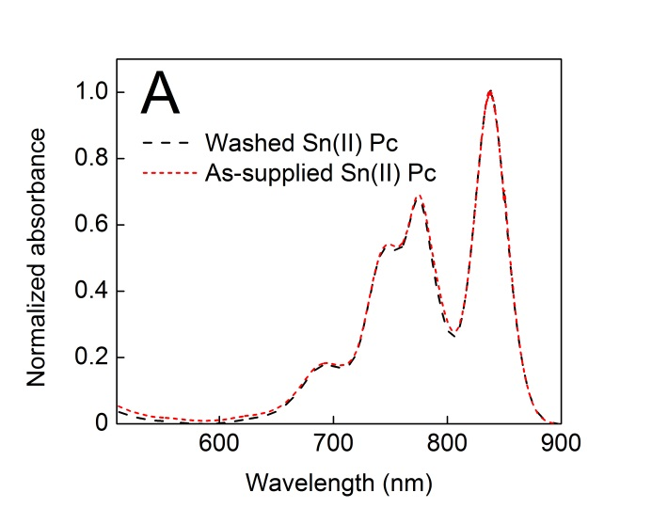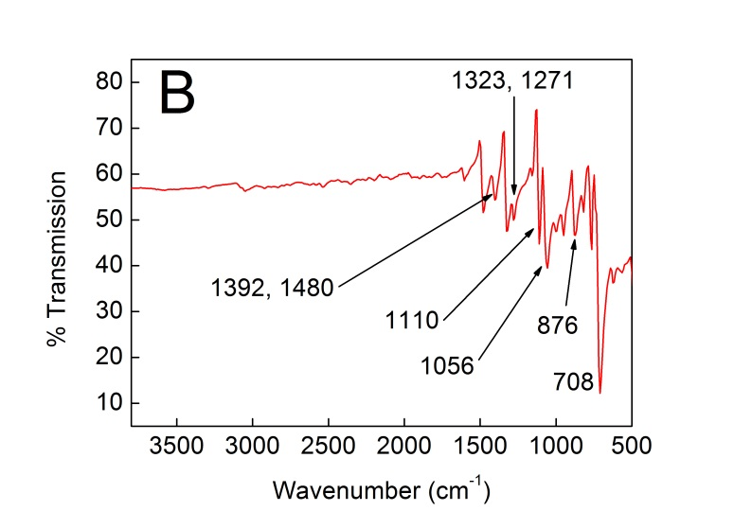
Figure 2A: Normalized UV-vis spectra of Sn(II) phthalocyanine in concentrated sulfuric acid before and after the washing procedure described above. The concentration of Sn(II) phthalocyanine was 35 μM in each case and plastic cuvettes were used. 2B: Infrared spectrum of Sn(II) phthalocyanine in the solid state after the washing procedure described above.

Electrode preparation: After washing, 50 mg Sn(II) phthalocyanine was placed into 10 mL of ethanol and sonicated to make a suspension. A 25 µL aliquot of this suspension was then placed on the 2 × 1 cm carbon foil electrode surface and allowed to dry. Successive 25 µL aliquots of the suspension were then placed on the electrode in the same way (with some perturbation of the previously-deposited layer(s) so as to make as even a layer as possible) until a loading of 1 mg cm⁻² (total loading of 2 mg) of Sn(II) phthalocyanine was achieved (as gauged by measuring the mass difference of a dry electrode after each drop-casting cycle).

Inductively Coupled Plasma Mass Spectrometry: Samples of various electrolytes were analyzed by Inductively Coupled Plasma Mass Spectrometry on an Agilent 7700 ICP-MS instrument at the Department of Pure and Applied Chemistry at the University of Strathclyde (UK). All samples were treated with concentrated nitric acid to aid analysis (final pH of samples was pH 1 – 1.3).

References

[] D. Scheiner, Determination of Ammonia and Kjeldahl Nitrogen by Indophenol Method, Water Res. 10 (1976) 31-36.
[] Handbook of Analytical Chemistry, L. Meites (Ed.), McGraw Hill, New York, 1963, Ch. 5, p. 13.
[] P. He, L. R. Faulkner, Intelligent, Automatic Compensation of Solution Resistance, Anal. Chem. 58 (1986) 517-523.
[] F. Ghani, J. Kristen, H. Riegler, Solubility Properties of Unsubstituted Metal Phthalocyanines in Different Types of Solvents, J. Chem. Eng. Data, 57 (2012) 439−449.
[] R. Kubiak, G. Dyrda, K. Ejsmont, Examples of UV-Vis profiles use as tool for evidence of the metallophthalocyanines transformation, J. Mol. Struct. 1130 (2017) 559-564.
[] W. J. Kroenke, M. E. Kenney, The Infrared Spectra of Some Tin and Lead Phthalocyanines, Inorg. Chem. 3 (1964) 696-698.

