Project Summary:
‘A Walking Story’ is a simple, easy-to-use card game for a variety of audiences. Originally starting as a prescriptive filmmaking game, grounded in the process of thinking about how, where, and why a filmmaker might choose a place, ‘A Walking Story’ shaped into becoming a more open and generalised set of prompts for, people (whether they be tourists/filmmakers/photographers) to see Glasgow (and any other space, on that) in a different way from what they’ve seen it before.

Note to Gareth: unsure how to list these components or plans. This is a preliminary idea
Component 1:

V1 of ‘ A Walking Story’ - Publication of V1 Game distributed across varied friends, family and filmmakers. (User Testing)

Component 2:

V2 of ‘A Walking Story’ - Academic Volume written and peer reviewed (Utilising the user testing as qualtiive findings for adaption of the game)

Component 3:

V3 of ‘A walking story’ to be used in schools, hospitals etc.

Main Content for Website:
When I first visited Glasgow, many years ago, I was told, ‘In Glasgow look up’. Yet, people often don't. The city has absolutely spectacular architecture, but not all of it is obvious. Sometimes, hidden down an alley or in a back court, you will find unvisited places that hold hundreds of stories. The ways in which the city presents itself to visitors and residents can feel limiting, prescriptive, fixed, not always attuned to the true magic of the place. What if it wasn’t like this? What if you had company as you walked through the city? Helping you to see it anew through small comments, observations, prompts and memories? What would you discover? What would you learn about the city you’re in? … and how might you share your new view on the city?

‘A Walking Story’ is this friend, prompting you to explore with your camera in a way that isn't prescriptive, it is designed to act as a catalyst for your own imagination. Start anywhere, pick a card, get walking, and capture things you may have missed. This began as a film making project but Gareth and I slowly realised that the function of this game didn't need to be solely for filmmaking. As we walked and tested the game, we realised it was about us, about rambling, cultural heritage, filmmaking, and our shared love of Glasgow as people who moved here from differing places within the UK, and when you play, it will be about you.

I’ve been considering how the cards can serve as dérive prompts, encouraging players to interrupt habitual movement and explore the city through spontaneous, attraction-driven wandering. From our first experience, we saw filmmaking as a form of layered interpretation-documenting traces, absences, and histories-rather than just capturing locations, making the game a tool for archaeological and architectural storytelling.

Similarly, I’ve been thinking about walking itself as an editing process, and about how the function of walking and exploring in a gameified way, such as this, creates associations between fragments of the city or elsewhere. The line of the walker and the line of the story join up, he argued, so that to trace out a pathway is to trace out a tale, one experienced at ground level, unfolding at the level of the walker, moving at their own pace, invisible to planners. Everyone is a storyteller in their own right, and if these cards allow for creative interpretation in any way, I’d be immensely pleased.

Credits Section:

Project Lead: Oscar Farmer (Link to Oscar’s Work - https://www.instagram.com/tendingthequiet/ / https://uk.linkedin.com/in/oscar-f-b993211a8)
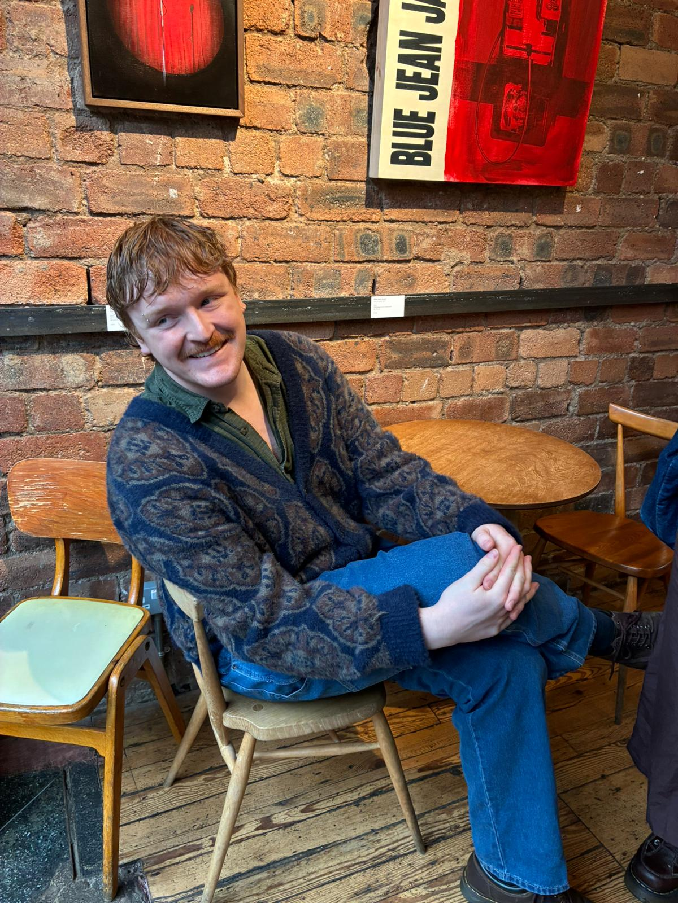

Graphic Designer & Artwork by Eve Farmer (Link to Eve’s Work - https://www.instagram.com/eve.unframed/)

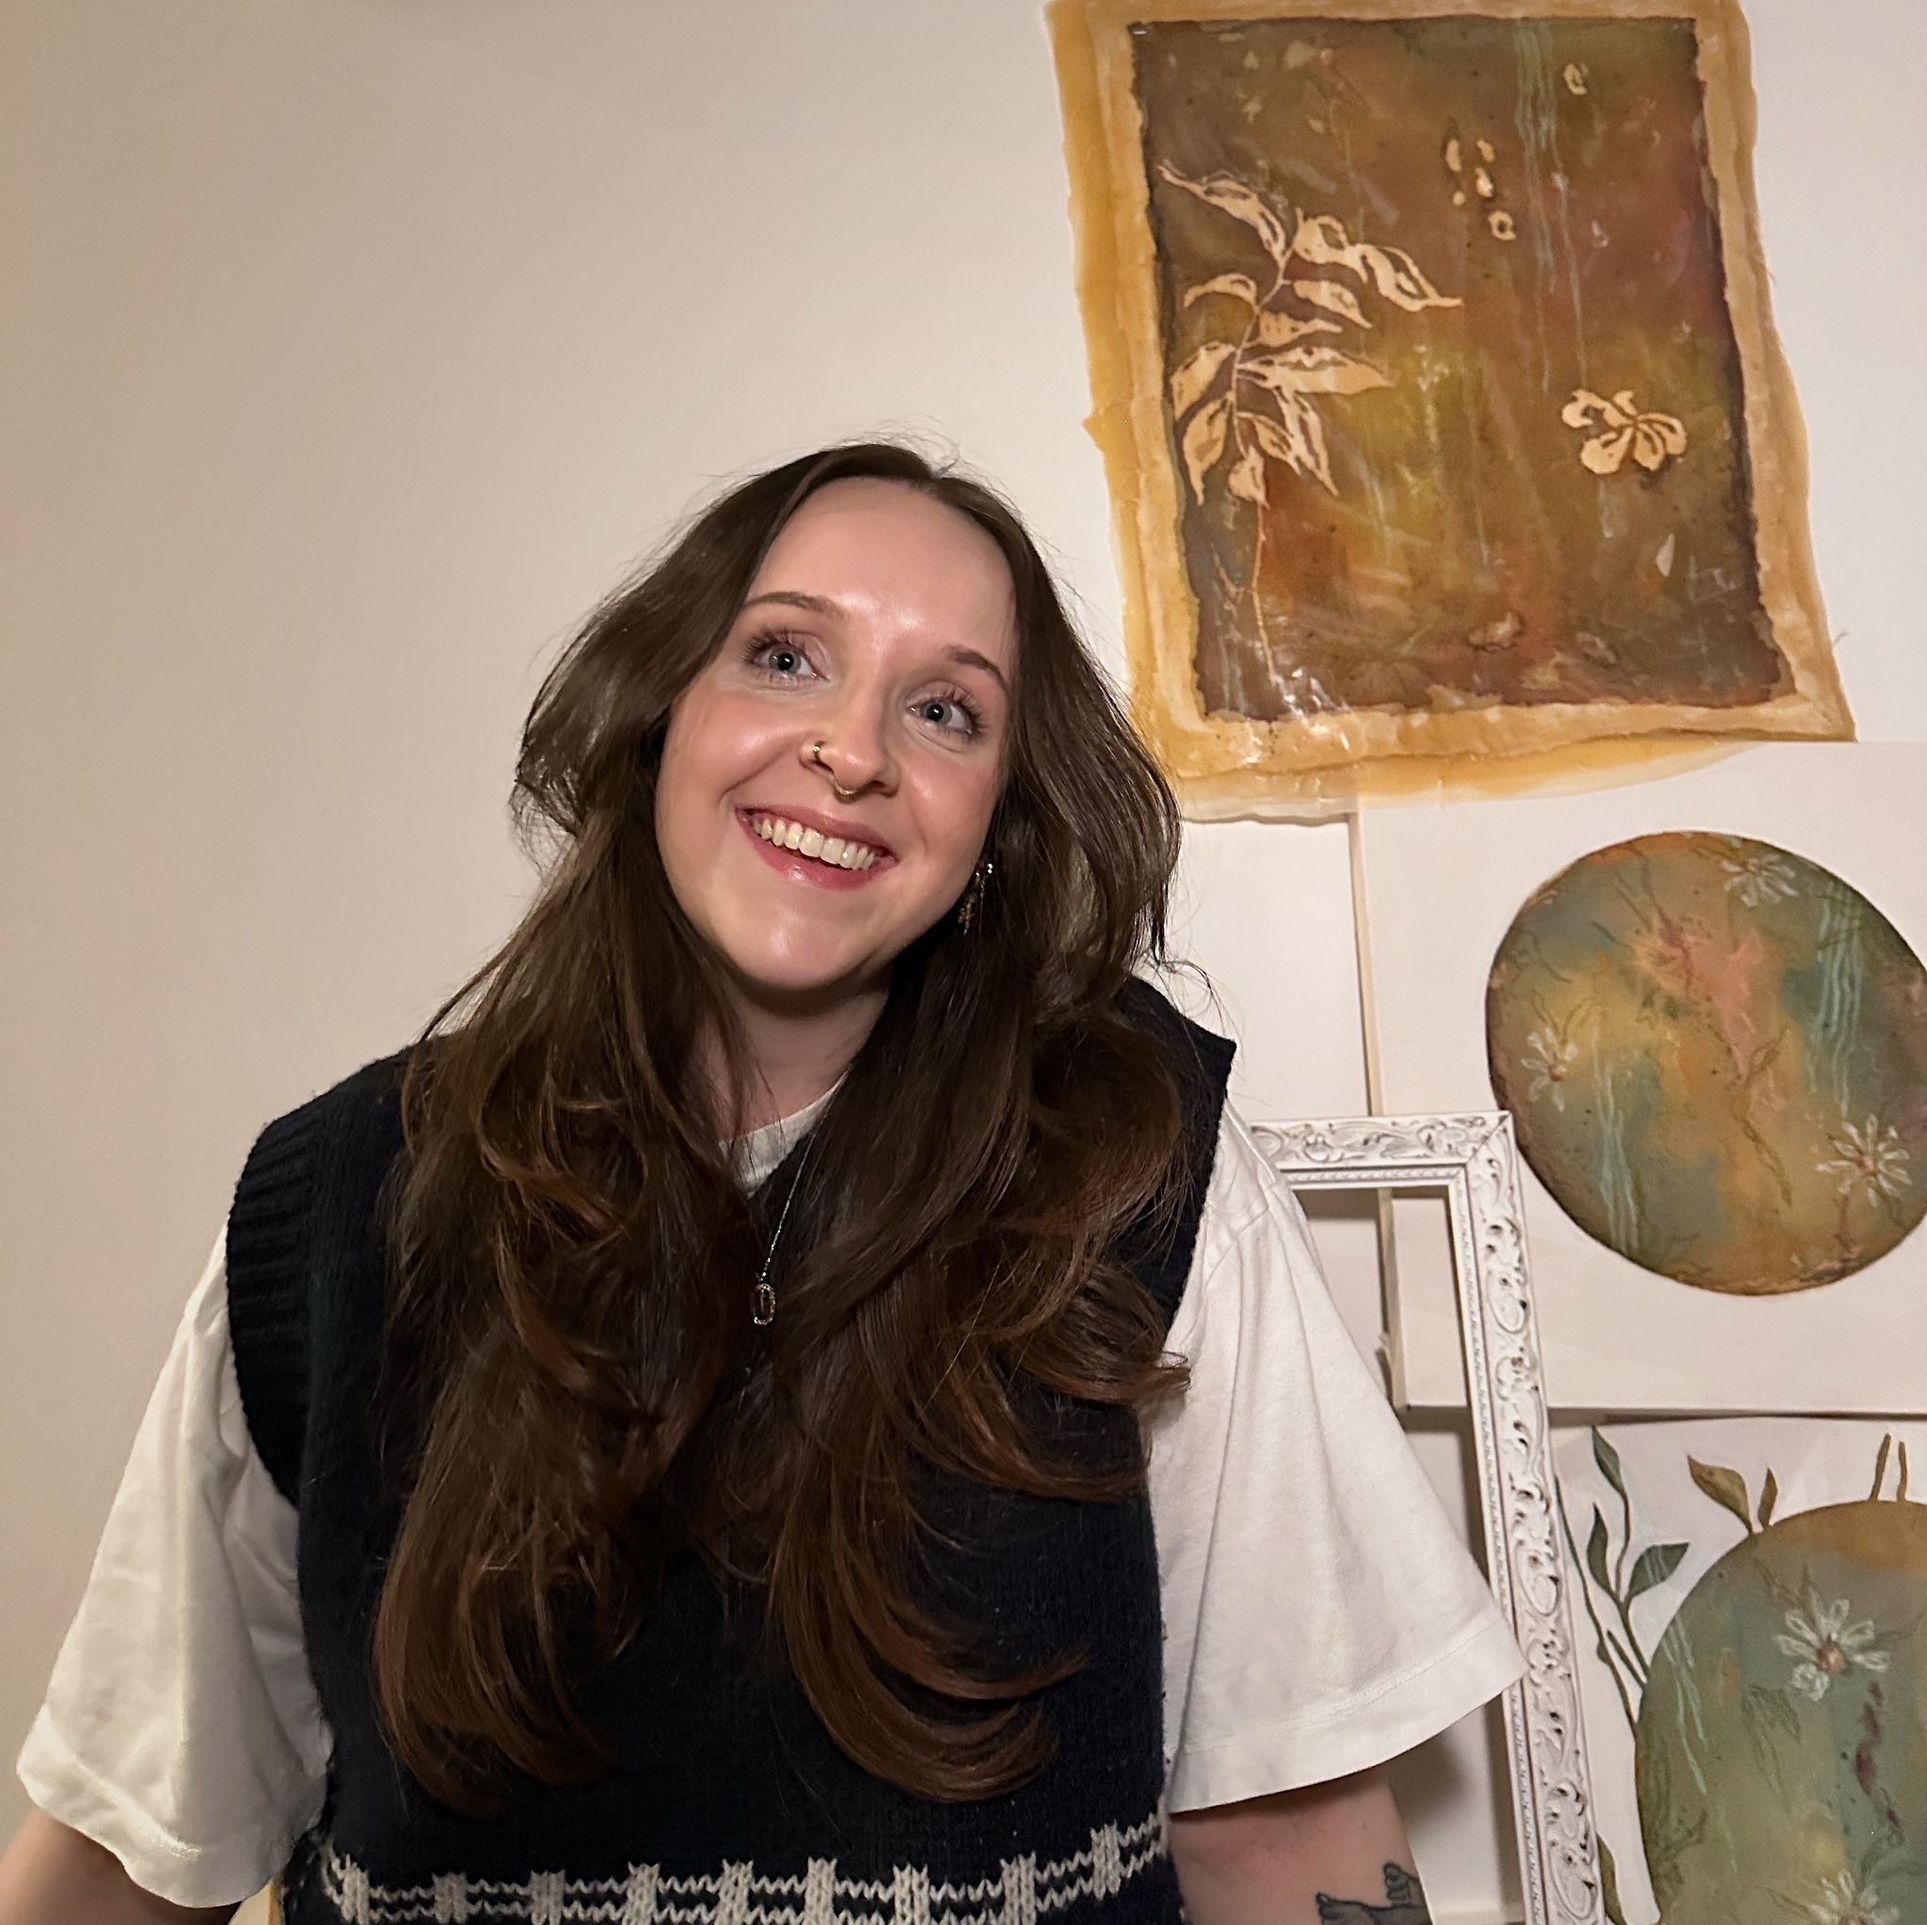

With input from: Gareth Beale

