PACES: Physical Activity and social ConnectednESs
Qualitative Interviews Study Information Sheet

Principal Investigators: Prof Sharon Simpson and Dr Emily Long
Email: paces@glasgow.ac.uk

You are being invited to take part in a research study. Before you decide whether to take part, it is important for you to understand why the research is being done and what it will involve.
Please take time to read the following information carefully.
Feel free to ask any questions before you decide.
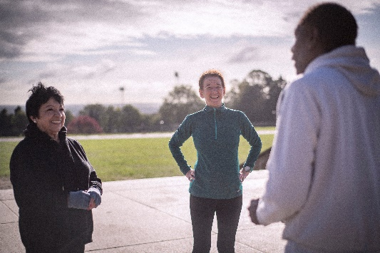
Being physically active and socially connected can help improve health and wellbeing as people get older. Becoming or staying active and socially connected is influenced by different factors like personal health, the area you live in and life circumstances.

Life changes like retirement, losing a loved one, moving to a new area, or becoming a carer can influence people’s physical activity and social connections.

This study aims to understand the different factors that influence being active and socially connected after people have experienced life changes. This will identify ways to support people to become or stay active and socially connected as they get older.

We would like to interview people aged 55 to 75 who live in Renfrewshire or South Lanarkshire and have experienced one or more of the following life changes in the last two to five years:
- Retirement
- Loss of a loved one (spouse, close family member or friend)
- Moved to a new area
- Becoming a carer for a loved one (spouse, parent, grandchild)

If you join the study, you will take part in an interview with a researcher who will ask you about your experiences of physical activity, social connections and your local area before, during and after the life transition(s) you have experienced. They will also ask you about how COVID-19 has affected your physical activity and social connections. We want to know about what can help people to be active and what might stop them from being active. We would like to hear from a wide range of people with different levels of physical activity.

You can choose whether the interview is conducted in-person at your home (complying with COVID-19 guidance), over the phone or by Microsoft Teams/Zoom. The interview will last around 60 to 90 minutes. Before you take part, you will be asked to sign a consent form/verbally consent to taking part in the interview.

With your permission, the interview will be recorded to provide an accurate copy of what was said. During the interview, you can choose not to answer any questions or stop the interview at any time.

You will receive a £20 gift voucher for taking part in the interview.
Frequently Asked Questions:
What will happen next? A member of the research team will get in touch with you to arrange a time to do the interview that is convenient to you.
Do I have to take part? No, it is up to you to decide whether you want to take part in the study. You can withdraw from the study at any time, and you do not have to tell us why. The information you have already provided will be retained and used in the study.
What will taking part mean for me? We can’t promise that taking part in the study will directly benefit you, but the information you give us will help us to find ways to support people like you to be more active and socially connected.

Will other people know I have taken part? Only members of the research team will know you took part. We will ask if you are happy to be contacted to take part in other parts of the PACES study. We will only contact you if you agree that we can, and only members of the study team will have access to your contact details.

All the information you provide will be stored in line with the General Data Protection Regulation (2018) requirements on password-protected computers linked to secure systems at University of Glasgow. We will need your name, address and/or email address and phone number to enable us to contact you. You will be allocated a participant ID number which will be used to anonymise any research data you provide. Your name and contact information will be held separately from your anonymised research data. Members of the research team will have access to your anonymised research data. Full details of how your data will be processed, stored and shared can be found in the PACES privacy notice provided.

What will happen to my information after the study? Your anonymised research data will be retained securely on a University of Glasgow computer server for at least 10 years (in accordance with best research practice guidelines). Your name and contact information will be destroyed when the study ends.

The information you provide during the study might be useful for future research or learning purposes. We will therefore ask if you are happy for us to share your anonymised data with other researchers (including student researchers) and educators in future. We will only share your data if you agree.

What will happen to the results? We will write about the study in publications and presentations. We can send you a summary of the findings if you would like. All reported information will be anonymised, and it will be impossible to personally identify you.

Who is running the study? The study is funded by MRC/CSO Social and Public Health Sciences Unit at the University of Glasgow.

Who has reviewed the study? The study has been reviewed by the College of Medical, Veterinary and Life Sciences Ethics Committee at the University of Glasgow.

For more information about the study, please contact:
Dr Victoria Palmer email: paces@glasgow.ac.uk
Or call our study freephone number: 0800 389 2129

For independent advice, or if you have concerns or feedback about the study, please contact: mvls-ethics-admin@glasgow.ac.uk

THANK YOU FOR CONSIDERING TAKING PART IN THIS STUDY

