Recruitment Documents for: Community Arts Centre Staff being interviewed in Strand 2 of Wellbeing in School Holidays (WSH) Study.

This file contains the four documents to be given to the staff participants in advance of data collection. (Individual Document file names are shown in the Header of each).

Participant type: Community Arts Centre Staff taking part in Interviews in Strand 2.

Documents:
- Introduction to the Study (WSH_STF_Str2_StudyIntro_v2)
- Participant Information Sheet (WSH_STF_Str2_PIS_v4)
- Participant Privacy Notice (WSH_STF_Str2_PrivacyNotice_v3)
- Participant Consent Form (WSH_STF_Str2_ConsentForm_v3)



Invitation to take part in the ‘Wellbeing in the School Holidays’ Study
PHOTO OF RESEARCHER
My name is Susie and I’m a researcher at the University of Glasgow working on a study called “Wellbeing in the School Holidays”.
My email address: s.smillie.1@research.gla.ac.uk

The study aims to find out more about how young people’s wellbeing is affected by school holidays. As part of this I am interested in the role of community arts organisations in supporting young people during the school holidays and am interviewing staff/volunteers at the participating organisations. You are being invited to take part in one of these interviews.
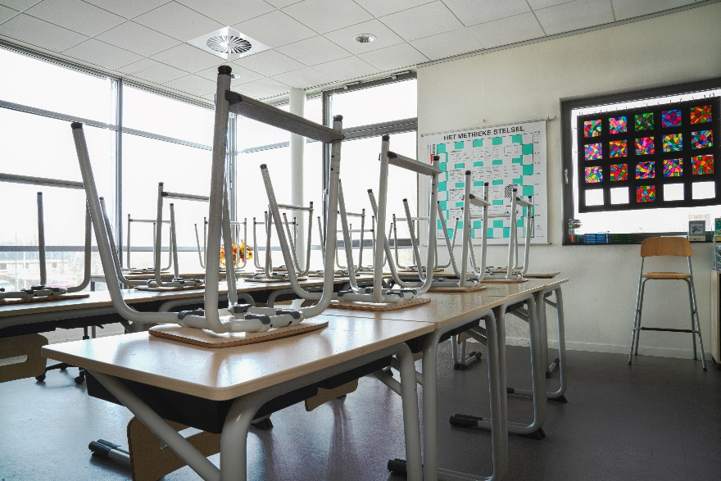
There are two documents that follow this page with information about the research and what we do with the information we collect. The third document is a consent form for you to sign if you’re happy to take part. You can return this to me by email (you can take a photo of it and send it to me) or bring the paper copy with you when we meet.

It can be a lot to take in so please email me ( s.smillie.1@research.gla.ac.uk ) if there’s anything that isn’t clear or you would like more information about. I’m happy to call you on the phone if that’s easier for you.

Participant Information Sheet

Title of Project: Wellbeing in the School Holidays
Section of project: Interviews with community arts organisation staff
Researcher: Susie Smillie
Supervisors: Dr Stephanie Chambers and Prof Nick Watson

You are being invited to take part in a research study. Before you decide if you are happy to take part it is important for you to understand why the research is being done and what it will involve. Please read the following information carefully and discuss it with others if you wish. Ask the researcher/s if there is anything that is not clear or if you would like more information. Take some time to decide whether or not you are happy to take part.

Thank you for reading this.

What is the purpose of the study?
The purpose of this study is to find out how young people feel during the school holidays and the kind of things they want to do, are able to do, and choose to do, during this time. There is very little previous research in this area and a better understanding of young people’s experiences of school holidays and their needs during this time can help inform decisions about how to meet those needs.
In particular the study aims to understand how important creative activities are to young people, these might be simple things they do themselves (e.g. drawing) or more involved activities and programmes they attend, e.g. at a community arts centre.

Why have I been asked to take part?
[COMMUNITY ARTS ORGANISATION] are supporting the research and adults who work or volunteer in the centre are being asked if they would like to participate in this part of the study. Some of the young people who attend the centre will be taking part in the study and the information you provide will give valuable context to allow a better understanding of the organisation and its role in the young people’s lives.

Do I have to take part?
No, you do not have to take part. Taking part or not will not impact on your role within the community arts organisation. If you do decide to take part you are free to withdraw from the study at any time. You can request for the information they have already given to be left out of the study any time before the end of data collection (likely to be December 2022).

What does taking part involve?

You will be asked to meet with the researcher to be interviewed either in person at a mutually agreed location, over the phone or by video call. The interview will last about 45-60 minutes and you will be asked about the kind of activities/resources/environment the organisation you work for provide for young people during school holidays, how you perceive these affect the wellbeing of the young people who take part and any thoughts you have about how the needs of local young people during the school holidays could be better met either within the organisation or more broadly.

Throughout the interview you do not have to answer any questions that you do not want to, and you can ask to take a break or to end the interview early if you want to.

The interviews will be recorded using a password-protected voice recorder and a transcript of what is said will be written out so that the researcher can look in more detail at what is discussed.

What are the risks and benefits of taking part?
There are no direct benefits to taking part but you may find it worthwhile or enjoyable to contribute your knowledge and experience to a project seeking to inform future school holiday activity provision and development of community arts organisations. Talking about the experiences of young people that you have worked with may be emotionally demanding and if this is the case and you would not like to continue you are free to skip questions, ask for a break or end the interview at any time.

Will the information that I give you in this study be kept confidential?

The information you provide will be stored in a locked cabinet or in password-protected and encrypted devices that meet University of Glasgow and legal standards for securing data. These files or documents will only be accessible by the research team. Personal data (e.g. name, contact details) will be stored separately from research data (e.g. recording of interview, photographs) at all times. Pseudonyms or ID numbers will be used in place of names and any other information that could potentially identify a participant, or other person known to them, will not be used in publications or reports.
Although these efforts will be made to anonymise you, the number of staff at the organisation is so small that it is not possible to guarantee complete confidentiality. Therefore if any direct quotations are to be used in reports or publications you will be asked to review these first and give permission for them to be used.

- Please note that assurances on confidentiality will be strictly adhered to unless evidence of wrongdoing or potential harm is uncovered. In such cases the University may be obliged to contact relevant statutory bodies/agencies.

What will happen to the results of this study?
The study will form the basis of a thesis written by the researcher which will be read and assessed by examiners for the award of PhD. The thesis will then be published and available to view on the University of Glasgow website. Publications in academic journals and other research outputs (e.g. conference presentations) may arise from the study. At the end of the study participants (and parents/carers of young people participants) will be given a summary of the research findings.
Who has reviewed the study?
This study has been considered and approved by the College of Social Sciences Research Ethics Committee, University of Glasgow.

Who can I contact for further Information?
If you have any questions about this study, you can ask contact:
- Researcher: Susie Smillie (s.smillie.1@research.gla.ac.uk )
- Supervisors: Stephanie Chambers (stephanie.chambers@glasgow.ac.uk ) or Nick (nicholas.watson@glasgow.ac.uk)

To pursue any complaint about the conduct of the research: contact the College of Social Sciences Ethics Officer, Dr Susan Batchelor, email: Susan.Batchelor@glasgow.ac.uk

Thank you for taking the time to read this.

End of Participant Information Sheet

Privacy Notice for Participation in Research Project (Staff Participant)

Name of project: Wellbeing in the School Holidays
Researcher: Susie Smillie
Supervisors: Dr Stephanie Chambers, Prof Nicholas Watson

Your Personal Data

The University of Glasgow will be what’s known as the ‘Data Controller’ of your personal data processed in relation to your participation in the research project “Wellbeing in the School Holidays”. This privacy notice will explain how The University of Glasgow will process that personal data.
Why we need it
We are collecting basic personal data such as your name and contact details in order to conduct our research. We need your name and contact details to arrange interviews or potentially follow up on the data you have provided. During your interview you may mention other personal data (e.g. ethnicity, religion) and this would be recorded as part of the interview but we will de-identify your personal data from the research data (your answers given during interview) by using pseudonyms or ID numbers for you rather than your real name and removing information you have mentioned in your interview that might lead to you being identified.
Legal basis for processing your data
We must have a legal basis for processing all personal data. As this processing is for Academic Research we will be relying upon Task in the Public Interest in order to process the basic personal data that you provide. For any special categories data collected we will be processing this on the basis that it is necessary for archiving purposes, scientific or historical research purposes or statistical purposes
What we do with it and who we share it with
All the personal data you submit is processed by researchers at University of Glasgow. In addition, security measures are in place to ensure that your personal data remains safe: personal details are stored separately from all other research data (in separate locked cabinets/drawers and in separate secure electronic folders on password-protected, encrypted devices that are accessible only by the research team.
It is possible that you might discuss some of your personal data during your recorded interview with the researcher. Some of these recordings will be transcribed by a third party company contracted by the University of Glasgow under conditions that ensure that the confidentiality of the data is maintained. These recordings will not include participants full names or contact details and recordings and transcripts will be transferred to the company, and back to the University, in a secure way using passwords and secure storage.
Please consult the Consent form and Participant Information Sheet which accompany this notice.
We will provide you with a summary of the study findings at the end of the study.

What are your rights?

GDPR provides that individuals have certain rights including: to request access to, copies of and rectification or erasure of personal data and to object to processing. In addition, data subjects may also have the right to restrict the processing of the personal data and to data portability. You can request access to the information we process about you at any time.

Please note that as we are processing your personal data for research purposes, the ability to exercise these rights may vary as there are potentially applicable research exemptions under the GDPR and the Data Protection Act 2018. For more information on these exemptions, please see UofG Research with personal and special categories of data.
(https://www.gla.ac.uk/myglasgow/dpfoioffice/a-ztopics/research/ )
If you wish to exercise any of these rights, please submit your request via the webform (https://www.gla.ac.uk/myglasgow/dpfoioffice/gdpr/gdprrequests/) or contact dp@gla.ac.uk

Complaints
If you wish to raise a complaint on how we have handled your personal data, you can contact the University Data Protection Officer who will investigate the matter.
Our Data Protection Officer can be contacted at dataprotectionofficer@glasgow.ac.uk

If you are not satisfied with our response or believe we are not processing your personal data in accordance with the law, you can complain to the Information Commissioner’s Office (ICO) https://ico.org.uk/

Who has ethically reviewed the project?
This project has been ethically approved via the College of Social Sciences Research Ethics Committee.
How long do we keep it for?
Your personal data (e.g. name and contact details)will be retained by the University until the end of the study when we will need your details to send you a summary of the research findings. This will be no longer than the period of ethical approval (until 01/10/2024). After this time, personal data will be securely deleted.
Your research data (e.g. transcripts of discussions with researcher) will be retained for a period of ten years in line with the University of Glasgow Guidelines. Specific details in relation to research data storage are provided on the Participant Information Sheet and Consent Form which accompany this notice.
End of Privacy Notice _________________________________________________

Participant Consent Form (Staff)

Title of Project: Wellbeing in the School Holidays
Researcher: Susie Smillie
Supervisors: Stephanie Chambers and Nick Watson

Please read the following statements, tick the appropriate box at the end and sign in the space provided.

- I confirm that I have read and understood the Participant Information Sheet for the above study and have had the opportunity to ask questions.
- I understand that my participation is voluntary and that I am free to withdraw at any time, without giving any reason.
- I consent to my interviews being audio-recorded
- I acknowledge that participants will be referred to by pseudonym.
- I acknowledge the provision of a Privacy Notice in relation to this research project.

I agree that:
- All names and other material likely to identify individuals will be anonymised.
- The material will be treated as confidential and kept in secure storage at all times.
- Personal data (names and contact details) will be destroyed once the project is complete.
- Research data (de-identified data e.g. transcripts of interviews) will be retained in secure storage for a period of 10 years in accordance with University of Glasgow policy, after which it will be destroyed
- The research data may be used in future publications, both print and online, but you will not be identified in these.
- I waive my copyright to any data collected as part of this project.

Please tick ONE as appropriate:

I agree to take part in this research study ☐
OR
I do not agree to take part in this research study ☐

Your Name
Your Signature
Date

………………………………………………………………………………………………………..
TO BE COMPLETED BY RESEARCHER
Name of Researcher | Signature | Date

End of Form.

