Recruitment Documents for: Young People taking part in focus groups in Strand 2 of Wellbeing in School Holidays (WSH) Study.

This file contains the four documents to be given to the young people participants in advance of data collection. (Individual Document file names are shown in the Header of each).

Participant type: Young People taking part in Focus Groups in Strand 2.

Documents:
- Introduction to the Study (WSH_YP_Str2_StudyIntro_v2)
- Participant Information Sheet (WSH_YP_Str2_PIS_v4)
- Participant Privacy Notice (WSH_YP_Str1Str2_PrivacyNotice_v4)
- Participant Consent Form (WSH_YP_Str2_ConsentForm_v4)

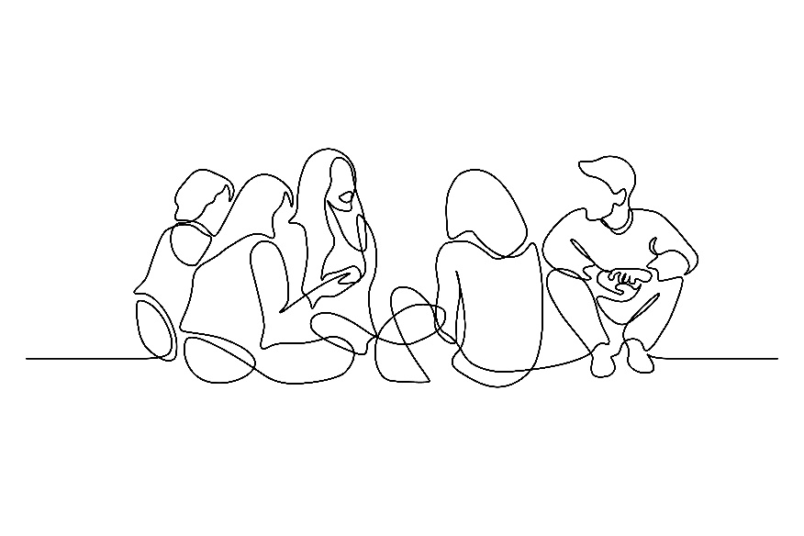

Invitation to take part in the ‘Wellbeing in the School Holidays’ Study

PHOTO OF RESEARCHER
My name is Susie and I’m a researcher at the University of Glasgow working on a project called “Wellbeing in the School Holidays”.
My email address: s.smillie.1@research.gla.ac.uk

Research is a way of finding out more about something. The kind of research I do looks at what things affect how people feel in their minds, bodies and lives.
Understanding this better can help change things to improve people’s lives.

We all have different lives so it’s important that research tries to include the variety of experiences different people have.

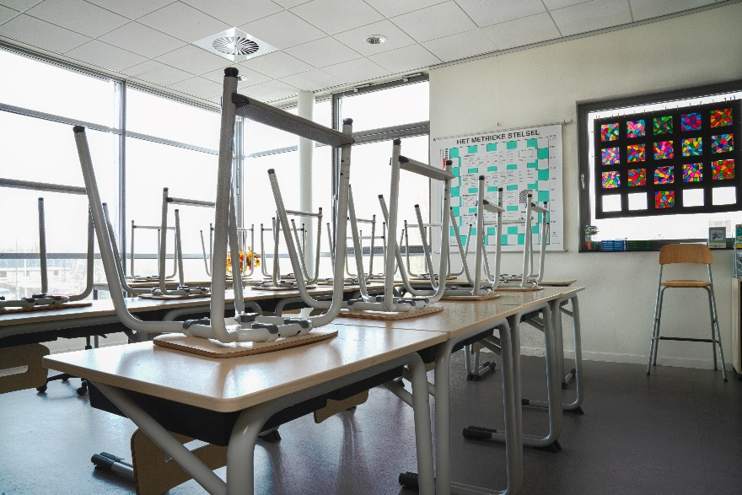
This project is about school holidays, how important creative activities are to young people during this time and how community arts organisations support young people during school holidays.

When people take part in research like this it’s important that they have enough information about it so that they can agree to take part (‘consent’) knowing what it is they’re agreeing to.

For that reason there are pages that follow this one with lots of information. It can be a lot to take in so please take your time, speak to someone you trust if you want to discuss it more, or you can contact me if there’s anything that isn’t clear or you would like more information about.
Here are some of the main important points:
- I’d like you to take part in a group or two with some other young people
- One group would be with people you know from [ARTS ORG], the other would be mixed with young people from a similar organisation.
- You can choose to write, draw or speak about what you think (or all of these). You don’t have to answer any questions you don’t want to.
- I’d like to record our chat so I can remember what we said and take photos of anything that is written or drawn (not of you).

Young Person Participant Information Sheet

Project title: Wellbeing in the School Holidays
Researcher: Susie Smillie
Supervisors: Stephanie Chambers and Nick Watson

1. What is the purpose of the study
This study aims to find out more about how young people feel during the school holidays. This includes the kind of things they want to do, are able to do, and choose to do, during this time. I also want to find out if creative things (like drawing, listening to music, or making something) are important to young people in school holidays.
My job as the researcher on the project is to work with young people to collect information about this and then to write about it in a way that other people can learn from. This can help other people (like teachers, other researchers, people in government) to better understand how young people feel and what they need.

2. Why have I been chosen?
You are being asked to take part because you are part of the [TITLE OF YOUTH GROUP] at [TITLE OF ORGANISATION], which is one of the community arts centres the project is working with.

3. Do I have to take part?
No, you do not have to take part in this study and not taking part will not affect anything you take part in at [TITLE OF ORGANISATION].
Even if your parents/carers have agreed to you taking part you can still decide not to take part if you do not want to. If, after you have started to take part, you change your mind, just let me know and I will not use any information you have given me in my writing.
There are two different parts to this study so you might have taken part in something before, or you might be asked in the future. You can take part in both if you want to.

4. What will happen to me if I take part?
If you decide to take part I will ask you to take part in two ‘focus groups’. These are groups with other young people where I’ll ask the group what they think about young people’s experiences of school holidays and how you think being part of a community arts centre, like [COMMUNITY ARTS CENTRE], affects what young people, like you, are able to do or be. One of these groups will be only with other young people from [COMMUNITY ARTS CENTRE] and another will be with young people from another community arts centre.
During the sessions I’ll try to make sure everyone has an opportunity to speak if they want to but you don’t have to answer any questions that you don’t want to. There will be opportunities to take part by drawing or writing if you don’t want to speak in the group. Each group will last about an hour and I’ll record the session on a voice recorder so that afterwards I can listen carefully to what was said. I’ll also take photos of what we draw or write together but I won’t take photos of you or anything that could identify you.

5. Will the information that I give you in this study be kept confidential?
I will keep the information in a locked cabinet or in a locked file on my computer. When I write about what I have found, your name will not be mentioned. If you like you can choose another name for me to use when I am writing about what you said. No-one else will know which name you have chosen. (More details on how we use and look after your information is in the document ‘Privacy Notice’)
When I come to write about the project I will sometimes use quotes, which means I might write exactly what you, or another young person, has said. I will not use anything that would be recognised by other people who know you.
At the beginning of the group I will ask you all to keep the discussion confidential. In other words, that what is shared there by other young people should not be repeated outside the group.

None of the staff at [COMMUNITY ARTS CENTRE] will be with us during the session but they may know you are taking part since they are helping me to hold the group at the centre and may be in the building. I will not tell the staff who has said what during the group but they may read quotes in my report (although they will not know who has said this).
However, if during our conversation I hear anything which makes me worried that you, or other young people, might be in danger of harm, I might have to tell other people who need to know about this. If this is ever the case I will do my best to talk to you about it first and explain what I need to do.

6. What will happen to the results of this study
When I have gathered all of the information from everyone who is taking part I will write about what I have learned in a thesis (a long essay). This will be read and marked by senior researchers and then made available on the university website. I might also write shorter essays for journals (research newspapers) or tell other researchers about my work at conferences. I will tell you and the other young people who have taken part what I have found out about the different experiences of school holidays and how these affect young people.

7. Who has reviewed the study?
This study has been reviewed and agreed by the College of Social Sciences Research Ethics Committee, University of Glasgow

8. Who can I contact for further Information?
If you have any questions about this study, you can ask me, Susie (s.smillie.1@research.gla.ac.uk )
or my supervisors, Stephanie (stephanie.chambers@glasgow.ac.uk ) or Nick (nicholas.watson@glasgow.ac.uk )
or the Ethics Officer for the College of Social Sciences, Dr Susan Batchelor, email: Susan.Batchelor@glasgow.ac.uk
Thank you for reading this.
End of Participant Information Sheet _________________________________________________

Privacy Notice for Participation in Research Project

(Young Person Participant)

Name of project: Wellbeing in the School Holidays
Researcher: Susie Smillie
Supervisors: Dr Stephanie Chambers, Prof Nicholas Watson

Information about you (your ‘personal data’)
This sheet will explain what the University of Glasgow (called the ‘Data Controller’) will do with personal information about you, your ‘personal data’, that you give while taking part in the Wellbeing in the School Holidays study.
More detail about what taking part in the study involves is in the Participant Information Sheet that is with this notice.

Why we need your personal data
We are collecting basic personal data such as your name and contact details so that we can do our research. We only collect data that we need for the research project.
We need your name and your contact details (or your parent/carer details) to keep in contact with you while you’re taking part. We will use pseudonyms (fake names) and numbers in place of your name throughout the research so that you are not identified.
We might ask you for some other personal data (e.g. gender, ethnicity). This is so that we can try to represent different groups of people in the research. Personal data like this might also affect how you experience school holidays, so it might be something you talk about with the researcher when you are meeting with them.

Legal basis for processing your data
Your personal data is protected by law so we must have a specific legal reason for using it.
Our reason is that the research is what is known as a “task in the public interest”.

What we do with it and who we share it with
Almost all of the personal data you give us is processed by researchers at University of Glasgow, mainly by Susie Smillie.
Sometimes we use a separate company for transcribing (writing out) the recordings of interviews and group discussions. The person transcribing the recording will not know your full name or contact details. This company, and the people who work for them have an agreement with the University to maintain confidentiality and are bound by the same laws around personal data. The recordings and transcripts are transferred to them, and back to the University, in a secure way using passwords and secure storage.
We keep your name and contact details separate from all other information you give us and we use pseudonyms and numbers in place of your name.
Security measures are in place to make sure that your personal data remains safe: personal details are stored separately from all other research data (in separate locked cabinets/drawers and in separate secure electronic folders on password-protected, encrypted devices that can only be accessed by the researchers.
Please see the Consent form and Participant Information Sheet with this notice.
We will provide you, and your parent/carer, with a summary of the study findings at the end of the study.

What are your rights?
GDPR (the set of laws that help protect your personal data) makes sure that people have certain rights including: to request access to, copies of and changes or deletion of personal data and to object to processing. People may also have the right to restrict the ways the data is processed. You can request access to the information we process about you at any time.

Please note that as we are processing your personal data for research purposes, the ability to exercise these rights may vary as there are potentially applicable research exemptions under the GDPR and the Data Protection Act 2018. For more information on these exemptions, please see UofG Research with personal and special categories of data. (https://www.gla.ac.uk/myglasgow/dpfoioffice/a-ztopics/research/)
If you wish to exercise any of these rights, please submit your request via the webform (https://www.gla.ac.uk/myglasgow/dpfoioffice/gdpr/gdprrequests/)
or contact dp@gla.ac.uk

Complaints
If you wish to raise a complaint on how we have handled your personal data, you can contact the University Data Protection Officer who will investigate the matter.
Our Data Protection Officer can be contacted at dataprotectionofficer@glasgow.ac.uk

If you are not satisfied with our response or believe we are not processing your personal data in accordance with the law, you can complain to the Information Commissioner’s Office (ICO) https://ico.org.uk/

Who has ethically reviewed the project?
This project has been ethically approved by the College of Social Sciences Research Ethics Committee.

How long do we keep your data for?
Your personal data (name and contact details) will be kept by the University only until the end of the study (until 01/10/2024). when we need your details to send a summary of the research findings. After this time, personal data will be securely deleted.
Your research data (the information you speak about to the researcher) will be retained for ten years in line with the University of Glasgow Guidelines.

End of Privacy Notice _________________________________________________

Wellbeing in the School Holidays Study
Young Person Consent Form

I would like to hear what you think about school holidays and spending time at [COMMUNITY ARTS CENTRE] during school holidays. This will be in a group with other young people who also attend community arts centres.

Please circle ‘Yes’ or ‘No’ to show that you agree to taking part or not.

- Have you had a chance to read the information I gave you and had an opportunity to ask me any questions about it?



- Do you want to go ahead with taking part in the group discussion about school holidays and [COMMUNITY ARTS CENTRE]?

- Do you understand that you don’t have to take part if you don’t want to, and that you can choose to stop taking part at any time, or ask to skip any questions you don’t want to answer?

- Can I record our chat and take photos of the things you write/draw?

- Can I tell other people what you think? I will not tell them your name.

- Do you understand how we will look after the information you give us and what we will use it for?

Please write your name in the box below.

I agree to take part in the study:

TO BE COMPLETED BY RESEARCHER
Name of Researcher | Signature | Date

______________________End of form______________________________

