Recruitment Documents for: Parents/Carers of Young People taking part in focus groups in Strand 2 of Wellbeing in School Holidays (WSH) Study.

This file contains the four documents to be given to the parents/carer of young people participants in advance of data collection. (Individual Document file names are shown in the Header of each).

Participant type: Young People taking part in Strand 2 Focus Groups

Documents:
- Introduction to the Study (WSH_PC_Str1Str2_StudyIntro_v3)
- Participant Information Sheet (WSH_PC_Str2_PIS_v4)
- Participant Privacy Notice (WSH_PC_Str1Str2_PrivacyNotice_v4)
- Participant Consent Form (WSH_PC_PilotStr1Str2_ConsentForm_v3)


Invitation to take part in the ‘Wellbeing in the School Holidays’ Study
PHOTO OF RESEARCHER
My name is Susie and I’m a researcher at the University of Glasgow working on a study called “Wellbeing in the School Holidays”.
My email address: s.smillie.1@research.gla.ac.uk

The study aims to find out more about how young people feel during the school holidays and the kind of things they want to do, are able to do, and choose to do, during this time. The young person you care for is invited to contribute to this research. We need consent from both you and the young person.
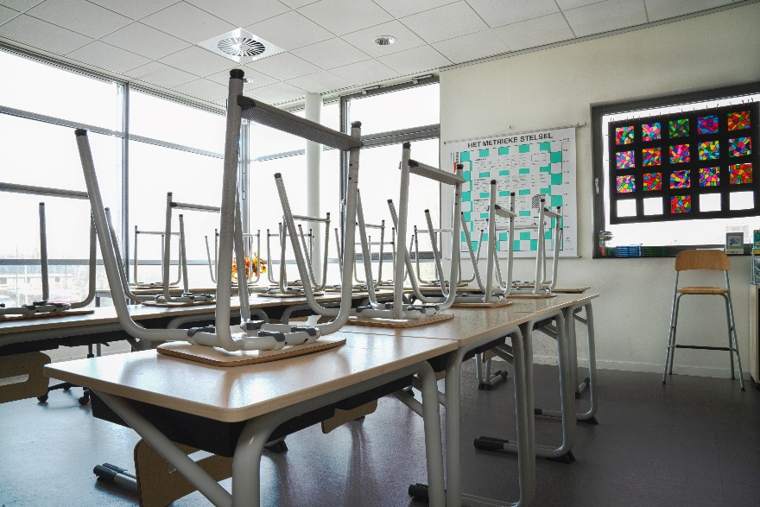
There are two documents that follow this page with information about the research and what we do with the information we collect. The third document is a consent form for you to sign if you’re happy to give your permission. You can return this to me by email (you can take a photo of it and send it to me) or your young person can bring the paper copy with them when I meet with them.


It can be a lot to take in so please email me ( s.smillie.1@research.gla.ac.uk ) if there’s anything that isn’t clear or you would like more information about. I’m happy to call you on the phone if that’s easier for you.

Parent/Carer Information Sheet

Title of Project: Wellbeing in the School Holidays
Section of project: Focus groups with young people
Researcher: Susie Smillie
Supervisors: Dr Stephanie Chambers and Prof Nick Watson

The young person you care for is being invited to take part in a research study. Before you decide if you are happy for them to take part it is important for you to understand why the research is being done and what it will involve. Please read the following information carefully and discuss it with the young person you care for and others if you wish. Ask the researcher/s if there is anything that is not clear or if you would like more information. Take some time to decide whether or not you are happy to give permission for them to take part.

What is the purpose of the study?
The purpose of this study is to find out how young people feel during the school holidays and the kind of things they want to do, are able to do, and choose to do, during this time. There is very little previous research in this area. A better understanding of young people’s experiences of school holidays and their needs during this time can help inform decisions about how to meet those needs.
In particular the study aims to understand how important creative activities are to young people. These might be simple things they do themselves (e.g. drawing) or activities and programmes they attend.

Why has the young person I care for been asked to take part?
[COMMUNITY ARTS CENTRE] are supporting the research and young people who attend activities in the centre are being asked if they would like to participate in this part of the study.

Do they have to take part?
No, they do not have to take part. Young people who take part in the study must have parent/carer permission, and they must also agree to take part themselves. They are free to withdraw, or you can withdraw them, from the study at any time. They/you can request for the information they have already given to be left out of the study any time before the end of data collection (likely to be December 2022).

There are two parts to the study and the young person you care for may take part in either or both of these so you may have already been asked to provide permission for a different part, or you may be in the future.

What does taking part involve?
Young people taking part in this portion of the study will be asked to take part in two focus groups to talk about their thoughts about how [COMMUNITY ARTS CENTRE], and the activities they offer, support or engage young people, in particular during school holidays. One focus group will be with other young people from [Participant’s COMMUNITY ARTS CENTRE], and another focus group will be with young people from both [Participant’s COMMUNITY ARTS CENTRE] and another community arts centre. The young people participating will have opportunities to speak, write and draw their ideas and thoughts around what works well in these organisations, what could be better, and how they think provision for school holiday support and activities more generally could be improved.

Young people taking part will be reminded throughout the meetings that they do not have to answer any questions that they do not want to, and they can ask to take a break or to leave the group early if they want to.
Each group will last about an hour and will be held at one of the community arts centres involved in the study. If this means that the young person you care for will be required to travel, arrangements for this will be made through [COMMUNITY ARTS ORGANISATION]. If COVID-19 restrictions mean that the group cannot meet in person then this will be conducted by video conference instead.
The groups will be recorded using a password-protected voice recorder and a transcript of what is said will be written out so that the researcher can look in more detail at what different things the young people taking part talk about. Writing or drawing that the young people do during the sessions will be photographed or scanned and saved as digital documents and paper copies securely destroyed. No photos will be taken of participants themselves.
As a thank you to the young people taking part they will each be offered a £10 Love To Shop voucher.

What are the risks and benefits of taking part?
The young people taking part in the study may find it a worthwhile, interesting and enjoyable experience and may find value in contributing their voice to a project seeking to inform future school holiday activity provision and development of community arts organisations. The young people involved may find it emotionally demanding to discuss particular experiences of school holidays but the researcher will ensure participants are supported during the group, reminded that they are free to skip questions, take a break, leave the group early or withdraw. Young people may be signposted to other supports if necessary and/or encouraged to talk to trusted family or friends.

Will the information that I (or the young person I care for) give you in this study be kept confidential?
The information you, or the young person you care for, provide will be stored in a locked cabinet or in password-protected and encrypted devices that meet University of Glasgow and legal standards for securing data. These files or documents will only be accessible by the research team. Personal data (e.g. name, contact details) will be stored separately from research data (e.g. recording of interview, photographs) at all times. Participant quotes may be used in the final report (thesis) or in any subsequent publication or presentation but pseudonyms or ID numbers will be used in place of names and any other information that could potentially identify a participant will not be used in publications or reports.

The nature of the focus groups means that other young people taking part will know who each other are. While we will ask participants to maintain and respect each other’s confidentiality we cannot guarantee that this will be the case. Likewise, staff working at [COMMUNITY ARTS ORGANISATION] will be aware of who is taking part in the groups but will not be present during the groups themselves and will be asked to maintain the confidentiality of the participants.

- Please note that assurances on confidentiality will be strictly adhered to unless evidence of wrongdoing or potential harm is uncovered. In such cases the University may be obliged to contact relevant statutory bodies/agencies.

What will happen to the results of this study?
The study will form the basis of a thesis written by the researcher which will be read and assessed by examiners for the award of PhD. The thesis will then be published and available to view on the University of Glasgow website. Publications in academic journals and other research outputs (e.g. conference presentations) may arise from the study. At the end of the study participants and their parents/carers will be given a summary of the research findings
Who has reviewed the study?
This study has been considered and approved by the College of Social Sciences Research Ethics Committee, University of Glasgow.
Who can I contact for further Information?
If you have any questions about this study, you can ask contact:
- Researcher: Susie Smillie (s.smillie.1@research.gla.ac.uk )
- Supervisors: Dr Stephanie Chambers (stephanie.chambers@glasgow.ac.uk ) or Prof Nick Watson (nicholas.watson@glasgow.ac.uk )
To pursue any complaint about the conduct of the research: contact the College of Social Sciences Ethics Officer, Dr Susan Batchelor, email: Susan.Batchelor@glasgow.ac.uk
Thank you for taking the time to read this.
End of Participant Information Sheet _________________________________________________

Privacy Notice for Participation in Research Project

(Parent/Carer of Young Person Participant)

Name of project: Wellbeing in the School Holidays
Researcher: Susie Smillie
Supervisors: Dr Stephanie Chambers, Prof Nicholas Watson

Your Personal Data and the Personal Data of the young person you care for
The University of Glasgow will be what’s known as the ‘Data Controller’ of your personal data, and the personal data of the young person you care for, processed in relation to their participation in the research project “Wellbeing in the School Holidays”. This privacy notice will explain how The University of Glasgow will process your personal data (please see Young Person Privacy Notice for explanation of how we process the personal data of the young person you care for).

Why we need it
We are collecting basic personal data such as your name and contact details in order to conduct our research. We need your name and contact details to send you information about the study and to arrange to meet with the young person you care for.
Legal basis for processing your data
We must have a legal basis for processing all personal data. As this processing is for Academic Research we will be relying upon Task in the Public Interest in order to process the basic personal data that you provide

What we do with it and who we share it with
All the personal data you submit is processed by researchers at University of Glasgow. In addition, security measures are in place to ensure that your personal data remains safe: personal details are stored separately from all other research data in separate locked cabinets/drawers and in separate secure electronic folders on password-protected, encrypted devices that are accessible only by the research team.
We will provide you, and the young person you care for, with a summary of the study findings at the end of the study.

What are your rights?
GDPR provides that individuals have certain rights including: to request access to, copies of and rectification or erasure of personal data and to object to processing. In addition, data subjects may also have the right to restrict the processing of the personal data and to data portability. You can request access to the information we process about you at any time.

Please note that as we are processing your personal data for research purposes, the ability to exercise these rights may vary as there are potentially applicable research exemptions under the GDPR and the Data Protection Act 2018. For more information on these exemptions, please see UofG Research with personal and special categories of data. ((https://www.gla.ac.uk/myglasgow/dpfoioffice/a-ztopics/research/ ))

If you wish to exercise any of these rights, please submit your request via the webform ( https://www.gla.ac.uk/myglasgow/dpfoioffice/gdpr/gdprrequests/ ) or contact dp@gla.ac.uk

Complaints
If you wish to raise a complaint on how we have handled your personal data, you can contact the University Data Protection Officer who will investigate the matter.
Our Data Protection Officer can be contacted at dataprotectionofficer@glasgow.ac.uk

If you are not satisfied with our response or believe we are not processing your personal data in accordance with the law, you can complain to the Information Commissioner’s Office (ICO) https://ico.org.uk/
Who has ethically reviewed the project?
This project has been ethically approved via the College of Social Sciences Research Ethics Committee.
How long do we keep it for?
Your personal data, and the personal data of the young person you care for, (e.g. name and contact details) will be retained by the University until the end of the study when we will need your details to send you a summary of the research findings. This will be no longer than the period of ethical approval (until 01/10/2024). After this time, personal data will be securely deleted.
End of Privacy Notice _________________________________________________

Parent/Carer Consent Form

Title of Project: Wellbeing in the School Holidays
Researcher: Susie Smillie
Supervisors: Stephanie Chambers and Nick Watson

Please read the following statements, tick the appropriate box at the end and sign in the space provided.

- I confirm that I have read and understood the Parent/Carer Participant Information Sheet for the above study and have had the opportunity to ask questions.

- I understand that the participation of the young person I care for is voluntary and that I am, and they are, free to withdraw them at any time, without giving any reason.

- I consent to the audio-recording of interviews with the young person I care for

- I acknowledge that participants will be referred to by pseudonym.

- I acknowledge the provision of a Privacy Notice in relation to this research project.

I agree that:

- All names and other material likely to identify individuals will be anonymised.

- The material will be treated as confidential and kept in secure storage at all times.

- Personal data (names and contact details) will be destroyed once the project is complete.

- Research data (de-identified data e.g. transcripts of interviews or focus group) will be retained in secure storage for a period of 10 years in accordance with University of Glasgow policy, after which they will be destroyed.

- The research data may be used in future publications, both print and online, including quotes from research participants, but neither you nor the young person you care for will be identified in these.

- On behalf of the young person I care for, I waive their copyright to any data collected as part of this project.

Please tick ONE as appropriate:

I agree to the young person I care for taking part in this research study ☐
OR
I do not agree to the young person I care for taking part in this research study ☐

Name of Participant (young person you care for)
Your Name
Your Signature
Date

………………………………………………………………………………………………………..
TO BE COMPLETED BY RESEARCHER
Name of Researcher | Signature | Date

……………… End of consent form ……………

