Recruitment Documents for: Young People being interviewed in Strand 1 of Wellbeing in School Holidays (WSH) Study.

This file contains the four documents to be given to the young people participants in advance of data collection. (Individual Document file names are shown in the Header of each).

Participant type: Young People being interviewed in Strand 1.

Documents:
- Introduction to the Study (WSH_YP_Str1_StudyIntro_v3)
- Participant Information Sheet (WSH_YP_Str1_PIS_v4)
- Participant Privacy Notice (WSH_YP_Str1Str2_PrivacyNotice_v4)
- Participant Consent Form (WSH_YP_PilotStr1_ConsentForm_v4)

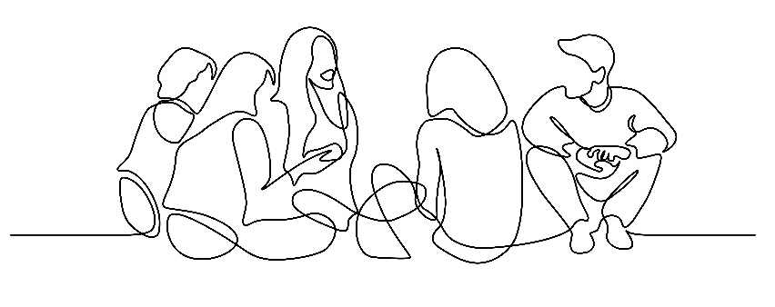

Invitation to take part in the ‘Wellbeing in the School Holidays’ Study

PHOTO OF RESEARCHER
My name is Susie and I’m a researcher at the University of Glasgow working on a project called “Wellbeing in the School Holidays”.
My email address: s.smillie.1@research.gla.ac.uk

Research is a way of finding out more about something. The kind of research I do looks at what things affect how people feel in their minds, bodies and lives.
Understanding this better can help change things to improve people’s lives.

We all have different lives so it’s important that research tries to include the variety of experiences different people have.

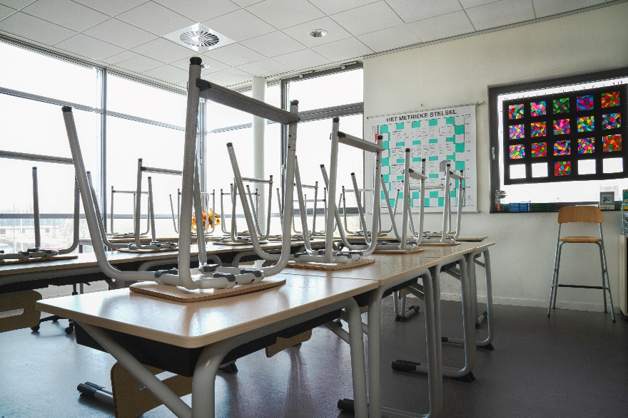
This project is about school holidays, so I’d like to hear what you think about school holidays, how you spend this time and how it makes you feel.

When people take part in research like this it’s important that they have enough information about it so that they can agree to take part (‘consent’) knowing what it is they’re agreeing to.

For that reason there are pages that follow this one with lots of information. It can be a lot to take in so please take your time, speak to someone you trust if you want to discuss it more, or you can contact me if there’s anything that isn’t clear or you would like more information about.

Here are some of the main important points:
- I’d like to meet you twice to have a chat about school holidays (once before the holidays and once after).
- We can meet in your home or somewhere else.
- You can have a parent/carer or a friend who is also taking part in the study with you if you want.
- I’d like to record our chat so I can remember what we said.
- You don’t need to answer any questions that you don’t want to.
- You’ll receive a gift voucher to thank you for your time

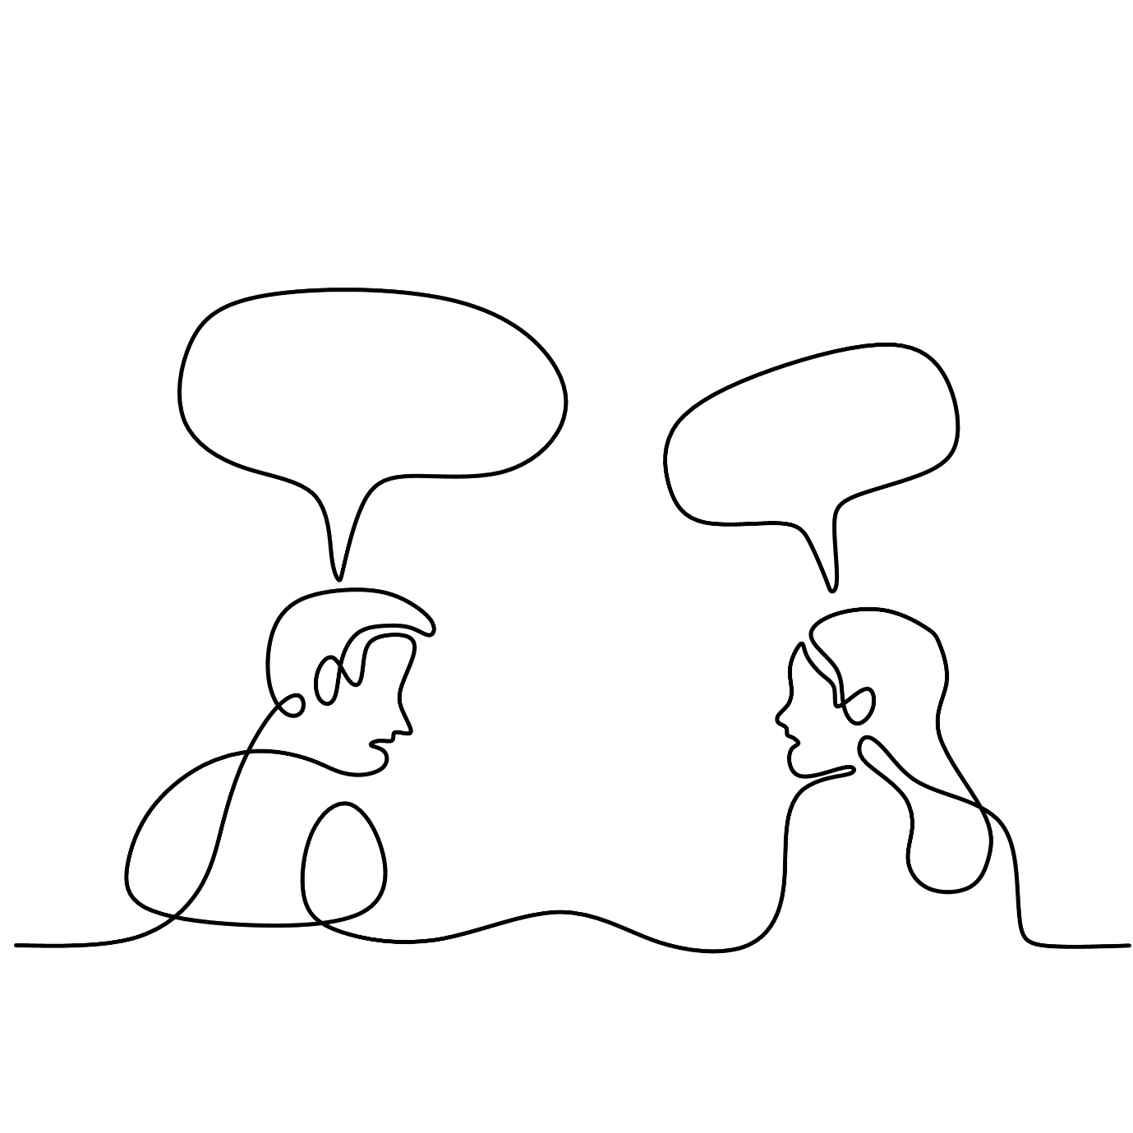

Young Person Participant Information Sheet

Project title: Wellbeing in the School Holidays
Researcher: Susie Smillie
Supervisors: Stephanie Chambers and Nick Watson

I hope that this sheet will answer any questions you have about the study.

1. What is the purpose of the study?
This study aims to find out more about how young people feel during the school holidays. This includes the kind of things they want to do, are able to do, and choose to do, during this time. I also want to find out if creative things (like drawing, listening to music, or making something) are important to young people in school holidays.
My job as the researcher on the project is to work with young people to collect information about this and then to write about it in a way that other people can learn from. This can help other people (like teachers, other researchers, people in government) to better understand how young people feel and what they need.

2. Why have I been chosen?
You are being asked to take part because you are aged 10-15 and you go to school in Glasgow or the area that surrounds it.

3. Do I have to take part?
No, you do not have to take part in this study. Even if your parents/carers have agreed to you taking part you can still decide not to take part if you do not want to. If, after you have started to take part, you change your mind, just let me know and I will not use any information you have given me in my writing.

There are two different parts to this study so you might have taken part in something before, or you might be asked in the future. You can take part in both if you want to.

4. What will happen to me if I take part?
If you decide to take part I will ask you to meet with me twice to talk about yourself and how you find school holidays. I’ll also ask you to act as a researcher of your own summer holidays. You can do this by recording what you do (e.g. taking photos, keeping a diary or drawing) or collecting things that remind you about what you did and how you felt (e.g. keeping ticket stubs, making a list of songs you listen to or tv shows you watch).
I’ll meet with you before the summer holidays and again at the end of the holidays/start of new term:
- When we meet before the holidays I’ll ask you to tell me a bit about your life and the kind of things you enjoy doing, what you think your summer holiday is going to be like and what you hope to do, or not do.
- When we meet after the holidays it will be a bit like “show and tell” - I’ll ask you to bring along anything you have recorded, collected or made that you would like to show me. These things will help us talk about your summer holidays, help you remember what you did and how you felt. If you decide not to bring anything that’s fine, we can still talk about what you remember doing during the holidays and how this was for you.

At any of our meetings you do not have to answer any questions that you don’t want to.
Each meeting we have will last about an hour and I will record your answers on a voice recorder so that afterwards I can listen carefully to what you said. The recording will also be written out like a script so that I can look more carefully at the different things you, and the other young people taking part, say.
If you write or draw anything or show me anything you have collected or made during the summer I would like to take photos of these but I won’t take photos of you or anything that could identify you. I might ask you for permission to use some of these photos in things I later write about the study, you don’t have to agree to this if you don’t want to.
You can meet with me alone or if you feel like it would be helpful your parent/carer or a friend who is also taking part in the study can sit in the meeting with us.

To thank you for your time taking part in the research I would like to give you some ‘Love To Shop’ gift vouchers that you can spend in lots of different high street shops. We have a £10 voucher for you after the first meeting and another £10 voucher after the second.

5. Will the information that I give you in this study be kept confidential?
I will keep the information in a locked cabinet or in a locked file on my computer. When I write about what I have found, your name will not be mentioned. If you like, you can choose another name for me to use when I am writing about what you said. No-one else will know which name you have chosen. (More details on how we use and look after your information is in the document ‘Privacy Notice’).
When I come to write about the project I will sometimes use quotes, which means I might write exactly what you, or another young person, has said. I will not use anything that would be recognised by other people who know you.

However, if during our conversation I hear anything which makes me worried that you, or other young people, might be in danger of harm, I might have to tell other people who need to know about this. If this is ever the case I will do my best to talk to you about it first and explain what I need to do.

6. What will happen to the results of this study
When I have gathered all of the information from everyone who is taking part I will write about what I have learned in a thesis (a long essay). This will be read and marked by senior researchers and then made available on the university website. I might also write shorter essays for journals (research newspapers) or tell other researchers about my work at conferences. At the end of the study I will tell you and the other young people who have taken part what I have found out about the different experiences of school holidays and how these affect young people.

7. Who has reviewed the study?
This study has been reviewed and agreed by the College of Social Sciences Research Ethics Committee, University of Glasgow

8. Who can I contact for further Information?
If you have any questions about this study, you can ask me, Susie (s.smillie.1@research.gla.ac.uk)
or my supervisors, Stephanie (stephanie.chambers@glasgow.ac.uk ) or Nick (nicholas.watson@glasgow.ac.uk )
or the Ethics Officer for the College of Social Sciences, Dr Susan Batchelor, email: Susan.Batchelor@glasgow.ac.uk

Thank you for reading this.

End of Participant Information Sheet _________________________________________________

Privacy Notice for Participation in Research Project

(Young Person Participant)

Name of project: Wellbeing in the School Holidays
Researcher: Susie Smillie
Supervisors: Dr Stephanie Chambers, Prof Nicholas Watson

Information about you (your ‘personal data’)
This sheet will explain what the University of Glasgow (called the ‘Data Controller’) will do with personal information about you, your ‘personal data’, that you give while taking part in the Wellbeing in the School Holidays study.
More detail about what taking part in the study involves is in the Participant Information Sheet that is with this notice.

Why we need your personal data
We are collecting basic personal data such as your name and contact details so that we can do our research. We only collect data that we need for the research project.
We need your name and your contact details (or your parent/carer details) to keep in contact with you while you’re taking part. We will use pseudonyms (fake names) and numbers in place of your name throughout the research so that you are not identified.
We might ask you for some other personal data (e.g. gender, ethnicity). This is so that we can try to represent different groups of people in the research. Personal data like this might also affect how you experience school holidays, so it might be something you talk about with the researcher when you are meeting with them.

Legal basis for processing your data
Your personal data is protected by law so we must have a specific legal reason for using it.
Our reason is that the research is what is known as a “task in the public interest”.

What we do with it and who we share it with
Almost all of the personal data you give us is processed by researchers at University of Glasgow, mainly by Susie Smillie.
Sometimes we use a separate company for transcribing (writing out) the recordings of interviews and group discussions. The person transcribing the recording will not know your full name or contact details. This company, and the people who work for them have an agreement with the University to maintain confidentiality and are bound by the same laws around personal data. The recordings and transcripts are transferred to them, and back to the University, in a secure way using passwords and secure storage.
We keep your name and contact details separate from all other information you give us and we use pseudonyms and numbers in place of your name.
Security measures are in place to make sure that your personal data remains safe: personal details are stored separately from all other research data (in separate locked cabinets/drawers and in separate secure electronic folders on password-protected, encrypted devices that can only be accessed by the researchers.
Please see the Consent form and Participant Information Sheet with this notice.
We will provide you, and your parent/carer, with a summary of the study findings at the end of the study.

What are your rights?
GDPR (the set of laws that help protect your personal data) makes sure that people have certain rights including: to request access to, copies of and changes or deletion of personal data and to object to processing. People may also have the right to restrict the ways the data is processed. You can request access to the information we process about you at any time.

Please note that as we are processing your personal data for research purposes, the ability to exercise these rights may vary as there are potentially applicable research exemptions under the GDPR and the Data Protection Act 2018. For more information on these exemptions, please see UofG Research with personal and special categories of data. (https://www.gla.ac.uk/myglasgow/dpfoioffice/a-ztopics/research/)
If you wish to exercise any of these rights, please submit your request via the webform (https://www.gla.ac.uk/myglasgow/dpfoioffice/gdpr/gdprrequests/)
or contact dp@gla.ac.uk

Complaints
If you wish to raise a complaint on how we have handled your personal data, you can contact the University Data Protection Officer who will investigate the matter.
Our Data Protection Officer can be contacted at dataprotectionofficer@glasgow.ac.uk

If you are not satisfied with our response or believe we are not processing your personal data in accordance with the law, you can complain to the Information Commissioner’s Office (ICO) https://ico.org.uk/

Who has ethically reviewed the project?
This project has been ethically approved by the College of Social Sciences Research Ethics Committee.

How long do we keep your data for?
Your personal data (name and contact details) will be kept by the University only until the end of the study (until 01/10/2024). when we need your details to send a summary of the research findings. After this time, personal data will be securely deleted.
Your research data (the information you speak about to the researcher) will be retained for ten years in line with the University of Glasgow Guidelines.

End of Privacy Notice ______________________

Wellbeing in the School Holidays Study
Young Person Consent Form (Interviews)

I would like to hear what you think about school holidays, how you spend this time and how it makes you feel.

Please circle ‘Yes’ or ‘No’ to show that you agree to taking part or not.

- Have you had a chance to read the information I gave you and had an opportunity to ask me any questions about it?



- Do you want to go ahead with talking to me about school holidays?

- Do you understand that you don’t have to take part if you don’t want to, and that you can choose to stop taking part at any time, or ask to skip any questions you don’t want to answer?

- Can I record our chat and take photos of the things you write/draw/show me?

- Can I tell other people what you think? I will not tell them your name.

- Do you understand how we will look after the information you give us and what we will use it for?

Please write your name in the box below to show you agree to taking part.

I agree to take part in the study:

TO BE COMPLETED BY RESEARCHER
Name of Researcher | Signature | Date

End of Form.

