Recruitment Documents for: Parents/Carers of Young People being interviewed in Strand 1 of Wellbeing in School Holidays (WSH) Study.

This file contains the four documents to be given to the parents/carers of young people participants in advance of data collection. (Individual Document file names are shown in the Header of each).

Contents:
- Introduction to the Study (WSH_PC_ Str1Str2Pilot_StudyIntro_v2)
- Parent/Carer Participant Information Sheet (WSH_PC_Str1_PIS_v4)
- Privacy Notice (WSH_PC_Str1Str2_PrivacyNotice_v4)
- Consent Form (WSH_PC_PilotStr1Str2_ConsentForm_v3)



Invitation to take part in the ‘Wellbeing in the School Holidays’ Study
PHOTO OF RESEARCHER
My name is Susie and I’m a researcher at the University of Glasgow working on a study called “Wellbeing in the School Holidays”.
My email address: s.smillie.1@research.gla.ac.uk

The study aims to find out more about how young people feel during the school holidays and the kind of things they want to do, are able to do, and choose to do, during this time. The young person you care for is invited to contribute to this research. We need consent from both you and the young person.
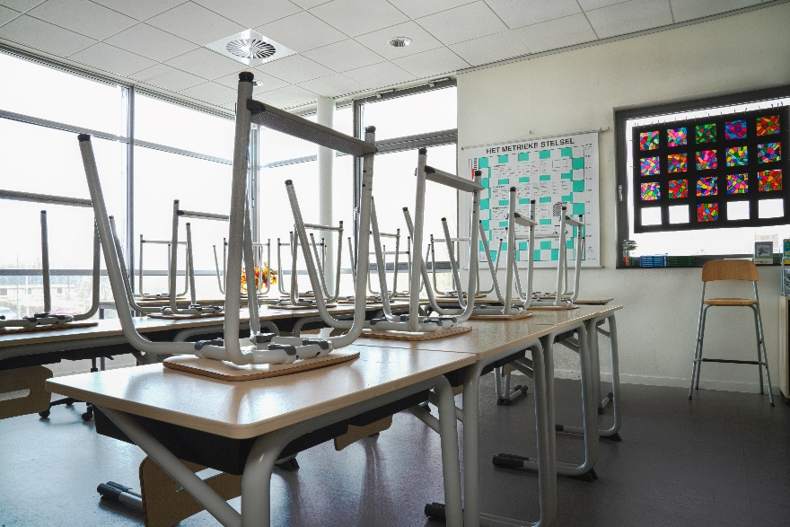
There are two documents that follow this page with information about the research and what we do with the information we collect. The third document is a consent form for you to sign if you’re happy to give your permission. You can return this to me by email (you can take a photo of it and send it to me) or your young person can bring the paper copy with them when I meet with them.


It can be a lot to take in so please email me ( s.smillie.1@research.gla.ac.uk ) if there’s anything that isn’t clear or you would like more information about. I’m happy to call you on the phone if that’s easier for you.

Parent/Carer Information Sheet

Title of Project: Wellbeing in the School Holidays
Section of project: Interviews with young people
Researcher: Susie Smillie
Supervisors: Dr Stephanie Chambers and Prof Nick Watson

The young person you care for is being invited to take part in a research study. Before you decide if you are happy for them to take part it is important for you to understand why the research is being done and what it will involve. Please read the following information carefully and discuss it with the young person you care for and others if you wish. Ask the researcher/s if there is anything that is not clear or if you would like more information. Take some time to decide whether or not you are happy to give permission for them to take part.

What is the purpose of the study?
The purpose of this study is to find out how young people feel during the school holidays and the kind of things they want to do, are able to do, and choose to do, during this time. There is very little previous research in this area. A better understanding of young people’s experiences of school holidays and their needs during this time can help inform decisions about how to meet those needs.

In particular the study aims to understand how important creative activities are to young people. These might be simple things they do themselves (e.g. drawing) or activities and programmes they attend.

Why has the young person I care for been asked to take part?
The study is looking for young people aged 10-15 who live in Greater Glasgow (Glasgow and the surrounding local authority areas) and normally attend school. You or the young person you care for may have heard about the study through an arts organisation they are involved with because those organisations have agreed to support the study.

Do they have to take part?
No, they do not have to take part. Young people who take part in the study must have parent/carer permission, and they must also agree to take part themselves. They are free to withdraw, or you can withdraw them, from the study at any time. They/you can request for the information they have already given to be left out of the study any time before the end of data collection (likely to be December 2022).

There are two parts to the study and the young person you care for may take part in either or both of these so you may have already been asked to provide permission for a different part, or you may be in the future.

What does taking part involve?
Young people taking part in this portion of the study will be asked to meet with the researcher twice to be interviewed. They will be asked about how they spend their time during the school holidays, the kind of things they do or would like to do and how they feel during this time. To help the young people remember the kind of things they did over the holiday period they will be asked to collect, make or record things as reminders and will be given various ideas of how to do this.
- The first interview will be before the summer holidays begin, will last about an hour and will focus on how the young person feels about school holidays generally, as well as what they think the upcoming holiday will be like.
- Over the course of the holidays the young person can choose to collect or record reminders that will help them to do a “show and tell” with the researcher at the end of the holidays. What they do will depend on what the young person wants to, and can manage to, do and can be as much or as little as they want to or are able to do. Some ideas include keeping a diary, taking photos, drawing some of the things they do, writing a list of songs they listened to.
- The second interview will be at the end of the holidays or beginning of the new school year, will last about an hour, and will have a “show and tell” format. The researcher will ask the young person to bring anything they have collected, made or recorded and talk about the different experiences they’ve had during the summer holidays. If young people don’t manage to, or want to, bring anything along, we will still be able to talk about their holiday experiences.

Young people taking part are reminded throughout the meetings that they do not have to answer any questions that they do not want to, and they can ask to take a break or to end the interview early if they want to.

Each interview will last about an hour and the young person you care for can meet alone with the researcher or be accompanied by you, or a friend who is also taking part in the research, if they would prefer. We can meet at the young person’s home or a mutually agreed location that suits the young person best. If COVID-19 restrictions mean that we cannot meet indoors in person then we can do this outside, over the phone or video call depending on what suits best.

The interviews will be recorded using a password-protected voice recorder and a transcript of what is said will be written out so that the researcher can look in more detail at what different things the young people taking part talk about. If the young person brings items to the second interview these will be photographed and the items returned with the young person. No photographs will be taken of the young person and if they bring or show photographs of themselves at the second interview faces and any other identifiable features will be obscured in any images taken. None of these images will be used in publication or other dissemination without the explicit written permission of the young person.
As a thank you to the young people taking part they will be offered a £10 Love To Shop voucher after each interview.

What are the risks and benefits of taking part?
The young people taking part in the study may find it a worthwhile, interesting and enjoyable experience and may find value in contributing their voice to a project seeking to inform future school holiday activities and development of community arts organisations. The young people involved may find it emotionally demanding to discuss particular experiences of school holidays but the researcher will ensure participants are supported during the interview, reminded that they are free to skip questions, take a break, end the interview early or withdraw. Young people may be signposted to other supports if necessary and/or encouraged to talk to trusted family or friends.

Will the information that I (or the young person I care for) give you in this study be kept confidential?
The information you, or the young person you care for, provide will be stored in a locked cabinet or in password-protected and encrypted devices that meet University of Glasgow and legal standards for securing data. These files or documents will only be accessible by the research team. Personal data (e.g. name, contact details) will be stored separately from research data (e.g. recording of interview, photographs) at all times. Participant quotations may be used in the final report (thesis) or in any subsequent publication or presentation but pseudonyms or ID numbers will be used in place of names and any other information that could potentially identify a participant will not be used in publications or reports.
If the young person you care for is taking part in an interview held at the local community arts centre that they attend it is possible that the staff there may see them and therefore determine that they are taking part. This will be made clear to you and the young person when the interview is scheduled and alternative locations will be offered if that is preferred.

- Please note that assurances on confidentiality will be strictly adhered to unless evidence of wrongdoing or potential harm is uncovered. In such cases the University may be obliged to contact relevant statutory bodies/agencies.

What will happen to the results of this study?
The study will form the basis of a thesis written by the researcher which will be read and assessed by examiners for the award of a PhD. The thesis will then be published and available to view on the University of Glasgow website. Publications in academic journals and other research outputs (e.g. conference presentations) may arise from the study. At the end of the study participants and their parents/carers will be given a summary of the research findings.
Who has reviewed the study?
This study has been considered and approved by the College of Social Sciences Research Ethics Committee, University of Glasgow.
Who can I contact for further Information?
If you have any questions about this study, you can ask contact:
- Researcher: Susie Smillie (s.smillie.1@research.gla.ac.uk )
- Supervisors: Dr Stephanie Chambers (stephanie.chambers@glasgow.ac.uk ) or Prof Nick Watson (nicholas.watson@glasgow.ac.uk)

To pursue any complaint about the conduct of the research: contact the College of Social Sciences Ethics Officer, Dr Susan Batchelor, email: Susan.Batchelor@glasgow.ac.uk

Thank you for taking the time to read this.

End of Parent/Carer Participant Information Sheet _________________________________________________

Privacy Notice for Participation in Research Project

(Parent/Carer of Young Person Participant)

Name of project: Wellbeing in the School Holidays
Researcher: Susie Smillie
Supervisors: Dr Stephanie Chambers, Prof Nicholas Watson

Your Personal Data and the Personal Data of the young person you care for
The University of Glasgow will be what’s known as the ‘Data Controller’ of your personal data, and the personal data of the young person you care for, processed in relation to their participation in the research project “Wellbeing in the School Holidays”. This privacy notice will explain how The University of Glasgow will process your personal data (please see Young Person Privacy Notice for explanation of how we process the personal data of the young person you care for).

Why we need it
We are collecting basic personal data such as your name and contact details in order to conduct our research. We need your name and contact details to send you information about the study and to arrange to meet with the young person you care for.
Legal basis for processing your data
We must have a legal basis for processing all personal data. As this processing is for Academic Research we will be relying upon Task in the Public Interest in order to process the basic personal data that you provide

What we do with it and who we share it with
All the personal data you submit is processed by researchers at University of Glasgow. In addition, security measures are in place to ensure that your personal data remains safe: personal details are stored separately from all other research data in separate locked cabinets/drawers and in separate secure electronic folders on password-protected, encrypted devices that are accessible only by the research team.
We will provide you, and the young person you care for, with a summary of the study findings at the end of the study.

What are your rights?
GDPR provides that individuals have certain rights including: to request access to, copies of and rectification or erasure of personal data and to object to processing. In addition, data subjects may also have the right to restrict the processing of the personal data and to data portability. You can request access to the information we process about you at any time.

Please note that as we are processing your personal data for research purposes, the ability to exercise these rights may vary as there are potentially applicable research exemptions under the GDPR and the Data Protection Act 2018. For more information on these exemptions, please see UofG Research with personal and special categories of data. ((https://www.gla.ac.uk/myglasgow/dpfoioffice/a-ztopics/research/ ))

If you wish to exercise any of these rights, please submit your request via the webform ( https://www.gla.ac.uk/myglasgow/dpfoioffice/gdpr/gdprrequests/ ) or contact dp@gla.ac.uk

Complaints
If you wish to raise a complaint on how we have handled your personal data, you can contact the University Data Protection Officer who will investigate the matter.
Our Data Protection Officer can be contacted at dataprotectionofficer@glasgow.ac.uk

If you are not satisfied with our response or believe we are not processing your personal data in accordance with the law, you can complain to the Information Commissioner’s Office (ICO) https://ico.org.uk/
Who has ethically reviewed the project?
This project has been ethically approved via the College of Social Sciences Research Ethics Committee.
How long do we keep it for?
Your personal data, and the personal data of the young person you care for, (e.g. name and contact details) will be retained by the University until the end of the study when we will need your details to send you a summary of the research findings. This will be no longer than the period of ethical approval (until 01/10/2024). After this time, personal data will be securely deleted.
End of Privacy Notice _________________________________________________

Parent/Carer Consent Form

Title of Project: Wellbeing in the School Holidays
Researcher: Susie Smillie
Supervisors: Stephanie Chambers and Nick Watson

Please read the following statements, tick the appropriate box at the end and sign in the space provided.

- I confirm that I have read and understood the Parent/Carer Participant Information Sheet for the above study and have had the opportunity to ask questions.

- I understand that the participation of the young person I care for is voluntary and that I am, and they are, free to withdraw them at any time, without giving any reason.

- I consent to the audio-recording of interviews with the young person I care for

- I acknowledge that participants will be referred to by pseudonym.

- I acknowledge the provision of a Privacy Notice in relation to this research project.

I agree that:

- All names and other material likely to identify individuals will be anonymised.

- The material will be treated as confidential and kept in secure storage at all times.

- Personal data (names and contact details) will be destroyed once the project is complete.

- Research data (de-identified data e.g. transcripts of interviews or focus group) will be retained in secure storage for a period of 10 years in accordance with University of Glasgow policy, after which they will be destroyed.

- The research data may be used in future publications, both print and online, including quotes from research participants, but neither you nor the young person you care for will be identified in these.

- On behalf of the young person I care for, I waive their copyright to any data collected as part of this project.

Please tick ONE as appropriate:

I agree to the young person I care for taking part in this research study ☐
OR
I do not agree to the young person I care for taking part in this research study ☐

Name of Participant (young person you care for)
Your Name
Your Signature
Date

………………………………………………………………………………………………………..
TO BE COMPLETED BY RESEARCHER
Name of Researcher | Signature | Date

……………… End of consent form ……………

