DRINK  STUDY | DRINKING  REALWORLD  EXPERIENCES and  ONLINE  NETWORKS
Are you 18 - 25  years old and  do you regularly  drink alcohol?  Do you use  Facebook etc?  Would you and  some friends talk to us about your views on drinking?  VOUCHER  £25 | 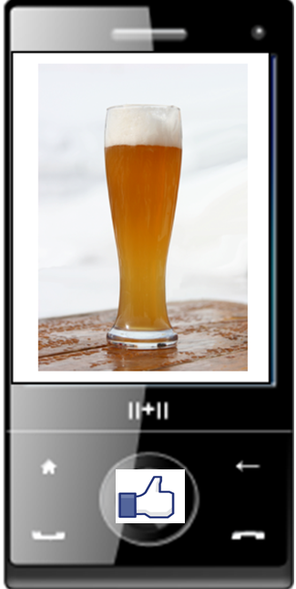
PLEASE TURN OVER
FOR MORE INFORMATION

Email: DRINK@sphsu.mrc.ac.uk

Freephone: 0800 389 2129 – Option 8
Text: DRINK to 88802
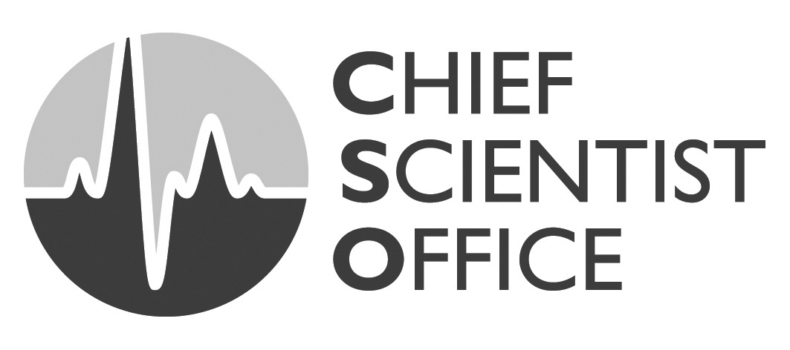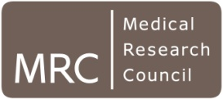
DRINK  STUDY | DRINKING  REALWORLD  EXPERIENCES and  ONLINE  NETWORKS
Are you 18 - 25
years old and
do you regularly
drink alcohol?

Do you use
Facebook etc?

Would you and
some friends talk to us about your views on drinking?
VOUCHER
£25
PLEASE TURN OVER
FOR MORE INFORMATION

Email: DRINK@sphsu.mrc.ac.uk

Freephone: 0800 389 2129 – Option 8
Text: DRINK to 88802

What is the study about?
Most studies have focused on teenage drinking. We want to talk to older men and women about their views on alcohol. For example:-
- Do you tend to drink at home or in pubs?
- Does your drinking depend which friends you are with?
- Are there differences in men and women’s drinking in the 21st century?

What would I have to do?

- We are looking for 4 to 6 friends aged 35-50 years who would be willing to take part in a group discussion lasting around 1½ hours at our department (off Byres Road) or at a location to suit you
- We offer a £20 gift token and refreshments for each person

Who’s running the study and how do I take part?
We are researchers at the MRC Social & Public Health Sciences Unit and are based at Glasgow University. Please contact us if you would like to take part in the study or if you would like some further information:-

Email: DRINK/TOAST@sphsu.mrc.ac.uk

Freephone: 0800 389 2129

Text: DRINK/TOAST to 88802

