Data Set Information Sheet: Synergising Multi-Modal Data: Unveiling Audio-Visual and Radar Insights
This “ReadMe.pdf” file was generated on 2025-11-17 by Nour Ghadban

1-Overview
This repository contains a proof‑of‑concept multimodal dataset built to evaluate the potential of audio–visual–radar (AVR) fusion for near‑field speech recognition. The corpus synchronises audio, video and radar measurements collected from four fluent but non‑native English speakers. Each participant recorded the same ten short English words twenty times, resulting in 800 multimodal samples in total. The dataset is deliberately modest in size and serves as a stepping stone for future, larger collections.

2-Purpose
The primary objective of the dataset is to explore how micro‑Doppler radar sensing can enhance the robustness of conventional audio–visual speech‑recognition systems when audio and video channels are degraded by noise, occlusion or poor lighting. Integrating radar data allows the system to capture articulatory micro‑vibrations that are otherwise invisible to microphones and cameras.

Contributors
- Dr. Nour Ghadban, University of Glasgow
- Dr. Hira Hameed (affiliate)
- Prof. Qammer H. Abbasi
- Prof. Muhammad Imran
- Prof. Jonathan Cooper
- Dr. Julien Le Kernec

3-Data Collection
- Participants: Four fluent but non‑native English speakers aged 28–40. The cohort comprised one male and three females.
- Words: Ten English words: soap, turn, doll, bite, make, sheep, long, learn, mess and talk.
- Repetitions: Each participant pronounced every word 20 times, yielding 200 multimodal samples per subject (20 repetitions × 10 words). Across all four subjects this amounts to 800 samples in total.
- Environment: Recordings were made under controlled indoor conditions in the James Watt School of Engineering, University of Glasgow. To ensure sufficient micro‑Doppler signal strength, speakers stood approximately 2 metres from the radar sensor.

4-Folder Structure
Table 1 Details of the Data Set (Folders, Files, Description, and Number of Samples)
dataset_root/
├── subject1/
│ ├── audio/
│ ├── video/
│ └── radar/
├── subject2/
│ ├── audio/
│ ├── video/
│ └── radar/
├── subject3/
│ ├── audio/
│ ├── video/
│ └── radar/
└── subject4/
├── audio/
├── video/
└── radar/
Within each subject directory there are ten subfolders named after the spoken words (e.g. soap/, turn/, etc.). Each word folder contains 20 audio files, 20 video files and 20 radar spectrograms corresponding to the twenty repetitions.
Table 2. The Dataset words And Participant’s
Subject | Description | Audio Samples | Video Samples | Radar Samples | Total Samples
1 (female) | Ten words × 20 repetitions | 200 | 200 | 200 | 200
2 (male) | Ten words × 20 repetitions | 200 | 200 | 200 | 200
3 (female) | Ten words × 20 repetitions | 200 | 200 | 200 | 200
4 (female) | Ten words × 20 repetitions | 200 | 200 | 200 | 200

5-Modalities

5-1 Audio
- Recording format: WAV
- Sampling rate: 44.1 kHz
- Bit depth: 16‑bit
- Channels: Mono (single channel)
- Recording duration: ~6 seconds per utterance

5-2 Video
- Recording format: AVI
- Resolution: 1920 × 1080 pixels (1080p)
- Frame rate: 30 frames per second
- Colour depth: 8 bits per channel

5-3 Radar
- Sensor: XeThru X4M03 IR‑UWB radar
- Centre frequency: 8.745 GHz
- Bandwidth: 1.5 GHz
- Frame rate: 300 Hz
- Detection range: nominally up to 10 metres; however, speech‑related micro‑vibrations are reliably captured only within ≈2 metres of the sensor.
- Data format: Raw radar chirps were processed into range–Doppler spectrograms using a short‑time Fourier transform (STFT) with a 256‑sample window and 50 % overlap. Adaptive Wiener filtering was applied to reduce noise. Each spectrogram was resized to 224 × 224 pixels before being saved as a JPG image.

6-Data Processing
The raw radar, audio and video streams were recorded simultaneously and automatically aligned using pretrained machine‑learning models to ensure temporal consistency across modalities. Audio features were derived using Mel‑frequency cepstral coefficients (MFCCs), video frames were cropped around the mouth region and encoded with ResNet‑50, and radar signals were converted into spectrograms and encoded with MobileNetV2 (see the associated publication for details). Feature scaling and Shapley Additive Explanations (SHAP) were employed to reduce dimensionality while preserving interpretability.

7-Hardware Specifications
- Radar sensor: XeThru X4M03 IR‑UWB radar (8.745 GHz centre frequency, 1.5 GHz bandwidth, 300 Hz frame rate)
- Microphone: 44.1 kHz sampling rate, 16‑bit resolution
- Camera: 1080p resolution, 30 fps, 8‑bit colour depth
- Recording workstation: Intel Core i9‑13900 CPU (24 cores), 64 GB DDR5 RAM, NVIDIA RTX 3090 GPU

8-Radar Processing:

8-1 Description of methods used for collection/generation of data:
The dataset is made up of various actions gathered by the UWB Radar sensor (Xethru X4M03). The Radar is based on Novelda's X4 system-on-chip (SoC), which includes an integrated receiver and transmitter antenna and delivers exceptionally accurate distance and movement measurements. The target was 0.45M away from the Radar when the data was collected. Each task took 6 seconds to complete. The experimental setup was used to acquire the data (see Figure 1).

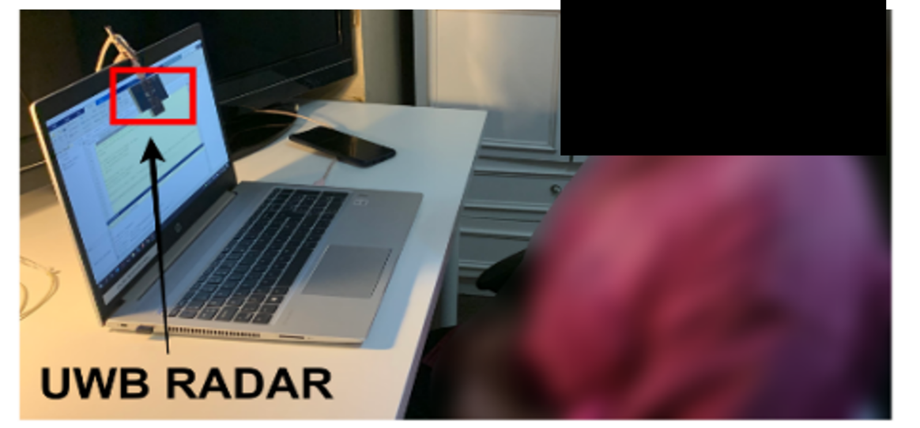
Figure 1 Experimental Setup

8-2 Methods for processing the data:
Run the Embebbed Software for the X4MO3 development kit from the Xthru Embedded Platform (XEP). The XEP protocol was used to connect the radar transmitter and reception units. Radar operation with XEP requires a system parameter (see Table 3).
Table 3 System Parameters
Parameter | Value
Radar Platform | Xethru radar X4M03
Instrumental Range | 9.6m
Operating Frequency | 7.29 GHz
Transmitter Power | 6.3 dBm
Activity Duration | 6 seconds
Distance | 0.45 meter

XEP is free and open-source software. This example is modified to include the Radar as the transmitting and receiving devices.The raw form of the channel state information output is written to .dat files which are then converted to a processable format (see Figure 2).
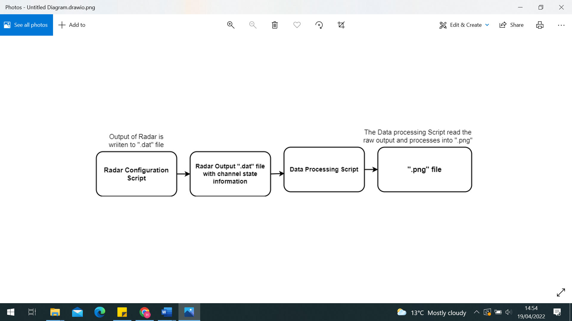
Figure 2 Data flow in the data collection stage

Secondly, the radar chip was configured via the XEP interface with x4driver. Data were recorded from the module at 500 frames per second (FPS) in the form of float message data. A loop was used to read the “Digital Audio Tape” (.dat) data file and save the data into a DataStream variable, which was mapped into a complex range-time-intensity matrix. Thereafter, a moving target indication (MTI) filter was applied to get the Doppler range map. Afterward, the second MTI was used as a Butterworth 4th order filter to generate the Spectrograms using the following parameters: window length, overlap percentage, and fast Fourier transform (FFT) padding factor. In particular, a window length of 128 samples, and a padding factor of 16 were used. In addition, a range profile was created by first converting each chirp to an FFT. A second FFT is then conducted on a defined number of consecutive chirps for a given range bin. Furthermore, a short-time Fourier transform (STFT) was used to create these spectrograms. Spectrogram came into the Joint Photographic Experts Group(.jpg) format. The .jpg files would hold the data sets that will be used for training and testing the Deep Learning (DL) algorithm, see an example in (see Figure 3). The above process was repeated for all the data files in this data set.
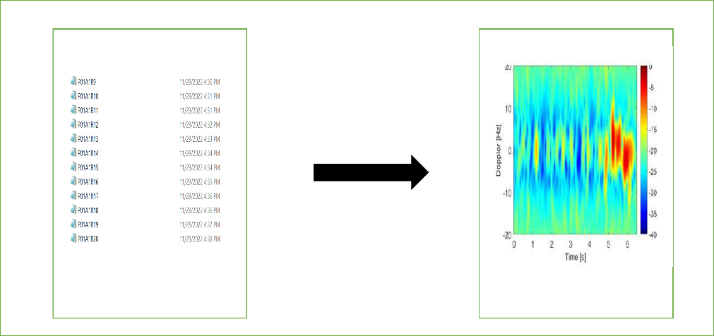
Figure 3 Channel state information capture of “Soap” activity in ".dat" format and the corresponding plo

Instrument- or software-specific information needed to interpret the data:
Data files are in “. dat” format and convert it into “. Png” using MATLAB Script.

9- Acknowledgments
This work was supported by the Engineering and Physical Sciences Research Council (EPSRC) under grant EP/T021020/1 and by the Cara fellowship programme. Data collection and experiments were conducted in accordance with the ethical standards of the University of Glasgow (approval ref. 300230076, 5 February 2024).

