Comparing Membranes for Proton Exchange Membrane Water Electrolysis: Performance, Stability and Hydrogen Crossover
Abdulhai H. Faqeeh ^{a,b}, Alex T. Pitman ^{b}, Zeliha Ertekin ^{b} , Paula L. Lalaguna ^{b}, and Mark D. Symes*^{b}
ªDepartment of Chemistry, College of Science, King Khalid University, Abha, 61413, Saudi Arabia
^{b}School of Chemistry, University of Glasgow, Glasgow, G12 8QQ, United Kingdom

*Email: mark.symes@glasgow.ac.uk

Abstract
The supply of Nafion and Aquivion proton exchange membranes is currently severely constrained, prompting a search for alternatives. In this work, a new commercial proton exchange membrane (PFSA D170-U) was evaluated and compared with two other membranes: Nafion™ N117 and Aquivion® E98-15S. The performance, stability over 100 h, and H₂ crossover characteristics of these three membranes were investigated in a flow cell electrolyser by testing each membrane type in triplicate using a fresh sample of membrane for each experimental run. At 60 °C, the three membranes showed an average performance of 1 A cm^{–2} at 2.0 V and an average degradation rate of 1.2 mV h^{–1} after stability tests for 100 h at a fixed current density of 1.0 A cm^{–2}. The three membranes showed similar metrics, suggesting that PFSA D170-U is a promising proton exchange membrane alternative to Nafion and Aquivion membranes for research purposes. Additionally, the physical, morphological, structural, thermal and mechanical properties of the PFSA D170-U membrane were examined.

Keywords: Proton exchange membrane; Perfluorinated sulfonic acid membrane; Water electrolysis; Nafion; Aquivion.

Flow cell components, setup, and assembly
The flow cell used in this work (active area = 13.7 cm²) has previously been reported and characterised, and open access designs for this cell are available [7]. In brief, the flow cell comprised of a pair of 3 mm-thick Ti current collector/flow-field plates with six serpentine channels per plate. The cathode consisted of 0.5 mg cm^{–2} Pt/C (supported on Vulcan carbon and mixed with Nafion ionomer) deposited on a carbon cloth (W1S1011, FuelCellStore, SKU: 11060059). At the anode side, a Ti fibre felt (FuelCellStore, SKU: 40050001) coated with Ti microparticles (5 µm, US Nanomaterials Research﻿, Inc.) and IrO₂ (99.9%, Sigma Aldrich) were used. These anodes were prepared in-house as follows (see also Figure 1). Firstly, in a glove box under N₂, 2.5 g of 5 µm Ti ﻿microparticles were added into a vial. Subsequently, ﻿10 g of isopropanol and 2.5 mg of 5% alcohol-based Nafion solution (Nafion™ D520CS, Ion Power, Inc.) were added into the vial and mixed with the Ti ﻿microparticles with the aid of ultrasonication of the vial in an ice bath for 15 min. Due to the lack of a commercially available D170-U ionomer solution, Nafion ionomer solution was used in preparing all catalyst inks as the two polymers have similar structures. After this initial mixing, 10 g of ethylene glycol was added to this mixture, which was ultrasonicated for an additional 1 h to give a suspension. The Ti fibre felts were sprayed with this suspension and then placed in a preheated oven at 200 °C for 7 min to ensure the evaporation of the ethylene glycol before weighing. Immediately before spraying, the bottle containing the suspension was shaken vigorously, ensuring the homogenous dispersion of Ti microparticles in the suspension. When spraying, the airbrush was positioned around 15 cm away from the centre of the Ti fibre felt and the air compressor pressure was set at 2 bar. The spray process started from the centre, and was then directed towards the top edge of the felt and continued in a clockwise direction until the entire Ti fibre felt was coated; multiple spray circles were required for obtaining the desired mass loading (approximately 1 mg cm⁻² of Ti microparticles on the surface of the fibre in this case). ﻿Subsequently, this Ti microparticle-coated Ti fibre felt was sprayed with IrO₂ ink. This ink was prepared by mixing Nafion solution, carbon black (carbon black, acetylene, 50% compressed, 99.9+%, Thermo Fisher Scientific), and IrO₂ powder in a 15:20:65 mass ratio, in addition to ~5 mL of isopropanol, followed by ultrasonication of this mixture in an ice bath for 2 h. It was noticed that the incorporation of carbon black in the anode ink preparation increases the ink viscosity, achieving strong binding between the GDL and anode catalyst layer and even dispersion on the anode GDL surface. After ultrasonication, this ink mixture was placed in the freezer at −20 °C for 15 min before spraying to increase its wettability. The same spraying method used for spraying the microporous layer was followed for spraying the IrO₂ catalyst, except that the air compressor pressure was set at 1.5 bar. After spraying, the Ti fibre felt (with a mass loading of 1.5 mg cm^{–2} IrO₂,) was placed in a preheated oven at 100 °C for 1 h before use. The coated Ti fibre felt was tested immediately after spraying. Two different AB-182 double-action suction-feed airbrushes (0.5 mm nozzle, Everything Airbrush, UK) were used for spraying the microporous Ti suspension and IrO₂ ink. The addition of a Ti-based microporous layer into the anode GDL surface helps to improve the catalyst utilisation. This is because the microporous layer blocks the catalyst ink from seeping into the central and back sides of the anode electrode. As a result, enough catalyst remains at the surface of the anode gas diffusion layer, in contact with the membrane [16].

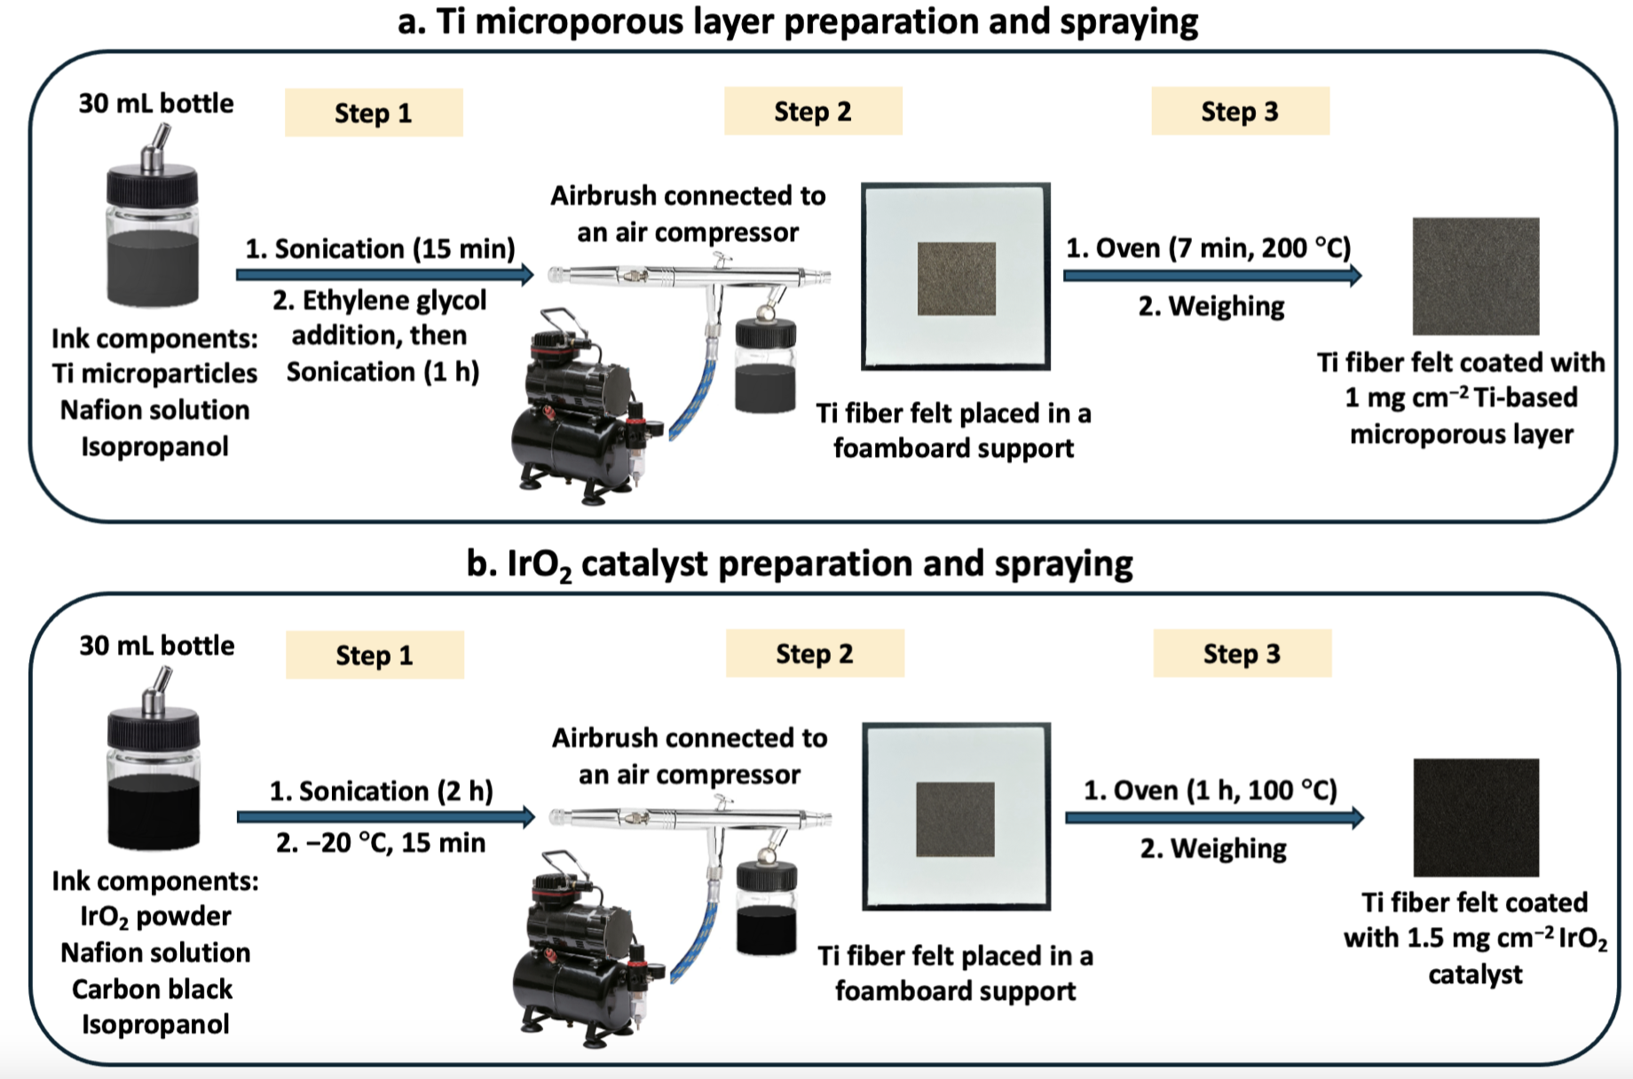
Figure 1: A schematic illustration of the protocols for (a) Ti microporous layer and (b) IrO₂ catalyst preparation and spraying on a Ti fibre felt.

Three different proton exchange membranes were evaluated in flow cell set-up: Nafion™ N117 (177.8 µm, Ion Power, Inc), Aquivion® E98-15S (150 µm, FuelCellStore), and PFSA D170-U (170 µm, FuelCellStore). Polytetrafluoroethylene gaskets (FuelCellStore) with various thicknesses (0.127 mm, 0.254 mm, and 0.508 mm) were employed, preventing both leakages and direct contact of the current collector/flow-field plates. All the flow components were assembled and compressed together with a 5.65 Nm clamping force on each bolt [7]. In all experiments, deionised water (15 MΩ-cm resistivity) was fed to both the anode and cathode through Norprene tubing (Merck Life Science UK Limited) at flow rate of 40 mL min⁻¹ using two Masterflex™ L/S peristaltic pumps (model 77201-60). The circulating liquid electrolyte was kept in 1 L media bottles as the electrolyte reservoirs. The temperature of both the anodic and cathodic water reservoirs was measured using K-type thermocouples placed on the outlets and inlets of the cathode and anode sides. The temperature data were monitored by a Pico TC-08 data logger (Pico Technology). A BioLogic SP-150 potentiostat equipped with an 80 A booster was used to conduct the electrochemical tests.

Electrolyte characterisation
Inductively coupled plasma optical emission spectroscopy (ICP-OES) analysis was conducted for detecting any leached metal residuals in the electrolyte reservoirs using an Agilent 5900 ICP-OES equipped with an Agilent SPS4 autosampler. The apparatus was calibrated with Ir and Pt reference standards. The ICP-OES samples were collected from the catholyte and anolyte circulating in the cell with volumes of 1.9 L and 0.7 L, respectively.

Electrochemical characterisation
Each type of membrane was assessed three times, using a fresh piece of membrane in each experimental run, and the results presented for each material are averages of these three repeats. Linear sweep voltammetry measurements were performed between 0 and 2.0 V at a scan rate of 10 mV s⁻¹. Chronopotentiometry measurements were performed at a fixed current density of 1.0 A cm⁻² for 100 h, as stability tests. Due to the observed electro-osmotic drag [17], water was pumped back from the cathode reservoir to the anode reservoir after approximately 48 h of electrolysis.

Proton exchange membrane pretreatment
The proton exchange membranes were delivered in a dry form, and then were submerged in deionised water at room temperature (at around 20 °C) for at least 24 h before use.

Gas chromatography analysis
To measure the extent of crossover of H₂ through the membrane from the cathode, an Agilent 8860 gas chromatograph system was used. All gas samples were taken from the anolyte reservoir’s headspace. A flowchart mapping out all the gas samples taken (in order) for gas chromatography analysis is shown in Figure 2. Pre-electrolysis baseline gas samples were taken after purging the anolyte with Ar at 1 bar for 30 min. Additional samples were taken after applying a fixed current density of 1.0 A cm⁻² for 1 h. Stability tests (wherein a constant current density of 1.0 A cm⁻² was applied for 100 h) were then performed, after which further gas samples were taken subsequent to purging the anolyte again with Ar for 30 min. Subsequently, additional samples were taken after applying a fixed current density of 1.0 A cm⁻² for another 1 h. By this method, the amount of H₂ crossover observed in the first hour of electrolysis (with a pristine membrane) could be compared to the crossover observed over a duration of 1 h with the same membrane but after 100 h of galvanostatic electrolysis, to see if the amount of crossover had increased (which would suggest some degradation of the membrane).

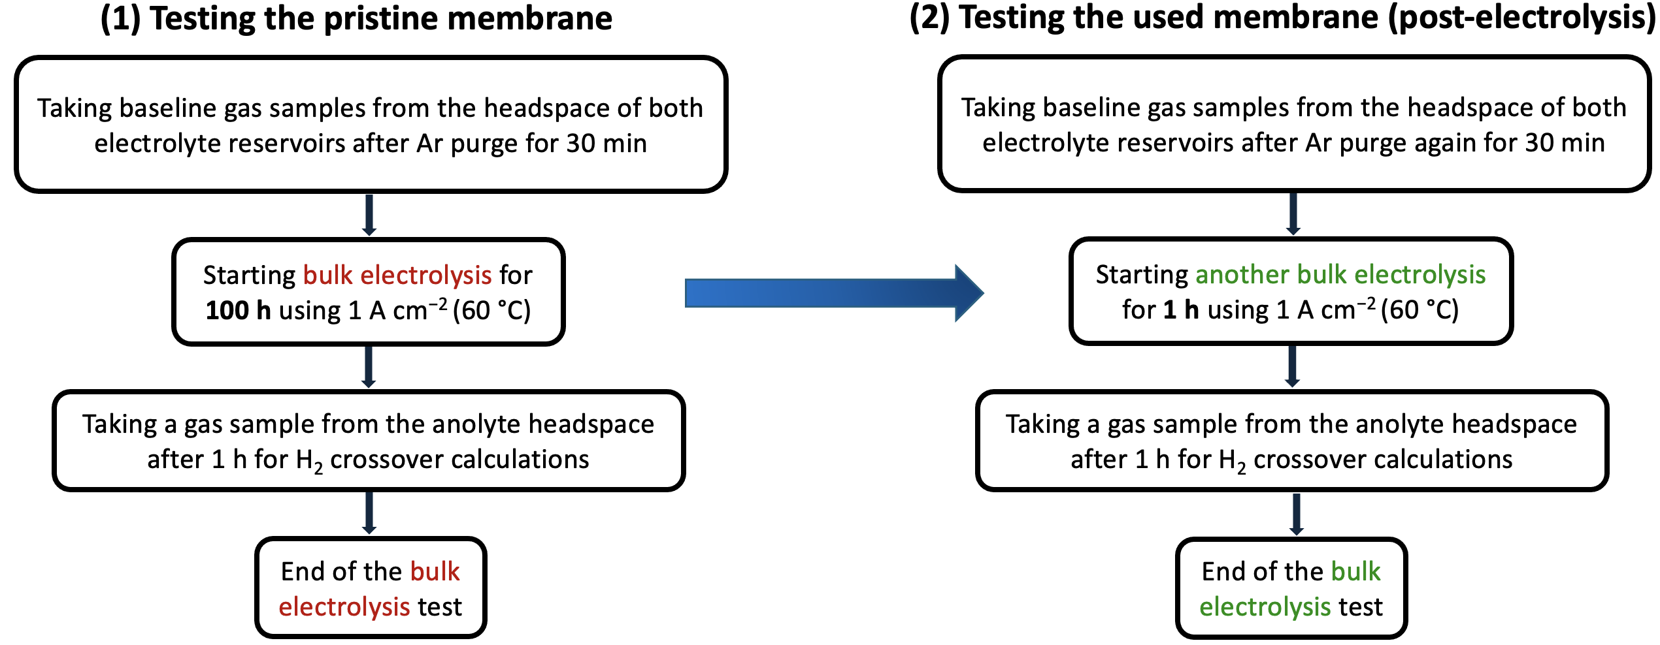
Figure 2: A flowchart illustrating the sequential collection of gas samples from the headspace of the electrolyte reservoirs for gas chromatography analysis: (1) prior to and (2) following each stability test (bulk electrolysis at 1.0 A cm⁻² for 100 h).

A calibration curve for H₂ quantitative analysis was generated to correlate the peak areas (generated by the gas chromatography instrument) with the amount of H₂ expressed in moles. The calibration curve (Figure 3) was prepared to quantify the amount of that H₂ crossed over to the anode side by injecting four different standards of H₂ gas (1%, 2%, 3%, 5% H₂/argon standards).
Figure 3: A calibration curve generated by injecting four different standards of H₂ gas (1%, 2%, 3%, 5% H₂/argon standards) using various volumes, to quantify the amount of H₂ that crossed over to the anode side.

All the H₂ quantity values were calculated by considering the headspace of the anolyte reservoir and the gas microsyringe volume (600 µL) used to collect the H₂ gas samples from the anolyte headspace, as shown in the following equation (equation 1).

$The H_{2} quantity \left(in moles\right)=\frac{Hydrogen peak area × headspace volume (L)}{ Calibration curve slope × 0.0006 L (gas microsyringe volume)}$ (1)

Characterisation of the membranes
To investigate the PFSA D170-U membrane’s morphology in its pristine form and after a stability test, scanning electron microscope analysis was conducted. It was performed in the Geoanalytical Electron Microscopy and Spectroscopy (GEMS) facility at the School of Geographical and Earth Sciences, University of Glasgow, using a Zeiss Sigma variable-pressure field-emission scanning electron microscope under high vacuum conditions. Fourier transform infrared measurements were conducted using a Jasco FT/IR-4100 infrared spectroscopy instrument. The measurements were taken before and after each stability test, using these parameters: a scan number of 128, a resolution of 4.0 cm⁻¹, and a wavenumber range of 4000 to 600 cm⁻¹. Atomic force microscopy (AFM) measurements were conducted using a Bruker Dimension Icon system equipped with ScanAsyst and PeakForce Tapping mode, employing a silicon tip (ScanAsyst-Air-HPI). AFM was performed on 1 cm × 1 cm samples of the PFSA D170-U membrane in both dry and hydrated forms (the hydrated form being obtained by soaked in deionised water for 24 h). Mean roughness values were obtained using Gwyddion software for AFM image analysis. X-ray diffractometry (XRD) was performed using a Rigaku MiniFlex instrument with Cu Kα radiation to examine the surface morphology and crystallinity of the PFSA D170-U membrane in both dry and hydrated forms. The scanning diffraction angle 2θ ranged from 10−80° at a speed of 5 min per data point and a scanning rate of 1° min⁻¹. Thermal stability and decomposition behaviour of the D170-U membrane were investigated using thermogravimetric analysis (TGA) and simultaneous differential scanning calorimetry–thermogravimetric analysis (DSC–TGA). TGA measurements were performed using a Discovery TGA 5500 (TA Instruments), while DSC–TGA analyses were conducted with an SDT Q600 system. The membrane was analysed in both the dry form and after hydration by immersion in deionised water for 24 h. TGA scans were carried out under a nitrogen atmosphere from 25 °C to 700 °C at a constant heating rate of 10 °C min⁻¹. DSC measurements were conducted from ambient temperature to 300 °C at a heating rate of 5 °C min⁻¹ under a continuous nitrogen purge.

Ion exchange capacity (IEC) measurements
The ion exchange capacity (IEC, meq g ⁻¹) of the PFSA D170-U membrane was determined using an acid–base titration method. Prior to measurement, all pore-filling membranes were dried in a desiccator for 24 h to ensure accurate mass determination. The dried membranes were then weighed and immersed in 20 mL of 0.05 M NaOH solution for 24 h to allow for ion exchange. Subsequently, titration was performed by slowly adding 0.05 M HCl until the pH reached approximately 7, as monitored using a Hanna HI 9026 pH meter. The pH meter was calibrated with standard buffer solutions of pH 4.0 and 7.0 prior to use. The IEC value was calculated based on the number of moles exchanged within the pore-filling membrane (χ), using equations 2 and 3.
$χ={(V}_{NaOH}×C_{NaOH})-(V_{HCl} × C_{HCl})$ (2)
$Ion exchange capacity \left(IEC\right)= \frac{χ × 1000}{m}$ (3)

In equations 2 and 3, V_{NaOH} and V_{HCl} represent the volumes (in litres) of the NaOH and HCl solutions, respectively; C_{NaOH} and C_{HCl} represent their corresponding concentrations (mol L ⁻¹); and m refers to the mass of the dried membrane (g). All measurements were carried out at least three times, and the average value was reported as the final IEC.

Water uptake, dimensional swelling and mechanical properties measurements
To investigate the hydrophilicity of the PFSA D170-U membrane, membrane samples were first weighed (W_{dry}) after being dried in a vacuum oven (Aotelec, China) at 80 °C for 24 h. The dried membranes were then soaked in deionised water for 2 days to allow swelling to reach equilibrium. After removing the membrane from the water, the membrane surface was gently wiped, then weighed again (W_{wet}). The water uptake of the membranes was calculated using equation 4 below.

Water uptake$= \frac{W_{wet} - W_{dry}}{W_{dry}} ×100$ (4)

The linear expansion ratio (LER) and % swelling (area and thickness) were determined to evaluate the dimensional stability of the PFSA D170-U membrane. The experimental procedures for both measurements were similar. Initially, dry membrane samples were cut into rectangular shapes, and their initial length and surface area were measured and recorded as L_{dry} and A_{dry}, respectively. The samples were then immersed in deionised water for 2 days to allow for full hydration. After immersion, the membranes were removed from the water, and excess surface water was gently wiped away. The length, surface area and thickness of the swollen membranes were measured again and recorded as L_{wet} , A_{wet,} and T_{wet}, respectively. The linear expansion ratio, area, and thickness swelling percentage were then calculated using equations 5 , 6 and 7, respectively.

Linear expansion ratio$= \frac{L_{wet} - L_{dry}}{L_{dry}} ×100$ (5)
% Swelling (area) $= \frac{A_{wet} - A_{dry}}{A_{dry}} ×100$ (6)
% Swelling (thickness) $= \frac{T_{wet} - T_{dry}}{T_{dry}} ×100$ (7)
Nanoindentation tests were conducted using an Anton Paar nanoindenter to characterize the mechanical properties of the PFSA D170-U membrane. The hardness and elastic modulus were calculated from the load–displacement data obtained by nanoindentation.

