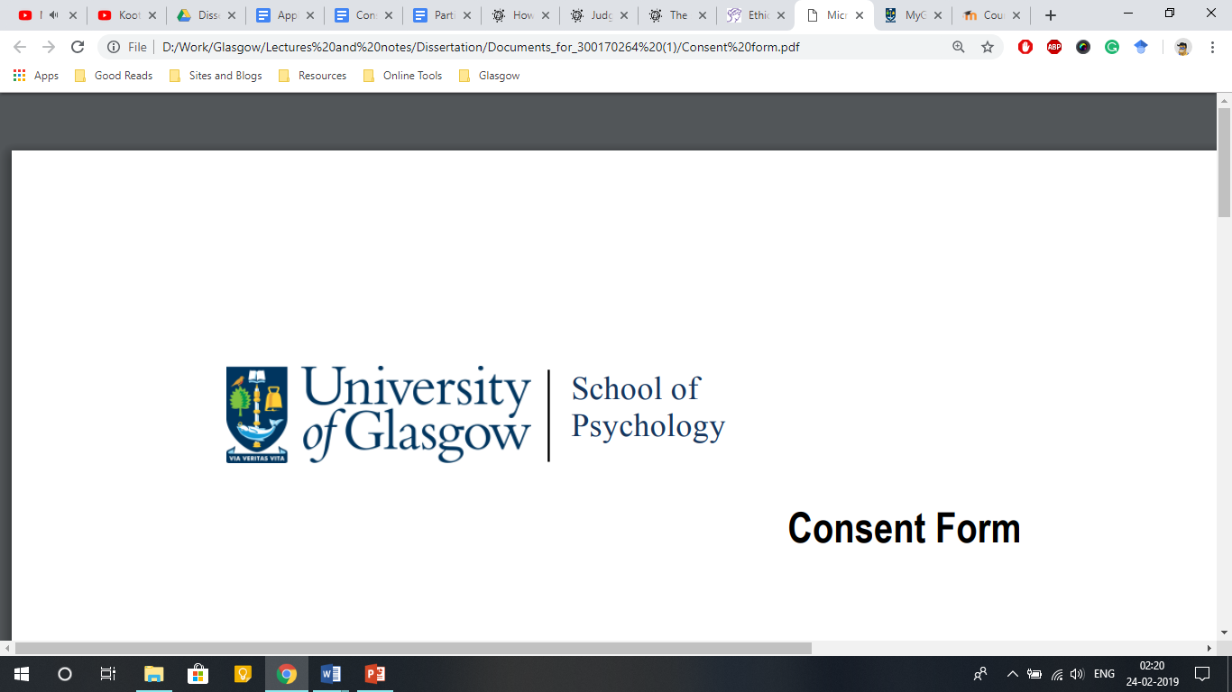

**Participant Information Sheet**

**Title of Project:** What makes voices convincing?

**Supervisor:** Dr Helena Paterson

**Student:** Kalliopi Mavromati (2374572M)

**Purpose of Study:**

This study aims to understand how we perceive voices as convincing.

**Description of the Study Procedures:**

You will hear different speakers say different things. After each clip, you will be asked to rate the voice on different aspects. The entire experiment should last approximately 30 minutes.

**Risks of Being in this Study:**

This experiment is non-invasive and thus poses no risk or harm to you.

**Confidentiality:**

Your age and gender will be recorded, but your answers will be recorded anonymously. Data with your anonymous Participant ID will be used for analysis for educational purposes in the context of a dissertation project. For scientific purposes, the data without identifying information might also be shared on research networks or journals according to the Open Science initiatives of our lab. When you consent to participate, you confirm that you understand the collected data may be shared as described above.

**Right to Refuse or Withdraw:**

Your participation is voluntary, and you can withdraw at any time, without giving a reason to the researcher and without incurring any penalty. If you wish for your data to not be submitted, you can exit without submitting.

**Further Information:**

If you require any further information about the experiment or your participation, or want to request a summary of our results, you can always reach out to us. You can contact me, Kalliopi Mavromati, by email at [2374572m@student.gla.ac.uk](mailto:2374572m@student.gla.ac.uk) (GUID: 2374572M) or my supervisor, Dr Helena Paterson, by email at [Helena.Paterson@glasgow.ac.uk](mailto:Helena.Paterson@glasgow.ac.uk).