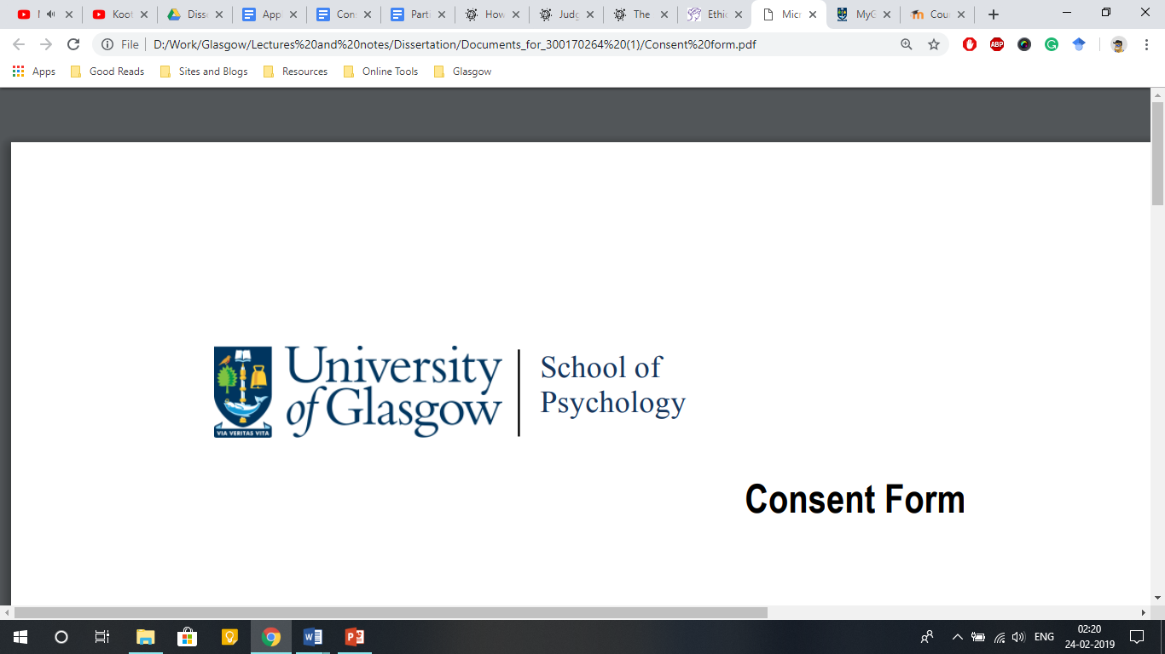

**Online Consent Form**

**Title of Project:** What makes voices convincing?

**Supervisor:** Dr Helena Paterson

**Student:** Kalliopi Mavromati (2374572M)

By continuing to the next step, please read the following statements and click ‘Yes’ if you agree.

* I have read the information provided and understand what my participation involves.
* I understand that my participation is voluntary and that I can withdraw at any time for any reason, without having to give a reason to the researcher and without penalty.
* I understand that the information collected will be kept anonymous during analysis and that grouped data may be shared in publications.
* I understand that anonymous data may be shared with other researchers and/or uploaded to an online data repository.
* I understand that any identifying information will be removed before any collected data is made publicly available.
* I understand that I can contact the researchers for further information and/or a summary of the anonymised results