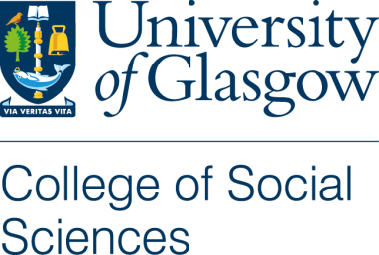

Participant Information Sheet

Title of Project: Encountering Windows and Mirrors in the Diaspora: Using Young Adult literature to explore the stories and counter-stories of East Asian young persons

Name of Researcher: Natalie Hsieh

To whom it may concern,
Your child is being invited to take part in a research study. Before your child decides to take part, it is important for you and your child to understand why the research is being done and what it will involve. Please read the following information carefully and discuss it with others if you wish. Ask the researcher if there is anything that is not clear or if you would like more information. Take some time to decide whether or not you wish for your child to take part.

Thank you for reading.

What is the purpose of the study?
It is increasingly difficult to deny that representation matters in all forms of media; two notable examples of this are the massive successes of the Hollywood films Black Panther and Crazy Rich Asians. But despite the strides being made in acknowledging the importance of representation, there is still barely any research regarding the representation and recognition of Asian young adult identities in contemporary Young Adult literature (YAL), and how Asian young adults themselves respond to these representations.
Because the label ‘Asian’ broadly covers a multitude of nationalities, ethnicities, cultures, and diasporas, this study will narrow the scope to specifically look at Asian Americans and British Asians of East Asian descent. The study itself will be an international, online book club comprised of East Asian students from both American and British diasporas.

What are the criteria to participate?
- Your child self-identifies as East Asian or of East Asian descent
- Your child currently lives in the United States or the United Kingdom
- Your child is between the ages of 16-18

What will my child be asked to do if he or she participates?
Firstly, participation is entirely voluntary and will not affect your child’s grades in any way. The study will take about 10 weeks, beginning in March 2023 and ending in May 2023 (there will be two weeks off for Easter Holidays where they will not be expected to complete any work for the study). Though this seems like a long period of time, it is mainly to give your child ample time to read two novels. Beyond the reading time, he or she ideally will not need to dedicate more than 30-45 minutes per week to this study. The most concrete time commitment will be two 45-minute Zoom sessions, spaced throughout the 10 weeks (more details below).
There are four main parts to the study:
- Your child will read two books over the span of 8 weeks: If You Still Recognise Me by Cynthia So and The Silence that Binds Us by Joanna Ho. He or she will have a month to read each book, which breaks down to about 100 pages per week (approx. 14 pages per day).
  - Of course your child is welcome to read beyond 100 pages, but no spoilers!
  - Trigger warnings are included in each description below – there is no expectation for your child to discuss these aspects of the book if he or she is uncomfortable, and you and your child will have access to a list of organisations and websites in cases of distress.

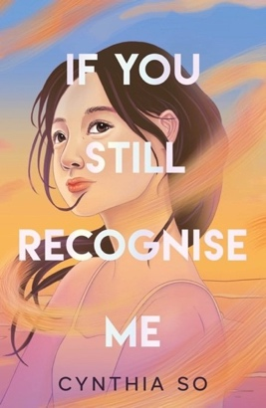
It’s the summer before university, and 18-year-old Elsie Lo is trying to figure out how to tell her best friend Ada that she has a crush on her. The problem? Ada lives in New York, across the ocean from Elsie in Oxford; they met online as active participants in the Eden Recoiling fandom (their favourite graphic novel series). The summer only gets more complicated as Elsie’s long-lost best friend Joan shows up unannounced, and Elsie’s estranged Po Po comes from Hong Kong to live with her family after eight years of no contact. As she forms new relationships and reckons with the truth about old ones, Elsie’s summer shapes her in both beautiful and bittersweet ways.
Similar to: Heartstopper; To All the Boys I’ve Loved Before
Trigger warnings: references to homophobia and emotionally abusive relationships
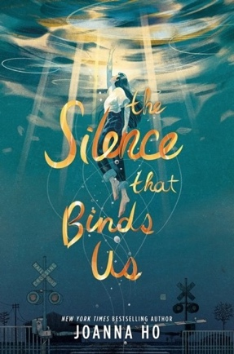
17-year-old Maybelline Chen dreams of being a writer, but her mother wants her to be more like her perfect brother Danny, who just got accepted into Princeton. The family believes that smart, popular Danny has it all figured out – but when they wake up to the news that he has committed suicide, their world falls apart. Soon, members of their San Francisco community accuse May’s parents of putting too much pressure on their son, and the blame for the increasing suicide rate is put on the entire Asian American community. May’s parents tell her to keep quiet and let it all blow over, but she resolves to fight back. What will be the cost of standing up and speaking her truth?

Similar to: The Hate U Give; Moxie
Trigger warnings: suicide, mental health challenges, racism and racist language

- Your child will post 2-3 reflections and questions on a Padlet after completing each week’s reading. He or she should periodically check back on the Padlet after posting to read and comment on the posts from other participants.
  - Your child cannot post personal photos or videos, but he or she can use emojis, gifs, and other non-identifying images in posts, if desired.
  - Your child’s posts do not need to be formal, but they must be respectful and appropriate. The researcher will delete any malicious, crude, or off-topic posts.
- Your child will be asked to participate in two synchronous ‘book talks’ over Zoom, with each session lasting no more than 45 minutes.
  - To work around the time difference (and for confidentiality purposes), there will be separate Zoom sessions for US and UK participants.
  - One ‘book talk’ will be in the middle of If You Still Recognise Me, and one will be in the middle of The Silence that Binds Us. This will give us the opportunity to expand beyond the Padlet to have a sustained dialogue about each book.
- Your child will create a zine (pronounced ‘zeen’) in the last two weeks of the study, which is essentially a little self-published magazine. Historically, zines have been used by countercultural movements and artists because they represent total creative freedom and are meant to be shared. Their zine should reflect this freedom – the only requirement is that he or she creates something that represents and reflects you in some way. This is your child’s chance to tell their story!

What if my child changes his or her mind halfway through the project?
- Your child can withdraw at any time without needing to provide a reason. As stated earlier, there will be no impact to their grades or academic standing.
- If you or your child want their contributed data to be removed from the study, please make this clear to the researcher within a month of the study’s conclusion so the researcher can make sure to take out all related data before beginning the analysis process. It cannot be guaranteed to be removed otherwise.

How will my child’s personal details be kept confidential?
  - Padlet:
    - To keep all posts anonymous, your child will NOT make an official Padlet account. Instead, he or she will choose a username/pseudonym to use when they post.
    - Your child should not post any personal videos or photos.
    - The Padlet will only be accessible through a unique, password-protected URL, and it is not open to the public.
    - All the data will be downloaded on a weekly basis to a secure password-protected computer, and then the Padlet will be wiped clean and reset.
- Zoom:
  - Your child will be in a smaller Zoom session with their peers. Even though they may already know each other, participants are strongly encouraged not to use their names or the names of other participants.
  - Private messaging between participants will be turned off.
  - Because confidentiality is impossible to guarantee in the case of live discussion, all participants must agree that any personal details revealed in the ‘book talk’ do not leave the online space of the Zoom.
  - The Zoom sessions will be audio recorded, but only the researcher will access the recordings and any personal details will be retroactively redacted in the transcript.
- Zine:
- The zines will be submitted directly to the researcher.
- Your child will have the option to share his or her zine with other participants, but this is not mandatory. If your child chooses to share, the researcher will first anonymise/redact any identifying details.
- All personal data will be deleted at the end of the research project and all participants will be pseudonymised in any future publications.
- Please note that confidentiality may not be guaranteed, due to the limited size of the participant sample. Confidentiality will be maintained as far as it is possible, unless during our conversation I hear anything which makes me worried that someone might be in danger of harm. I might have to inform relevant agencies of this.

How will the collected data from this study be used?
- During the study, all research data (audio files, Padlet posts, etc) will be kept on a password-protected laptop.
- After the study, the collected data will be pseudonymised and used primarily for the researcher’s PhD dissertation. Some data may also be used in conference papers and journal articles, if appropriate.
- The research data may be made available to other researchers working in the fields of Young Adult Literature and East Asian studies, upon personal request.

What will happen to the data after this study is over?
- The research data will be stored on a secure database for 10 years after the study is over. After this duration, the data will be destroyed in compliance with the current regulations in the UK.

This project has been considered and approved by the College Research Ethics Committee.

Details for further contact:
Researcher:
- Natalie Hsieh – n.hsieh.1@research.gla.ac.uk
Supervisors:
- Melanie Ramdarshan Bold – melanie.ramdarshanbold@glasgow.ac.uk
- Jennifer Farrar – jennifer.farrar@glasgow.ac.uk
To file a concern or complaint:
- Contact the College of Social Sciences Lead for Ethical Review, Dr Benjamin Franks –
socsci-ethics-lead@glasgow.ac.uk

