

Participant Information Sheet

Title of Project: Encountering Windows and Mirrors in the Diaspora: Using Young Adult literature to explore the stories and counter-stories of East Asian young persons

Name of Researcher: Natalie Hsieh

To whom it may concern,
You are being invited to take part in a research study. Before you decide to take part, it is important for you to understand why the research is being done and what it will involve. Please read the following information carefully and discuss it with others if you wish. Ask the researcher if there is anything that is not clear or if you would like more information. Take some time to decide whether or not you wish to take part.

Thank you for reading.

What is the purpose of the study?
We know that representation matters: two notable examples of this are the massive successes of the Hollywood films Black Panther and Crazy Rich Asians. But there is still barely any research regarding the representation and recognition of Asian young adult identities in contemporary Young Adult literature (YAL), and how Asian young adults themselves respond to these representations. This study will look specifically at Asian Americans and British Asians of East Asian descent.
The study itself will be an international, online book club comprised of East Asian students from both American and British diasporas.

What are the criteria to participate?
- You self-identify as East Asian or of East Asian descent
- You currently live in the United States or the United Kingdom
- You are between the ages of 16-18

What will I be asked to do if I participate?
Firstly, participation is entirely voluntary and will not affect your grades in any way. The study will take about 10 weeks in Summer 2023. This is mainly to give you time to read two novels; beyond the reading time, you ideally will not need to dedicate more than 30-45 minutes per week to this study.
There are four main parts to the study:
- You will read two books over the span of 8 weeks: If You Still Recognise Me by Cynthia So and The Silence that Binds Us by Joanna Ho.

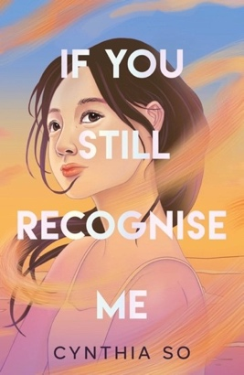
It’s the summer before university, and 18-year-old Elsie Lo is trying to figure out how to tell her best friend Ada that she has a crush on her. The problem? Ada lives in New York, across the ocean from Elsie in Oxford; they met online as active participants in the Eden Recoiling fandom (their favourite graphic novel series). The summer only gets more complicated as Elsie’s long-lost best friend Joan shows up unannounced, and Elsie’s estranged Po Po comes from Hong Kong to live with her family after eight years of no contact. As she forms new relationships and reckons with the truth about old ones, Elsie’s summer shapes her in both beautiful and bittersweet ways.
Similar to: Heartstopper; To All the Boys I’ve Loved Before
Trigger warnings: references to homophobia and emotionally abusive relationships
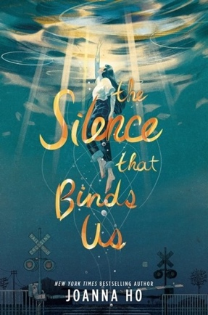
17-year-old Maybelline Chen dreams of being a writer, but her mother wants her to be more like her perfect brother Danny, who just got accepted into Princeton. The family believes that smart, popular Danny has it all figured out – but when they wake up to the news that he has committed suicide, their world falls apart. Soon, members of their San Francisco community accuse May’s parents of putting too much pressure on their son, and the blame for the increasing suicide rate is put on the entire Asian American community. May’s parents tell her to keep quiet and let it all blow over, but she resolves to fight back. What will be the cost of standing up and speaking her truth?

Similar to: The Hate U Give; Moxie
Trigger warnings: suicide, mental health challenges, racism and racist language

- You will post 2-3 reflections and questions on a Padlet after completing each week’s reading. You should periodically check back on the Padlet after posting to read and comment on the posts from other participants.
- You will be asked to participate in two synchronous ‘book talks’ over Zoom, with each session lasting no more than 45 minutes. To work around the time difference, there will be separate Zoom sessions for US and UK participants.
- You will create a zine (pronounced ‘zeen’) in the last two weeks of the study, which is essentially a little self-published magazine. Historically, zines have been used by countercultural movements and artists because they represent total creative freedom and are meant to be shared. Your zine should reflect this freedom – the only requirement is that you create something that represents and reflects you in some way. This is your chance to tell your story!

What if I change my mind halfway through the project?
- You can withdraw at any time without needing to provide a reason. If you want your contributed data to be removed from the study, please make this clear to the researcher within a month of the study’s conclusion so the researcher can make sure to take out all related data before beginning the analysis process. It cannot be guaranteed to be removed otherwise.

How will my personal details be kept confidential?
  - Padlet:
    - To keep posts anonymous, you will NOT make an official Padlet account. Instead, you will choose a username, and you should not post any personal videos or photos.
    - The Padlet will be password-protected. All the posts will be downloaded on a weekly basis, and then the Padlet will be reset.
- Zoom:
  - You have the option to leave your camera off. You are strongly encouraged not to use your name or the names of other participants, and private messaging between participants will be turned off.
  - The Zoom sessions will be recorded, but only the researcher will access the recordings and any personal details will be retroactively redacted in the transcript.
- Zine:
- The zines will be submitted directly to the researcher. You do not have to share your zine with other participants, but you can if you would like to (the researcher will first anonymise/redact any identifying details).
- Please note that confidentiality may not be guaranteed, due to the limited size of the participant sample. Confidentiality will be maintained as far as it is possible, unless I hear anything which makes me worried that someone might be in danger of harm. I might have to inform relevant agencies of this.

How will the collected data from this study be used?
- After the study, the collected data will be pseudonymised and used primarily for the researcher’s PhD dissertation.
- The research data may be made available to other researchers working in the fields of Young Adult Literature and East Asian studies, upon personal request.

What will happen to the data after this study is over?
- The research data will be stored on a secure database for 10 years after the study is over. After this duration, the data will be destroyed.

This project has been considered and approved by the College Research Ethics Committee.

Details for further contact:
Researcher:
- Natalie Hsieh – n.hsieh.1@research.gla.ac.uk
Supervisors:
- Melanie Ramdarshan Bold – melanie.ramdarshanbold@glasgow.ac.uk
- Jennifer Farrar – jennifer.farrar@glasgow.ac.uk
To file a concern or complaint:
- Contact the College of Social Sciences Lead for Ethical Review, Dr Benjamin Franks –
socsci-ethics-lead@glasgow.ac.uk

