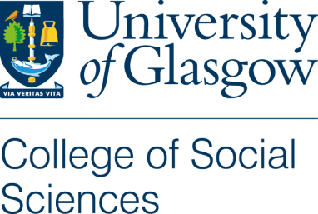

Participant Information Sheet - Interviews

Title of Project: Purpose in business: empowering employees and enhancing productivity

Name of Researchers: Prof Bridgette Wessels - Bridgette.wessels@glasgow.ac.uk and Dr Anna Clover – Anna.clover@glasgow.ac.uk

You are being invited to take part in a research study.

Before you decide to take part, it is important for you to understand why the research is being done and what it will involve.

Please read the following information carefully and discuss it with others if you wish.

Ask the researcher/s if there is anything that is not clear or if you would like more information. Take some time to decide whether or not you wish to take part.

Thank you for reading this.

This study is about businesses in Scotland that aim to do more than just make money. These businesses try to balance making a profit with helping people, improving the economy and protecting the environment. This means they have a specific purpose to support the environment, local communities, or other good causes.
Our goal is to understand what 'purpose' means to employees at your company, and the role of employees in supporting their organisation’s purpose. By doing this, we want to help Scottish businesses find ways to support people, the environment, and the economy.
We are speaking to employees and managers from different businesses in Scotland, working at different levels of these organisations.

If you decide to join, you will take part in a 45 to 60-minute interview via a Teams call with the researcher, Anna Clover.

You will also be asked to sign a consent form. This gives more information about the project and outlines your rights as a participant.

The interview will be an informal conversation. We will discuss topics such as your experiences at work, your views about your workplace, what you find meaningful at work and your views about your organisation’s purpose.

Participating in the interview is voluntary, and you can choose to take a break at any time or stop the interview at any time. If you do choose to participate, you can withdraw from the research up to the date of December the 30th, 2024.

With your permission, we will record the interviews and write down what you say. This information will be used in reports, academic papers, and presentations. It will be stored securely at the University of Glasgow and will be available in their online repository. Your identity will be protected with codes and fake names.

After the interview, we will keep your personal information private by giving your interview transcript a numerical code. We will not use your real name in any reports, academic papers, or presentations and will give you a fake name.

Your information will stay confidential unless the law requires otherwise.

The information we collect will help create research reports, conference papers, academic presentations, and journal articles. It will be safely stored on University of Glasgow servers and will be deleted after 10 years, by January 30, 2035.

The study is funded by The Productivity Institute and the Economic and Social Research Council.

This project has been considered and approved by the College Research Ethics Committee.

For any questions regarding the project, please contact the project’s Primary Investigator, Professor Bridgette Wessels: Bridgette.wessels@glasgow.ac.uk or the Research Associate, Dr Anna Clover: Anna.clover@glasgow.ac.uk

To pursue any complaint about the conduct of the research: contact the College of Social Sciences Lead for Ethical Review via email: socsci-ethics-lead@glasgow.ac.uk

