NiCuAg: An Electrochemically-Synthesised Trimetallic Stack for CO₂ Reduction

Hannah L.A. Dickinson and Mark D. Symes*
WestCHEM, School of Chemistry, University of Glasgow, Glasgow, G12 8QQ, United Kingdom
* Email: mark.symes@glasgow.ac.uk

Abstract
Electrochemical CO₂ reduction is a promising technique for the production of desirable hydrocarbons without the need to resort to fossil resources. However, high overpotentials and poor selectivity remain a challenge for CO₂ electro-reduction, especially for deep reduction by more than two electrons. One apparently attractive approach for breaking the scaling relations caused by simultaneous CO₂ reduction pathways and for achieving deeper reduction is the use of multi-metallic electrodes, where several promising metal catalysts are present in close proximity. Herein, noting the activity shown by Ni, Cu and Ag for CO₂ electroreduction when used individually, we set out to synthesise a tri-metallic “stack” catalyst, NiCuAg, and then to test this for electrochemical CO₂ reduction. The stack architecture was successfully generated and the trimetallic NiCuAg system did show improved Faradaic efficiency for the reduction of CO₂ to formic acid when compared to the bare Ni and bimetallic NiCu controls under some select conditions. However, the two-layer NiCu stack and bare Ni exhibited consistently higher Faradaic efficiencies than NiCuAg for deeper CO₂ electroreduction to methanol and ethanol, indicating that the combination of three individually promising metals does not necessarily translate into superior catalytic performance for deep carbon dioxide reduction.
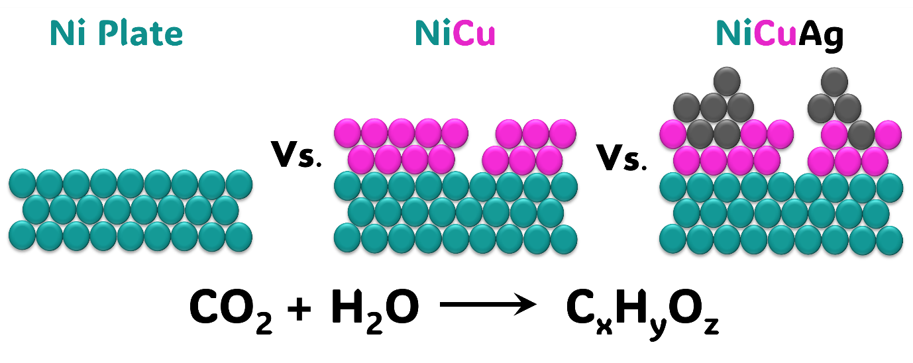
Keywords: carbon dioxide reduction; electrocatalysis; copper alloys; tandem catalysis; multi-metallic catalyst

Experimental
Materials
Nickel foil (0.5 mm, [7440-02-0], annealed, 99.5 %), copper (II) sulfate ([7758-98-7], anhydrous, 98%), and potassium hydrogen carbonate ([298-14-6], 99%) were obtained from Alfa Aesar. Silver nitrate ([7761-88-8], ACS reagent, >99%) was obtained from Sigma Aldrich. Nafion-117 membranes were obtained from Fuel Cell Store. Carbon Dioxide (99.8%, Industrial Grade) and Argon (99.9%) were supplied by BOC Limited. All chemicals were used as received without further purification and all solutions were produced using ultrapure water (15.8 MΩ-cm).

Catalyst Preparation
Nickel foil was cut to a size of 2 × 1 cm and the backside covered using Sellotape. This was used as the working electrode. The Ni surface was cleaned prior to any coating by sonication for 10 minutes each in: acetone, followed by isopropyl alcohol and finally deionised water. Copper electrodeposition (from a solution of 0.1 M CuSO4 at −200 mV vs. Ag/AgCl) was completed in an open beaker for 10 minutes whilst stirring. For copper deposition, a standard three-electrode setup was used: leak-free Ag/AgCl reference electrode (Innovative Instruments, Inc.), Ni foil working electrode, and graphite rod (Alfa Aesar) counter electrode. Where appropriate, a silver layer was added by galvanic replacement by placing the NiCu stack in a 0.01 M AgNO3 solution for two minutes, without stirring, to give NiCuAg. All catalysts were prepared at room temperature and pressure.

Characterisation
The surface morphology of the prepared electrocatalyst plates was analysed in the Geoanalytical Electron Microscopy and Spectroscopy (GEMS) facility at the School of Geographical and Earth Sciences, University of Glasgow, using a Carl Zeiss Sigma variable pressure analytical Scanning Electron Microscope (SEM) with Oxford Microanalysis with a 15 kV accelerating voltage. A 20 nm thick carbon layer was coated onto the samples prior to analysis. Cross-sectional Transmission Electron Microscopy (TEM) was completed at the Kelvin Nanocharacterisation Centre. A cross-sectional TEM lamella was extracted from the bulk sample and transferred onto a Cu TEM grid using a FEI Nova NanoLab 200 dual beam SEMFIB. The TEM imaging and analysis was done on a JEOL Atomic Resolution Microscope (JEM-ARM200cF) STEM, operating at 200 kV. This microscope is equipped with a cold field emission gun and a CEOS (Corrected Electron Optical Systems GmbH) probe corrector for STEM imaging and a Gatan GIF Quantum electron spectrometer for electron energy-loss spectroscopy (EELS).
X-ray diffraction (XRD) was undertaken using a Rigaku MiniFlex benchtop diffractometer equipped with Cu sealed tube X-ray source. The surface composition of the catalysts was analysed by X-ray photoelectron spectroscopy (XPS) at the University of St Andrews using a Scienta 300 with a SPECS monochromated X-Ray source. All data analyses and fittings were made using CasaXPS software.

Electrochemical Characterisation
Electrochemical studies were controlled by a Gamry interface 1010E potentiostat, at room temperature and pressure. Linear sweep voltammograms and electrochemical CO₂ reduction experiments were carried out in a custom-made air-tight two-compartment H-cell (Figure 1) under a constant flow of Ar or CO₂. A graphite rod and leak-free Ag/AgCl electrode were used as the counter and reference electrodes respectively. A Nafion-117 membrane was added to separate the anolyte and catholyte, alongside preventing the diffusion and re-oxidation of any reduction products. 0.1 M KHCO₃ was used as the electrolyte; it was purged with CO₂ or Ar gas for at least 30 minutes prior to testing. Linear sweep measurements were taken between +0.2 and −2.0 V vs. Ag/AgCl with a scan rate of 25 mV/s.

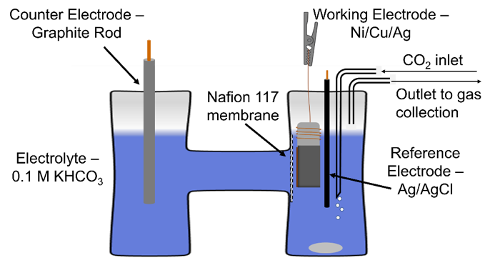
Figure 1. Custom air-tight H-cell set-up, as used for electrochemical CO₂ reduction tests.

Product Analysis
Gas Product Analysis
Possible gas products (H₂, CO, CH₄, C₂H₆ and C₂H₄) were flushed from the cell by the constant stream of Ar or CO₂ and collected in a gas sampling bag, and analysed post-electrolysis by gas chromatography (Agilent 8860) equipped with 2 Porapak Q columns and a MoleSieve 13X column. A thermal conductivity detector was used. Gas products were tested after CO₂ reduction experiments were completed. A gas chromatogram showing all possible peaks and the standard calibration curves are shown in Supplementary Figures S1 and S2.

Liquid Product Analysis
Liquid phase products were quantified by 1D ¹H Nuclear Magnetic Resonance (NMR) spectroscopy (400 MHz, Bruker). 400 μL of the post-electrolysis electrolyte solution was mixed with 70 μL D₂O ([7789-20-0], 99.9% D, Goss Scientific) and 30 μL of internal standard solution for analysis. The internal standard consisted of 10 mM dimethyl sulfoxide-D6 ([67-68-5], 99.9% D, Cambridge Isotope Laboratories, Inc) and 50 mM phenol ([108-95-2] ≥99.0%, Sigma Aldrich) prepared in 100 mL 0.1 M KHCO₃. The water suppression method was used to record the ¹H spectra. The relative peak area was compared to the first phenol peak (7.32 ppm); the ratio of the area of a given peak was compared with the standard curve to quantify the concentration produced. A typical sample ¹H NMR spectrum and the standard calibration curves are shown in Supplementary Figures S3 and S4 and Table S1.

Faradaic Efficiency Calculations
Faradaic efficiency expresses the selectivity for a particular product from an electrochemical reaction; it is calculated using Equation 1, where a is the number of transferred electrons according to the relevant balanced chemical equation, n is the number of moles of a given product, F is Faraday’s constant, and Q_{total} is the total charge passed.

$$\text{Faradaic Efficiency}= \frac{a × n ×F}{Q_{total}} × 100$$
( 1 )

