Enhancing Wave Propagation via Contextual Beamforming Dataset Information Sheet

GENERAL INFORMATION

Title of Dataset
Enhancing Wave Propagation via Contextual Beamforming

Author Information
Names: Jaspreet Kaur, Qammer H Abbasi, Abu Bakir Sharif, Olaoluwa R Popoola, Muhammad Ali Imran and Hasan T Abbas
Institution: University of Glasgow
Address: James Watt School of Engineering, College of Science and Engineering, University of Glasgow, Glasgow, G12 8QQ
Emails:
2585552k@student.gla.ac.uk, qammer.abbasi@glasgow.ac.uk, abubakir.sharif@glasgow.ac.uk, Olaoluwa.Popoola@glasgow.ac.uk, muhammad.imran@glasgow.ac.uk, Hasan.Abbas@glasgow.ac.uk

Date of data collection:
The data was collected in December 2021.

Geographic location of data collection:
Wireless Insite Software, James Watt South Building, Glasgow, G12 8QQ, United Kingdom

Information about funding sources that supported the collection of the data:
NA

SHARING/ACCESS INFORMATION

Licenses/restrictions placed on the data:
NA

Links to other publicly accessible locations of the data:
NA

Was data derived from another source?
No
Recommended citation for this dataset: Kaur, Jaspreet, et al. "Enhancing wave propagation via contextual beamforming." 2021 IEEE International Symposium on Antennas and Propagation and USNC-URSI Radio Science Meeting (APS/URSI). IEEE, 2021.

DATA & FILE OVERVIEW
Details of Data Folders and Files:
Version: 1.0
The simulation demonstrates the process of contextual beamforming in an urban environment. Data was collected through a simulation using Remcom Wireless InSite 3.3.0, utilizing a profile of the city of Rosslyn, Virginia. The scenario involved a moving vehicle communicating with 3 cellular base stations (BSs) at different heights and offsets. Data includes power delivered and received by mobile receivers (Rx1 to Rx16) along a predefined route, considering both Line of Sight (LoS) and Non-Line of Sight (NLoS) trajectories.
Folder Structure and Content:
The dataset is organized within a directory structure as follows, intended for use in a Windows file system environment:
Path: ~\Data\... (The root directory for dataset storage. Replace ... with the specific path where the dataset is stored on your system.)
Rosslyn: This folder contains all the simulation profile files related to the city of Rosslyn, Virginia, used for setting up the urban environment in the Remcom Wireless InSite simulation.
Results: This directory houses the .p2m files, which are the output files from the simulation detailing various parameters such as received power, path loss, propagation paths, angles of arrival, times of arrival, and directions of arrival. These files are essential for further analysis and for training machine learning models to enhance wave propagation through contextual beamforming.
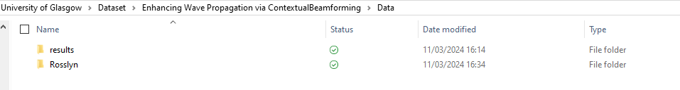
Figure 1: Data folder Structure
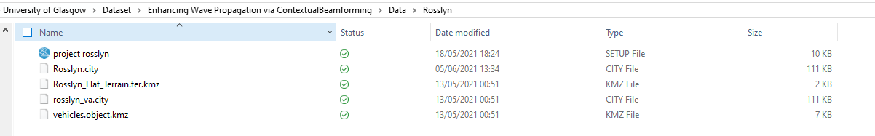
Figure 2: Data folder Structure
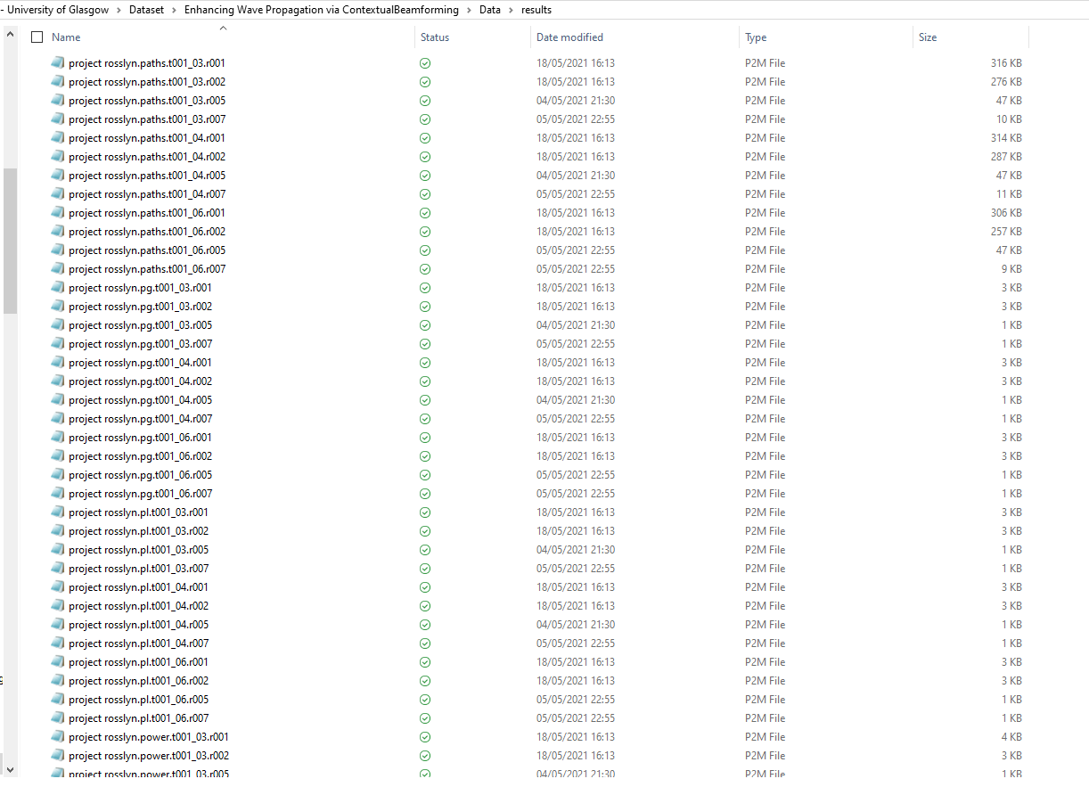
Figure 3: Data folder Structure
METHODOLOGICAL INFORMATION
Description of Methods Used for Collection/Generation of Data:
The simulation was set up using Remcom Wireless InSite 3.3.0 to mimic the cityscape of Rosslyn, Virginia. Different transmitters and mobile receivers were simulated to evaluate the effectiveness of contextual beamforming. Various parameters such as received power, path loss, angle of arrival, and time of arrival were recorded for further analysis.
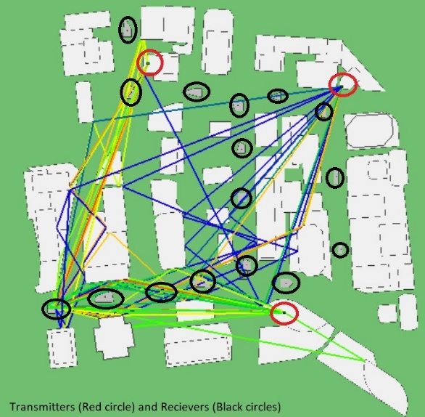
Figure 4: Setup

CONTRIBUTION AND USAGE
This dataset is intended for research purposes, specifically focusing on the development and testing of machine-learning models for enhancing wave propagation through contextual beamforming in urban environments. Researchers are encouraged to utilize this dataset for exploring the effectiveness of various machine learning algorithms in optimizing communication pathways in dense urban areas.
For any inquiries or feedback regarding the dataset, please contact:
Jaspreet Kaur
Ph.D. Scholar
James Watt School of Engineering
2585552k@student.gla.ac.uk

