Ethics Consent & Plain Language Statement

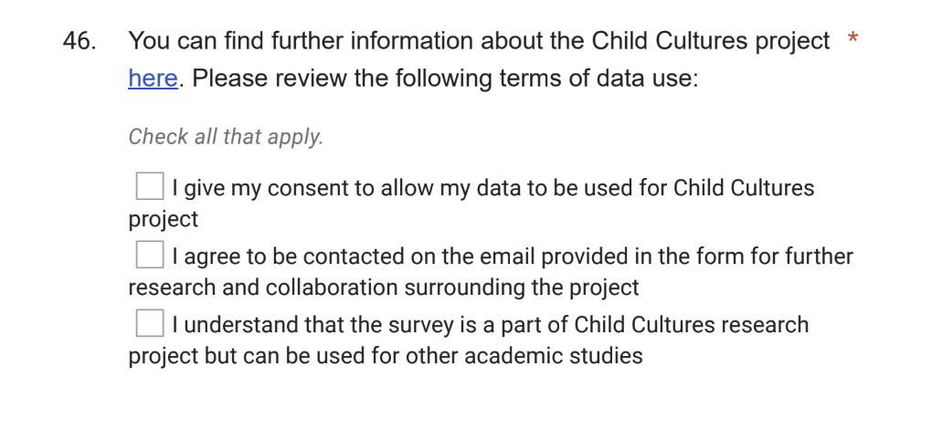

Participant Information

In the framework of "CHILDCULTURES: Challenging Adultism, Anthropocentrism and Other Exclusions with Children's Literature and Culture", a project hosted by the University of Glasgow and in partnership with IBBY, you are invited to participate in a global survey on children's literature prizes that include children and/or young people (under 18) in their juries.
The survey aims to produce knowledge, about different initiatives conducted worldwide, to be shared openly across the institutions that organise and promote these awards.
The survey will be followed by a digital publication featuring some of the obtained data, which will be co-produced with IBBYcat (the Catalonian branch of IBBY Spain) in mid-January.
Alongside, a virtual meeting to create a Network of Child Juries in Literary Prizes will be held on January 25, 2024 at 1pm CET. In this assembly, we hope to bring different initiatives together to share common challenges and learnings. All are invited to participate.
Please do not hesitate to reach out to project coordinator Macarena García-Gonzalez (Macarena.GarciaGonzalez@glasgow.ac.uk) if you have any question regarding the project or if you meet technical difficulties when filling the survey.

