Enhanced ultrasonic degradation of methylene blue using a catalyst-free dual-frequency treatment
Lukman A. Yusuf,ª Zeliha Ertekin,^{a.b} Shaun Fletcher,^{a.} and Mark D. Symes^{a*}

ª WestCHEM, School of Chemistry, University of Glasgow, University Avenue, Glasgow, G12 8QQ, United Kingdom.
^{b} Hacettepe University, Faculty of Science, Department of Chemistry, Beytepe, 06800 Ankara, Turkey.
* Email: mark.symes@glasgow.ac.uk (M. D. Symes)

Reagents and chemical analysis: The exemplar pollutant utilized in this paper is methylene blue. Methylene blue (CAS No. 122965-43-9) of high purity was purchased from ThermoFisher Scientific. It is an aromatic heterocyclic basic dye with a molecular weight of 319.85 g mol⁻¹. It is a well-known cationic and primary thiazine dye with molecular formula C16H18N3ClS and a λ_{max} of 664 nm. It has solubility of 43.6 g/L in aqueous solution at room temperature (25 °C). Methylene blue belongs to the polymethine dye class and contains an amino autochrome unit, making it a positively charged compound, see Fig. 1. for its molecular structure. According to the International Union of Pure and Applied Chemistry (IUPAC), its chemical name is [7-(dimethylamino)-N,N-dimethyl-3H-phenothiazin-3-iminium chloride], and it is indexed as colour index (CI) 52015.
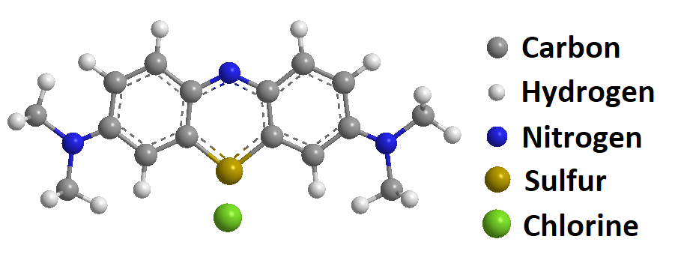
Fig 1. Molecular structure of methylene blue

Five sets of standard methylene blue solution of varying concentration (8 – 41 µM) equivalent to (2.56 – 13.1 mg/L) were prepared and used to obtain a calibration curve shown in Fig. S1. Each of the samples was scanned spectrometrically using an Agilent Cary 60 UV-vis spectrometer, and the absorbance values at 664 nm were recorded in each case. A 15 µM solution of methylene blue was then prepared and used as the solution for degradation experiments in the following experiments.
The machine employed for measuring total organic carbon (TOC) was a Thermalox elemental analyzer utilizing thermal oxidation techniques. This process oxidizes the organic carbon within the sample into CO_{2.} Subsequently, the CO₂ is detected and measured using non-dispersive infrared (NDIR), from which the TOC value is derived.

Acoustic set-up: Two types of acoustic device were used in this paper: an ultrasonic horn and an ultrasonic bath. The ultrasonic horn was a commercial Branson 450 W Digital sonifier, operating at 20 kHz through a 230 mm long tapered Ti probe, with a ¼ inch diameter (6.4 mm-ϕ) tip. The ultrasonic bath 320 W (Elmasonic P, Turbex) can be independently operated at 37 kHz and 80 kHz. The input power can be entered manually as a percentage value via the front panel of the control console for each of the acoustic devices.
The horn was vertically mounted with its tip submerged 20 ± 1 mm into a 25 mL solution of methylene blue, contained within a custom-made glass sonoreactor (50 mm-ϕ), see Fig. S2. Simultaneously, the sonoreactor was also vertically submerged, positioned roughly 10 ± 1 mm from the base of the ultrasonic bath, which was filled with 600 mL of deionized water, as illustrated in Fig. 2. The position of the horn and other devices remained fixed throughout all the experiments. In all the investigations reported in this work, the temperature of the samples was not maintained at a constant value during ultrasound treatment. We observed a temperature increase in the range of 15-20 °C over the 20-minute sonication period for the dual frequency ultrasound used in this study.

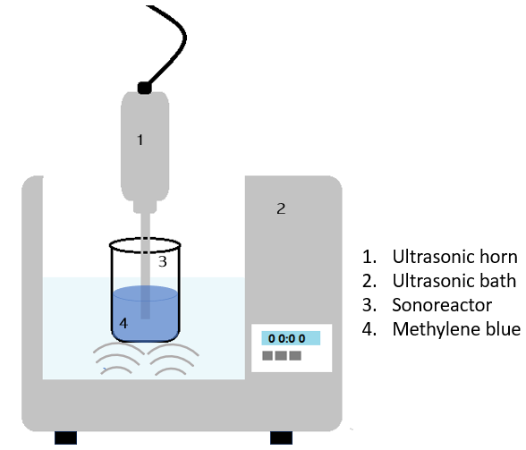
Fig. 2. Experimental set up for the degradation of methylene blue. The ultrasonic horn (Branson 450 W) was operating at 20 kHz and the ultrasonic bath (Elmasonic P, Turbex 320 W) was operating at two frequencies (37 and 80 kHz).

Fig S1. Calibration curve from different standard solutions of methylene blue. The standard solutions (8 – 41 µM, equivalent to 2.56 – 13.1 mg/L) were prepared from a stock solution of 0.1 mM. These solutions were analysed by UV-vis (Agilent Cary 60 UV-vis spectrometer), and the absorbance values at a wavelength of 664 nm were recorded.
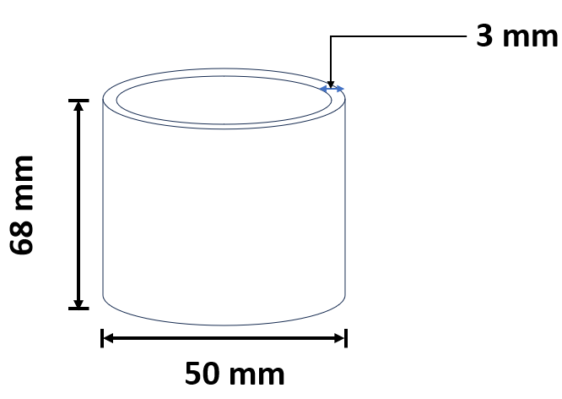
Fig. S2. Schematic diagram of the sonoreactor beaker used for the experiments. This reactor was built in-house from glass and was used throughout all the experiments.

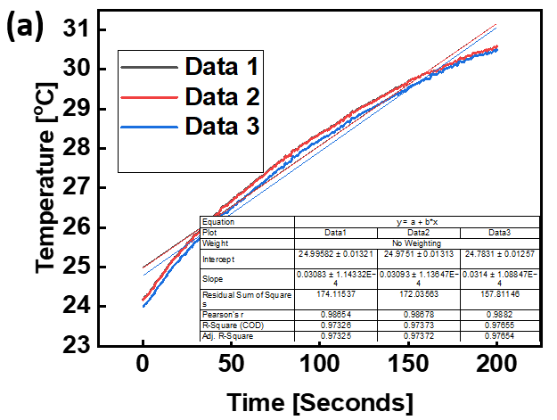
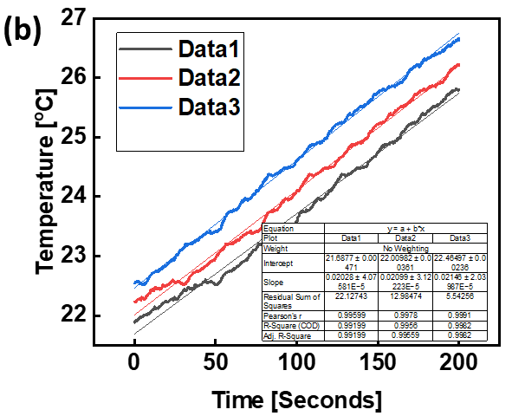
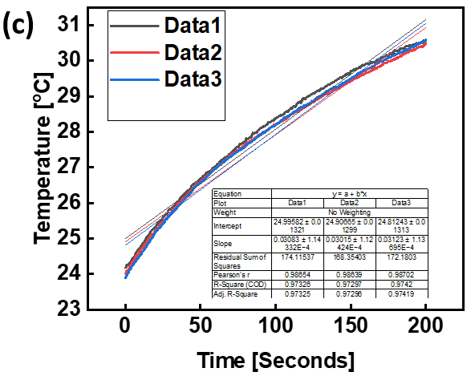
Fig. S3. Calorimetric data obtained from the temperature rise per second when (a) the ultrasonic bath was operated at frequency and input power of 37 kHz and 100% respectively; (b) the ultrasonic bath was operated at frequency and input power of 80 kHz and 100% respectively; and (c) the simultaneous combined operation of the ultrasonic horn (at 37 kHz and 60% input power) and the ultrasonic horn at 40% input power.

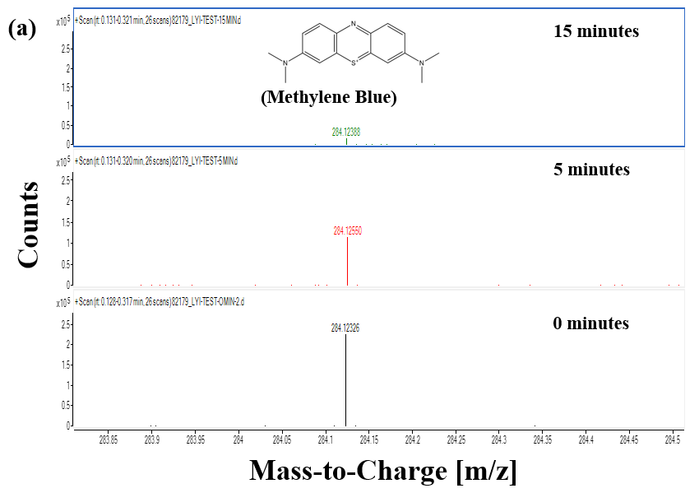
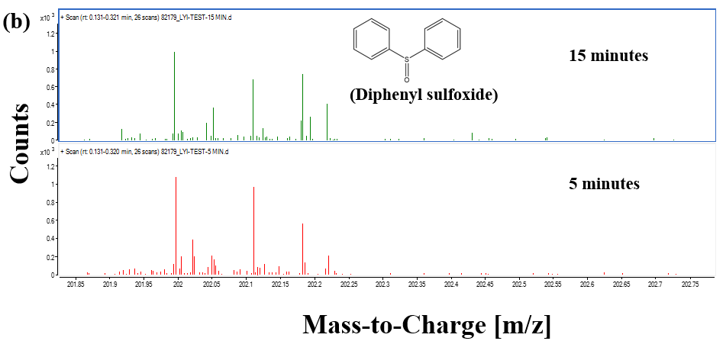
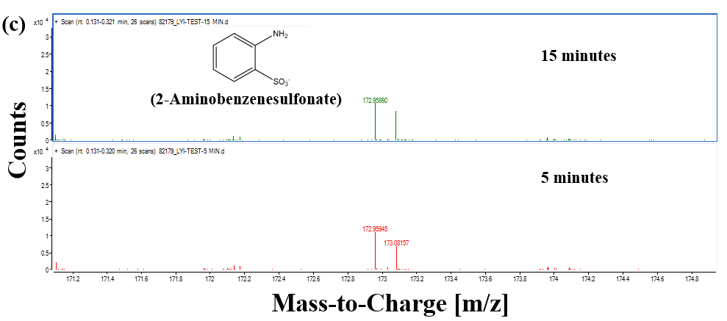
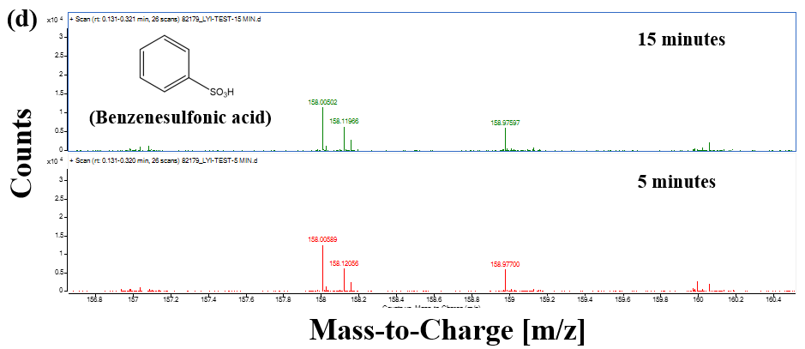
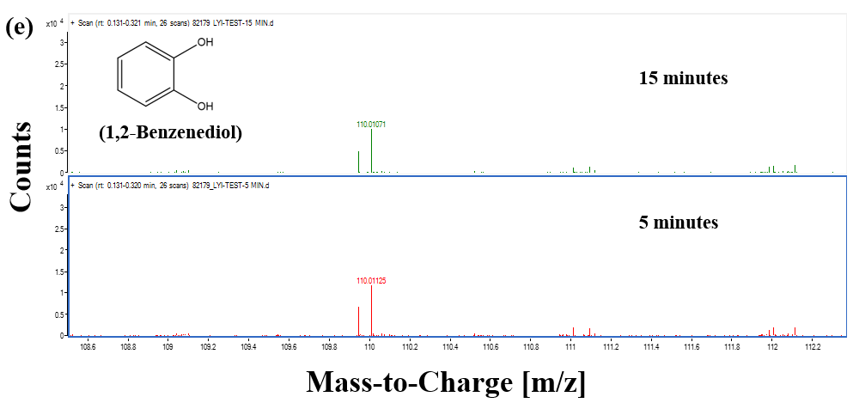

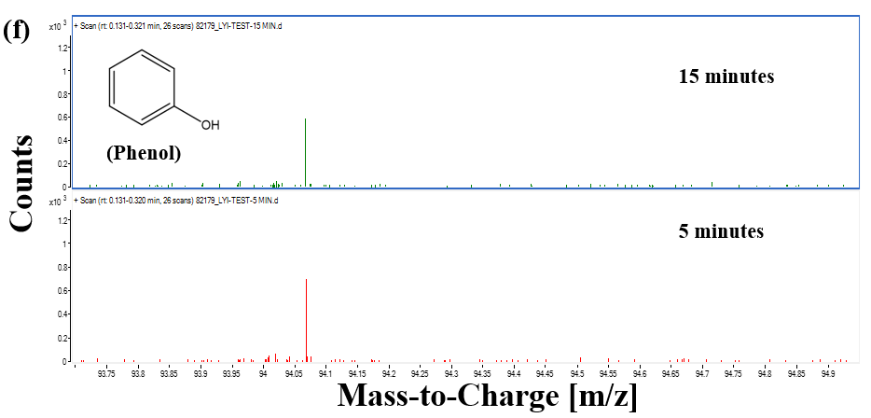
Fig. S4. Mass spectrometry data for methylene blue: (a) shows the extent of degradation of methylene blue after 5 and 15 minutes, (b-f) show the traces of the by-products as the sonication progresses.

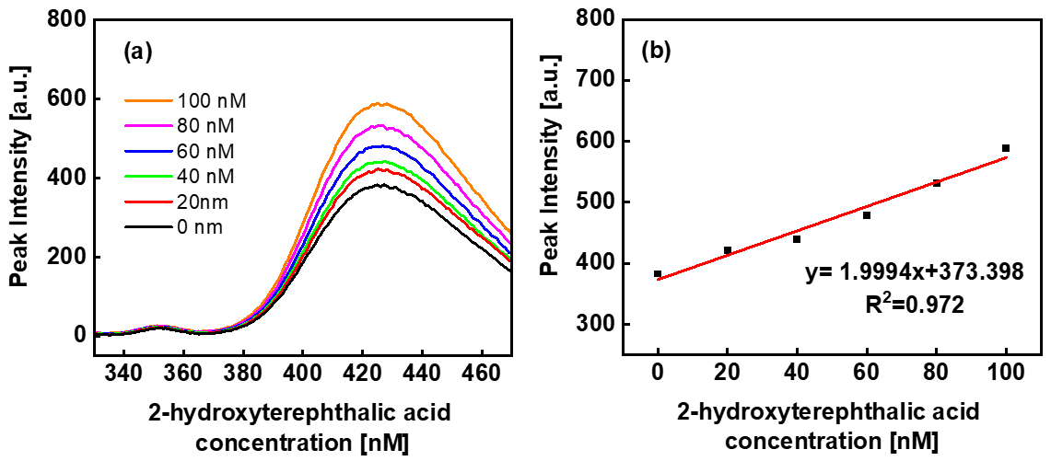
Fig. S5. Fluorescence spectra (a) and the resulting calibration curve (b) for 2-hydroxyterephthalic acid in alkaline aqueous solution with NaOH (2.5 × 10⁻³ mol) and phosphate buffer including KH₂PO₄ (2.2 × 10⁻³ mol) / Na₂HPO₄ (3.5 × 10⁻³ mol). The fluorescence of each solution was measured using a Perkin-Elmer Cary Eclipse Fluorescence spectrophotometer, employing an excitation wavelength of 315 nm and an analyzing wavelength of 425 nm; the emission wavelength ranged from 330 to 470 nm with a 10 nm excitation slit and a 10 nm emission slit, at a data acquisition rate of 600 nm per minute.
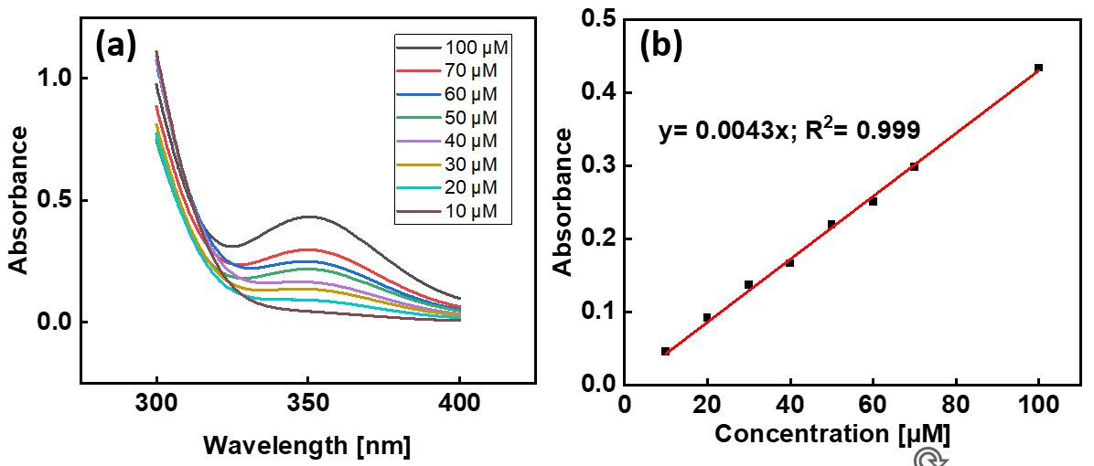
Fig. S6. (a) UV spectra from a standard solution and (b) the resulting plot of absorbance at 350 nm against standard solution concentration, which serves as the calibration curve for iodometric tests on standard solutions of hydrogen peroxide (10 – 100 μM, prepared from a 30% w/w stock solution of hydrogen peroxide in water). 600 μL of each standard solution was combined with 3 mL of potassium iodide solution (0.1 M) and 60 μL of ammonium molybdate solution (0.01 M) in a quartz cuvette. After five minutes the mixture was analysed by UV-vis (Agilent Cary 60 UV-vis spectrometer), and the absorbance at 350 nm was recorded.

