Room Temperature Electro-carboxylation of Styrene and Stilbene Derivatives: A Comparative Study

Nada Alhathlaul^{a,b}, Zeliha Ertekin^{a,c}, Stephen Sproulesª and Mark D. Symesª*

a. WestCHEM, School of Chemistry, University of Glasgow, G12 8QQ Glasgow, UK.
b. Chemistry Department, College of Science, Jouf University, P.O. BOX:2014, Sakaka, Saudi Arabia
c. Hacettepe University, Faculty of Science, Department of Chemistry, Beytepe, 06800 Ankara, Turkey.

*Corresponding Author: mark.symes@glasgow.ac.uk

1. Abstract
The use of carbon dioxide as a comparatively cheap, abundant and non-toxic C-1 synthon is a topic of considerable interest and importance. The electrochemical addition of carbon dioxide across carbon-carbon double bonds is one of the more promising of such procedures, offering the possibility to convert a range of alkene substrates to valuable carboxylated products. However, much remains unknown about both the mechanism of reaction and how to influence product specificity during electro-carboxylation of alkenes. Herein, we explore the electrochemical addition of carbon dioxide (1 atm) to a range of olefinic substrates using nickel working electrodes and magnesium anodes at room temperature, producing the mono-substituted carboxylate derivatives preferentially (with no formation of the Markovnikov isomers of these mono-substituted carboxylate derivatives when the starting materials are non-symmetrical). These findings are rationalized using both experimental and computational methods, suggesting that the choice of Ni as a working electrode is critical in determining the reaction outcomes that are observed. Moreover, we also present direct evidence that a pathway whereby the alkene substrates are first reduced at the electrode surface and then react with dissolved CO₂ is operating. Together, these results offer the potential for selective access to a range of valuable mono-carboxylic acids via the reduction of the corresponding alkene precursors in the presence of carbon dioxide.

2.1. Materials: Materials that are readily available for purchase (including supporting electrolytes, solvents, and alkenes) were used without undergoing any additional purification steps. Styrene (99% purity), α-methyl styrene (99% purity), trans-β-methyl styrene (97% purity), cis-β-methyl styrene (>98% purity), 1,1-diphenylethylene (98% purity), trans-stilbene (98% purity) and cis-stilbene (97% purity) were purchased from commercial sources and used as received. All the alkenes used in this study were purchased from Alfa Aesar, with the exception of Z-β-methyl styrene which was procured from TCI. The solvent used in this study, N,N-dimethylformamide, anhydrous, 99.8% purity, was obtained from Alfa Aesar and packaged under Argon. The supporting electrolyte, tetrabutylammonium hexafluorophosphate (nBu₄NPF₆, 98% purity) at a concentration of 0.1 M, was purchased from ThermoFisher Scientific. Carbon dioxide, with a purity of 99%, was purchased from BOC Ltd.

2.2. Electrochemical procedures: A BioLogic SP-150 potentiostat was employed for all cyclic voltammetry and chronopotentiometry experiments. The electrochemical carboxylation of the alkenes was conducted using a one-compartment electrochemical cell with five necks (see Figure 1). The electrodes were situated in three of these necks, while the remaining two were designated for the gas inlet and outlet channels. The reference electrode utilized was a saturated calomel electrode (CHI150, supplied by IJ Cambria Scientific Ltd), and the counter electrode (anode) was a magnesium rod measuring 6.35 mm in diameter and 25.4 mm in length, at a purity of 99.95% (metal basis) from Alfa Aesar. A nickel disc (BASi, 3.0 mm diameter) or a nickel mesh (0.35 × 2 cm², woven wire, 60 mesh, made from 0.18 mm wire, supplied by Alfa Aesar) were used as the working electrodes for cyclic voltammetry and bulk electrolysis respectively.

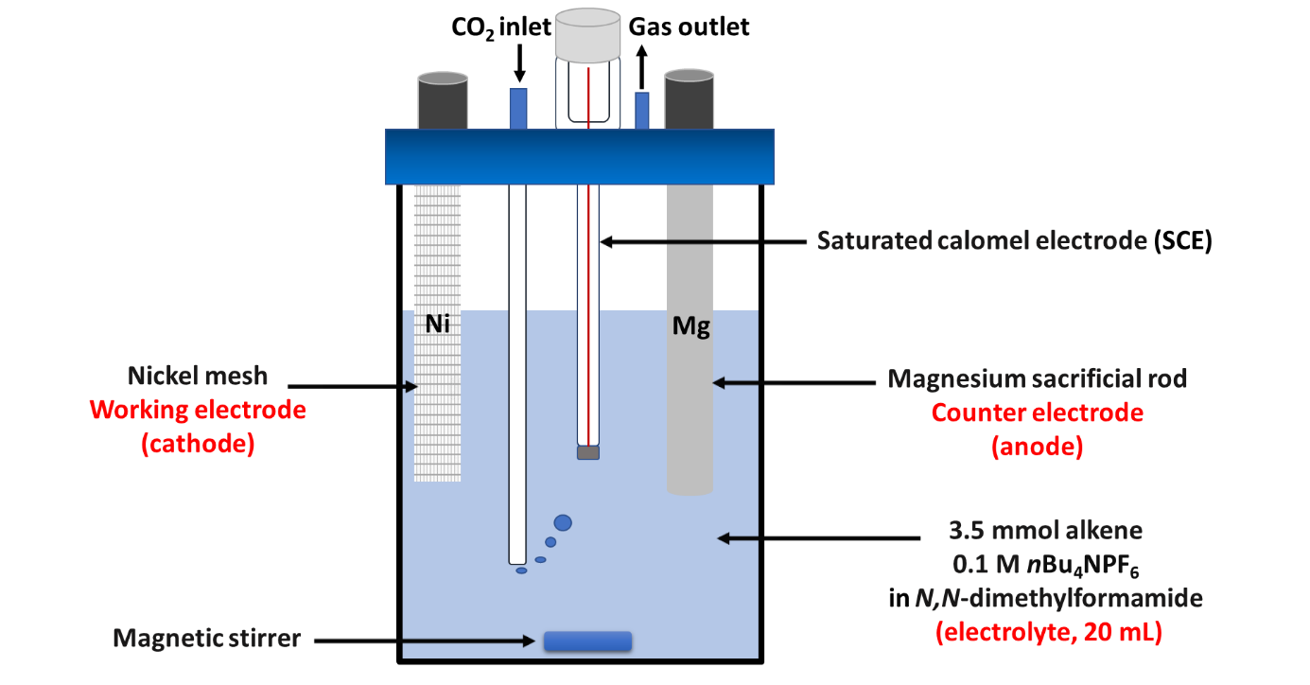
Figure 1: An illustration of the cell set-up for both cyclic voltammetry and bulk electrolysis in this study.

Prior to bulk electrolysis, the Ni mesh was sonicated in a sonication bath in 2 M HCl for 20 minutes and then rinsed with DMF. Meanwhile, the magnesium rod was sonicated in a sonication bath in DMF for 20 minutes. Both electrodes were then allowed to dry in the air. Bulk electrolysis was then initiated at room temperature (20 °C) with stirring under a constant stream of CO₂. In all cases, the electrolyte consisted of 0.1 M nBu₄NPF₆ in anhydrous N,N-dimethylformamide (volume = 20 mL). Into this volume of electrolyte, 3.5 mmol of alkene substrate was dissolved, giving a concentration of alkene substrate in the electrolyte of 0.175 M. For all bulk electrolyses, a fixed current of −35 mA was applied to the working electrode for 8 hours (corresponding to the passage of 3 F of charge relative to the number of moles of alkene present). The voltage required to deliver such currents was typically within the range −3 to −5.5 V vs SCE.
All cyclic voltammetry was performed under the same conditions and in the same cell as for bulk electrolysis, except using a Ni disc button working electrode (BASi, 3mm diameter). Cyclic voltammograms were recorded under Ar and under CO₂ for comparison (in both cases after bubbling for 20 minutes). The working electrode was polished between experiments. Cyclic voltammetry was recorded at a scan rate of 10 mV/s over the range 0 V to −3 V vs. SCE, starting from 0 V.

2.3. Workup procedure: The following procedure was adopted after bulk electrolysis for all the alkenes investigated. Firstly, the resulting electrolyte solution was placed in a round-bottomed flask, and the electrochemical cell and electrodes were washed with DMF and these rinsings added to the round-bottomed flask. The solvent was then removed under vacuum using a rotary evaporator. To the resulting residue was added 10 mL of 2.0 M hydrochloric acid (HCl) and the mixture stirred at room temperature for a duration of 3 hours. The purpose of this step was to fully protonate any carboxylic acids present, in order to facilitate their extraction into organic media. In the case of α-methyl styrene, cis-β-methyl styrene, and cis-stilbene, it was found that sonication for 30 minutes in an ice-filled sonication bath aided with breaking up the residue after addition of the HCl. After sonication, these mixtures were then stirred at room temperature for a duration of 3 hours as above. In all cases, the resulting mixture was then subjected to three successive extractions using diethyl ether, each with a volume of ether of 20 mL. It was found that chilling the aqueous phase prior to extraction was beneficial for improving the yield of products in the organic phase. The combined diethyl ether fractions were then combined and subjected to washing with saturated sodium chloride (brine solution). The organic phase was then dried using magnesium sulfate, filtered through filter paper, and evaporated using a rotary evaporator. Finally, the resulting solution was analyzed using nuclear magnetic resonance (NMR) spectroscopy. NMR spectra were recorded at room temperature using a Bruker 400 MHz NMR spectrometer. The products were dissolved in CDCl₃ for analysis. The analysis procedure is summarized in Figure 2.
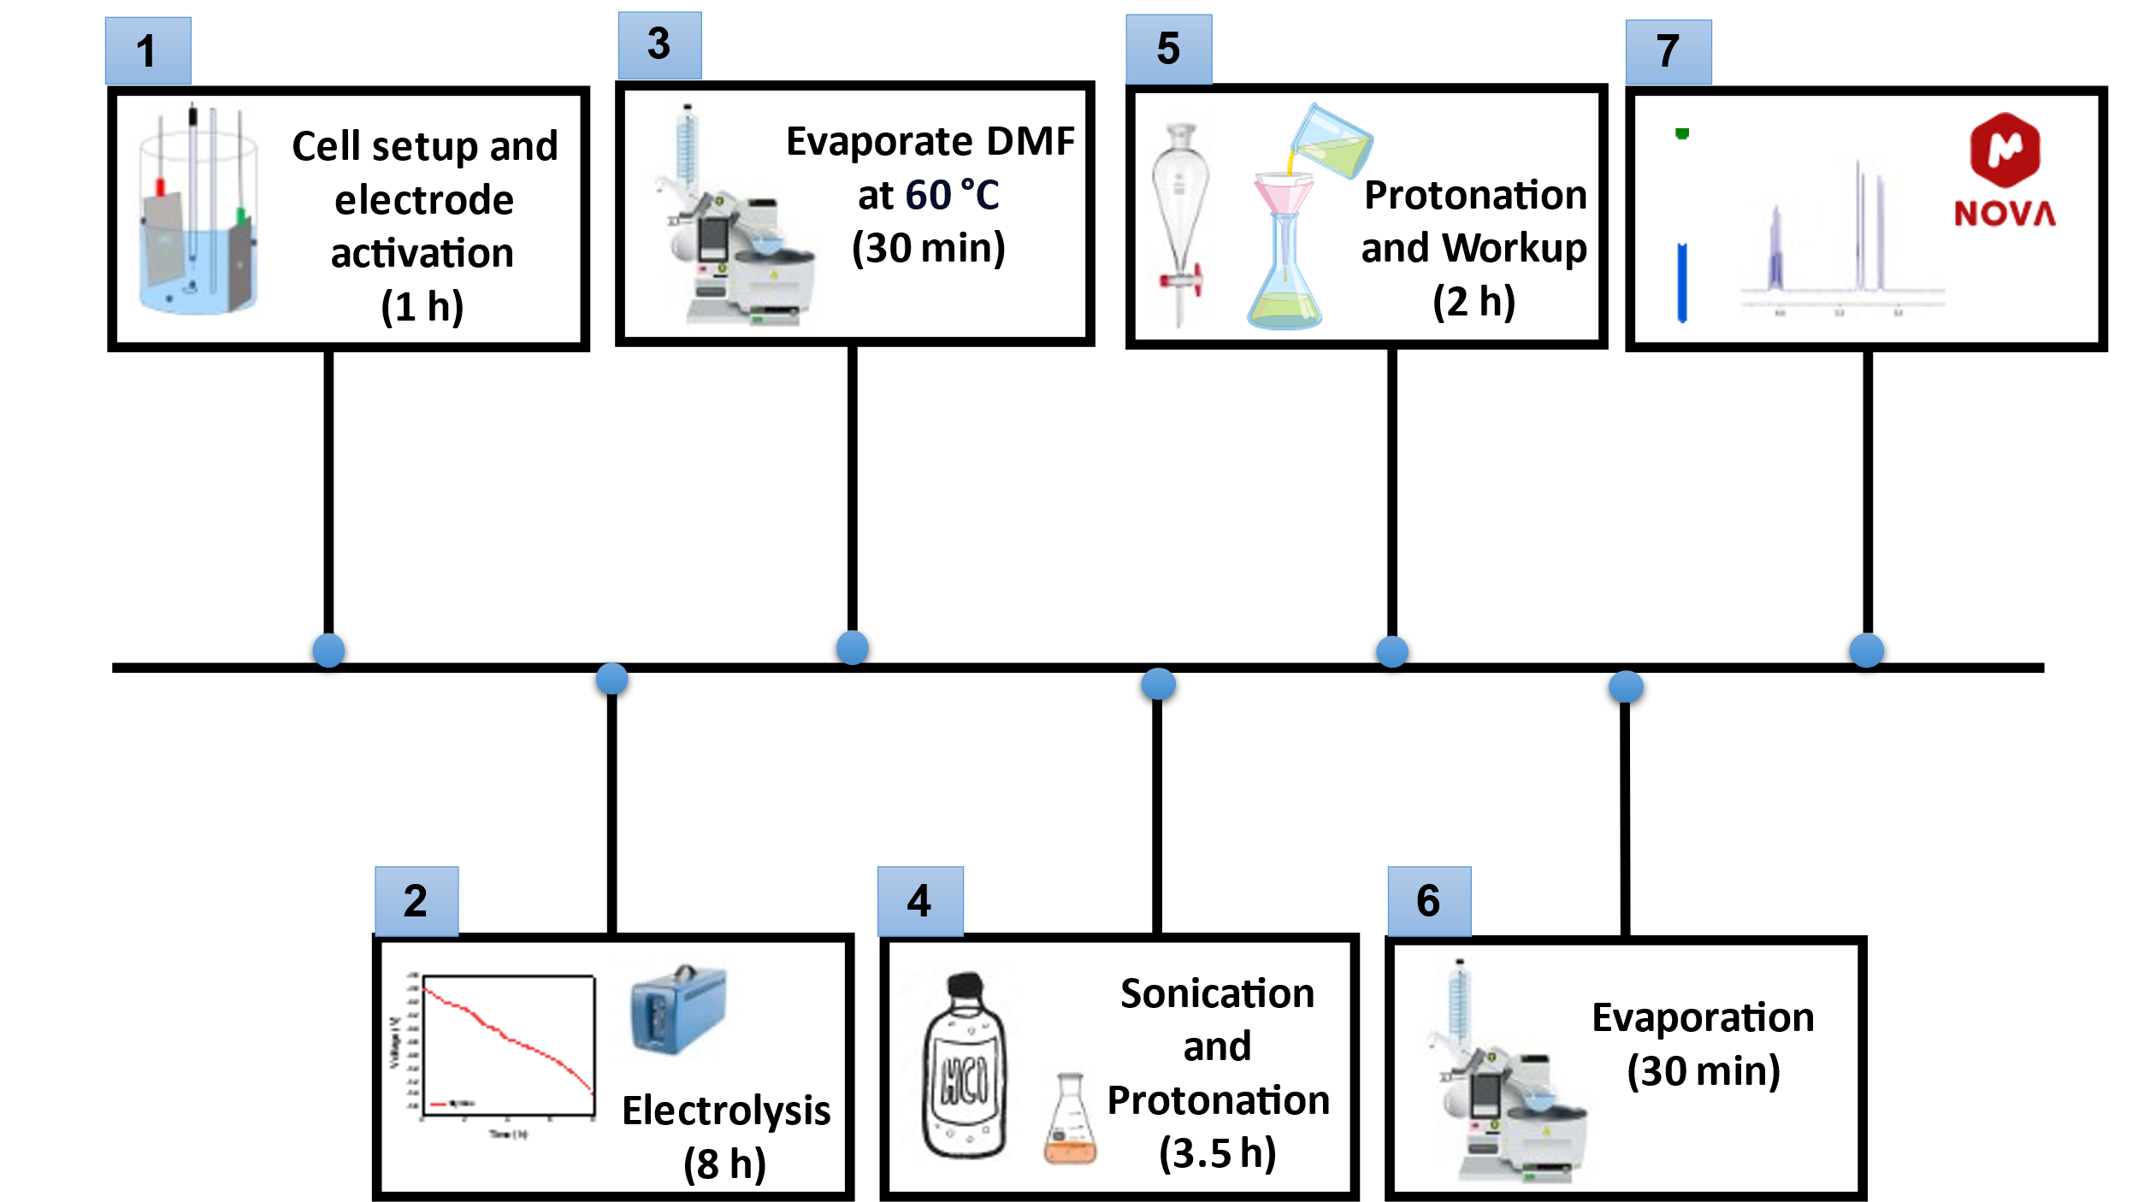

Figure 2: An illustration of the extraction and analysis procedure used to isolate the products of electrolysis in this study.

2.4. Computational details: The program package ORCA was used for density functional theory (DFT) calculations [16]. Geometry optimization employed the hybrid meta-generalized gradient approximation M06-2X functional [17]. The def2-TZVP basis set was used for all atoms [18, 19]. Auxiliary basis sets used to expand the electron density in the calculations were chosen to match the orbital basis. The RIJCOSX algorithm was used to speed the calculation of Hartree–Fock exchange [20, 21]. Solvation was incorporated using the Conductor-like Polarizable Continuum Model (C-PCM) with infinite continuum [22]. The self-consistent field calculations were tightly converged (1 × 10^{–8} E_{h} in energy, 1 × 10^{–7} E_{h} in the charge density, and 1 × 10^{–7} in the maximum element of the DIIS [23, 24] error vector). The geometry was converged with the following convergence criteria: change in energy <10^{–5} E_{h}, average force <5 × 10^{–4} E_{h} Bohr^{–1}, and the maximum force 10^{–4} Eh Bohr^{–1}. The geometry search for all complexes was carried out in redundant internal coordinates without imposing geometry constraints. Molecular orbitals and charge density maps were visualized via the program Molekel [25].

2.5. Physical characterisation: X-ray diffraction (XRD) analysis was performed using a Rigaku Mini Flex instrument with CuKα radiation. The scanning diffraction angle 2θ range was from 5° to 80° at a speed of 5° per minute. The morphology of the nickel mesh electrodes was analyzed using a Zeiss Sigma variable-pressure field-emission scanning electron microscope (FESEM) in the Geoanalytical Electron Microscopy and Spectroscopy (GEMS) facility at the School of Geographical and Earth Sciences, University of Glasgow. The untreated and treated Ni samples were placed on sample holders and a gold layer was applied for SEM imaging, while a carbon coating was utilized for EDX analysis to enhance electrical conductivity.

[17] Zhao, Y., & Truhlar, D. G. Construction of a Generalized Gradient Approximation by Restoring The Density-Gradient Expansion and Enforcing a Tight Lieb–Oxford Bound. The Journal of chemical physics, 128 (18) (2008).‏
[18] Weigend, F., & Ahlrichs, R. Balanced Basis Sets of Split Valence, Triple Zeta Valence and Quadruple Zeta Valence Quality for H to Rn: Design and Assessment of Accuracy. Physical Chemistry Chemical Physics, 7 (18), 3297-3305 (2005).‏
[19] Pantazis, D. A., Chen, X. Y., Landis, C. R., & Neese, F. All-Electron Scalar Relativistic Basis Sets for Third-Row Transition Metal Atoms. Journal of chemical theory and computation, 4 (6), 908-919 (2008).
[20] Izsák, R., & Neese, F. An Overlap Fitted Chain of Spheres Exchange Method. The Journal of chemical physics, 135 (14) (2011).
[21] Neese, F., Wennmohs, F., Hansen, A., & Becker, U. Efficient, Approximate and Parallel Hartree–Fock and Hybrid DFT Calculations. A ‘Chain-of-Spheres’ Algorithm for The Hartree–Fock Exchange. Chemical Physics, 356 (1-3), 98-109 (2009).
[22] Barone, V., & Cossi, M. Quantum Calculation of Molecular Energies and Energy Gradients in Solution by a Conductor Solvent Model. The Journal of Physical Chemistry A, 102 (11), 1995-2001 (1998).
[23] Pulay, P. Convergence Acceleration of Iterative Sequences. The Case of SCF Iteration. Chemical Physics Letters, 73 (2), 393-398 (1980).
[24] Pulay, P. Improved SCF convergence acceleration. J. Comput. Chem., 3 (4), 556-560 (1982).‏
[25] Molekel, Advanced Interactive 3D-Graphics for Molecular Sciences, Swiss National Supercomputing Centre. https://ugovaretto.github.io/molekel/ (accessed August 2023)
‏Click or tap here to enter text.

