Optimising the Electrochemical Reduction of CO₂ to Oxalic Acid in Propylene Carbonate

Halilu Sale^{1,2}, Gangi Reddy Ubbara¹, Mark D. Symes¹*
1. WestCHEM, School of Chemistry, University of Glasgow, G12 8QQ Glasgow, UK.
2. Energy Commission of Nigeria, Plot 701c Garki-Abuja, Nigeria

*Corresponding Author: Mark.Symes@glasgow.ac.uk

Abstract
Carbon dioxide (captured from the atmosphere or obtained by other routes) constitutes a useful and widely available building block for producing numerous valuable chemicals and fuels. Electrochemical methods for carbon dioxide reduction offer advantages in terms of scalability, the prospect of coupling directly to renewable power sources and the ability to reduce carbon dioxide without the co-production of harmful by-products. Of the various possible products of carbon dioxide electroreduction, oxalate/oxalic acid is an especially attractive target because of its wide use in many chemical and pharmaceutical processes. Herein, we report the results of a study on carbon dioxide electroreduction to oxalate/oxalic acid in a propylene carbonate solvent system, catalysed by the addition of benzonitrile. Our results show that the use of benzonitrile as a homogeneous electrocatalyst improves the Faradaic and reaction yields of oxalate/oxalic acid production, as well as the area-normalised rate of formation of oxalate/oxalic acid, giving a new record rate of formation of 1.65 ± 0.35 mM cm⁻² h⁻¹ (averaged over 1 h) at a voltage of ‒2.7 V vs SCE (‒2.46 V vs SHE). Such metrics in turn suggest that the electrochemical reduction of carbon dioxide to C₂₊ products via oxalate could be a promising avenue for further development for the sustainable production of key chemical feedstocks.

Experimental Section
Materials: The following materials were obtained from their respective suppliers and used without further purification: anhydrous propylene carbonate (C₄H₆O₃, Sigma-Aldrich, 99.7%), tetraethylammonium chloride (C₈H₂₀ClN, Sigma-Aldrich, 99.0%), sulfuric acid (H₂SO₄, Fisher Chemical, 95.0%), lead wire (Pb, Alfa Aesar, 1.0 mm diameter, 99.99% metals basis), lead rod (Pb, Alfa Aesar, 5 mm diameter, 99.99% metals basis), platinum wire (Pt, Alfa Aesar, 1.0 mm diameter, 99.99%), platinum foil (Pt, Alfa Aesar, 0.25 mm, 99.99% metals basis), anhydrous benzonitrile, (C₇H₅N, Sigma-Aldrich, 99%), Nafion membrane (Nafion-117, manufactured by Fuel Cell Store). Argon and CO₂ were supplied by BOC (99.99%).
Cyclic Voltammetry (CV): The cyclic voltammetry measurements were performed at 25 °C in single cells, using a Pb wire working electrode (area = 0.64 cm²), a saturated calomel reference electrode (SCE) and a Pt wire counter electrode. After setting up the cell as depicted in Figure S1 in the Supporting Information, the electrolyte was purged with argon (Ar) for 20 minutes to remove any dissolved oxygen before running the cyclic voltammetry measurements using a CHI potentiostat. This control experiment was followed by purging with CO₂ for another 20 minutes before another reading was taken to note the difference in the cyclic voltammograms resulting from a CO₂-saturated atmosphere. To evaluate the influence of benzonitrile on CO₂ reduction in the organic solvent, 2 mM benzonitrile was added to the electrolytic solution and further purged with CO₂ for another 20 minutes. Cyclic voltammetry was then performed. Concentrations of benzonitrile of 1 mM, 2 mM, 4 mM, 6 mM, 8 mM and 10 mM were probed; however, only very modest changes were observed in the voltammograms when the quantity of benzonitrile was increased beyond 2 mM (see Supporting Information, Figure S2), and so 2 mM concentrations were employed throughout the results presented below.
Chronoamperometry: Chronoamperometric experiments (bulk electrolysis) were performed using a CHI potentiostat in a H-cell having two compartments for the anolyte and catholyte separated by a Nafion 117 membrane as shown in Figure 1. The working electrode for bulk electrolysis (Pb rod, surface area = 3.5 cm²) and reference electrode (SCE) were placed in the catholyte (0.2 M tetraethylammonium chloride in propylene carbonate) while the counter electrode (platinum foil) was placed in the anolyte (0.5 M H₂SO₄). Bulk electrolysis was conducted at 25 °C for 5 h. To compare the outcome with the previously reported findings made with different reference electrodes, the potentials measured against SCE in this work were converted to the standard hydrogen electrode (SHE) scale using the equation E_{(SHE)} = E_{(calomel)} + E_{(SHE ‒ calomel)},⁴¹ while the potentials reported in other similar research against Ag/AgCl and other reference electrodes were also converted to SHE accordingly.^{41,42}

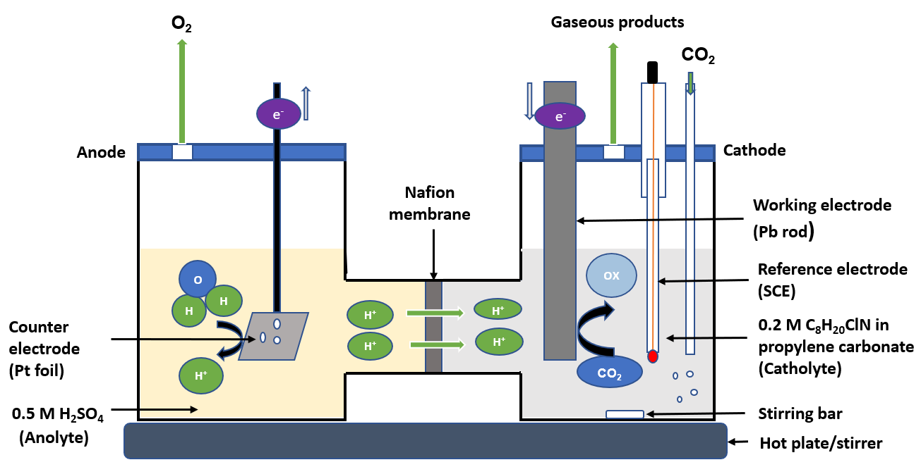
Figure 1: A schematic diagram of the H-cell used for bulk electrolysis of CO₂ in 0.2 M tetraethylammonium chloride and propylene carbonate. The righthand compartment of the cell is the catholyte where the working electrode (Pb rod with a surface area of 3.5 cm²) and a reference electrode (SCE) were placed, while the lefthand side contains the anolyte where the counter electrode (platinum foil with a surface area of 4 cm²) was placed. The two compartments are separated by Nafion membrane. The reaction was conducted at a temperature of 25 °C for 5 hours.

Figure 1 shows the configuration of the H-cell setup. Prior to each experiment, the Pb electrode was polished with sandpaper followed by sonicating in acetone for about 10 minutes, then rinsed with anhydrous propylene carbonate and dried under argon to remove any film of lead oxide impurities or moisture on the surface. The working electrode with a total surface area of 3.5 cm² was immersed in 40 mL of the catholyte while the counter electrode having a total surface area of 4 cm² was immersed in 40 mL of the anolyte solution. The cathodic compartment was then purged with Ar for 20 minutes to remove any dissolved oxygen, followed by purging with CO₂ for additional 20 minutes to saturate the electrolyte with CO₂ before commencing the chronoamperometric measurements under a constant supply of CO₂. Chronoamperometry was carried out in a closed cell at a range of applied potentials for 5 hours at each potential, starting from −2.2 V and ranging to −2.7 V (vs SCE) for both (1) 0.2 M tetraethylammonium chloride in propylene carbonate and (2) 0.2 M tetraethylammonium chloride in propylene carbonate with 2 mM benzonitrile. During the electrolysis, samples of the electrolyte solution were taken every hour for analysis of the products. The products were analysed by high-performance liquid chromatography (HPLC) using an Aminex HPX-87H, 300 mm × 7.8 mm column and an example chromatogram showing the peak intensity for a catalysed and uncatalysed sample at an applied potential of −2.2 (V vs. SCE) is depicted in Figure S3 (Supporting Information). The mobile phase used was 0.1% formic acid in HPLC grade acetonitrile and 0.1% formic acid in water in a ratio of 30:70 respectively. The HPLC machine was set at a flow rate of 0.6mL/min, at a temperature of 55 ºC, a pressure of 61.5 bar and a detector wavelength of 210 - 230 nm. Standard calibration curves were developed to determine the concentration of the main products (oxalic, glyoxylic, and glycolic acids) produced in the unknown samples. These calibration curves are shown in Figure S4 (Supporting Information).

