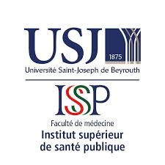

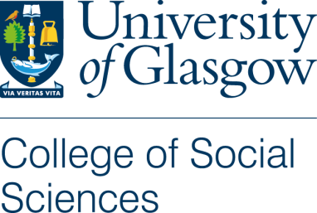

Participant Information Sheet
Title of Project: | How can we improve medical care in Lebanon?
Name of Researcher: | Molly Gilmour
Supervisors: | Dr. Chris Bunn, Dr Mia Perry and Prof. Kate O Donnell
Research Partner: | AMEL Association International

Invitation:

You are being invited to take part in a research study. Before you decide it is important for you to understand why the research is being done and what it will involve. Please take time to read the following information carefully and discuss it with others if you wish. Ask me if there is anything that is not clear or if you would like more information. Take time to decide whether or not you wish to take part.

Thank you for reading this.

What’s the purpose of the research study?
This study forms part of a doctoral research project on humanitarian healthcare in Lebanon. The main purpose of this study is to explore interactions and relationships of service users and service providers in medical aid clinics in Lebanon, and how we may be able to work together to improve humanitarian medical care. The aim is to understand more how people define effective and culturally appropriate humanitarian medical care.

Do I have to participate?

Your participation in this study is entirely voluntary. If you choose to participate, you have the right to withdraw at any time without providing a reason. In the event that you decide to withdraw, discussions will be held with you on how, if at all, any existing data will be used

What’s involved if I participate?

I hope that you will not only be involved in providing data for this study but will also help shape the research study design and activities. This will mean that your knowledge and expertise will help strengthen the design and customise it to suit you. The activities will be carried out either in English or Arabic, depending on the proficiency and preference of the participants.

Codevelopment Group
I will work with you and eight to twelve other people (as two groups, either medical service provider or service users) for approximately six to eight sessions of 1 - 2 hours. The purpose of the group is to analyse the social and cultural structures within the medical aid organisations, and we could make improvements to the service.. Every session will end with an opportunity to register for the next session, as an open opt in/opt out option for participation. Photographs will be taken of the material outputs of the codevelopment group.

Will my participation be anonymous and confidential?

Your participation will only be known to me, the PhD researcher, translator and others in the codevelopment group. I will audio-record the codevelopment group, but these recordings will only be heard by me, the PhD researcher, the translator and my supervisors. When I transcribe the codevelopment group recording, your real names will be replaced with unique code numbers and at the end of the research study the document linking your name to the code number will be destroyed making it anonymous. All other documents with any of our personal details will be destroyed at the end of the study.
In any publications coming from this research, you will be referred to as a pseudonym.
Please note that confidentiality will be maintained as far as it possible, unless during our conversation I hear anything which makes me worried that someone might be in danger of harm, I might have to inform relevant agencies of this.

What will happen to the data collected?

Codevelopment Group: The material outputs from the codevelopment group will be stored in a locked cupboard and seen only by those involved with this research projects codevelopment group. Throughout the data collection and analysis process, the outputs will be digitized and stored securely on an encrypted laptop. Only the PhD researcher, Molly and I, will be able to access it and it will only be shared with the supervision team.

If you would like, I will keep a note of your name and contact information to be able to communicate with you in matters relating to this project (for example, to share any findings with you) but this contact information will be stored separately from the data.
You will be able to withdraw your personal data (name, contact details) at any time. You will be able to withdraw your participation until January 2022.
The audio-recordings will be destroyed within one year of completion of the study.
The anonymised data (i.e. transcriptions and notes without names or other identifiers) will be stored in the University of Glasgow repository for 10 years after the end of the study and will be available to other researchers with restricted access.

What will happen to the results of this study?

Data that is created in this research will be used for this doctoral research; outputs are expected to be in the form of a thesis, conference paper, journal article, it may contribute to a section of a book and possibly be written in blog form. Photographs will be taken of the material outputs and may be used for publication. All personal identifiers will be removed for publication.

What should I do if I have concerns about this study?

This research study has been approved by the University of Glasgow College of Social Sciences Research Ethics Committee and has been given clearance by Saint Joseph University Beirut. However, if you have any concerns about how this research is being carried out please contact me directly or, if you prefer, contact the University of Glasgow Social Sciences Ethics Officer, Dr Muir Houston.

University of Glasgow College of Social Sciences Ethics Officer, Dr Muir Houston, email: Muir.Houston@glasgow.ac.uk

