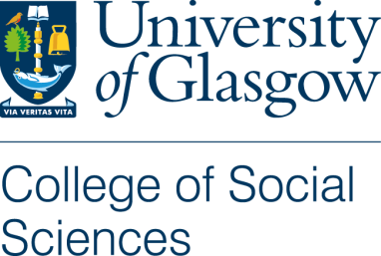
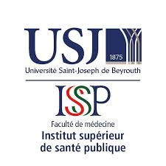
Consent Form: Codevelopment Group

Title of Project: How can we improve medical aid provision in Lebanon?
Name of Researcher: Molly Gilmour

I confirm that I have read and understood the Participant Information Sheet for the above study and have had the opportunity to ask questions.

I understand that my participation is voluntary and that I am free to withdraw at any time, without giving any reason.

I consent / do not consent to codevelopment groups being audio-recorded.

I consent / do not consent to codevelopment outputs being photographed.

I acknowledge that participants will be referred to by pseudonym.

Data Usage
- All names and other material likely to identify individuals will be anonymised.
- The material will be treated as confidential and kept in secure storage at all times.
- The material will be destroyed once the project is complete.
- The material may be used in future publications, both print and online.
- I agree to waive my copyright to any data collected as part of this project.
- I understand that other authenticated researchers will have access to this data only if they agree to preserve the confidentiality of the information as requested in this form.
- I understand that other authenticated researchers may use my words in publications, reports, web pages, and other research outputs, only if they agree to preserve the confidentiality of the information as requested in this form

I agree to take part in this research study

I do not agree to take part in this research study

Name of Participant ………………………………………… Signature ……………………………………………………..

Date ……………………………………

Name of Researcher ………………………………………………… Signature ……………………………………………………..

Date ……………………………………

