Data Set Information Sheet: An Efficient Deep Learning-based Spectrum Awareness Approach for Vehicular Communication

GENERAL INFORMATION

Title of Dataset
An Efficient Deep Learning-based Spectrum Awareness Approach for Vehicular Communication

Author Information
Names: Mr Syed Basit Ali Zaidi, Mr Mahmoud Shawky, Dr Ahmad Taha, Dr Qammer Abbasi, Professor Muhammad Ali Imran, and Dr Shuja Ansari
Institution: University of Glasgow
Address: James Watt School of Engineering, College of Science and Engineering, University of Glasgow, Glasgow, G12 8QQ
Emails: s.zaidi.2@research.gla.ac.uk; m.shawky.1@research.gla.ac.uk ; Ahmad.Taha@Glasgow.ac.uk;
Qammer.Abbasi@glasgow.ac.uk; Muhammad.Imran@glasgow.ac.uk; Shuja.Ansari@glasgow.ac.uk

Date of data collection:
The data was collected in the month of September 2022.

Geographic location of data collection:
Scotland 5G Centre, James Watt South Building, Glasgow, G12 8QQ, United Kingdom

Information about funding sources that supported the collection of the data:
NA

SHARING/ACCESS INFORMATION

Licenses/restrictions placed on the data:
NA

Links to other publicly accessible locations of the data:
NA

Was data derived from another source?
No
Recommended citation for this dataset: Basit A. Zaidi, Mahmoud A. Shawky, Ahmad Taha, Qammer H. Abbasi, Muhammad Ali Imran, and Shuja Ansari, “An Efficient Deep Learning-based Spectrum Awareness Approach for Vehicular Communication”.

DATA & FILE OVERVIEW

Details of Data Folders and Files
The dataset was divided into 4 classes, that is, a total of 33000 data samples, each represents a particular constellation type (see Table 1). The main data folder is subdivided into 4 folders corresponding to the 4 classes (see Figures and Table 1).
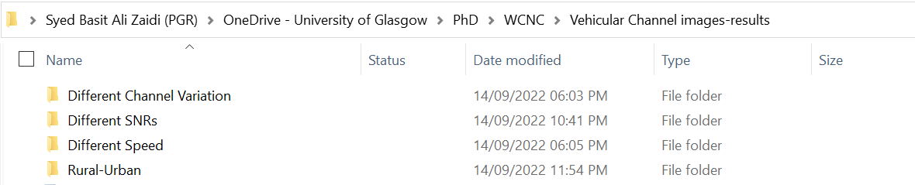
Figure 1 Data folder Structure

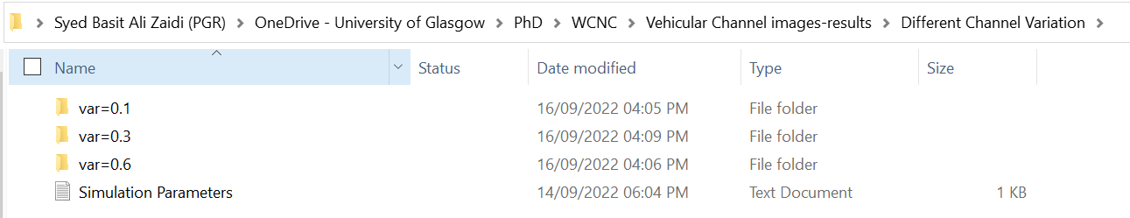
Figure 2 Data folder Structure

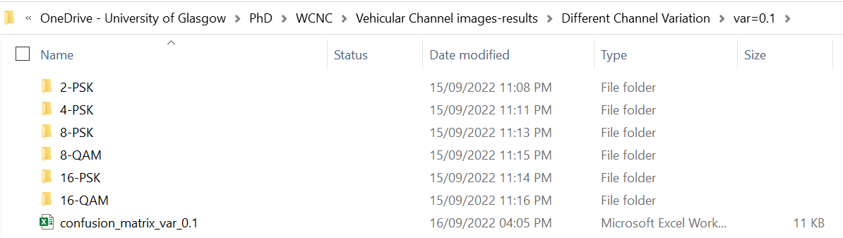
Figure 3 Data folder Structure

Table 1 Details of the Data Set (Folders, Files, Description, and Number of Samples)
Number of Folder | Folder Name | Class/File Name | Description | Number of Samples per Class
1 | Different Channel Variation | Var=0.1 | The received constellation points for different modulations for different channel variance i.e., 0.1,0.3,0.6 | 9000
 |  | Var=0.3
 |  | Var=0.6
2 | Different SNRs | SNR=15 | The received constellation points for different modulations for different channel SNRs i.e., 15,20,25 | 9000
 |  | SNR=20
 |  | SNR=25
3 | Different Speed | Speed=10 | The received constellation points for different modulations for different channel Speed i.e., 10,20,30 | 9000
 |  | Speed=20
 |  | Speed=30
4 | Rural-Urban | Rural | The received constellation points for different modulations for Rural and Urban | 6000
 |  | Urban

METHODOLOGICAL INFORMATION

Description of methods used for collection/generation of data:
The dataset represents spectrum monitoring and modulation classification techniques. For ultra-wideband spectrum monitoring, we use the start and stop frequencies to be 5.88 to 5.91 GHz, respectively. We use an OFDM communication system at fc = 5.9 GHz for the DSRC, with 256 subcarriers, 64 cyclic-prefix, and 125 subcarriers holding the transmitted data. Then, we use 2-PSK, 4-PSK, 8-PSK, 16-PSK, 8-QAM, and 16-QAM modulation and demodulation processes at the side of the transmitter and receiver, respectively. According to the modulation order, we acquired 150 training images with dimensions 273 × 328 pixels for each constellation type. Training samples for different constellations in the polar coordinates (in-phase and quadrature axes) are presented in Fig. 5. Based on the obtained data, the total training time was [74:13] minutes using Core-i7 CPU @ 2.7 GHz laptop with 16 GB RAM.
Figure 4 Implementation Block Diagram

Methods for processing the data:
Firstly, the USRP transmitter and receiver devices were configured to communicate together using the LabView to set parameters such as central frequency, number of Orthogonal Frequency Division Multiplexing (OFDM) subcarriers, and power levels (see Table 2).
Table 2 System Parameters
Parameter | Value
Central Frequency | 5.9 GHz
OFDM subcarriers | 256
Transmitter Gain (dB) | 30
Receiver Gain (dB) | 30

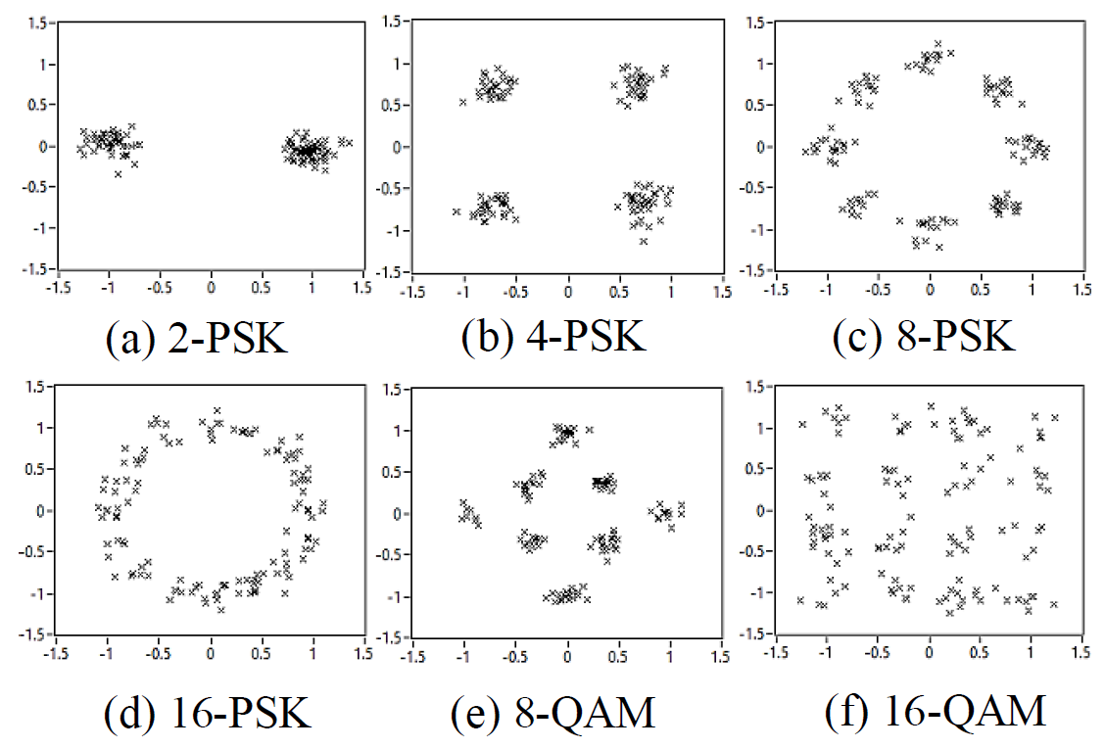
Figure 5 Training samples of different constellations

