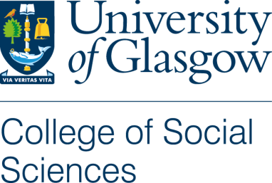
Consent Form
Relationship Experiences of Women with Disabilities in Georgia (Working title)
Name of Researcher: Anna Bochorishvili, PhD in Sociology; Email: a.bochorishvili.1@research.gla.ac.uk
Supervisors: Professor Nicholas Watson; Email: nicholas.watson@glasgow.ac.uk
Dr Francesca Stella; Email: Francesca.Stella@glasgow.ac.uk
- I confirm that I have read and understood the Plain Language Statement for the above study and have had the opportunity to ask questions.
- I understand that my participation is voluntary and that I am free to withdraw at any time, without giving any reason.
- I consent to interviews being audio-recorded.
- I acknowledge that participants will be referred to by pseudonym in any publications based on this data.
- All names and other material likely to identify individuals will be anonymised.
- The material will be treated as confidential and kept in secure storage at all times.
- The material will be retained in secure storage for use in future academic research
- The material, including the diagram (if any) may be used in future publications, both print and online.
I agree to take part in this research study
I agree to take part in this research study without creating the diagram
I do not agree to take part in this research study
Name of Participant …………………………………………
Signature ……………………………………………………..
Date ……………………………………
Name of Researcher …………………………………………………
Signature ……………………………………………………..
Date ……………………………………

