**Supporting Information for:**

**Highly Selective Electrocatalytic Reduction of Substituted Nitrobenzenes to their Aniline Derivatives using a Polyoxometalate Redox Mediator**

*Athanasios D. Stergiou, Daniel H. Broadhurst and Mark D. Symes\**

*WestCHEM, School of Chemistry, University of Glasgow, University Avenue, Glasgow, G12 8QQ, UK.*

*\*E-mail:* *mark.symes@glasgow.ac.uk*

**Experimental**

**1.1 General Experimental Remarks:** 1-bromo-4-nitrobenzene (98%), ethyl-4-nitrobenzoate (98%), 1-fluoro-2-nitrobenzene (99%), 2-nitrophenol (98%), 1-iodo-2-nitrobenzene (97%), 4-nitroacetophenone (98%), 1-fluoro-4-nitrobenzene (99%), 4-nitrobenzoic acid (99%) and 1-chloro-2-nitrobenzene (99%) were purchased from Alfa Aesar. 4-nitroanisole (97%), methyl-2-nitrobenzoate (>98%) and 2-nitrobenzonitrile (>98%) were purchased from Sigma Aldrich, while ethyl-3-nitrobenzoate (99%) was purchased from Fluorochem. Phosphotungstic acid (reagent grade) was supplied by both Sigma Aldrich and Alfa Aesar. Silicotungstic acid (reagent grade) was purchased from Sigma Aldrich. Chloroform (99.8%), acetone (99.5%) and phosphoric acid (85%) were purchased from Fisher Scientific. Dichloromethane (99.5%) and magnesium sulfate (99.2%) were purchased from VWR while diethyl ether (99.5%) was purchased from Scientific Laboratory Supplies Ltd. Deuterated chloroform (99.8%), dimethyl sulfoxide (99.9%) and methanol (99.8%) were supplied by Cambridge Isotope Laboratories. 254 µm-thick Nafion N-1110 membrane, used in the H-cells, was purchased from FuelCellStore and soaked in 1 M sulfuric acid solution overnight prior to use. Otherwise, all chemical reagents and solvents were used as purchased. Carbon felt, used as a high surface area electrode, was purchased from Alfa Aesar (3.18 mm thick, 99.0%). All electrolyte solutions were prepared with ultrapure deionised water (18.2 MΩ-cm resistivity), obtained froma Sartorius Arium Comfort combined water system. All NMR data were collected using a Bruker AV 400 instrument, at a constant temperature of 300 K. pH determinations were made with a Hanna HI 9025 waterproof pH meter. All other materials were obtained as stated in the text. Experiments performed at “room temperature” were carried out at 25 °C.

**1.2 General Electrochemical Methods:** Electrochemical studies were performed in a three-electrode configuration (unless otherwise stated) using either a CH Instruments CHI600D potentiostat or a BioLogic SP-150 potentiostat. A glassy carbon button electrode (surface area = 0.071 cm2) or carbon felt were used as the working electrodes (as specified), a Pt wire or a piece of carbon felt were used as the counter electrode (as specified), and an Ag/AgCl (NaCl, 3 M) reference electrode was used when specified. Glassy carbon working electrodes were polished using polishing powder and then washed with acetone and deionized water prior to use. Carbon felt electrodes were not re-used.

**1.3 Cyclic Voltammetry:** Cyclic voltammograms were collected in single chamber cells using a three-electrode set-up at room temperature at a scan rate of 10 mV/s (unless otherwise stated) in 1 M aqueous H3PO4 electrolyte. The solvent (10 mL) was thoroughly degassed with N2 prior to the experiments and kept under inert atmosphere throughout the process. Typically, to this degassed solvent was added 9.75 × 10–5 mol of the relevant nitroarene substrate (unless noted otherwise). To this solution, 1 equivalent mol of H3[PW12O40] (0.28 g) was then added in the electrochemical cell, followed by degassing and stirring for 5 min. A glassy carbon button electrode was used as the working electrode (area = 0.071 cm2), a Pt wire was used as the counter electrode and an Ag/AgCl (3 M NaCl) reference electrode was used. Measurements were conducted without stirring and with *i*R compensation enabled. The IUPAC convention was used when plotting the cyclic voltammograms.

**1.4 Electrocatalytic studies:** Electrocatalytic studies were performed as follows. Unless otherwise stated, 9.74 × 10–4 mol of the relevant nitroarene was added to 30 mL of a 3.3 mM aqueous solution of phosphotungstic acid (*i.e.* a 10 mol% ratio of phosphotungstic acid relative to the nitroarene). This solution was then placed into the working electrode compartment of an H-cell. For the less soluble nitroarenes (ethyl-2-nitrobenzoate, 4-nitroacetophenone, etc.) half this amount of starting material was used, *i.e.* 4.87 × 10–4 mol, but still with a 10 mol% ratio of phosphotungstic acid (1.65 mM) relative to the nitroarene. The counter electrode side of the cell was filled with 1 M aqueous H3PO4 electrolyte solution. The two compartments of the H-cell were separated by a Nafion N-1110 membrane (see Figure S1 for a representation of the electrolysis set-up). Typically, bulk electrolysis was then carried out at –0.38 V vs. Ag/AgCl under an inert atmosphere until substrate reduction was complete, as judged by the falling off of the current to background levels. The working and counter electrodes for bulk electrolysis were both rectangular strips of carbon felt (of dimension 3 × 2 cm) and an Ag/AgCl reference electrode was used.

After electrolysis for a given time, the (now dark blue) solution was removed from the working electrode compartment of the H-cell. The pH of this solution was then raised above the p*K*a value of the anticipated product using 1 M NaOH in order to deprotonate the R-NH3+ salt and form the neutral R-NH2 state. This in turn allowed the reduced organic product to be extracted into organic solvents for isolation. The pH values in question for the various conversions were: 2-nitrophenol to 2-aminophenol, pH = 6.0, 1-bromo-4-nitrobenzene to 4-bromoaniline, pH = 6.1, 2-nitrotoluene to 2-aminotoluene, pH = 5.7, 2-nitrobenzonitrile to 2-aminobenzonitrile, pH = 6.1, methyl-2-nitrobenzoate to methyl-2-aminobenzoate, pH = 3.5, 1-chloro-2-nitrobenzene to 2-chloroaniline, pH = 3.7, ethyl-4-nitrobenzoate to ethyl-4-aminobenzoate, pH = 5.0, 4-nitrobenzoic acid to 4-aminobenzoic acid, pH = 3.7, 4-fluoro-1-nitrobenzene to 4-fluoroaniline, pH = 6.3, 4-nitroacetophenone to 4-aminoacetophenone, pH = 4.0, 1-iodo-3-nitrobenzene to 3-iodoaniline, pH = 5.0 and ethyl-3-nitrobenzoate to ethyl-3-aminobenzoate, pH = 4.0.

Ethyl-4-aminobenzoate, ethyl-3-aminobenzoate and 3-iodoaniline were extracted using chloroform, 2-aminophenol was extracted using dichloromethane and 4-bromoaniline, 4-fluoroaniline, 2-aminotoluene, methyl-2-aminobenzoate, 2-aminobenzonitrile, 2-chloroaniline, 4-aminobenzoic acid and 4-aminoacetophenone were extracted using diethyl ether. In all cases, after extraction, magnesium sulfate was added to the organic phase in order to remove any remaining water. The organic phase was then filtered and concentrated under reduced pressure using a rotary evaporator to give the isolated reduced aniline derivatives.

**1.5 1H NMR determination of conversions:** After extraction into organic solvent and concentration under reduced pressure, the conversion of the starting material was determined *via* the integration of the relevant 1H NMR peaks. After the 1H NMR peaks in any given spectrum had been identified and assigned, peaks corresponding to the same number of protons in both the starting material and the various products were compared, allowing the percentage of starting material converted to each product (or not converted, and hence still present as starting material) to be determined.

**Electrolysis setup**

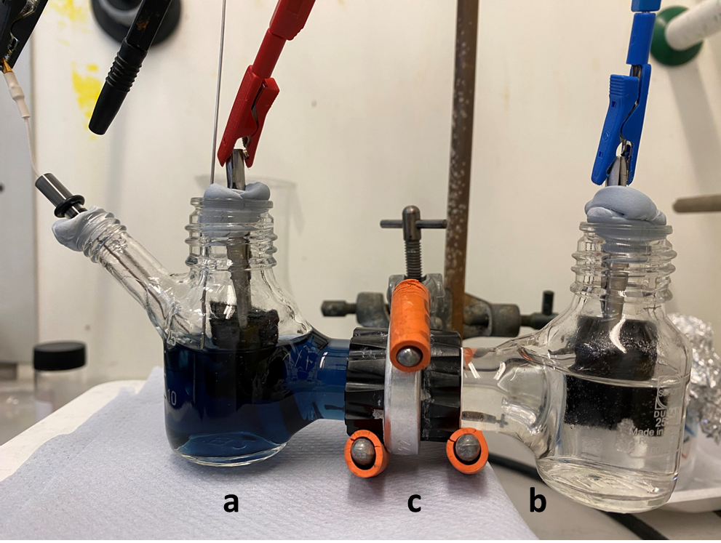

**Figure S1:** Image of the electrolysis set-up. a) working electrode side of the H-cell containing the working and reference electrode, the redox mediator and the starting material, b) counter electrode side of the H-cell containing the counter electrode and the electrolyte, and c) the Nafion membrane that separates the two compartments.

**Cyclic Voltammograms**



**Figure S2:** Cyclic voltammogram of the starting material 1-chloro-2-nitrobenzene in 1 M aqueous H3PO4, using 9.74 × 10–5 mol of both the nitroarene and the redox mediator. A glassy carbon working electrode (surface area = 0.071 cm2), a Pt wire counter electrode and a Ag/AgCl reference electrode were used. Scan rate 10 mV/s.



**Figure S3:** Cyclic voltammogram of the starting material 2-benzonitrile in 1 M aqueous H3PO4, using 9.74 × 10–5 mol of both the nitroarene and the redox mediator. A glassy carbon working electrode (surface area = 0.071 cm2), a Pt wire counter electrode and a Ag/AgCl reference electrode were used. Scan rate 10 mV/s.



**Figure S4:** Cyclic voltammogram of the starting material 2-nitrophenol in 1 M aqueous H3PO4, using 9.74 × 10–5 mol of both the nitroarene and the redox mediator. A glassy carbon working electrode (surface area = 0.071 cm2), a Pt wire counter electrode and a Ag/AgCl reference electrode were used. Scan rate 10 mV/s.



**Figure S5:** Cyclic voltammogram of the starting material 2-nitrotoluene in 1 M aqueous H3PO4, using 9.74 × 10–5 mol of both the nitroarene and the redox mediator. A glassy carbon working electrode (surface area = 0.071 cm2), a Pt wire counter electrode and a Ag/AgCl reference electrode were used. Scan rate 10 mV/s.



**Figure S6:** Cyclic voltammogram of the starting material 1-iodo-3-nitrobenzene in 1 M aqueous H3PO4, using 1.95 × 10–4 mol of starting material and 9.74 × 10–5 mol of the redox mediator. A glassy carbon working electrode (surface area = 0.071 cm2), a Pt wire counter electrode and a Ag/AgCl reference electrode were used. Scan rate 10 mV/s.



**Figure S7:** Cyclic voltammogram of the starting material 1-bromo-4-nitrobenzene in 1 M aqueous H3PO4, using 1.95 × 10–4 mol of starting material and 9.74 × 10–5 mol of the redox mediator. A glassy carbon working electrode (surface area = 0.071 cm2), a Pt wire counter electrode and a Ag/AgCl reference electrode were used. Scan rate 10 mV/s.



**Figure S8:** Cyclic voltammogram of the starting material 4-nitroacetophenone in 1 M aqueous H3PO4, using 9.74 × 10–5 mol of both the nitroarene and the redox mediator. A glassy carbon working electrode (surface area = 0.071 cm2), a Pt wire counter electrode and a Ag/AgCl reference electrode were used. Scan rate 10 mV/s.



**Figure S9:** Cyclic voltammogram of the starting material 1-fluoro-4-nitrobenzene in 1 M aqueous H3PO4, using 1.95 × 10–4 mol of starting material and 9.74 × 10–5 mol of the redox mediator. A glassy carbon working electrode (surface area = 0.071 cm2), a Pt wire counter electrode and a Ag/AgCl reference electrode were used. Scan rate 10 mV/s.



**Figure S10:** Cyclic voltammogram of the starting material 4-nitrobenzoic acid in 1 M aqueous H3PO4, using 1.95 × 10–4 mol of starting material and 9.74 × 10–5 mol of the redox mediator. A glassy carbon working electrode (surface area = 0.071 cm2), a Pt wire counter electrode and a Ag/AgCl reference electrode were used. Scan rate 10 mV/s.



**Figure S11:** Cyclic voltammogram of the starting material ethyl-4-nitrobenzoate in 1 M aqueous H3PO4, using 9.74 × 10–5 mol of both the nitroarene and the redox mediator. A glassy carbon working electrode (surface area = 0.071 cm2), a Pt wire counter electrode and a Ag/AgCl reference electrode were used. Scan rate 10 mV/s.



**Figure S12:** Cyclic voltammogram of the starting material methyl-2-nitrobenzoate in 1 M aqueous H3PO4, using 1.95 × 10–4 mol of starting material and 9.74 × 10–5 mol the redox mediator. A glassy carbon working electrode (surface area = 0.071 cm2), a Pt wire counter electrode and a Ag/AgCl reference electrode were used. Scan rate 10 mV/s.



**Figure S13:** Cyclic voltammogram of the starting material ethyl-3-nitrobenzoate in 1 M aqueous H3PO4, using 9.74 × 10–5 mol of both the nitroarene and the redox mediator. A glassy carbon working electrode (surface area = 0.071 cm2), a Pt wire counter electrode and a Ag/AgCl reference electrode were used. Scan rate 10 mV/s.

**NMR data**



**Figure S14:** Reduction of ethyl-3-nitrobenzoate.1H NMR spectra of the ethyl-3-nitrobenzoate starting material (A), a sample of pure ethyl-3-aminobenzoate (B), the spectrum of the electrocatalytic reaction medium after extraction and concentration (C) and the spectrum of the extracted and concentrated reaction medium from a direct (i.e. non-mediated) electrochemical reduction of ethyl-3-nitrobenzoate (D). All spectra were obtained in DMSO-d6.



**Figure S15:** Reduction of 1-chloro-2-nitrobenzene.1H NMR spectra of the 1-chloro-2-nitrobenzene starting material (A), a sample of pure 2-chloroaniline (B), the spectrum of the electrocatalytic reaction medium after extraction and concentration (C) and the spectrum of the extracted and concentrated reaction medium from a direct (i.e. non-mediated) electrochemical reduction of 1-chloro-2-nitrobenzene (D). All spectra were obtained in DMSO-d6.



**Figure S16:** Reduction of 2-nitrobenzonitrile.1H NMR spectra of the 2-nitrobenzonitrile starting material (A), a sample of 2-aminobenzonitrile (B), the spectrum of the electrocatalytic reaction medium after extraction and concentration (C) and the spectrum of the extracted and concentrated reaction medium from a direct (i.e. non-mediated) electrochemical reduction of 2-nitrobenzonitrile (D). All spectra were obtained in CDCl3.



**Figure S17:** Reduction of 1-bromo-4-nitrobenzene.1H NMR spectra of the 1-bromo-4-nitrobenzene starting material (A), a sample of 4-bromoaniline (B), the spectrum of the electrocatalytic reaction medium after extraction and concentration (C) and the spectrum of the extracted and concentrated reaction medium from a direct (i.e. non-mediated) electrochemical reduction of 1-bromo-4-nitrobenzene (D). All spectra were obtained in MeOD.



**Figure S18:** Reduction of 1-fluoro-4-nitrobenzene.1H NMR spectra of the 1-fluoro-4-nitrobenzene starting material (A), a sample of 4-fluoroaniline (B), the spectrum of the electrocatalytic reaction medium after extraction and concentration (C) and the spectrum of the extracted and concentrated reaction medium from a direct (i.e. non-mediated) electrochemical reduction of 1-fluoro-4-nitrobenzene (D). All spectra were obtained in CDCl3.



**Figure S19:** Reduction of 4-nitroacetophenone.1H NMR spectra of the 4-nitroacetophenone starting material (A), a sample of 4-aminoacetophenone (B), the spectrum of the electrocatalytic reaction medium after extraction and concentration (C) and the spectrum of the extracted and concentrated reaction medium from a direct (i.e. non-mediated) electrochemical reduction of 4-nitroacetophenone (D). All spectra were obtained in CDCl3.



**Figure S20:** Reduction of 4-nitrobenzoic acid.1H NMR spectra of the 4-nitrobenzoic acid starting material (A), a sample of 4-aminobenzoic acid (B), the spectrum of the electrocatalytic reaction medium after extraction and concentration (C) and the spectrum of the extracted and concentrated reaction medium from a direct (i.e. non-mediated) electrochemical reduction of 4-nitrobenzoic acid (D). All spectra were obtained in DMSO-d6.



**Figure S21:** Reduction of ethyl-4-nitrobenzoate.1H NMR spectra of the ethyl-4-nitrobenzoate starting material (A), a sample of ethyl-4-aminobenzoate (B), the spectrum of the electrocatalytic reaction medium after extraction and concentration (C) and the spectrum of the extracted and concentrated reaction medium from a direct (i.e. non-mediated) electrochemical reduction of ethyl-4-nitrobenzoate (D). All spectra were obtained in CDCl3.



**Figure S22:** Reduction of methyl-2-nitrobenzoate.1H NMR spectra of the methyl-2-nitrobenzoate starting material (A), a sample of methyl-2-aminobenzoate (B), the spectrum of the electrocatalytic reaction medium after extraction and concentration (C) and the spectrum of the extracted and concentrated reaction medium from a direct (i.e. non-mediated) electrochemical reduction of methyl-2-nitrobenzoate (D). All spectra were obtained in MeOD.



**Figure S23:** Reduction of 2-nitrophenol.1H NMR spectra of the 2-nitrophenol starting material (A), a sample of 2-aminophenol (B), the spectrum of the electrocatalytic reaction medium after extraction and concentration (C) and the spectrum of the extracted and concentrated reaction medium from a direct (i.e. non-mediated) electrochemical reduction of 2-nitrophenol (D). All spectra were obtained in DMSO-d6.



**Figure S24:** Reduction of 2-nitrotoluene.1H NMR spectra of the 2-nitrotoluene starting material (A), a sample of 2-aminotoluene (B), the spectrum of the electrocatalytic reaction medium after extraction and concentration (C) and the spectrum of the extracted and concentrated reaction medium from a direct (i.e. non-mediated) electrochemical reduction of 2-nitrotoluene (D). All spectra were obtained in MeOD.



**Figure S25:** Reduction of 1-iodo-3-nitrobenzene.1H NMR spectra of the 1-iodo-3-nitrobenzene starting material (A), a sample of 3-iodoaniline (B), the spectrum of the electrocatalytic reaction medium after extraction and concentration (C) and the spectrum of the extracted and concentrated reaction medium from a direct (i.e. non-mediated) electrochemical reduction of 1-iodo-3-nitrobenzene (D). All spectra were obtained in MeOD.

**Example Electrolysis Curve**

**Figure S26:** Example curve showing the bulk electrolysis of the nitroarene methyl-2-nitrobenzoate, where 0.088 g (4.87 × 10–4 moles) of the starting material were used together with 4.86 × 10–5 moles (10 mol%) of the polyoxometalate mediator in 30 mL electrolyte.



**Figure S27:** 1H NMR spectrum of2-aminophenol (Table 1, entry 1) from the electrocatalytic reaction medium after extraction and concentration. The spectrum was obtained in d6-DMSO. The peak at 3.5 ppm is water and the peak at 5.6 ppm is dichloromethane (from the extraction).

**Figure S28:** 1H NMR spectrum of4-bromo-aniline (Table 1, entry 2) from the electrocatalytic reaction medium after extraction, concentration, and purification. Spectrum was obtained in CDCl3.

**Figure S29:** 1H NMR spectrum of2-methylaniline (Table 1, entry 3) from the electrocatalytic reaction medium after extraction, concentration, and purification. Spectrum was obtained in MeOD. The water peak at 4.8 ppm overlays the amine N-H peak.

**Figure S30:** 1H NMR spectrum of2-aminobenzonitrile (Table 1, entry 4) from the electrocatalytic reaction medium after extraction, concentration, and purification. Spectrum was obtained in CDCl3.



**Figure S31:** 1H NMR spectrum ofmethyl-2-aminobenzoate (Table 1, entry 5) from the electrocatalytic reaction medium after extraction and concentration. The spectrum was obtained in MeOD. The peak at 4.8 ppm is due to water in the NMR solvent.

**Figure S32:** 1H NMR spectrum of2-chloroaniline (Table 1, entry 6) from the electrocatalytic reaction medium after extraction, concentration, and purification. Spectrum was obtained in CDCl3.

**Figure S33:** 1H NMR spectrum ofethyl-4-aminobenzoate (Table 1, entry 7) from the electrocatalytic reaction medium after extraction, concentration, and purification. Spectrum was obtained in CDCl3.

**Figure S34:** 1H NMR spectrum of4-aminobenzoic acid (Table 1, entry 8) from the electrocatalytic reaction medium after extraction, concentration, and purification. Spectrum was obtained in d6-DMSO.

**Figure S35:** 1H NMR spectrum of4-fluoroaniline (Table 1, entry 9) from the electrocatalytic reaction medium after extraction, concentration, and purification. Spectrum was obtained in CDCl3.

**Figure S36:** 1H NMR spectrum of4-aminoacetophenone (Table 1, entry 10) from the electrocatalytic reaction medium after extraction, concentration, and purification. Spectrum was obtained in CDCl3.

**Figure S37:** 1H NMR spectrum of3-iodoaniline (Table 1, entry 11) from the electrocatalytic reaction medium after extraction, concentration, and purification. Spectrum was obtained in CDCl3.

**Figure S38:** 1H NMR spectrum ofethyl-3-aminobenzoate (Table 1, entry 12) from the electrocatalytic reaction medium after extraction, concentration, and purification. Spectrum was obtained in CDCl3.