Data Set Information Sheet: NodeNS Sensor

This “ReadMe.pdf” file was generated on 2021-07-27 by Zheqi Yu

GENERAL INFORMATION

Title of Dataset
NodeNS Human Activity Dataset

Author Information
Names: Mr Zheqi Yu, Dr Ahmad Taha, Professor Muhammad Ali Imran, and Dr Qammer Abbasi
Institution: University of Glasgow
Address: James Watt School of Engineering, College of Science and Engineering, University of Glasgow, Glasgow, G12 8QQ
Emails: z.yu.2@research.gla.ac.uk; Ahmad.Taha@Glasgow.ac.uk; Muhammad.Imran@glasgow.ac.uk; Qammer.Abbasi@glasgow.ac.uk;

Date of data collection:
The data was collected over the second week of July 2021.

Geographic location of data collection:
Room 618, James Watt South Building, Glasgow, G12 8QQ, United Kingdom
Information about funding sources that supported the collection of the data:
This work was supported in parts by
Engineering and Physical Sciences Research Council (EPSRC)
grants, EP/T021020/1 and EP/T021063/1.

SHARING/ACCESS INFORMATION

Licenses/restrictions placed on the data:
NA

Links to other publicly accessible locations of the data:
NA

Was data derived from another source?
No
Recommended citation for this dataset:
Z. Yu et al., "A Radar-Based Human Activity Recognition Using a Novel 3-D Point Cloud Classifier," in IEEE Sensors Journal, vol. 22, no. 19, pp. 18218-18227, 1 Oct.1, 2022, doi: 10.1109/JSEN.2022.3198395.

DATA & FILE OVERVIEW

Details of Data Folders and Files
The dataset was divided into 4 classes, that is, a total of 1011 data samples/files, each represents a particular number of subjects and activities (see Table 1). The main data folder is subdivided into 15 folders corresponding to the 15 classes (see Figure 1 and Table 1).
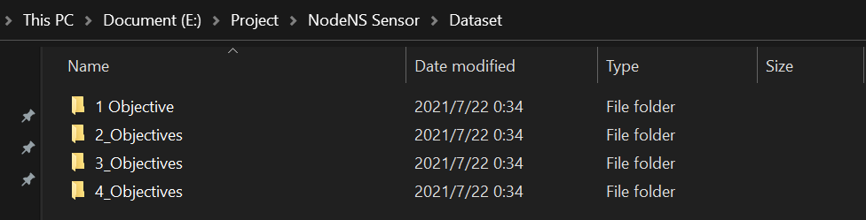
Persons:
P1: S1
P2: S2
P3: S3
P4: S4
Figure 1 Data folder Structure
Table 1 Details of the Data Set (Folders, Files, Description, and Number of Samples)

Number of Subjects | Folder Name | Class/File Name | Experiment: Person | Description | Number of Samples per Class
1 | Sitting | 1_Sitting | P1 | One subject performing the action of "Sitting" | 101
 | Standing | 1_Standing | P1 | One subject performing the action of "Standing" | 101
 | Walking | 1_Walking | P1 | One subject performing the action of "Walking" | 101
 | Fall | 1_Fall | P1 | One subject performing the action of "Fall" | 101
 | Pick Up | 1_Pick_Up | P1 | One subject performing the action of "Pick up a  box" | 101
2 | 2_Subjects_1_Sitting_1_Standing | 2_1_Sit_1_Stand | 2_Exp_1_1:  P2(Sit) + P1  (Stand) | One subject performing the action of "Sitting" and one subject performing the action of "Standing", at the same time | 40
2_Exp_1_2:
P1(Sit)+P2 (Stand)
2_Exp_1_3:
P2(Sit) + P1
(Stand)
2_Exp_1_4:
P1(Sit) + P2
(Stand)
 | 2_Subjects_1_Sitting_1_Pick_Up | 2_1_Sit_1_Pick_Up | 2_Exp_2_1:  P2(Sit) + P1  (Pick) | One subject performing the action of "Sitting" and one subject performing the action of "Pick up a box", at the same time | 40
2_Exp_2_2:
P1(Sit) + P2(Pick)
2_Exp_2_3:
P1(Sit) + P2(Pick)
2_Exp_2_4:
P2(Sit) + P1(Pick)
 | 2_Subjects_1_Standing_1_Pick_Up | 2_1_Sit_1_Pick_Up | 2_Exp_3_1:  P2(Stand) + P1(Pick) | One subject performing the action of "Standing" and one subject performing the action of "Pick up a box", at the same time | 39
2_Exp_3_2:
P1(Stand) + P2(Pick)
2_Exp_3_3:
P1(Stand) + P2(Pick)
2_Exp_3_4:
P2(Stand) + P1(Pick)
3 | 3_Subjects_1_Sitting1_Standing_1_Pick_Up | 3_1_Sit_1_Stand_1_Pick_Up | 3_Exp_1_1:  P3(Sit) + P2(Stand) + P3(Pick) | One subject performing the action of "Sitting", one subject performing the action of "Standing" and one subject performing the action of "Pick up a box", at the same time | 93
3_Exp_1_2:
P1(Sit) + P3(Stand) + P2(Pick)
3_Exp_1_3:
P2(Sit) + P1(Stand) + P3(Pick)
 | 3_Subjects_1_Standing_1_Pick_Up_1_Sitting | 3_1_Stand_1_Pick_Up_1_Sit | 3_Exp_3_1:  P1(Sit) + P3(Stand) + P2(Pick) | One subject performing the action of "Standing", one subject performing the action of "Pick up a box" and one subject performing the action of "Sitting", at the same time | 62
3_Exp_5_1:
P3(Sit) + P2(Stand) + P1(Pick)
 | 3_Subjects_1_Pick_Up_1_Sitting_1_Standing | 3_1_Pick_Up_1_Sit_1_Stand | 3_Exp_2_1:  P2(Sit) + P1(Stand) + P3(Pick) | One subject performing the action of "Pick up a box", one subject performing the action of "Sitting" and one subject performing the action of "Standing", at the same time | 62
3_Exp_4_1:
P3(Sit) + P2(Stand) + P1(Pick)
4 | 4_Subjects_1_Sitting_1_Standing_1_Pick_Up_1_Sitting | 4_1_Sit_1_Stand_1_Pick_Up_1_Sit | 4_Exp_1_1:  P3(Sit) + P2(Stand) + P4(Pick) + P1(Sit) | One subjects performing the action of "Sitting", one subject performing the action of "Standing", one subject performing the action of "Pick up a box" and one subjects performing the action of "Sitting", at the same time | 80
4_Exp_1_2:
P1(Sit) + P3(Stand) + P2(Pick) + P4(Sit)
4_Exp_1_3:
P4(Sit) + P1(Stand) + P3(Pick) + P2(Sit)
4_Exp_3_3:
P4(Sit) + P1(Stand) + P2(Pick) + P3(Sit)
 | 4_Subjects_1_Sitting_1_Sitting_1_Standing_1_Pick_Up | 4_1_Sit_1_Sit_1_Stand_1_Pick_Up | 4_Exp_2_1:  P3(Sit) + P2(Sit) + P4(Stand) + P1(Pick) | One subjects performing the action of "Sitting", one subject performing the action of "Sitting", one subject performing the action of "Standing" and one subjects performing the action of "Pick up a box", at the same time | 30
 | 4_Subjects_1_Pick_Up_1_Sitting_1_Sitting_1_Standing | 4_1_Pick_Up_1_Sit_1_Sit_1_Stand | 4_Exp_2_2:  P3(Pick) + P2(Sit) + P4(Sit) + P1(Pick) | One subjects performing the action of "Pick up a box", one subject performing the action of "Sitting", one subject performing the action of "Sitting" and one subjects performing the action of "Standing", at the same time | 30
4_Exp_3_1:
P2(Pick) + P3(Sit) + P4(Sit) + P1(Stand)
 | 4_Subjects_1_Standing_1_Pick_Up_1_Sitting_1_Sitting | 4_1_Stand_1_Pick_Up_1_Sit_1_Sit | 4_Exp_2_3:  P3(Stand) + P2(Pick) + P4(Sit) + P1(Sit) | One subjects performing the action of "Standing", one subject performing the action of "Pick up a box", one subject performing the action of "Sitting" and one subjects performing the action of "Sitting", at the same time | 30
4_Exp_3_2:
P1(Stand) + P2(Pick) + P3(Sit) + P4(Sit)

METHODOLOGICAL INFORMATION

Description of methods used for collection/generation of data:
The dataset collects activities through NodeNS Sensor, which using a Window Host computer with Matlab 2020b. Figure 2 (a) and (b) shows the experimental setup which was used to collect the data.
Figure 2 (a) is a photo for data collection room (Could we ask about the photo from Dr Ahmad?).
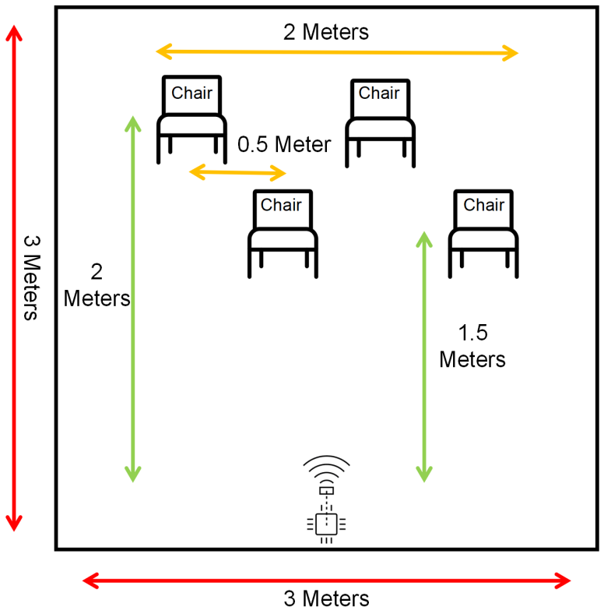
Figure 2b Experimental Setup

Methods for processing the data:
Figure 3 shows the workflow of the NodeNS sensor performing human activity collection.
For NodeNS Sensor: First, connect the sensor with the computer serial port through the USB cable and configure the correct sensor serial communication port in Matlab. Then, use the Matlab Data Acquisition project to open the hardware configuration interface. After setting the path to save the file and loading the hardware configuration, start capturing human body movement information. In this hardware configuration, we used a 3D environment configuration and a fixed 5s acquisition time. Each time of activity point-cloud data collected will be saved in the set path for the mat format. Finally, depending on Matlab plot function can load and show the point-cloud data of the activity again. Figure 4 shows the point-cloud data of the human walking movement captured by the NodeNS sensor.
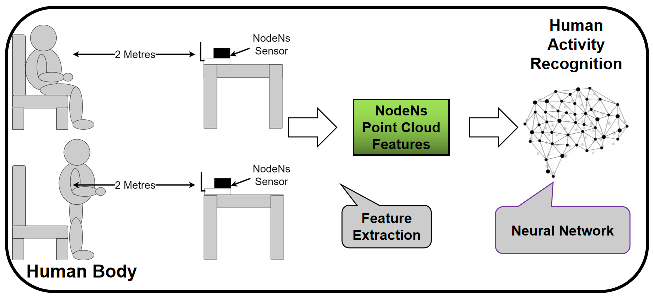
Figure 3 Data flow in the data collection stage

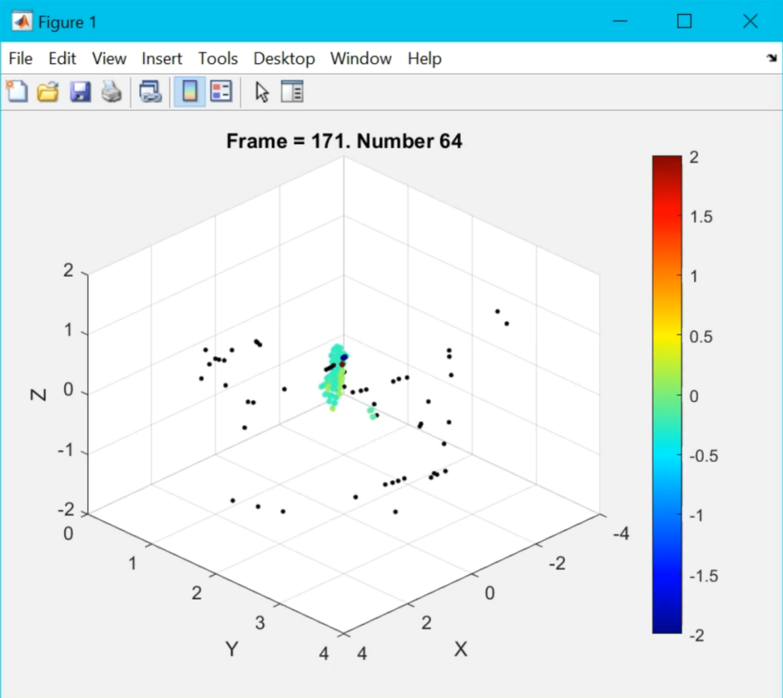
Figure 4 NodeNS Sensor raw information capture of “Walking” activity in "mat" format and the corresponding plot on the Matlab

Instrument- or software-specific information needed to interpret the data:
NodeNS Sensor Data files are all in “.mat” format which could be opened using Matlab and further processed using python.

