Data Set Information Sheet: Recognising British Sign Language using Deep Learning: A Contact-less and Privacy-Preserving Approach
This “ReadMe.pdf” file was generated on 2022-07-08 by Hira Hameed

GENERAL INFORMATION

Title of Dataset
Recognising British Sign Language using Deep Learning: A Contact-less and Privacy-Preserving Approach

Author Information
Names: Hira Hameed, Dr Muhammad Usman, Dr Ahsen Tahir, Professor Muhammad Ali Imran, and Dr Qammer Abbasi
Institution: University of Glasgow
Address: James Watt School of Engineering, College of Science and Engineering, University of Glasgow, Glasgow, G12 8QQ
Emails:
2683961H@student.gla.ac.uk; Muhammad.Usman@glasgow.ac.uk; ahsen.tahir@glasgow.ac.uk
Qammer.Abbasi@glasgow.ac.uk; Muhammad.Imran@glasgow.ac.uk

Date of data collection:
The data was collected over the first week of March 2022.

Geographic location of data collection:
Scotland 5G Centre, James Watt South Building, Glasgow, G12 8QQ, United Kingdom

Information about funding sources that supported the collection of the data:
This work was supported in part by the Engineering and Physical Sciences Research Council (EPSRC) grant: COG-MHEAR (ref. EP/T021063/1).

SHARING/ACCESS INFORMATION

Licenses/restrictions placed on the data:
NA

Links to other publicly accessible locations of the data:
NA

Was data derived from another source?
No
Recommended citation for this dataset: Hameed, H., Usman, M., Tahir, A., Imran, M. and Abbasi, Q. (2022), Recognising British Sign Language using Deep Learning: A Contact-less and Privacy-Preserving Approach, University of Glasgow.

DATA & FILE OVERVIEW

Details of Data Folders and Files
The dataset was divided into two subfolders, that is, a total of 1800 data samples/files (see Figure 1)., each represents a particular number of subjects and activities (see Figure 2). The data folder is subdivided into 15 folders corresponding to the 15 classes (see Figure 3, Table 1, and Table 2).

Figure 1 Data folder Structure
Figure 2 Radar Data folder Structure

Figure 3 Each Data folder Structure
Table 1 Details of the Data Set with 141 CM (Folders, Files, Description, and Number of Samples)
Number of Subjects | Folder Name | Technology | Description | Number of Samples per Class
1 | Subject1(Female:01) | Radar | Female subject performed 15 Sign such drink, eat, help, stop, walk, confused, depressed, pleased, hate, and sad, family, brother, father, mother, and sister | 225
2 | Subject2 (Male) | Radar | Female and Male subject performed 15 Sign such drink, eat, help, stop, walk, confused, depressed, pleased, hate, and sad, family, brother, father, mother, and sister | 225
3 | Subject3 (Female:03) | Radar | Female subject performed 15 Sign such drink, eat, help, stop, walk, confused, depressed, pleased, hate, and sad, family, brother, father, mother, and sister | 225
4 | Subject4 (Female:04) | Radar | Female subject performed 15 Sign such drink, eat, help, stop, walk, confused, depressed, pleased, hate, and sad, family, brother, father, mother, and sister | 225

Table 2 Details of the Data Set with 154 CM (Folders, Files, Description, and Number of Samples)
Number of Subjects | Folder Name | Technology | Description | Number of Samples per Class
1 | Subject1(Female:01) | Radar | Female subject performed 15 Sign such drink, eat, help, stop, walk, confused, depressed, pleased, hate, and sad, family, brother, father, mother, and sister | 225
2 | Subject2 (Male) | Radar | Female and Male subject performed 15 Sign such drink, eat, help, stop, walk, confused, depressed, pleased, hate, and sad, family, brother, father, mother, and sister | 225
3 | Subject3 (Female:03) | Radar | Female subject performed 15 Sign such drink, eat, help, stop, walk, confused, depressed, pleased, hate, and sad, family, brother, father, mother, and sister | 225
4 | Subject4 (Female:04) | Radar | Female subject performed 15 Sign such drink, eat, help, stop, walk, confused, depressed, pleased, hate, and sad, family, brother, father, mother, and sister | 225

METHODOLOGICAL INFORMATION
- Experimental Setup Using USRP

Description of methods used for collection/generation of data:
The dataset is made up of various actions gathered by the UWB Radar sensor (Xethru X4M03). The Radar is based on Novelda's X4 system-on-chip (SoC), which includes an integrated receiver and transmitter antenna and delivers exceptionally accurate distance and movement measurements. The target was 141 CM and 154 CM away from the Radar when the data was collected. Each task took 5 seconds to complete. Through the modular connector XEP, Radar was connected to a PC with Intel(R) Core (TM) i7-7700 3.60 GHz processors and 16 GB RAM. The experimental setup that was used to acquire the data (see Figure 4).
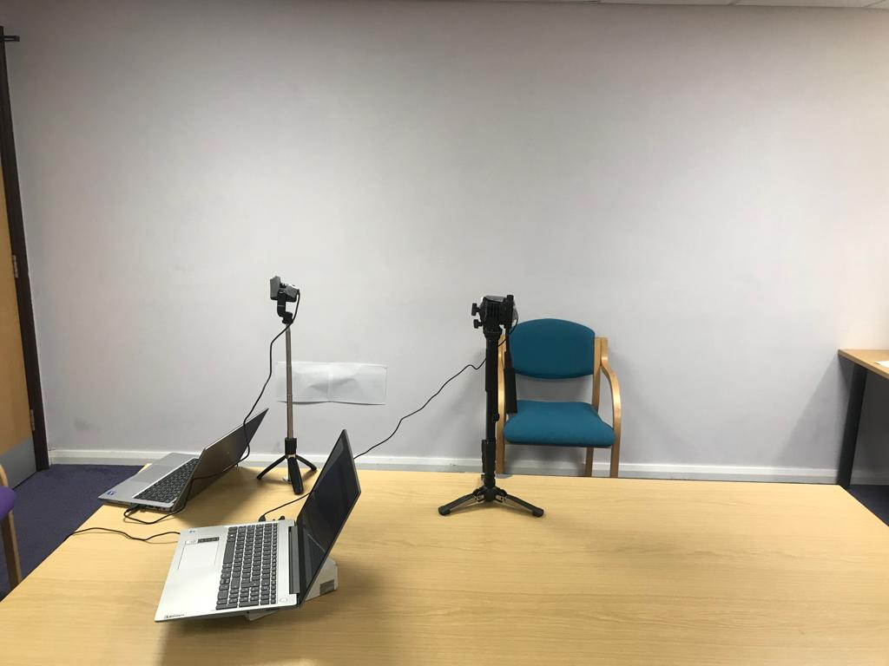
Figure 4 Experimental Setup

Methods for processing the data:
Run the Embebbed Software for the X4MO3 development kit from the Xthru Embedded Platform (XEP). The XEP protocol was used to connect the radar transmitter and reception units. Radar operation with XEP requires a system parameter (see Table 2).
Table 3 System Parameters
Parameter | Value
Radar Platform | Xethru radar X4M03
Instrumental Range | 9.6m
Operating Frequency | 7.29 GHz
Transmitter Power | 6.3 dBm
Activity Duration | 5 seconds
Distance | 141 CM and 154 CM

XEP is free and open-source software. This example is modified to include the Radar as the transmitting and receiving devices. The raw form of the channel state information output is written to .dat files which are then converted to a processable format (see Figure 5).
Figure 5 Data flow in the data collection stage

Secondly, the radar chip was configured via the XEP interface with x4driver. Data were recorded from the module at 500 frames per second (FPS) in the form of the float message data. A loop was used to read the “Digital Audio Tape” (.dat) data file and save the data into a DataStream variable, which was mapped into a complex range-time-intensity matrix. Thereafter, moving target indication (MTI) filter was applied to get the Doppler range map. Afterwards, the second MTI was used as a Butterworth 4th order filter to generate the Spectrograms using the following parameters: window length, overlap percentage, and fast Fourier transform (FFT) padding factor. In particular, a window length of 128 samples, and a padding factor of 16 was used. In addition, a range profile was created by first converting each chirp to an FFT. A second FFT is then conducted on a defined number of consecutive chirps for a given range bin. Further more, a short time Fourier transform (STFT) was used to create these spectrograms.Spectrogram came into Joint Photographic Experts Group(.jpg) format. The .jpg files would hold the data sets that will be used for training and testing of the Deep Learning (DL) algorithm, see an example in (see Figure 6). The above process was repeated for all the data files in this data set.

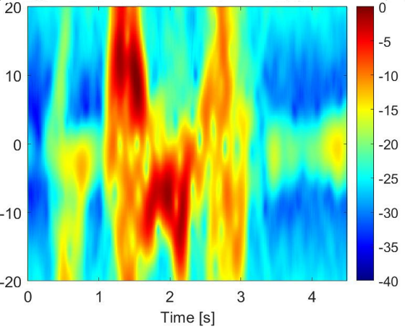

Figure 6 Channel state information capture of “Sad” activity in ".dat" format and the corresponding plot

Instrument- or software-specific information needed to interpret the data:
Data files are in “. dat” format and convert it into “. Png” using MATLAB Script.

