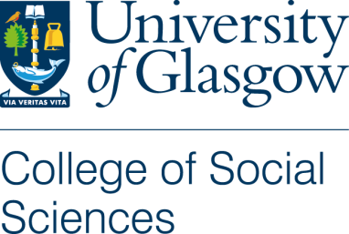

Plain Language Statement

1. Study title and Researcher Details
A comparison of media content and audience reception of Al-Jazeera English and the BBC in their portrayal of the Israel-Palestine conflict (working title).

Researcher: Cairistiona Russell PhD Candidate in Sociology.
Supervisors: Professor Gregory Philo and Professor Andrew Hoskins.

2. Invitation paragraph
You are being invited to take part in a research study. Before you decide it is important for you to understand why the research is being done and what it will involve. Please take time to read the following information carefully and discuss it with others if you wish. Ask us if there is anything that is not clear or if you would like more information. Take time to decide whether or not you wish to take part.
Thank you for reading this.

3. What is the purpose of the study?
The purpose of this study is to identify the key differences in the media coverage of the Israel-Palestine conflict and how different audience groups respond to the content of different media covering the conflict.
The research will last for the duration of my PhD; the research started in 2012 and is expected to last approximately 6 years in total.

4. Why have I been chosen?
You have been chosen because you are a journalist and I am interested in how journalists operate on a day to day basis.
Ten journalists will be interviewed as well as ten focus groups made up on average of five people in each group.

5. Do I have to take part?
No you do not have to take part and your involvement in this study is completely voluntary, you are free to withdraw from this study at any point and you do not need to provide a reason.

6. What will happen to me if I take part?
If you chose to take part you will be a participant in an interview that will last around 45 minutes depending on how much you have to say. In the course of the interview you will be asked to comment on media coverage of the Israel-Palestine conflict. With your permission the interview will be audio-taped.
This research is expected to take six years however you will only be expected to take part in one interview.

7. Will my taking part in this study be kept confidential?
In the final write up of this research if you prefer you will not be identified by your name. The only people who will have access to the data will be myself and my two supervisors. However please note that confidentiality may not be guaranteed; due to the limited size of the participant sample.

8. What will happen to the results of the research study?
The results of the research will be written up in a final report for my doctorate thesis.
The results of the research will be written up in a final report for my doctorate thesis. In the final report you will not be named if this is something you would prefer. You will also be able to request a copy of the final report if you so wish. The results may also appear in journal articles and books, where again you will not be named if this is something you would prefer.

9. Who is organising and funding the research?
The research is self funded.

10. Who has reviewed the study?
The project has been reviewed by the College of Social Sciences Research Ethics Committee.

11. Contact for Further Information
If you require any more information please contact myself, Cairistiona Russell at c.russell.1@research.gla.ac.uk. Or either of my supervisors Professor Gregory Philo greogry.philo@glasgow.ac.uk and Professor Andrew Hoskins Andrew.Hoskins@glasgow.ac.uk.
If you request further information about this research project or would like to pursue a complaint: please direct this to the College of Social Sciences Ethics Officer, Dr Muir Houston, email: Muir.Houston@glasgow.ac.uk

