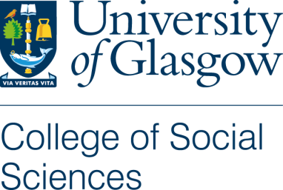

Consent Form

Title of Project: A Comparison of the BBC and Al-Jazeera in their portrayal of the Israel Palestine conflict (working title).

Name of Researcher: Cairistiona Russell

1. I confirm that I have read and understand the Plain Language Statement for the above study and have had the opportunity to ask questions.

2. I understand that my participation is voluntary and that I am free to withdraw at any time, without giving any reason.

3. I give my consent for the focus group to be audio-taped and understand that I can ask for a copy of the transcript to verify.

4. I understand that in any publications arising from this research I will be referred to by pseudonym and not identified by name.

5. I agree / do not agree (delete as applicable) to take part in the above study.

Name of Participant Date Signature

Researcher Date Signature

