README file for Results repository of “Simulated assessment of light transport through ischaemic skin flaps”

Introduction
The research investigates simulated light interaction with a complex 7-layer model (below).
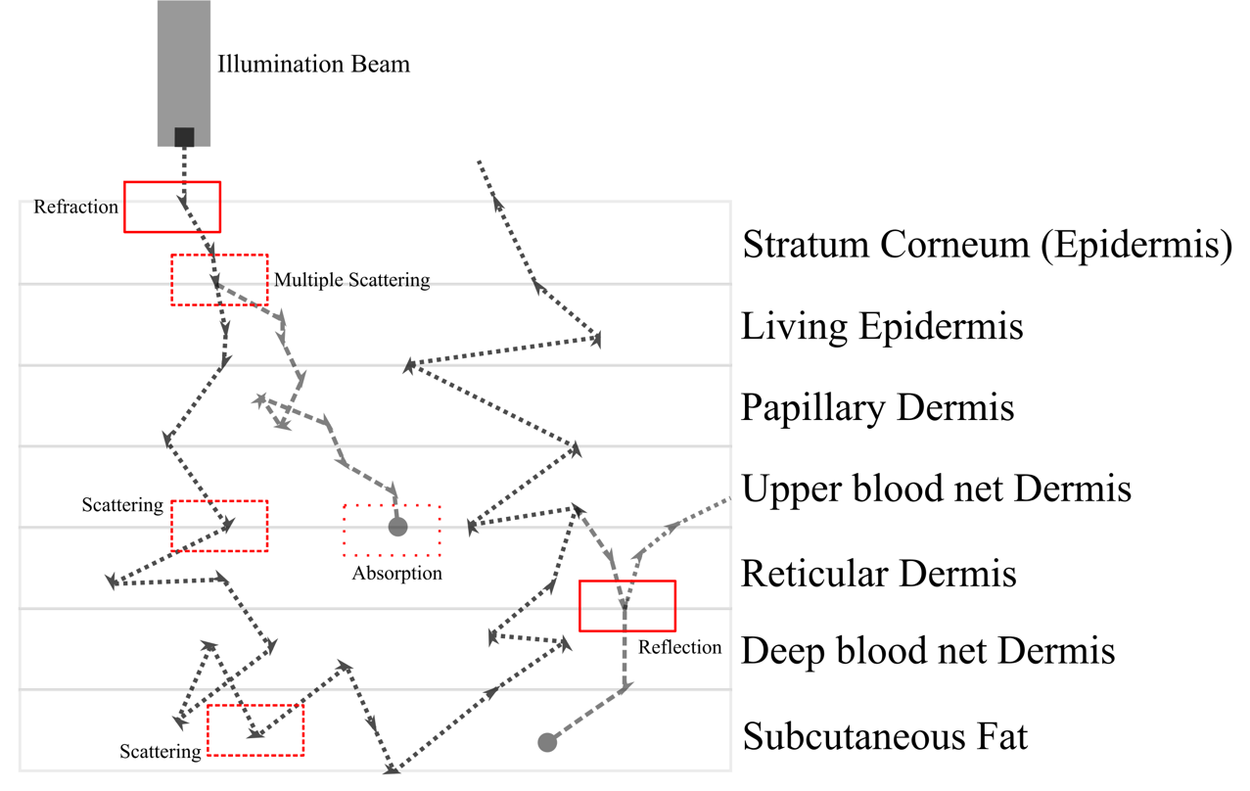
Figure 1 – Refraction, scattering, absorption and reflection occur within the seven-layer skin model when illuminated by a beam. Depending on the wavelength, different degrees of these interactions occur.
The objective of the research, titled “Simulated assessment of light transport through ischaemic skin flaps”, attempts to understand differential interaction to draw inferences of clinical relevance to monitor free flaps in post-operative care.

Abstract:
Currently, skin grafts and flaps are assessed for reperfusion in post-operative care using colour, capillary refill, temperature, texture and Doppler signal (if available). While these techniques are effective, they are prone to error due to their qualitative nature. In this research, we explore using different wavelengths of light to quantify the response of ischaemic tissue. The assessment provides us with indicators that are key to our goal of developing a point-of-care diagnostics device, capable of observing reduced perfusion quantitatively. For this purpose, we set up a detailed optical model including the layers of the skin. This simplified model includes optical properties of the tissue, inclusive of melanin and haemoglobin. We simulate models of healthy, perfused tissue and perfusion-deprived tissue to assess the responses when illuminated with visible and near-infrared wavelengths of light. In addition to detailed fluence maps of photon propagation, we propose a simple, mathematical model to assess the differential propagation of photons in tissue; the optical reperfusion factor (ORF). Our results show clear advantages of using light at longer wavelengths (red, near-infrared) and the inferences drawn from the simulations hold significant clinical relevance. The wavelengths and their interaction with healthy and ischaemic tissue inform the design and requirements of a non-contact and safe optical diagnostic device. The modelling approach is applicable beyond the current research, wherein other medical conditions that can be mathematically represented in the skin can be investigated. Through these, additional inferences and approaches to other point-of-care devices can be realised.

Repository Contents
The repository folder contains:
- mcxlab (folder to add to MATLAB path containing all the files needed to run the .m files in the scenarios
- Simulation Scenarios and Results (folder containing the models and optical properties, specific to each case)
- OPR Comparisons (folder containing the optical reperfusion factor (OPR) in different scenarios)
- Optical Properties (Excel file containing all the calculated and/or adopted optical properties for the various Monte Carlo simulations).
These files have been verified to run on a Windows 10 PC running MATLAB 2021.

Simulation Scenarios and Results
Variable cfg.prop sets all optical properties. If you wish to change these values DO NOT change the repeating 0 0 1 1; Values as they are set to the volume itself and the grid. The sheet titled “Values for MCX” in the Excel spreadsheet contained within the folder shows how these values can be copied in for each case. By default, the number of photons being simulated is 10⁹ which may take a long time if your PC does not have sufficient graphics processing.
Generally, 10⁶ should be enough to get reasonable results. cfg.nphotons should be altered to change this value.

OPR Comparisons
The files within this folder run two simulations, then calculates the variance using the optical reperfusion factor (ORF) relationship. These files can be modified in the same fashion as the raw results, just ensure to change both the photon counts if you wish to lower the values.

If you have any queries, please contact Dr Akhil Kallepalli (Akhil.Kallepalli@glasgow.ac.uk).

