This is a Research Dataset associated with the journal article
“Development of an age-dependent micronutrient centile charts and their utility in children with chronic gastrointestinal conditions at risk of deficiencies: A proof-of-concept study” authored by Maha Al Fify, ....
Data formats and software for the analysis:
The provided data includes two .csv files named “controls.csv” containing data from a healthy control (reference) group described in the paper, and “cases.csv” which is an empty template to be filled with data from your patient group. An R script named “calc_z_scores.R” is also included.
In order to use this script, you will need the following:
- R software. This can be downloaded here: https://www.r-project.org/
- RStudio (available for free on desktop here: https://www.rstudio.com/products/rstudio/download/)
These instructions use R version 4.0.4 and RStudio version 1.4.1106.

Description of datasets:
The provided R script will calculate micronutrient z-scores and create centile charts adjusted for age. When creating your “cases.csv” file of your patient data from the template, you must always fill in data for the “ID” and “Age” columns, and also data for at least one micronutrient. For example, if you wish to calculate z-scores for micronutrient B1, you would need to input data underneath the column headings “ID”, “Age”, and “B1”.
Please note, for measurements in plasma use columns “Zn”, “Cu”, “Sn” or “Mg”. For measurements in red blood cells use “ZnRBC”, “CuRBC”, “SnRBC”, “MgRBC”, “B1”, “B2”, or “B6”. These correspond with the control data provided.
Save the R script and the two .csv files in the same folder.
To load the files in R, set the folder that contains all of your files as the working directory. You will then be able to see the files available in your working directory in the “files” window at the bottom right of the screen.
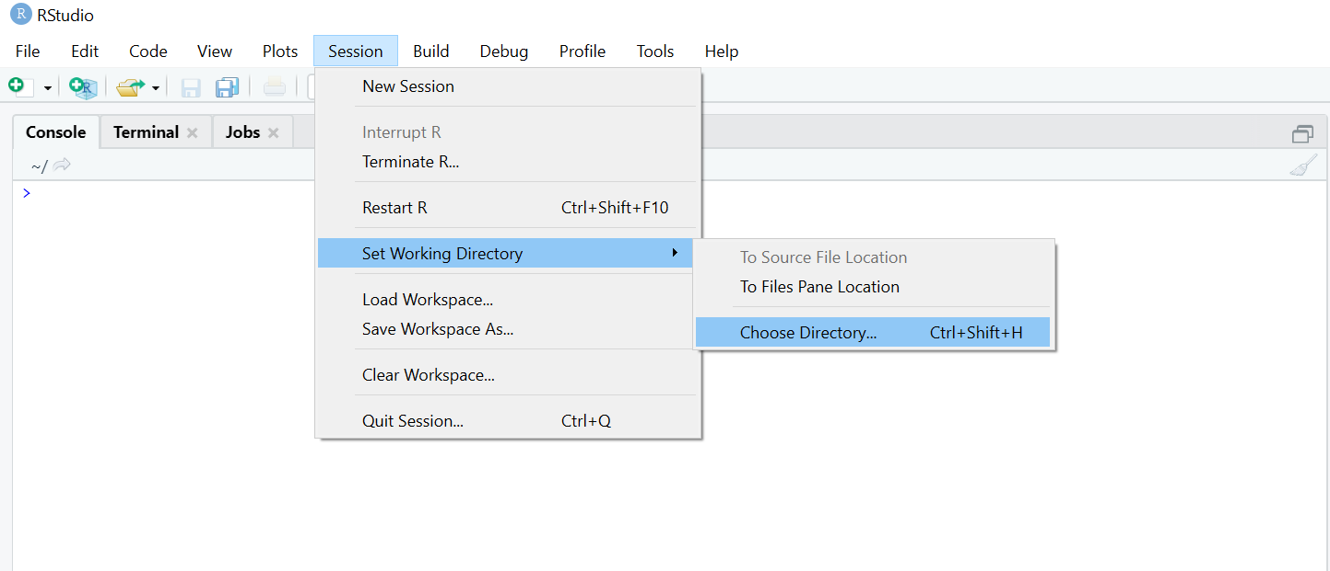

Open the script by clicking on its name in the “files” window. The script provided will work for micronutrient “B1” but to run analysis for other micronutrients, you must edit line 35 in the script and change “B1” to the name of your micronutrient. This must exactly match the corresponding column name in both “cases.csv” and “controls.csv”.
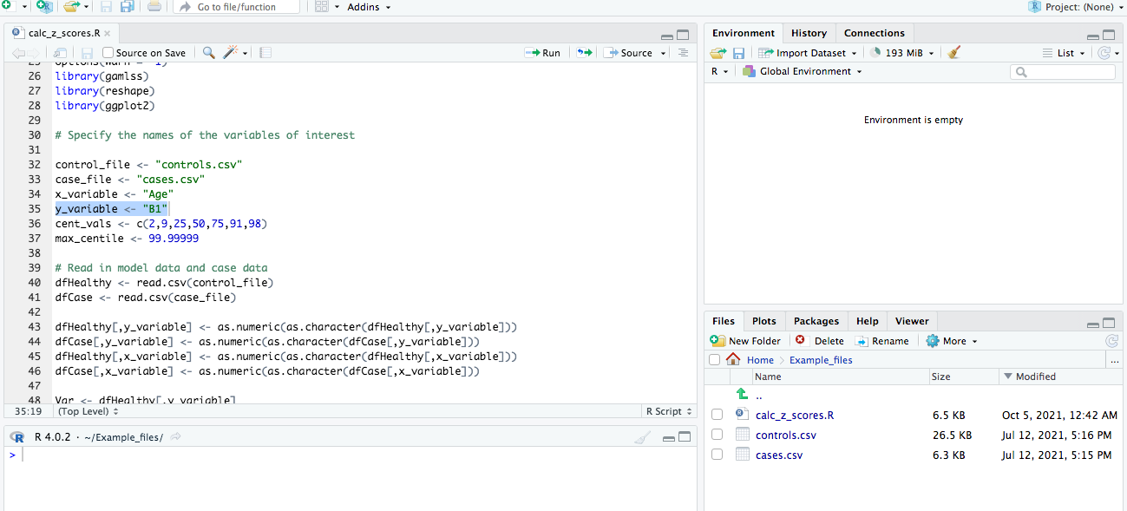

The script can now run. To do this, highlight the scipt with ctrl+A (or click and drag) then click “Run” or press ctrl+Enter. The script will automatically save pdf files of the created centile charts and .csv files of the calculated z-scores into the folder that you selected as the working directory.
