Open Access Readme for:
An Investigation of a (Vinylbenzyl) Trimethylammonium and N-Vinylimidazole-Substituted Poly (Vinylidene
Fluoride-Co-Hexafluoropropylene) Copolymer as an Anion-Exchange Membrane in a Lignin-Oxidising Electrolyser
Patrick J. McHugh ^{1,†}, Arindam K. Das ^{1,2,†}, Alexander G. Wallace ¹, Vaibhav Kulshrestha ², Vinod K. Shahi ^{2,}* and Mark D. Symes ^{1,}*
¹ WestCHEM, School of Chemistry, University of Glasgow, University Avenue, Glasgow G12 8QQ, UK; p.mchugh.1@research.gla.ac.uk (P.J.M.); arindamkumar91@gmail.com (A.K.D.);
A.G.Wallace@soton.ac.uk (A.G.W.)
² Central Salt and Marine Chemicals Research Institute, Bhavnagar 364002 , Gujarat, India; vaibhavk@csmcri.res.in
* Correspondence: vkshahi@csmcri.res.in (V.K.S.); mark.symes@glasgow.ac.uk (M.D.S.)
† These authors contributed equally.

2.1. Materials
Ultrapure deionised water (18.2 MΩ·cm) obtained from a Sartorius Arium Comfort combined water system was used in all experiments. Alkali (Kraft) lignin and sodium hydroxide (≥98%) were purchased from Sigma Aldrich and Honeywell, respectively. The electrodes used were commercial products purchased from FuelCellStore. The anode used was Pt/Ru catalyst (2 mg cm⁻², 50% Pt/50% Ru wt/wt) impregnated on carbon cloth (410 μm thick microporous layer). The cathode used was a Pt/C catalyst (0.2 mg cm⁻², 20% wt Pt) impregnated on identical carbon cloth to the anode. The commercial anion-exchange membrane FUMAPEM FAA-3-50 was purchased from FuelCellStore. Poly (vinylidene fluoride-co-hexafluoropropylene) (M_{n}~130,000 g/mol), N-vinylimidazole and (vinylbenzyl) trimethylammonium chloride monomers were purchased from Sigma Aldrich and used without further purification. Dimethylacetamide and isopropyl alcohol were supplied by SD Fine-Chem Ltd. (Mumbai, India).
2.2. Flow Cell Components
The flow cell was assembled as shown in Figure 1. The anolyte used was a solution of alkali lignin (10 g L⁻¹ in 1 M NaOH) and the catholyte was an aqueous solution of NaOH (1 M). The feed solutions were transported to and from the cell using two Fisherbrand GP1100 general purpose peristaltic pumps at a flow rate of 10 mL min⁻¹. The flow plates used were fabricated from stainless steel, with 6 channels (0.9 × 0.9 mm) through which the feedstock solutions were passed. Gaskets were cut from either 0.45 mm or 0.1 mm thick polytetrafluoroethylene (PTFE). The stack compression was 5.65 Nm and the active area of the membrane was 12.96 cm². The temperature within the cell was controlled by heating the reservoirs of the feed solutions in an oil bath. The temperature was monitored using K-type thermocouples inserted into the inlet and outlet of the anodic side. Temperature data were recorded using a Pico TC-08 data logger and PicoLog software for Windows.
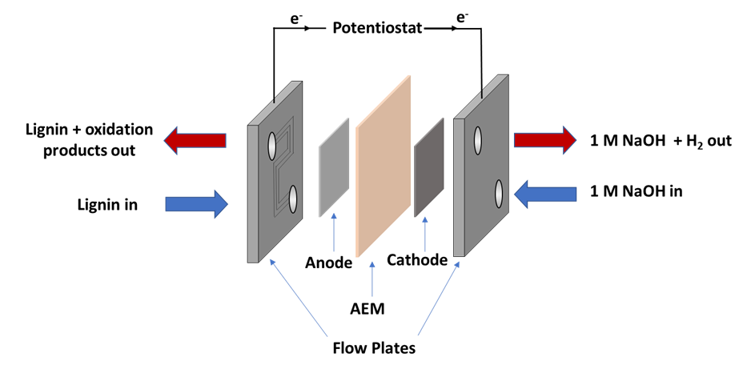
Figure 1. Diagram of the electrolyser cell setup used for lignin electrolysis. The electrolyser setup is a “zero-gap” configuration where the anode and cathode catalysts are sandwiched between the conductive flow plates. The potentiostat is connected to each flow plate by way of terminal spades with banana jacks, and so the flow plates also function as current collectors.

2.3. Electrochemical Characterisation of the Cell
Electrochemical impedance spectroscopy (EIS) and linear sweep voltammetry (LSV) data were recorded for the electrolyser cell using a Bio-Logic SP-150 potentiostat equipped with a VMP3B-20 20 A booster. Data were recorded and analysed using EC-Lab (v11.12). Unless stated otherwise, EIS was carried out under the following experimental parameters: electrolyte flow rate = 10 mL min⁻¹, quiet time (resting at the DC bias potential) = 10 min, starting frequency = 1 MHz, ending frequency = 10 mHz, DC bias = 0.5 V (vs. the open circuit potential), AC excitation amplitude = 14.1 mV. LSV data were recorded at a scan rate of 0.5 mV s⁻¹. The EIS data were fitted to an equivalent circuit, L₁ + R₁ + Q₁/R₂ using AfterMath (v1.5.9644, Pine Research Instrumentation Inc. (Durham, USA)). The details of the components of the equivalent circuit are as follows: L₁, which is an inductor; R₁, which corresponds to the series resistance of the cell (R_{s}); R₂, which corresponds to the polarisation resistance of the cell (R_{p}); Q₁, which represents a constant phase element.
2.4. Preparation of PVIB Membrane
Firstly, poly (vinylidene fluoride-co-hexafluoropropylene) (PVDF-co-HFP, 10 g) was dissolved in dimethylacetamide (500 mL). Then, saturated NaOH in isopropanol (10 mL) was added dropwise, over 30 min, while the solution was stirred vigorously at room temperature. During this step the colourless solution turned light brown in colour. The resulting dehydrofluorinated PVDF-co-HFP was then precipitated in water, filtered and then rinsed 3–4 times with deionised water and dried under vacuum at 70 °C. This polymer was then dissolved in a round-bottomed flask containing dimethylacetamide, N-vinylimidazole (20% wt), and (vinylbenzyl)trimethylammonium chloride at different weight % concentrations (4%, 6%, 8% and 10%), giving four different types of PVIB membrane on the basis of the amount of (vinylbenzyl)trimethylammonium chloride added: PVIB-4, PVIB-6, PVIB-8 and PVIB-10, respectively. The copolymerisation reaction was initiated by addition of 0.1% of azobisisobutyronitrile (AIBN), and the mixture was continuously stirred at 60 °C for 8 h under an N₂ atmosphere. The resulting viscous solution was cast onto a clean glass plate and dried under vacuum at 55 °C for 24 h. After this, the membrane was equilibrated in 1 M NaOH for 24 h to complete the exchange of Cl⁻ for OH⁻. These hydroxide-exchanged membranes were analysed after thoroughly washing with double distilled water 4–5 times.
2.5. Characterisation of the PVIB Membrane
A number of analytical techniques were used to characterise the structure, functional groups, surface and phase morphology of the as-prepared PVIB and its precursors. Functional group analysis of the samples was performed using the PerkinElmer FT-IR spectrometer. Surface and cross-sectional morphology on freshly prepared membranes was analysed on a field-emission electron microscope (FE-SEM) using a JEOL JEM 7100F (USA) instrument. TEM images were recorded with a JEOL JEM 2100 microscope. Scanning electron microscopy on membranes after use in the PVIB-based electrolyser was performed with a Philips XL30 ESEM instrument equipped with an Oxford Instruments Energy 250 energy dispersive spectrometer system at an acceleration voltage of 20 kV. Following use in a lignin-oxidising electrolyser, membranes were thoroughly washed and then submerged in ultrapure water for 2 h, before being oven-dried for 4 h at 55 °C. Samples cut from the membrane were then loaded onto 12 mm AGAR scientific conductive carbon tabs. Images were obtained with acceleration voltages between 12 kV and 20 kV.
To measure the ion-exchange capacity, 2.5 × 2.5 cm² fragments of the prepared membrane were submerged in 1.0 N NaCl (AR grade) solution for 24 h in order for the membrane to be entirely converted to the form with the chloride counter ion. These membrane squares were then removed from solution, thoroughly washed with ultra-pure water and equilibrated in deionised water for 2 h to remove any excess chloride ions from the membrane surface. Finally, the membrane squares were dried in a vacuum oven for 4 h at 55 °C and then weighed. The chloride-saturated membrane was subsequently immersed in 0.1 M Na₂SO₄ in order to allow exchange of the chloride counter ions for SO₄²⁻. The chloride ions thus released into solution were titrated by Mohr’s method using 0.001 N AgNO₃ and dichromate solution as the indicator. The ion-exchange capacity (IEC) was then determined using the formula in Equation (1), where V_{AgNO3} is the volume of 0.001 N AgNO₃ solution added and M_{Dry} is the dry mass of the membrane square:
$$IEC \left(meq g^{-1}\right)=\frac{0.001 N {×V}_{AgNO_{3}}}{M_{Dry}}$$ | (1)
The ionic conductivity (σ) of the prepared membranes was measured at 30 °C using AC impedance spectroscopy with an AutoLab Model PGSTAT 30 potentiostat/galvanostat frequency response analyser. This instrument was connected to the conductivity cell. The conductivity cell itself was made in-house and consisted of two circular stainless-steel electrodes (each of effective area 1.0 cm²), each of which was encased in an acrylic outer cylinder (approximately 2 cm thick). The membrane was sandwiched between the two stainless-steel electrodes using 0.1 M NaCl as the conducting medium. The frequency of sinusoidal current perturbation was swept from 1 MHz to 1 Hz over the course of each experiment, and the current demanded was swept at 1 μA per second. The resulting Nyquist plot was then used to obtain the resistance of the membrane. The conductivity of the membrane was calculated by entering values for the membrane area (A), the distance between the electrodes (i.e., membrane thickness, L) and the resistance (R) into Equation (2) below:
$$σ \left(S {cm}^{-1}\right)=\frac{L \left(cm\right)}{R \left(Ω\right) × A \left({cm}^{2}\right)}$$
The mechanical strength of the membrane samples (rectangular pieces of size 26 cm²) was studied by using a bursting strength tester machine (model No. 807DMP, Test Techno Consultants, Gujarat, India). The stability of the prepared PVIB membranes in alkaline media was studied by immersing the membranes in 5.0 M NaOH for 72 h at 30 °C. The mass and conductivity of the treated membranes were unaltered by this treatment, suggesting that they are stable in alkaline media at room temperature for at least 72 h.

