This is a Research Dataset associated with the journal article
“Handgrip strength as a surrogate maker of lean mass and risk of malnutrition in paediatric patients” authored by Shona Mckirdy, Sarah Willliamson, Ben Nichols, Konstantinos Gerasimidis.
Data formats and software for the analysis:
The provided data includes one .csv file labelled “controls” containing data from a healthy control group described in the paper and two R scripts with file extensions “.R”. To use these scripts, you will need to create a second .csv file labelled “cases” containing data from your patient group.
In order to use these scripts, you will need the following:
- R software. This can be downloaded here: https://www.r-project.org/
- RStudio (available for free on desktop here: https://www.rstudio.com/products/rstudio/download/)
These instructions use R version 4.0.4 and Rstudio version 1.4.1106.

Description of datasets:
The provided R scripts will calculate handgrip strength z-scores and create centile charts adjusted for age or for height. Ensure that you use the correct R script for your data. When creating your “cases.csv” file of your patient data, ensure that the column heading exactly match those in the “controls.csv” file. For example, if you wish to calculate handgrip strength z-scores adjusted for age, you would need to include the column headings “ID”, “Gender”, “Max Grip Strength”, and “Age”. Max grip strength should be in kg, age in years, and height in cm.
Save the R script and the two .csv files in the same folder.
To load the files in R, set the folder that contains all of your files as the working directory. You will then be able to see the files available in your working directory in the “files” window at the bottom right of the screen.
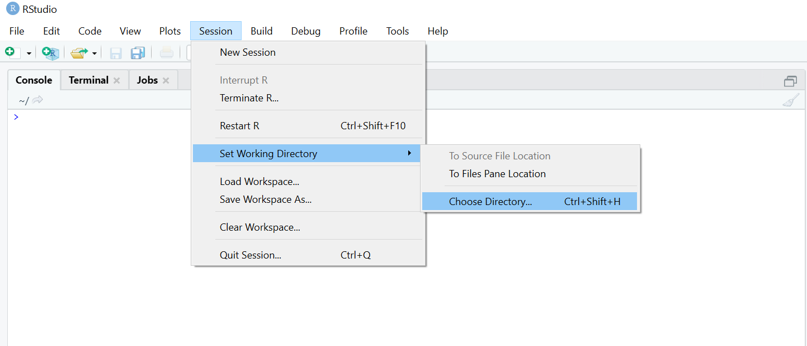

From the “files” window in the bottom right of the screen, click on the R script to open it. Then, select “cases.csv” and “controls.csv” to “Import Dataset”. Wait until the preview data has loaded then select “Import”.
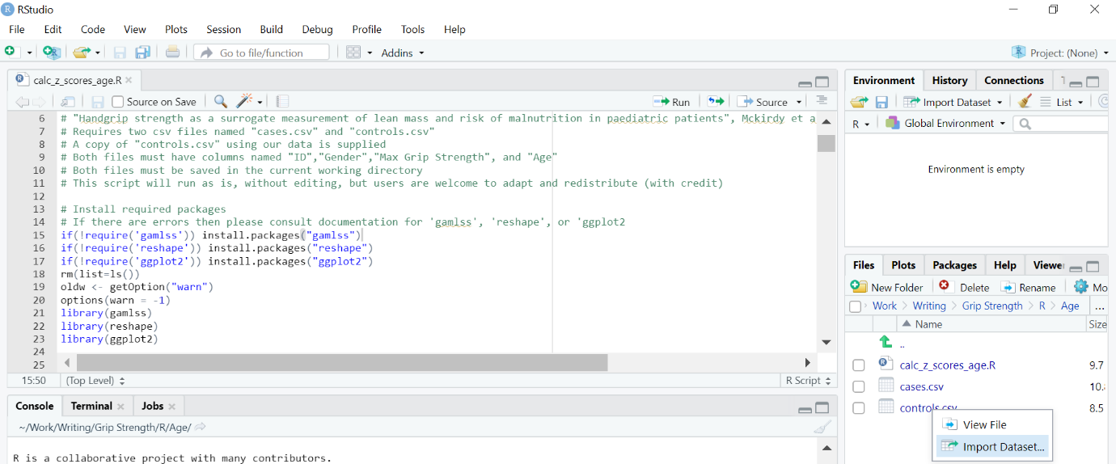

The script can now run. To do this, highlight the scipt with ctrl+A (or click and drag) then click “Run” or press ctrl+Enter. The script will automatically save pdf files of the created centile charts and .csv files of the calculated z-scores into the folder that you selected as the working directory.
