**Data sets for:**

**Selective Aldehyde Reductions in Neutral Water Catalysed by Encapsulation in a Supramolecular Cage**

*Avishek Paul,† Michael A. Shipman,† Dolapo Y. Onabule,Stephen Sproules* and Mark D. Symes\**

*WestCHEM, School of Chemistry, University of Glasgow, University Avenue, Glasgow, G12 8QQ, United Kingdom*

*†These authors contributed equally to this work*

*\*Email: mark.symes@glasgow.ac.uk; stephen.sproules@glasgow.ac.uk*

|  |  |
| --- | --- |
| *Index* | *Page* |
| General experimental remarks | S3 |
| Figure **S1** | S4 |
| Details of computational calculations | S5 |
| Figure **S9** | S30 |
| Figure **S10** | S31 |
| Figure **S11** | S32 |
| Characterisation of isolated products | S33 |
| Figure **S23** | S45 |
| Figure **S24** | S46 |
| References | S47 |
|  |  |

**General Experimental Remarks:** The FeII4L6 cage was prepared as previously reported by Nitschke and co-workers.S1 Iron(II) sulfate heptahydrate (≥99%), furfural (99%), benzaldehyde (≥99%), and 5-methylfurfural (99%) were purchased from Sigma-Aldrich. 4,4′-diaminobiphenyl-2,2′-disulfonic acid (≥70%), tetramethylammonium hydroxide (98%), sodium cyanoborohydride (95%), dimethyl sulfoxide (99.8%), nitrobenzaldehyde (99%), anisaldehyde (99%), phenyl acetaldehyde (95%), acetophenone (99%) and chlorobenzaldehyde (99%) were purchased from Alfa Aesar. Hexane (≥95%), acid-washed sand and sodium bicarbonate (≥99.7%) were purchased from Fischer Scientific. Ethanol (100%), dichloromethane (100%), magnesium sulfate and acetone (≥95%) were purchased from VWR. Hydrochloric acid was purchased from Honeywell. Silica 60 (0.04-0.063 mm) was purchased from Merck. 4-(Diphenylamino)benzaldehyde was purchased from TCI. D2O (99.9%) and CDCl3 (99.8%) were purchased from Cambridge Isotope Laboratories. Pyridine-2-carboxaldehyde (99%) was purchased from Acros Organics. All chemical reagents and solvents were used as purchased. All 1H and 13C NMR spectra were recorded on a Bruker AVI 400 instrument or a Bruker AVIII 500 instrument (as indicated in the text), at a constant temperature of 298 K. Chemical shifts are reported in parts per million from low to high field. Coupling constants (*J*) are reported in hertz (Hz). Standard abbreviations indicating multiplicity were used as follows: m = multiplet, t = triplet, d = doublet, s = singlet, br = broad. LC-MS mass spectra (ESI, positive mode, Bruker micrOTOF-Q machine) were collected by the services facility at the School of Chemistry, University of Glasgow.

**Typical procedure:** 100 mg (0.027 mmol, 0.09 equiv.) of the [Fe4L6] cage (as the tetramethylammonium salt) was weighed into a 14 mL vial with a small magnetic stir-bar. The vial was closed with a rubber septum and kept under nitrogen using Schlenk techniques. Aldehyde (0.3 mmol, 1 equiv.) was added to the same vial (using a micro-syringe for liquids) under a nitrogen atmosphere. 3 mL of degassed distilled water was then injected into the same vial under nitrogen, and the reaction mixture stirred for 1 h at 50 °C. Meanwhile, NaCNBH3 (0.3 mmol, 19 mg, 1 equiv.) was weighed out inside a glove-box into a separate vial sealed with a rubber septum. 2 mL of degassed distilled water was then injected in this vial containing the NaCNBH3 under nitrogen. The aqueous solution of NaCNBH3 was then transferred to the main reaction vial under nitrogen. The reaction mixture was then kept stirring for another 6 hours at 50 °C inside the sealed vial. After this time, the reaction mixture was allowed to cool down to room temperature before extraction of the products with dichloromethane (4 × 20 mL). The organic layers were combined and dried over MgSO4. The solvent was removed under reduced pressure and the products were isolated by column chromatography using diethyl ether/hexane mixtures as the eluents (the ratio varied with the *Rf* values of the product; typically, 20-40% diethyl ether in hexane was used). The solvents were then carefully removed under reduced pressure at 25 °C and finally the product was dried under high-vacuum with cooling (in order to prevent any evaporation of the products). Characterisation of all alcohol products is given in the ESI. Control reactions without cage were conducted in an entirely analogous manner, save for the addition of cage. Under these standard conditions, the pH of the reaction medium was 7. The pH could be adjusted to other values by using sodium bicarbonate and/or NaOH (to move more basic), or HCl or phosphoric acid (to move to more acidic pH).



**Figure S1:** NOESY spectrum of the Fe4L6 cage in D2O in the presence of 10 equivalents of furfural after heating to 50 °C for 1 h, showing exchange cross-peaks between peaks assigned to free cage and the new set of cage-like peaks that appears upon addition of furfural. Mixing time = 0.3 s, T = 298 K, 500 MHz.

**Details of computational calculations**

The program package ORCA was used for all calculations.S2 The input geometry for all molecules were generated using ArgusLab beginning from crystallographic coordinates.S3 Single point calculations on the generated structures were carried out at the BP86 level of theory.S4 Calculations were performed in the gas phase and in an infinite continuum using the conductor-like screening model (COSMO).S5 A segmented all-electron relativistically contracted basis set of triple-ζ quality (def2-TZVP) for C, H and O atoms of furfural substrate.S6 The cage atoms were described by a split-valence basis sets with one set of polarization functions (def2-SVP),S7 with Grimme’s dispersion correction D3.S8 A scalar relativistic correction was applied using the zeroth-order regular approximation (ZORA) methodS9 as implemented by van Wüllen.S10 The RI approximation combined with the appropriate Ahlrichs auxiliary basis set was used to speed up the calculations.S11 The self-consistent field calculations were tightly converged (1 × 10–8 *E*h in energy, 1 × 10–7 *E*h in the density charge, and 1 × 10–7 in the maximum element of the DIISS12 error vector). The geometry was converged with the following convergence criteria: change in energy <10–5 *E*h, average force <5 × 10–4 *E*h Bohr–1, and the maximum force 10–4 *E*h Bohr–1. Canonical orbitals were generated with the program Molekel.S13

**Table S1.** Optimized Coordinates for Furfural@Fe4

O 26.103496 1.982647 7.970626

C 25.014022 1.982235 8.600488

C 24.569007 0.784956 9.308091

O 25.303194 -0.357143 9.378099

C 23.376906 0.686812 9.985882

C 24.518349 -1.179320 10.125756

C 23.338593 -0.580359 10.490723

H 24.405118 2.874974 8.619591

H 24.799722 -2.186001 10.398557

H 22.537962 -1.029399 11.064622

H 22.617684 1.454163 10.096674

Fe 29.529320 5.145010 7.752050

Fe 16.657645 4.240447 9.061381

Fe 23.269656 -4.943525 2.693838

Fe 24.451656 -3.836448 15.612484

S 24.232595 5.810595 10.777608

S 30.294603 -0.214082 10.787883

S 26.002374 2.680028 3.414229

S 16.803383 -1.159678 6.252870

S 20.141554 3.093404 13.904829

S 25.965752 -6.265770 10.198073

S 22.171554 8.184955 8.283488

S 27.514705 1.318093 14.563280

S 28.217439 -0.503189 2.210755

S 20.001908 0.181186 2.532813

S 18.979970 -1.650650 14.038904

S 21.618683 -6.402377 8.349955

O 22.953396 6.845756 11.303112

O 30.176617 -1.582523 9.740740

O 23.932187 4.438757 11.426931

O 25.460520 6.266572 11.601614

O 25.911116 1.850450 2.113299

O 30.480760 -0.789568 12.211958

O 31.702657 0.371393 10.524639

O 15.317380 -0.728283 6.255951

O 24.373557 3.093042 3.808330

O 26.604969 3.995087 2.864616

O 19.147607 4.226441 14.255478

O 16.930907 -2.336938 7.510881

O 26.469710 -7.274728 11.257488

O 20.472340 2.321304 15.414995

O 16.870589 -1.952625 4.925885

O 21.415058 3.898698 13.555302

O 25.530888 -7.224666 9.064470

O 27.387929 -5.473436 9.621107

O 23.468311 8.536355 9.049046

O 27.833216 1.131892 16.251312

O 21.144659 9.562059 8.468714

O 26.368761 2.353611 14.478998

O 28.621494 0.989401 2.224815

O 22.641164 8.248522 6.810975

O 28.722985 2.121195 14.025434

O 29.361037 -1.151100 3.026048

O 21.158998 1.457143 2.397487

O 18.552981 -2.585798 15.427695

O 28.488319 -1.030586 0.587800

O 19.889273 -0.409438 1.107013

O 18.624425 0.872633 2.668791

O 21.896474 -7.325435 9.783952

O 17.914891 -0.529796 13.980295

O 18.597397 -2.530749 12.825897

O 21.057944 -7.421320 7.329370

O 20.368151 -5.540430 8.642529

N 29.488634 7.029006 8.591260

N 31.425229 4.769829 8.475933

N 16.297919 6.049937 8.141910

N 14.935567 3.378713 8.335786

N 22.831306 -4.234261 16.826444

N 27.655251 5.587747 6.838933

N 28.769847 4.583968 9.625558

N 29.712411 3.165731 7.019546

N 17.663938 3.831666 7.246622

N 16.937642 2.332983 9.908462

N 23.123922 -4.440380 14.102410

N 18.309224 5.159598 9.925528

N 26.115359 -3.626053 14.339770

N 23.678765 -2.964689 2.214143

N 21.510299 -4.592992 3.789440

N 23.887371 -1.811813 15.550660

N 24.579839 -4.948674 4.354603

N 15.736503 4.854756 10.804316

N 25.147263 -5.775316 15.753902

N 22.160100 -4.860810 0.954012

N 22.775524 -6.912212 3.037995

N 25.609703 -3.190636 17.192157

N 24.993210 -5.419507 1.668370

C 31.585873 5.915831 5.562272

C 29.818011 8.223354 8.003321

C 32.213928 5.593691 9.238757

C 15.535594 7.092025 8.605125

C 14.008312 3.939208 7.496850

C 22.739248 -4.078627 18.185630

C 31.896134 6.464469 4.315815

C 29.761435 9.396656 8.759366

C 33.503338 5.182052 9.583471

C 15.458210 8.268993 7.857259

C 12.862599 3.212824 7.163086

C 21.568478 -4.468048 18.840774

C 30.866660 6.939932 3.497706

C 29.379615 9.332429 10.104004

C 33.972721 3.942565 9.136556

C 16.158538 8.364846 6.649955

C 12.680267 1.930686 7.694539

C 20.514379 -5.016541 18.101513

C 29.538339 6.867701 3.927204

C 29.058599 8.102398 10.686964

C 33.156665 3.123467 8.350603

C 16.921948 7.286377 6.191751

C 13.639636 1.379321 8.550400

C 20.631709 -5.173424 16.716770

C 29.256984 6.310587 5.178790

C 29.122722 6.944287 9.907147

C 31.870976 3.561764 8.019624

C 16.980448 6.119632 6.960068

C 14.775160 2.129215 8.869252

C 21.815121 -4.778666 16.086777

C 27.879633 6.199720 5.696320

C 28.776472 5.608876 10.442530

C 30.933570 2.733557 7.233683

C 17.713307 4.917010 6.513434

C 15.879864 1.587945 9.693856

C 21.993897 -4.851640 14.618109

C 26.357024 5.431761 7.270430

C 28.403879 3.350093 10.078037

C 28.795179 2.347665 6.410587

C 18.186150 2.655087 6.778502

C 17.986361 1.857150 10.645377

C 23.328073 -4.457338 12.754810

C 25.977314 5.687622 8.596922

C 29.305209 2.276829 10.068409

C 27.953873 2.817946 5.392214

C 17.441039 1.472023 6.820161

C 18.540544 2.610102 11.689099

C 24.394392 -5.178441 12.208142

C 24.633112 5.632879 9.006036

C 29.013448 1.073236 10.731186

C 27.094275 1.956138 4.688013

C 17.912439 0.281527 6.250415

C 19.555233 2.090594 12.509108

C 24.578473 -5.272453 10.823638

C 23.626072 5.383198 8.052012

C 27.782945 0.930947 11.410684

C 27.099439 0.574104 4.987511

C 19.180385 0.255820 5.627066

C 20.035520 0.782418 12.284945

C 23.665586 -4.642258 9.953494

C 23.986182 5.123624 6.728175

C 26.867548 1.989609 11.387179

C 27.916850 0.099743 6.017895

C 19.914976 1.447353 5.549949

C 19.500553 0.035748 11.225736

C 22.564177 -3.961154 10.493435

C 25.326717 5.138219 6.345893

C 27.189120 3.189763 10.762541

C 28.754034 0.967893 6.716085

C 19.421967 2.631327 6.098995

C 18.474215 0.552862 10.434405

C 22.387191 -3.884008 11.877727

C 22.199101 5.361425 8.426758

C 27.443747 -0.270771 12.207882

C 26.261073 -0.396751 4.254807

C 19.778952 -1.001480 5.103723

C 21.020469 0.133768 13.186950

C 23.848695 -4.684598 8.485663

C 21.492517 6.550486 8.696051

C 27.185075 -0.184017 13.594085

C 26.596119 -0.843228 2.959290

C 20.243971 -1.125982 3.772578

C 20.678841 -1.012911 13.937082

C 22.985158 -5.425685 7.656800

C 20.198516 6.477057 9.223841

C 26.731428 -1.310097 14.286250

C 25.703622 -1.669111 2.264074

C 20.852355 -2.319797 3.355764

C 21.654130 -1.658541 14.701594

C 23.231918 -5.489241 6.278754

C 19.552389 5.234883 9.380818

C 26.518109 -2.528712 13.637977

C 24.542943 -2.163300 2.889334

C 20.990191 -3.408612 4.223658

C 22.977532 -1.210742 14.732158

C 24.302684 -4.807271 5.689674

C 20.217980 4.071207 8.983646

C 26.883765 -2.634791 12.282229

C 24.298888 -1.832849 4.224773

C 20.483788 -3.289794 5.531246

C 23.293090 -0.018263 14.053774

C 25.166060 -4.078362 6.537537

C 21.540746 4.129481 8.542762

C 27.324282 -1.515030 11.572600

C 25.136985 -0.936702 4.893405

C 19.912165 -2.096938 5.970301

C 22.328204 0.639821 13.281593

C 24.942027 -4.021646 7.912940

C 17.953320 5.862964 10.970041

C 26.814872 -4.732026 14.310226

C 23.262992 -2.683921 1.006625

C 20.884710 -5.723020 4.014291

C 24.436034 -1.149780 16.536510

C 25.812861 -5.123133 3.943483

C 16.583814 5.674847 11.502344

C 26.322634 -5.905941 15.064580

C 22.387750 -3.665110 0.324586

C 21.539186 -6.991326 3.618724

C 25.365152 -1.866184 17.442570

C 26.066878 -5.383917 2.512326

C 16.158401 6.257578 12.698913

C 26.990130 -7.133927 15.053840

C 21.778858 -3.399452 -0.904640

C 20.979035 -8.242394 3.891132

C 26.021855 -1.226355 18.497363

C 27.350247 -5.630837 2.015531

C 14.863441 5.996877 13.158231

C 26.445701 -8.209379 15.762580

C 20.947954 -4.369570 -1.474390

C 21.695557 -9.395127 3.552430

C 26.913209 -1.959455 19.287395

C 27.509970 -5.914819 0.655684

C 14.009429 5.164807 12.425442

C 25.248352 -8.053227 16.469364

C 20.736206 -5.588853 -0.820786

C 22.957366 -9.291383 2.955135

C 27.141900 -3.314092 19.020652

C 26.396179 -5.958194 -0.189733

C 14.459362 4.596064 11.231365

C 24.600518 -6.815739 16.460830

C 21.359708 -5.830134 0.405888

C 23.494198 -8.027793 2.696266

C 26.474172 -3.928792 17.958752

C 25.125870 -5.706175 0.333475

N 30.273990 5.842144 5.959132

O 20.661516 0.577918 8.387260

O 23.412719 1.538263 6.081353

O 22.627443 -1.799926 7.345380

H 32.383345 5.564975 6.203900

H 30.127774 8.265569 6.966898

H 31.855183 6.560453 9.567017

H 14.994300 7.011395 9.539502

H 14.154937 4.935127 7.096608

H 23.563939 -3.667616 18.754351

H 32.928629 6.526928 3.987145

H 30.015768 10.350532 8.308280

H 34.138248 5.821880 10.188254

H 14.860742 9.103141 8.211079

H 12.118335 3.640555 6.498898

H 21.478925 -4.350342 19.916033

H 31.100243 7.369849 2.528753

H 29.333107 10.240485 10.696755

H 34.973449 3.615752 9.400426

H 16.103316 9.276564 6.063525

H 11.794084 1.359487 7.436694

H 19.601302 -5.319139 18.604351

H 28.740509 7.240216 3.291540

H 28.760711 8.055033 11.730202

H 33.520456 2.158386 8.010963

H 17.453500 7.358381 5.247531

H 13.505289 0.377300 8.946625

H 19.807991 -5.588265 16.143557

H 27.070865 6.618954 5.095805

H 28.480401 5.507416 11.488545

H 31.269887 1.758561 6.877226

H 18.180496 4.922866 5.527314

H 15.796099 0.579307 10.102238

H 21.186405 -5.233914 13.991080

H 26.690397 6.042916 9.300885

H 30.295520 2.413397 9.679804

H 28.042822 3.826782 5.049776

H 16.430596 1.493071 7.163839

H 18.102118 3.550781 11.957468

H 25.021477 -5.769989 12.848208

H 23.222599 4.916504 5.983698

H 25.906637 1.897161 11.885926

H 27.914296 -0.955269 6.274101

H 20.885071 1.457953 5.071803

H 19.865194 -0.967853 11.025255

H 21.847021 -3.473605 9.838893

H 25.559943 4.928057 5.309789

H 26.484280 4.004239 10.813392

H 29.367497 0.557276 7.512698

H 20.028615 3.528768 6.021613

H 18.077936 -0.060488 9.629867

H 21.525831 -3.350674 12.267524

H 19.668662 7.396001 9.457006

H 26.670726 -1.255846 15.355653

H 25.949138 -1.989068 1.255334

H 21.104411 -2.431188 2.317457

H 21.338386 -2.438854 15.366485

H 22.668303 -6.188294 5.703523

H 19.743231 3.105093 9.081185

H 26.787205 -3.579648 11.758638

H 23.428432 -2.225864 4.733588

H 20.568373 -4.114422 6.231465

H 24.297032 0.390368 14.102894

H 26.012613 -3.532307 6.132525

H 22.057015 3.206963 8.304155

H 27.535896 -1.612771 10.512069

H 24.913087 -0.658213 5.916917

H 19.584661 -2.024179 7.002891

H 22.611454 1.532352 12.731980

H 25.629412 -3.457505 8.534890

H 18.671181 6.476271 11.516748

H 27.739028 -4.808861 13.734326

H 23.479482 -1.721820 0.539636

H 19.920273 -5.752340 4.524404

H 24.220111 -0.092855 16.703541

H 26.649912 -5.178272 4.640810

H 16.821746 6.898144 13.272343

H 27.916454 -7.258945 14.501032

H 21.941001 -2.453573 -1.412815

H 20.007458 -8.324923 4.369087

H 25.851256 -0.173619 18.702027

H 28.214956 -5.609666 2.672172

H 14.519826 6.441044 14.087061

H 26.953674 -9.168594 15.764298

H 20.467285 -4.177004 -2.428330

H 21.273856 -10.373754 3.758866

H 27.430336 -1.475562 20.109933

H 28.500347 -6.109314 0.256332

H 13.002500 4.967482 12.779156

H 24.827504 -8.886401 17.023195

H 20.097919 -6.344715 -1.267237

H 23.513269 -10.185760 2.692323

H 27.830473 -3.884018 19.636372

H 26.518203 -6.185048 -1.244076

H 13.795488 3.968133 10.651430

H 23.680864 -6.687287 17.017166

H 21.215754 -6.780112 0.904249

H 24.465955 -7.937248 2.226121

H 26.637635 -4.979640 17.755014

H 24.259974 -5.740478 -0.315771

H 20.758275 -0.425930 8.608960

H 21.504512 0.808679 7.839229

H 23.198517 1.108281 5.166831

H 22.885211 2.425802 6.083573

H 22.436457 -1.069344 6.641242

H 23.612864 -1.644888 7.600931

**Table S2.** Optimized Coordinates for Furfural+Fe4 cage

C 25.766242 -12.689030 6.584066

C 26.069608 -14.027515 6.606795

C 26.515861 -14.336449 5.335320

O 26.509615 -13.253025 4.504834

C 26.041848 -12.248642 5.302623

C 26.950462 -15.675627 4.913261

H 25.384695 -12.093142 7.410392

H 25.976360 -14.703527 7.454643

H 25.905369 -11.224833 4.960937

O 27.344172 -15.871966 3.731572

H 26.934364 -16.503999 5.619074

Fe 29.548918 5.153947 7.808217

Fe 16.749220 3.974397 9.156576

Fe 23.330022 -4.847207 2.577506

Fe 24.505599 -3.828559 15.419106

S 24.214256 6.057369 10.573064

S 30.401813 0.145426 11.381948

S 26.712082 2.448930 3.084197

S 17.160005 -1.419089 6.575953

S 20.824572 3.213660 13.218232

S 26.155249 -5.989781 10.019739

S 22.184740 7.767312 7.558209

S 27.163760 1.435565 14.531451

S 28.421040 -1.713444 3.901180

S 19.527113 -0.030542 2.726936

S 19.285184 0.057069 15.320490

S 22.088199 -6.479588 8.341321

O 23.006386 7.255352 10.873171

O 30.519689 -1.302590 10.447398

O 23.770678 4.819414 11.386211

O 25.442026 6.516401 11.395285

O 26.996609 1.386615 1.996205

O 30.418617 -0.307110 12.861306

O 31.791609 0.815086 11.262069

O 15.651628 -1.150099 6.792653

O 25.050416 2.881322 2.893346

O 27.505480 3.658011 2.533541

O 20.824970 4.582688 12.497094

O 17.585621 -2.581839 7.780568

O 26.795948 -6.800254 11.171600

O 20.465426 3.578197 14.867865

O 17.130861 -2.193561 5.236911

O 22.334057 2.876679 13.187276

O 25.707298 -7.124602 9.068863

O 27.481635 -5.213876 9.230347

O 23.436243 8.338782 8.263911

O 27.241694 1.314982 16.253503

O 21.101382 9.103827 7.398401

O 25.973556 2.381309 14.246070

O 29.284443 -0.450751 3.669758

O 22.708244 7.523420 6.123147

O 28.378463 2.310996 14.141664

O 28.909952 -2.194411 5.287537

O 20.447905 1.402653 2.439718

O 19.120916 -0.161689 17.026572

O 29.031337 -2.878628 2.780602

O 19.312913 -0.656882 1.328307

O 18.093921 0.449741 3.057114

O 22.537201 -7.361757 9.757286

O 18.634647 1.427432 15.024264

O 18.260958 -0.923364 14.702326

O 21.493521 -7.540483 7.384575

O 20.822340 -5.680210 8.730128

N 30.354972 5.738389 6.001044

N 29.487414 7.081322 8.537671

N 31.411683 4.791145 8.617707

N 16.533846 5.976159 8.585840

N 14.949504 3.185972 8.546349

N 22.811071 -4.172226 16.542514

N 27.726475 5.501614 6.796694

N 28.700822 4.707660 9.663401

N 29.706402 3.151821 7.230603

N 17.600677 3.676182 7.292056

N 17.037917 2.029021 9.893815

N 23.166426 -4.120834 13.811738

N 18.334562 5.010774 9.701069

N 26.227239 -3.618360 14.241084

N 23.655816 -2.803686 2.301419

N 21.673861 -4.590956 3.829786

N 24.063279 -1.805763 15.582263

N 24.714456 -5.028301 4.137115

N 16.026065 4.538232 10.968266

N 25.047335 -5.815162 15.375399

N 22.106400 -4.603570 0.935599

N 22.845896 -6.840921 2.787633

N 25.645514 -3.444718 17.096930

N 24.985706 -5.258207 1.417807

C 31.680409 5.807652 5.654311

C 29.855272 8.238033 7.900671

C 32.207192 5.656708 9.323204

C 15.357586 6.690842 8.775762

C 14.001864 3.785727 7.759437

C 22.706910 -4.235525 17.908658

C 32.033052 6.270412 4.384291

C 29.772450 9.451859 8.587314

C 33.470745 5.235007 9.744113

C 15.047052 7.783427 7.963576

C 12.828068 3.092377 7.454163

C 21.450814 -4.417374 18.491657

C 31.030265 6.660684 3.490356

C 29.322447 9.465372 9.912699

C 33.905366 3.941594 9.432505

C 15.829276 8.043523 6.843004

C 12.646984 1.794724 7.946294

C 20.321824 -4.532298 17.673371

C 29.685654 6.590019 3.867041

C 28.957833 8.272610 10.545956

C 33.080818 3.077100 8.705214

C 16.826306 7.142468 6.482247

C 13.640568 1.192510 8.725227

C 20.452005 -4.474163 16.282346

C 29.361560 6.125656 5.145080

C 29.049941 7.072267 9.836555

C 31.822779 3.525495 8.293788

C 17.086520 6.041525 7.308979

C 14.804146 1.911434 9.013894

C 21.721637 -4.292923 15.725697

C 27.963038 5.992097 5.604238

C 28.651548 5.770031 10.423414

C 30.866179 2.654736 7.573578

C 17.719631 4.834585 6.699419

C 15.946581 1.316850 9.736683

C 21.944500 -4.253648 14.265842

C 26.441207 5.289063 7.213521

C 28.369788 3.482888 10.151705

C 28.750885 2.386611 6.636498

C 18.183465 2.537664 6.813985

C 18.067037 1.575324 10.668535

C 23.426508 -4.153989 12.468380

C 26.004762 5.744396 8.462085

C 29.362786 2.530108 10.411231

C 28.220543 2.756964 5.396517

C 17.523640 1.309806 6.913385

C 18.766702 2.449009 11.516383

C 24.496659 -4.900798 11.966731

C 24.674380 5.591754 8.872696

C 29.056533 1.316726 11.039505

C 27.313634 1.932957 4.719728

C 18.109084 0.125832 6.452702

C 19.837185 1.994166 12.299894

C 24.755965 -4.982069 10.594088

C 23.729802 5.050338 7.979568

C 27.730425 1.057166 11.440936

C 26.935641 0.699789 5.287653

C 19.388767 0.165626 5.863340

C 20.145726 0.618072 12.324161

C 23.905560 -4.325260 9.686346

C 24.148008 4.599328 6.723311

C 26.736774 2.012359 11.193092

C 27.463597 0.321918 6.529885

C 20.048754 1.394740 5.735415

C 19.449318 -0.259062 11.486450

C 22.810851 -3.599499 10.169724

C 25.485255 4.720378 6.342402

C 27.059973 3.223102 10.583164

C 28.379198 1.145583 7.187613

C 19.446114 2.570658 6.183842

C 18.434074 0.212393 10.658421

C 22.561607 -3.530293 11.541294

C 22.294183 5.043808 8.311188

C 27.378003 -0.159272 12.196855

C 26.082838 -0.249211 4.546252

C 20.019804 -1.051748 5.316576

C 21.180803 0.062671 13.215042

C 24.079784 -4.485738 8.231711

C 21.546334 6.235929 8.304508

C 27.074734 -0.104357 13.573812

C 26.640569 -1.358980 3.878096

C 20.135620 -1.252963 3.925879

C 20.933883 -0.157308 14.587321

C 23.327504 -5.437644 7.516523

C 20.237770 6.233048 8.794953

C 26.725417 -1.275077 14.251567

C 25.813250 -2.208007 3.138115

C 20.704193 -2.437149 3.444469

C 21.938692 -0.713161 15.387623

C 23.552568 -5.608314 6.146522

C 19.611473 5.031340 9.201663

C 26.649290 -2.501871 13.586935

C 24.434409 -1.989932 3.061664

C 21.177134 -3.422338 4.317175

C 23.145223 -1.159129 14.820217

C 24.493118 -4.830404 5.464729

C 20.328973 3.833820 9.056111

C 27.030754 -2.560381 12.232157

C 23.894793 -0.846898 3.677047

C 20.996179 -3.240661 5.699363

C 23.356122 -0.991728 13.447217

C 25.286328 -3.930881 6.201441

C 21.667400 3.841881 8.656677

C 27.367132 -1.396572 11.539225

C 24.707509 0.001052 4.434070

C 20.452259 -2.054917 6.195064

C 22.399669 -0.350413 12.658863

C 25.065159 -3.743318 7.567649

C 17.485258 6.005821 9.775788

C 26.877410 -4.751782 14.161754

C 23.023391 -2.360467 1.247851

C 21.101512 -5.736051 4.092914

C 24.489147 -1.327131 16.721734

C 25.896201 -5.351233 3.681466

C 16.694780 5.719902 11.021213

C 26.269490 -5.957062 14.773670

C 22.193922 -3.315755 0.474493

C 21.703176 -6.969072 3.532721

C 25.401511 -2.167982 17.531783

C 26.068467 -5.509213 2.218707

C 16.585091 6.523136 12.157790

C 26.852357 -7.223430 14.677778

C 21.465625 -2.932423 -0.654859

C 21.175649 -8.238872 3.781773

C 26.025664 -1.697230 18.689711

C 27.295025 -5.849205 1.641733

C 15.785078 6.067493 13.219006

C 26.175295 -8.324430 15.213163

C 20.666685 -3.881017 -1.301952

C 21.824009 -9.359470 3.252464

C 26.889974 -2.546685 19.388221

C 27.389284 -5.937269 0.249010

C 15.117153 4.830986 13.134950

C 24.929491 -8.155972 15.829111

C 20.598605 -5.193374 -0.819876

C 22.985479 -9.206222 2.486671

C 27.120119 -3.849734 18.931886

C 26.269225 -5.684040 -0.551149

C 15.252573 4.050760 11.980896

C 24.367995 -6.879196 15.908104

C 21.333969 -5.549565 0.313192

C 23.493591 -7.925637 2.255351

C 26.480340 -4.296667 17.773241

C 25.055673 -5.343371 0.051275

H 32.454068 5.515976 6.353011

H 30.212839 8.218717 6.878616

H 31.870593 6.660964 9.548579

H 14.696581 6.471400 9.608438

H 14.162151 4.779334 7.361681

H 23.584065 -4.144798 18.537102

H 33.077290 6.329733 4.094256

H 30.057433 10.377467 8.097293

H 34.112017 5.906962 10.305632

H 14.187388 8.406976 8.188263

H 12.066235 3.553595 6.833892

H 21.351333 -4.465966 19.571311

H 31.296785 7.019151 2.501151

H 29.254632 10.405444 10.450988

H 34.885184 3.607161 9.758446

H 15.591314 8.881303 6.195284

H 11.740617 1.247345 7.707457

H 19.342215 -4.671636 18.119433

H 28.908460 6.888424 3.169742

H 28.603206 8.286510 11.572310

H 33.415816 2.070524 8.473378

H 17.309794 7.240011 5.514367

H 13.513133 0.173829 9.079305

H 19.574886 -4.571667 15.649394

H 27.153414 6.285034 4.933435

H 28.296327 5.716348 11.454189

H 31.130804 1.619602 7.351140

H 18.176102 4.917189 5.711983

H 15.839151 0.316691 10.157004

H 21.098388 -4.421338 13.598193

H 26.660298 6.316738 9.083323

H 30.395808 2.769329 10.229845

H 28.601363 3.628097 4.893068

H 16.503075 1.281758 7.241191

H 18.475063 3.484678 11.593177

H 25.055357 -5.532793 12.621668

H 23.429487 4.182153 6.022924

H 25.712397 1.833726 11.508904

H 27.192005 -0.632223 6.973510

H 21.033662 1.442909 5.278787

H 19.695237 -1.317487 11.473800

H 22.131374 -3.107154 9.478978

H 25.773108 4.373534 5.356001

H 26.284548 3.962195 10.456554

H 28.796689 0.815368 8.133467

H 19.995898 3.501707 6.084144

H 17.949293 -0.492877 9.990384

H 21.698613 -2.965992 11.878848

H 19.707552 7.175523 8.787709

H 26.598071 -1.234960 15.318769

H 26.268082 -2.985204 2.546613

H 20.679010 -2.627516 2.386477

H 21.740746 -0.897045 16.439945

H 23.058018 -6.416494 5.637458

H 19.865586 2.880500 9.248525

H 27.016414 -3.501201 11.693266

H 22.840149 -0.617415 3.583724

H 21.286459 -4.013329 6.398762

H 24.266617 -1.342252 12.979584

H 26.068485 -3.360226 5.715538

H 22.216503 2.905289 8.614228

H 27.612398 -1.458467 10.482453

H 24.267056 0.868457 4.918175

H 20.348427 -1.926054 7.268983

H 22.591376 -0.216384 11.597645

H 25.676790 -3.030544 8.114464

H 17.921034 6.994435 9.897254

H 27.816849 -4.834682 13.612849

H 23.094115 -1.316008 0.939209

H 20.206538 -5.795853 4.714869

H 24.247159 -0.311096 17.037566

H 26.744524 -5.499138 4.352000

H 17.103639 7.474282 12.223366

H 27.810549 -7.358929 14.185078

H 21.509176 -1.912499 -1.025035

H 20.279277 -8.360733 4.382526

H 25.849359 -0.686238 19.044696

H 28.167205 -6.038742 2.260315

H 15.684902 6.672722 14.114220

H 26.614980 -9.314379 15.145557

H 20.095648 -3.597754 -2.180478

H 21.425625 -10.351978 3.437716

H 27.382095 -2.194727 20.289303

H 28.335101 -6.202028 -0.213048

H 14.509094 4.480359 13.962769

H 24.404903 -9.010526 16.244627

H 19.981230 -5.929937 -1.324313

H 23.486606 -10.075810 2.073487

H 27.784876 -4.511218 19.478395

H 26.341766 -5.755747 -1.631760

H 14.769203 3.083895 11.894596

H 23.407908 -6.737355 16.389568

H 21.294267 -6.565620 0.686025

H 24.386719 -7.799336 1.656061

H 26.638806 -5.310319 17.428005

H 24.182137 -5.157983 -0.561330

**Table S3.** Optimized Coordinates for Furfuralium@Fe4

O 26.018845 1.887731 8.108643

C 24.931166 1.905073 8.743157

C 24.470010 0.704712 9.431133

O 25.206881 -0.434326 9.509848

C 23.265386 0.599590 10.083540

C 24.412304 -1.262507 10.238473

C 23.222751 -0.670396 10.581396

H 24.338082 2.811428 8.785608

H 24.697421 -2.266266 10.515937

H 22.415447 -1.123606 11.141624

H 22.501928 1.364398 10.182938

H 26.343986 2.716200 7.637683

Fe 29.537622 5.156368 7.740710

Fe 16.663426 4.249305 9.056319

Fe 23.273327 -4.932412 2.690294

Fe 24.453681 -3.842579 15.610057

S 24.238163 5.814975 10.760896

S 30.259066 -0.230882 10.723023

S 26.011842 2.676044 3.408537

S 16.811730 -1.160297 6.263467

S 20.123821 3.113607 13.917169

S 25.975056 -6.245011 10.197002

S 22.184012 8.163430 8.239262

S 27.526562 1.315215 14.563711

S 28.230247 -0.512362 2.220348

S 19.986889 0.182185 2.529598

S 18.967888 -1.668049 14.055160

S 21.621740 -6.481142 8.326298

O 22.956653 6.854798 11.271292

O 30.107373 -1.582600 9.657936

O 23.938058 4.450202 11.424988

O 25.463021 6.283047 11.582576

O 25.930889 1.853968 2.102228

O 30.459949 -0.828695 12.135848

O 31.670104 0.340658 10.445885

O 15.325365 -0.730394 6.278685

O 24.377396 3.058049 3.810597

O 26.591765 4.005001 2.867959

O 19.124259 4.241858 14.267258

O 16.949875 -2.338869 7.519076

O 26.523854 -7.222299 11.263867

O 20.467915 2.351999 15.429714

O 16.869573 -1.951478 4.935009

O 21.389890 3.925799 13.556677

O 25.556702 -7.232982 9.082316

O 27.363969 -5.416196 9.589984

O 23.496728 8.509362 8.979825

O 27.865316 1.115022 16.246248

O 21.169206 9.547324 8.439808

O 26.382319 2.354149 14.501921

O 28.625338 0.982515 2.197250

O 22.626796 8.219840 6.758197

O 28.730167 2.119733 14.017569

O 29.371373 -1.131215 3.061332

O 21.137174 1.463846 2.390400

O 18.546655 -2.601910 15.446590

O 28.517585 -1.082531 0.614794

O 19.871767 -0.408354 1.103931

O 18.606606 0.866967 2.670832

O 21.903523 -7.392789 9.766821

O 17.897254 -0.552529 13.995847

O 18.588151 -2.552247 12.844219

O 21.102887 -7.517721 7.301310

O 20.344917 -5.651628 8.598139

N 29.493225 7.040617 8.579065

N 31.433025 4.783076 8.469297

N 16.309516 6.058045 8.131697

N 14.938845 3.391915 8.331482

N 22.844578 -4.245487 16.837125

N 27.664069 5.597380 6.822056

N 28.773518 4.594385 9.615452

N 29.728278 3.178694 7.005462

N 17.669764 3.833060 7.243448

N 16.935643 2.343053 9.910021

N 23.115336 -4.458678 14.109590

N 18.318257 5.163176 9.917498

N 26.109167 -3.622856 14.327868

N 23.679134 -2.950572 2.218751

N 21.510130 -4.588879 3.778790

N 23.880130 -1.818910 15.552376

N 24.572850 -4.939258 4.358311

N 15.744018 4.872392 10.796505

N 25.160685 -5.777583 15.748292

N 22.171504 -4.847048 0.945543

N 22.781442 -6.903218 3.025727

N 25.620266 -3.191495 17.181711

N 25.003787 -5.399725 1.673305

C 31.598202 5.928981 5.555391

C 29.823214 8.234930 7.991196

C 32.218654 5.607279 9.234952

C 15.550121 7.104059 8.591329

C 14.013728 3.953786 7.491099

C 22.760736 -4.081719 18.195901

C 31.910925 6.475312 4.308614

C 29.766685 9.408359 8.747087

C 33.507941 5.197079 9.582360

C 15.474568 8.278116 7.838532

C 12.866168 3.230192 7.157623

C 21.594334 -4.467671 18.860672

C 30.882727 6.946136 3.486175

C 29.383044 9.344520 10.091236

C 33.980734 3.959020 9.134919

C 16.172851 8.366824 6.629549

C 12.679943 1.949244 7.690559

C 20.536146 -5.021511 18.131400

C 29.553349 6.871713 3.911833

C 29.060646 8.114712 10.673776

C 33.168495 3.140222 8.344830

C 16.932545 7.284388 6.174764

C 13.637306 1.396316 8.547594

C 20.645450 -5.187518 16.747126

C 29.269607 6.317812 5.164356

C 29.125977 6.956321 9.894405

C 31.882660 3.576707 8.011889

C 16.989963 6.121127 6.948390

C 14.774592 2.143617 8.866299

C 21.824518 -4.795273 16.107391

C 27.890818 6.204810 5.677588

C 28.779665 5.621372 10.430432

C 30.950027 2.749126 7.220241

C 17.719577 4.915379 6.505848

C 15.875711 1.601243 9.694659

C 21.992839 -4.875471 14.638199

C 26.364589 5.444375 7.251945

C 28.402371 3.362233 10.071797

C 28.815461 2.358118 6.394715

C 18.193617 2.655500 6.780298

C 17.977499 1.866004 10.656293

C 23.306137 -4.489228 12.759267

C 25.984723 5.689939 8.580417

C 29.289884 2.278193 10.042249

C 27.980636 2.822760 5.368476

C 17.449153 1.472387 6.825270

C 18.530410 2.621922 11.698631

C 24.386895 -5.186244 12.209736

C 24.641789 5.620296 8.991704

C 28.994476 1.073782 10.702907

C 27.114531 1.958327 4.675541

C 17.919480 0.281841 6.255037

C 19.536722 2.101317 12.528569

C 24.563503 -5.287630 10.824717

C 23.635869 5.358987 8.039926

C 27.774401 0.941887 11.403860

C 27.111625 0.579179 4.989359

C 19.185719 0.256297 5.628051

C 20.009378 0.788025 12.316670

C 23.626974 -4.691627 9.955552

C 23.995581 5.111061 6.713983

C 26.871811 2.011604 11.400602

C 27.925842 0.110667 6.025412

C 19.921641 1.447109 5.550901

C 19.475585 0.038675 11.258374

C 22.507000 -4.043299 10.498135

C 25.334837 5.145909 6.327621

C 27.196949 3.211095 10.775923

C 28.766668 0.982218 6.714828

C 19.429554 2.631046 6.100706

C 18.457926 0.557221 10.457377

C 22.339650 -3.956379 11.883528

C 22.208207 5.341119 8.414596

C 27.432637 -0.261554 12.199495

C 26.271578 -0.394004 4.260962

C 19.781872 -1.000500 5.101822

C 20.994691 0.140819 13.220698

C 23.815474 -4.718928 8.487458

C 21.502627 6.534289 8.669340

C 27.180996 -0.179244 13.587788

C 26.605346 -0.842568 2.965924

C 20.239230 -1.124393 3.768119

C 20.663492 -1.021437 13.951939

C 22.971066 -5.470792 7.648581

C 20.208956 6.469041 9.199248

C 26.724879 -1.305975 14.277973

C 25.709314 -1.663876 2.270178

C 20.847016 -2.317300 3.348317

C 21.645903 -1.674218 14.701696

C 23.224393 -5.517085 6.270959

C 19.561533 5.229857 9.371992

C 26.506688 -2.522608 13.627219

C 24.545842 -2.152618 2.894724

C 20.990519 -3.405797 4.215776

C 22.965684 -1.216168 14.739492

C 24.285168 -4.810619 5.692332

C 20.225500 4.060336 8.988949

C 26.867235 -2.625188 12.270095

C 24.302546 -1.821484 4.230219

C 20.490823 -3.288205 5.525787

C 23.270382 -0.009776 14.080436

C 25.131122 -4.073111 6.549864

C 21.548341 4.111473 8.547213

C 27.304002 -1.503514 11.560972

C 25.144651 -0.928940 4.899345

C 19.920590 -2.095813 5.967785

C 22.298935 0.654686 13.322469

C 24.896919 -4.027825 7.924220

C 17.964569 5.874216 10.957461

C 26.818136 -4.722856 14.300502

C 23.264811 -2.665930 1.011617

C 20.885798 -5.720039 3.999960

C 24.433195 -1.156124 16.535672

C 25.809338 -5.103850 3.954168

C 16.593583 5.694009 11.490179

C 26.335476 -5.900131 15.056317

C 22.395539 -3.647362 0.322571

C 21.542255 -6.986117 3.600155

C 25.370548 -1.868893 17.435431

C 26.072687 -5.359842 2.523397

C 16.168870 6.285050 12.683001

C 27.010947 -7.123671 15.043463

C 21.787617 -3.377765 -0.906328

C 20.983133 -8.238875 3.866533

C 26.029210 -1.227287 18.488007

C 27.360150 -5.597153 2.032713

C 14.872680 6.030694 13.142878

C 26.474913 -8.203196 15.752386

C 20.961576 -4.348245 -1.482472

C 21.703784 -9.389340 3.528895

C 26.927884 -1.957091 19.272697

C 27.528879 -5.875879 0.672819

C 14.016798 5.196546 12.414580

C 25.278295 -8.055237 16.462175

C 20.753519 -5.571643 -0.835420

C 22.968751 -9.281725 2.938924

C 27.161733 -3.310155 19.002949

C 26.420089 -5.922416 -0.179064

C 14.465953 4.619412 11.224268

C 24.622734 -6.821711 16.456560

C 21.375510 -5.816510 0.391290

C 23.504386 -8.016477 2.685618

C 26.491848 -3.926521 17.943408

C 25.145433 -5.679782 0.337982

N 30.285450 5.854266 5.949196

O 20.623883 0.542991 8.388546

O 23.435566 1.563241 6.131056

O 22.638703 -1.788011 7.353724

H 32.394575 5.580270 6.199427

H 30.133511 8.277183 6.954918

H 31.857261 6.572819 9.564202

H 15.009208 7.028769 9.526361

H 14.163388 4.948650 7.089448

H 23.588018 -3.665652 18.756983

H 32.944401 6.539071 3.983190

H 30.022649 10.361902 8.296170

H 34.139861 5.836487 10.190546

H 14.879419 9.115278 8.189303

H 12.123614 3.659101 6.492307

H 21.511205 -4.342507 19.935584

H 31.117799 7.373783 2.516608

H 29.336519 10.252488 10.684169

H 34.980906 3.632888 9.402051

H 16.118326 9.275758 6.038759

H 11.792422 1.380106 7.432776

H 19.626091 -5.320950 18.641531

H 28.756613 7.240118 3.272367

H 28.760588 8.067728 11.716411

H 33.534950 2.176417 8.003984

H 17.461645 7.350427 5.228719

H 13.499861 0.395206 8.945179

H 19.818472 -5.606357 16.181501

H 27.083561 6.621786 5.073499

H 28.482877 5.522711 11.476494

H 31.288169 1.774691 6.863721

H 18.186282 4.916908 5.519520

H 15.786521 0.594691 10.106772

H 21.182670 -5.268693 14.021483

H 26.695646 6.050391 9.283819

H 30.274967 2.404993 9.638564

H 28.070239 3.830776 5.021774

H 16.439631 1.493508 7.171876

H 18.097458 3.567486 11.957713

H 25.032887 -5.756816 12.848392

H 23.232079 4.901623 5.970073

H 25.917324 1.927198 11.912964

H 27.919771 -0.942536 6.293373

H 20.891664 1.457345 5.071691

H 19.834959 -0.967954 11.064692

H 21.772258 -3.580707 9.845093

H 25.567258 4.940890 5.290268

H 26.501385 4.032109 10.841657

H 29.378091 0.577437 7.515909

H 20.036139 3.528517 6.022426

H 18.062637 -0.059254 9.654706

H 21.467220 -3.442062 12.275111

H 19.680472 7.391382 9.422177

H 26.667980 -1.254409 15.347718

H 25.954290 -1.984835 1.261636

H 21.094199 -2.428556 2.308655

H 21.336718 -2.467081 15.354061

H 22.675892 -6.221449 5.687362

H 19.749608 3.095795 9.097742

H 26.767488 -3.568595 11.744535

H 23.429785 -2.211053 4.738266

H 20.579841 -4.113191 6.225256

H 24.271963 0.404894 14.132725

H 25.972265 -3.512292 6.153589

H 22.062394 3.184950 8.321557

H 27.506755 -1.598404 10.498465

H 24.921486 -0.649374 5.922727

H 19.598246 -2.023339 7.001934

H 22.576260 1.556477 12.785286

H 25.569291 -3.452273 8.553162

H 18.684689 6.488436 11.499989

H 27.742099 -4.793045 13.723521

H 23.480562 -1.701657 0.548680

H 19.920640 -5.751469 4.508481

H 24.214423 -0.100294 16.706118

H 26.642228 -5.155204 4.656733

H 16.833354 6.927488 13.253030

H 27.936631 -7.242298 14.488199

H 21.946354 -2.428474 -1.409222

H 20.009503 -8.324396 4.339770

H 25.854319 -0.175746 18.695236

H 28.221214 -5.572046 2.693966

H 14.529198 6.481832 14.068419

H 26.988757 -9.159282 15.751757

H 20.481668 -4.152640 -2.436181

H 21.282897 -10.369249 3.730709

H 27.446207 -1.472112 20.093821

H 28.522581 -6.062894 0.278252

H 13.008946 5.004351 12.768703

H 24.864363 -8.891623 17.016393

H 20.118490 -6.327549 -1.286428

H 23.527924 -10.174418 2.677349

H 27.855444 -3.877782 19.615009

H 26.549427 -6.143711 -1.233749

H 13.800623 3.990047 10.647389

H 23.703994 -6.699200 17.015837

H 21.233485 -6.769148 0.885068

H 24.478693 -7.922728 2.221350

H 26.658955 -4.976439 17.738200

H 24.283349 -5.715163 -0.316340

H 20.750390 -0.450741 8.639365

H 21.478598 0.794527 7.868077

H 23.203199 1.096670 5.239313

H 22.879554 2.432905 6.121781

H 22.438237 -1.061277 6.648189

H 23.613739 -1.602908 7.629386

**Table S4.** Composition of the HOMO and LUMO of Furfural and Furfuralium

|  |  |  |  |  |  |  |  |  |
| --- | --- | --- | --- | --- | --- | --- | --- | --- |
|  | Furfural | | | | Furfuralium | | | |
| *exohedral* | | *endohedral* | | *exohedral* | | *endohedral* | |
| HOMO | LUMO | HOMO | LUMO | HOMO | LUMO | HOMO | LUMO |
| O1 | 0.002 | 0.060 | 0.000 | 0.062 | 0.000 | 0.048 | 0.002 | 0.009 |
| C2 | 0.051 | 0.024 | 0.044 | 0.031 | 0.297 | 0.001 | 0.275 | 0.141 |
| C3 | 0.008 | 0.128 | 0.005 | 0.119 | 0.023 | 0.171 | 0.046 | 0.006 |
| C4 | 0.002 | 0.000 | 0.001 | 0.000 | 0.162 | 0.002 | 0.097 | 0.015 |
| C5 | 0.001 | 0.158 | 0.000 | 0.154 | 0.288 | 0.183 | 0.253 | 0.014 |
| C6 | 0.025 | 0.254 | 0.016 | 0.230 | 0.079 | 0.382 | 0.078 | 0.485 |
| O2 | 0.700 | 0.188 | 0.715 | 0.196 | 0.112 | 0.151 | 0.099 | 0.134 |
|  |  |  |  |  |  |  |  |  |

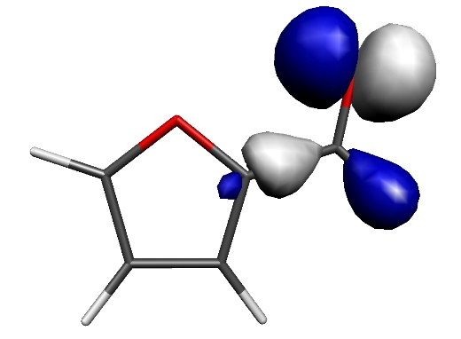 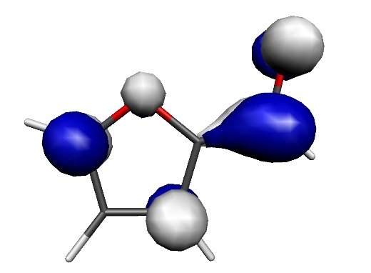

**Figure S2.** Isosurface plot of the HOMO (left) and LUMO (right) for furfural

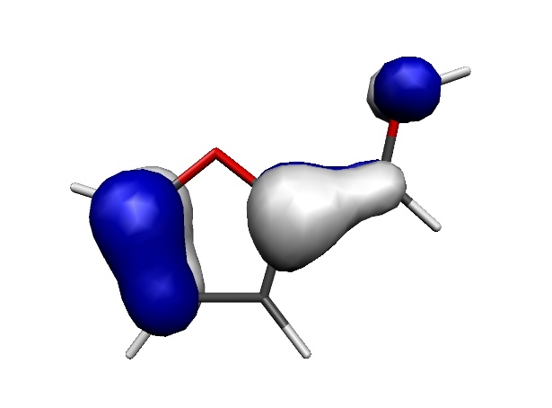 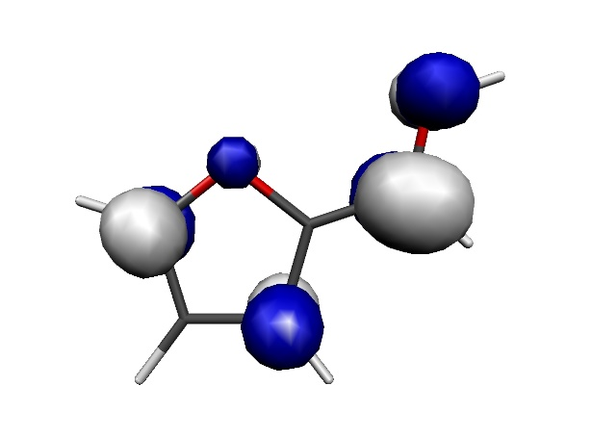

**Figure S3.** Isosurface plot of the HOMO (left) and LUMO (right) for the furfuralium cation

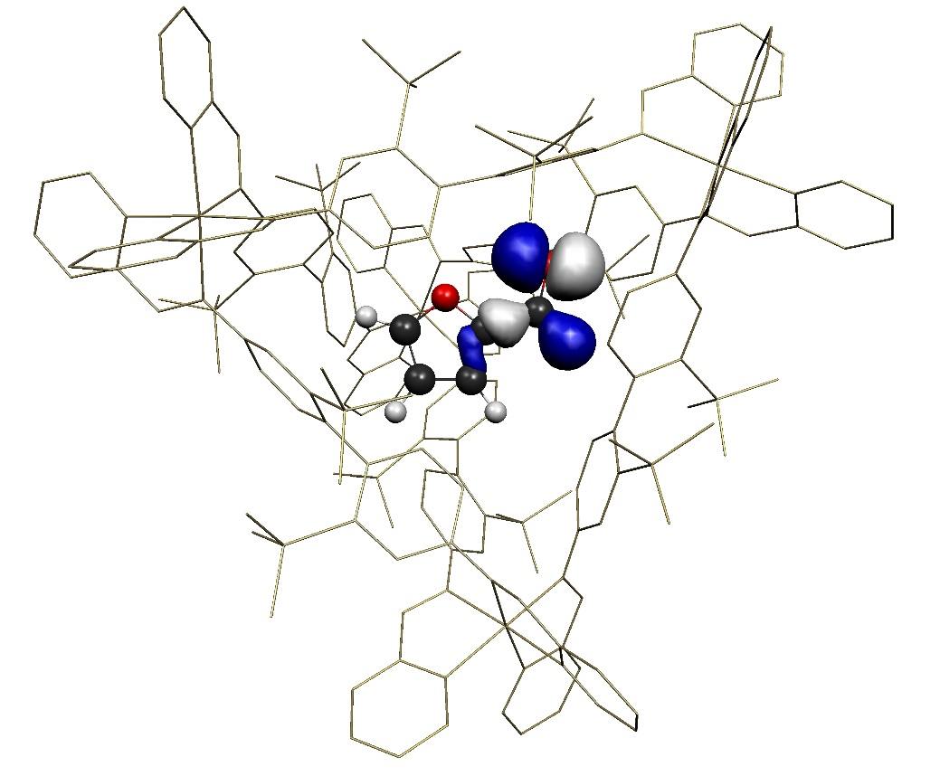

**Figure S4.** Isosurface plot of the HOMO of furfural@Fe4

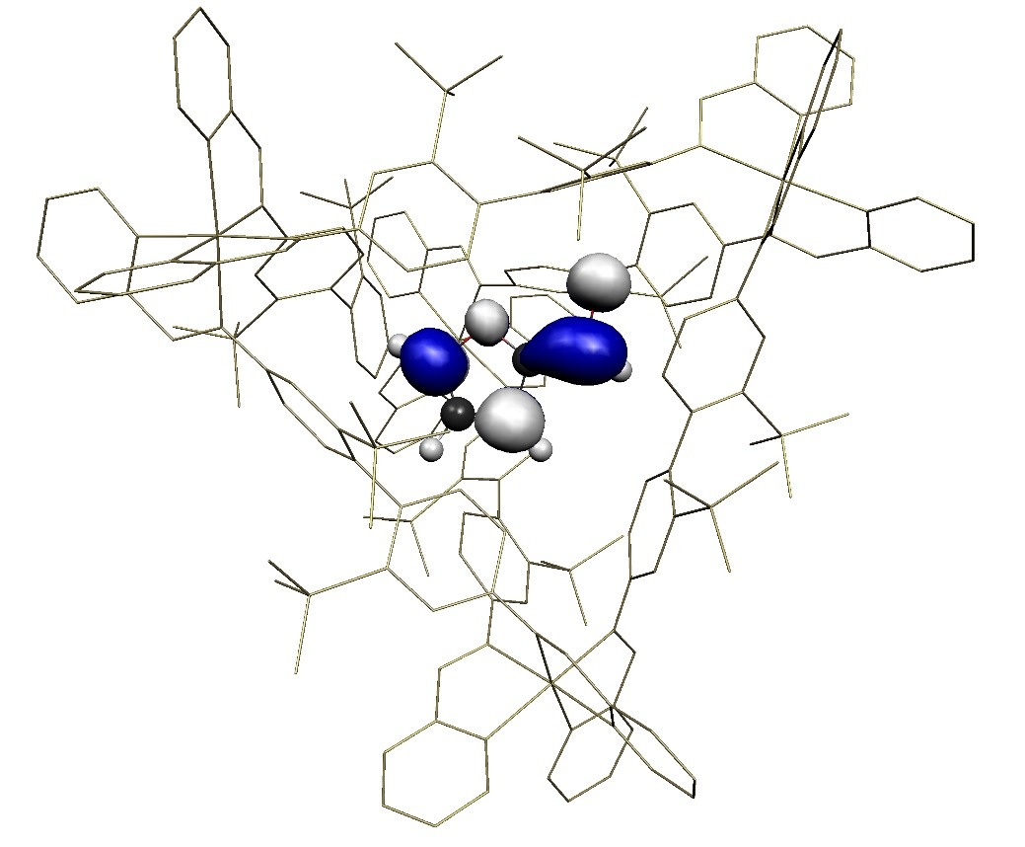

**Figure S5.** Isosurface plot of the LUMO of furfural@Fe4

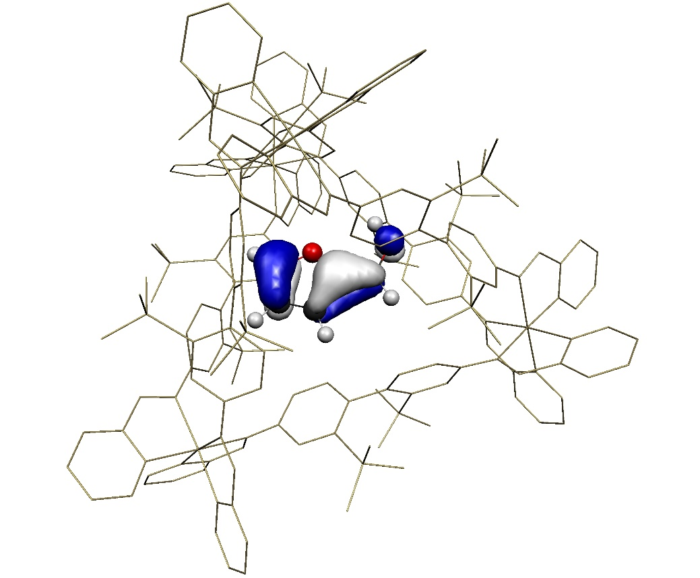

**Figure S6.** Isosurface plot of the HOMO of furfuralium@Fe4

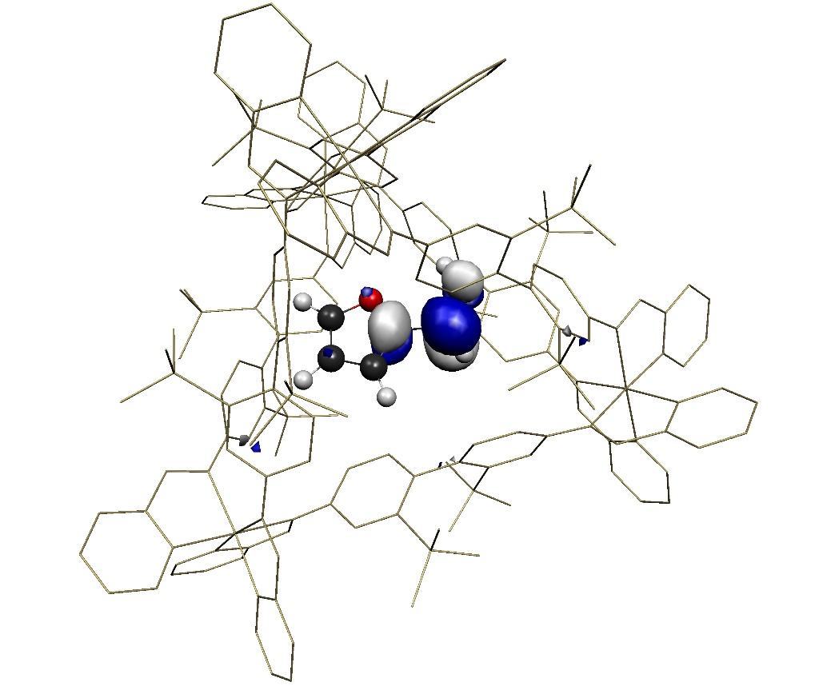

**Figure S7.** Isosurface plot of the LUMO of furfuralium@Fe4

**Table S5.** Geometry Optimized Coordinates for Furfural

C 25.766242003 -12.689030002 6.584066001

C 26.069608003 -14.027515002 6.606795001

C 26.515861003 -14.336449002 5.335320001

O 26.509615003 -13.253025002 4.504834001

C 26.041848003 -12.248642001 5.302623001

C 26.950462003 -15.675627002 4.913261001

O 27.344172003 -15.871966002 3.731572000

H 25.384695003 -12.093142001 7.410392001

H 25.976360003 -14.703527002 7.454643001

H 25.905369003 -11.224833001 4.960937001

H 26.934364003 -16.503999002 5.619074001

**Table S6.** Geometry Optimized Coordinates for Furfuralium

O 23.339822 2.004865 7.568671

C 23.862178 1.038313 8.190501

C 23.102588 -0.199655 8.396733

O 21.828582 -0.379645 7.949597

C 23.586937 -1.306869 9.056753

C 21.531636 -1.645752 8.355541

C 22.580227 -2.231573 9.029226

H 24.878845 1.121652 8.575038

H 24.567060 -1.426124 9.507588

H 20.578265 -2.127409 8.165368

H 22.603226 -3.229820 9.453826

H 23.853968 2.862093 7.420399

**Calculations on *p*-*tert*-butylbenzaldehyde**

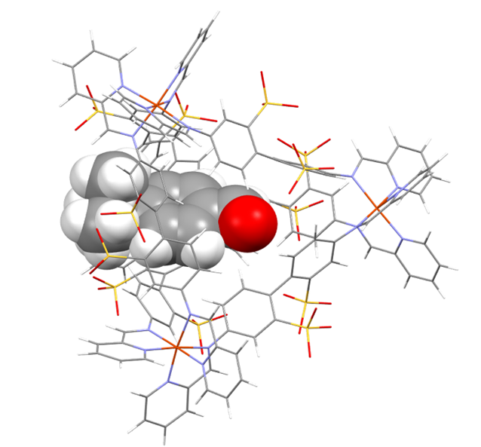

**Figure S8:** Energy-minimized structure for the *p*-*tert*-butylbenzaldehyde substrate (space-filled) encapsulated within the Fe4L6 cage, orientated with aldehyde functionality enclosed within the cage. This, and similar (partially) encapsulated *p*-*tert*-butylbenzaldehyde@Fe4L6 species are around 21 kcal mol–1 less stable than “free” *p*-*tert*-butylbenzaldehyde outside the cage. The length of the substrate exceeds the interior dimensions of the cage such that (in this example) the bulky t-butyl functionality protrudes through one of the triangular faces of the cage.



**Figure S9:** LCMS (negative mode) analysis of the aqueous (cage-containing) phase after reaction shows (in addition to intact cage) a number of minor components with the masses indicated above. The peaks at 432.0, 523.1 and 525.1 corresponding to cage ligands in various states of reduction whilst the peaks at 503.1, 513.0 and 514.1 correspond to the reduced products of scrambling reactions between furfural and the cage ligands. Hence there is a small amount of decomposition of the cage with each addition of hydride and/or aldehyde. These insights not only account for the discrepancy between furfural conversion and yield of furfuryl alcohol, but also suggest why reaction yields decrease in subsequent catalytic cycles.

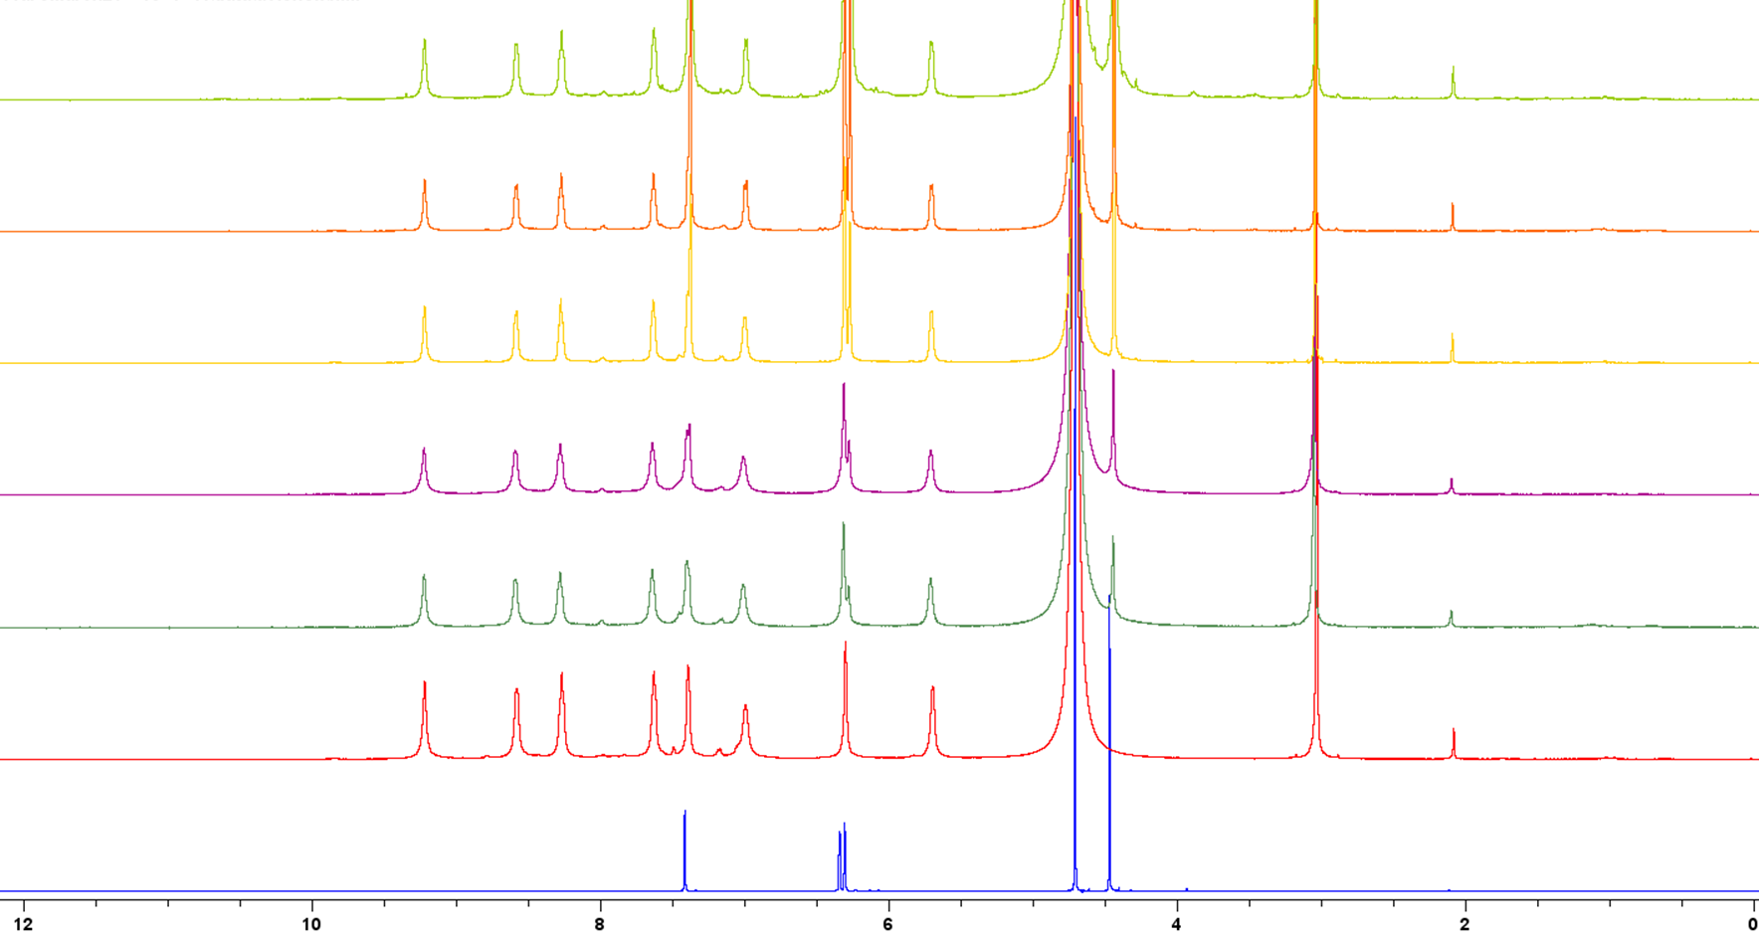

**Figure S10:** Stacked 1H NMR spectra (500 MHz) in D2O at 298 K showing free furfuryl alcohol (blue spectrum, bottom), free FeII4L6 cage on its own (red spectrum, second bottom) and then mixtures of cage and furfuryl alcohol (after equilibration at 50 °C for 6 h) in the following ratios (cage : furfuryl alcohol); 1:6 (dark green), 1:13 (purple), 1:25 (yellow), 1:50 (orange) and 1:100 (light green, uppermost spectrum). There are no obvious peak shifts or new peaks for encapsulated furfuryl alcohol, even at 100-fold excess of the guest (light green spectrum at the top). Meanwhile, peaks for free furfuryl alcohol (bottom spectrum) are not obviously shifted by addition of cage. Moreover, the overlap of these peaks with cage peaks makes observing any slight shifts that there may be impossible. All this suggests a very minimal association constant. The poor encapsulation of furfuryl alcohol relative to furan could be as a result of furfuryl alcohol’s greater electron-richness (disfavouring association with the anionic cage), and is also probably a function of their relative water solubilities: furfural has a solubility of 83 g/L in water at room temperature, but furfuryl alcohol is fully miscible in water at this temperature.



**Figure S11:** Yields of furfuryl alcohol *vs.* time in the presence of 9 mol% cage or in the absence of cage. Yields in the presence of cage (black line and squares for the first addition of furfural and NaCNBH3, and blue line and triangles for the second addition) are isolated yields. Yields in the absence of cage (red line and circles) were determined by 1H NMR and are likely to be slight over-estimates of the amount of furfuryl alcohol produced.The blue trace in the figure above shows the effects of adding a further equivalent of both furfural and NaCNBH3 to an ongoing catalytic reaction at t = 6 h. Typically, conversion of a further 20% of this furfural was then achieved over the following 6 h, corresponding to a further two turnovers of the cage. Alternatively, after a single catalytic run, the Fe4L6 cage could be recovered from the aqueous phase (after extraction of the organics) by precipitation with acetone. After centrifugation and recrystallization from water/acetone, the recovered cage could then be re-used in catalytic experiments (albeit delivering conversion rates of only half that of fresh cage). Taken together, these data suggest that the cage can (at least to some extent, and notwithstanding the degradation pathways mentioned above) be recycled and re-used for more than one catalytic reaction, preforming multiple turnovers in each experiment.

**Entry 1:** 100 mg (0.027 mmol) of [Fe4L6] cage, 29 mg (0.3 mmol) of furfural and 19 mg (0.3 mmol) of NaCNBH3 were taken in 5 mL distilled water under a nitrogen atmosphere and stirred for 6 hours at 50 °C. Isolated yield: 65% (19 mg, 0.19 mmol). 1H NMR (500 MHz, CDCl3) δ = 7.39 (s, J = 1.1 Hz, 1H), 6.34 (d, J = 3.1 Hz, 1H), 6.28 (d, J = 3.2 Hz, 1H), 4.59 (s, 2H), 2.06 (br s, 1H). 13C NMR (126 MHz, CDCl3) δ = 154.15, 142.71, 110.50, 107.89, 57.56. Mass spectroscopy (ESI): mass calculated for C5H6NaO2 ([M+Na]+)­­: 121.0266; Mass found: 121.0239.

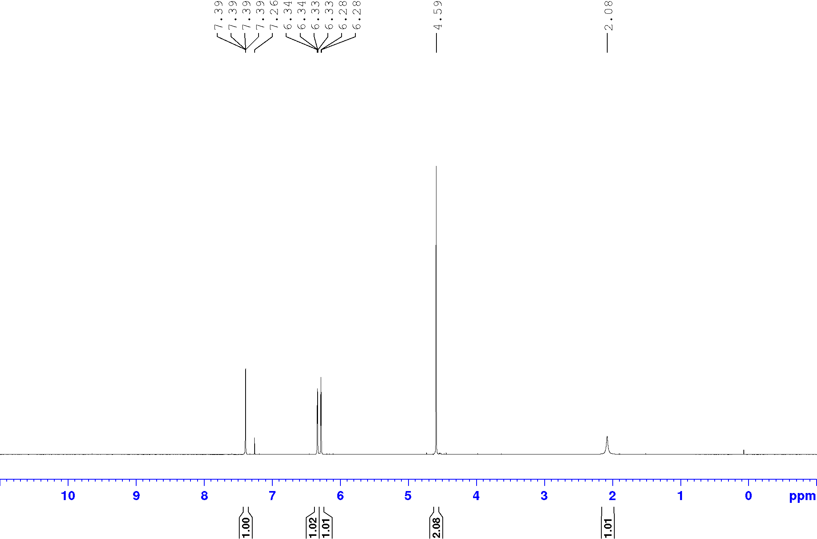

**Figure S12:** 1H NMR of extracted furfuryl alcohol [CDCl3, 500 MHz]

**Entry 2:** 100 mg (0.027 mmol) of [Fe4L6] cage, 33 mg (0.3 mmol) of 5-methylfurfural and 19 mg (0.3 mmol) of NaCNBH3 were taken in 5 mL distilled water under a nitrogen atmosphere and stirred for 6 hours at 50 °C. Isolated yield: 51% (17 mg, 0.15 mmol). 1H NMR (500 MHz, CDCl3) δ = 6.17 (d, *J* = 3.0 Hz, 1H), 5.91 (m, 1H), 4.55 (d, *J* = 6.0 Hz, 2H), 2.29 (s, 3H), 1.66 (t, *J* = 6.0 Hz, 1H). 13C NMR (126 MHz, CDCl3) δ = 152.62, 152.38, 108.94, 106.39, 57.75, 13.72. Mass spectroscopy (ESI): mass calculated for C6H8NaO2 ([M+Na]+)­­: 135.0422; Mass found: 135.0403.

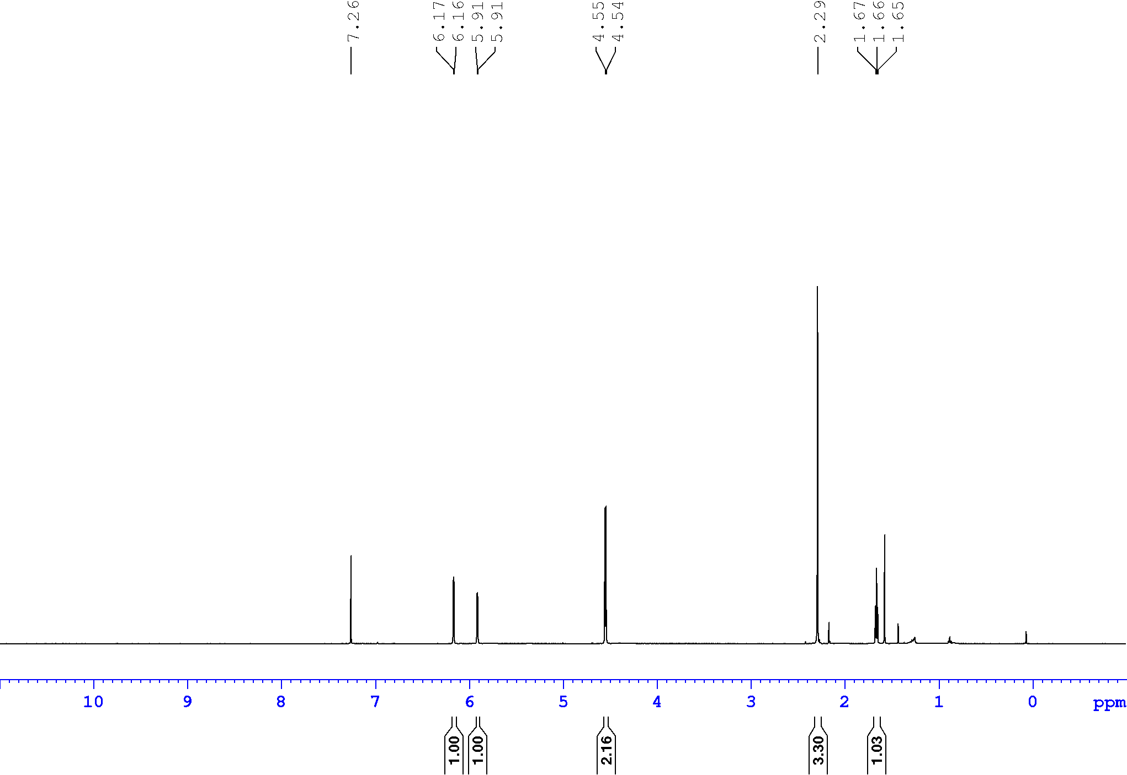

**Figure S13:** 1H NMR of extracted 5-methylfurfuryl alcohol [CDCl3, 500 MHz]

**Entry 3:** 100 mg (0.027 mmol) of [Fe4L6] cage, 32 mg (0.3 mmol) of benzaldehyde and 19 mg (0.3 mmol) of NaCNBH3 were taken in 5 mL distilled water under a nitrogen atmosphere and stirred for 6 hours at 50 °C. Isolated yield: 62% (20 mg, 0.19 mmol). 1H NMR (500 MHz, CDCl3) δ = 7.39-7.28 (m, 5H), 4.68 (s, 2H), 1.99 (br s, 1H). 13C NMR (126 MHz, CDCl3) δ = 141.00, 128.70, 127.79, 127.14, 65.47. Mass spectroscopy (ESI): mass calculated for C7H8NaO ([M+Na]+)­­: 131.0473; Mass found: 131.1604.

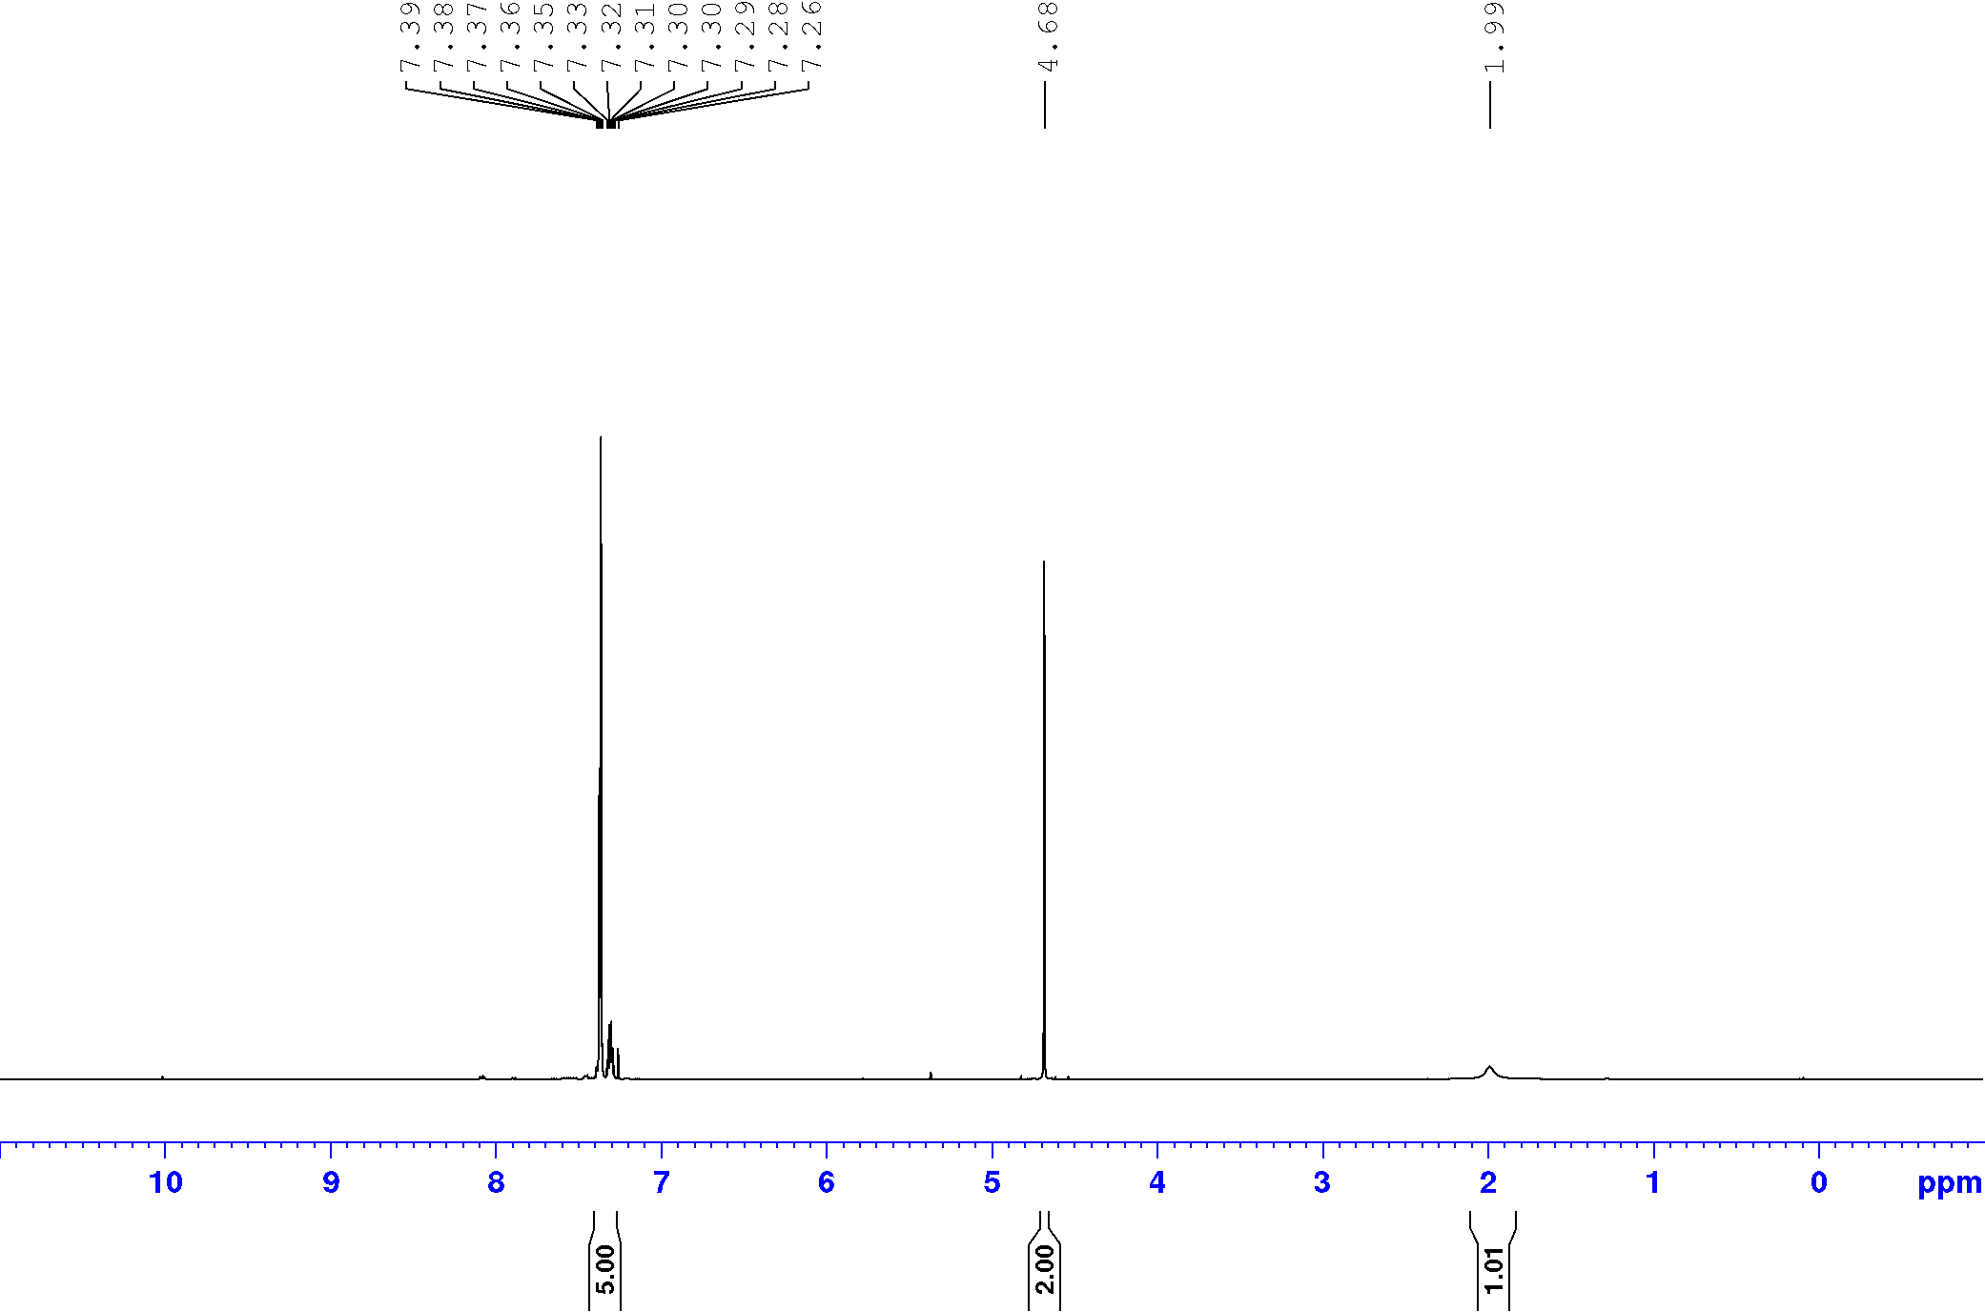

**Figure S14:** 1H NMR of extracted benzyl alcohol [CDCl3, 500 MHz]

**Entry 4:** 100 mg (0.027 mmol) of [Fe4L6] cage, 41 mg (0.3 mmol) of 4-methoxybenzaldehyde and 19 mg (0.3 mmol) of NaCNBH3 were taken in 5 mL distilled water under a nitrogen atmosphere and stirred for 6 hours at 50 °C. Yield:**** 51% (21 mg, 0.15 mmol). 1H NMR (500 MHz, CDCl3) δ = 7.28 (d, *J* = 8.6 Hz, 2H), 6.89 (d, *J* = 8.6 Hz, 2H), 4.60 (s, 2H), 3.81 (s, 3H), 1.77 (br s, 1H). 13C NMR (126 MHz, CDCl3) δ = 159.36, 133.29, 128.80, 114.11, 65.17, 55.45. Mass spectroscopy (ESI): mass calculated for C8H10NaO2 ([M+Na]+)­­: 161.0579; Mass found: 161.0569.

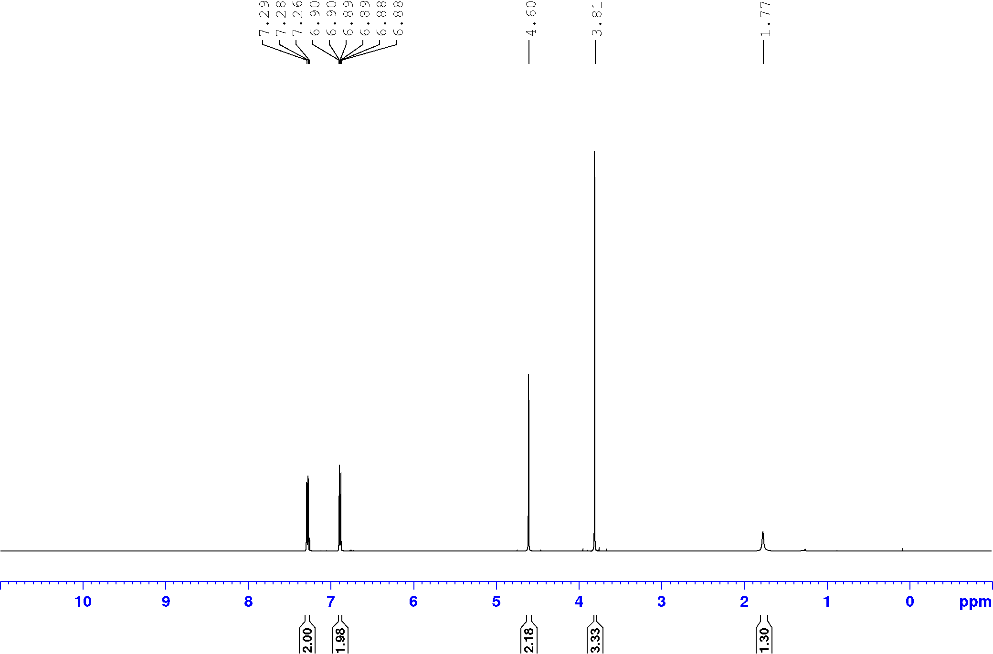

**Figure S15:** 1H NMR of extracted 4-methoxybenzyl alcohol (entry 4) [CDCl3, 500 MHz]



**Entry 5:** 100 mg (0.027 mmol) of [Fe4L6] cage, 45 mg (0.3 mmol) of 4-nitrobenzaldehyde and 19 mg (0.3 mmol) of NaCNBH3 were taken in 5 mL distilled water under a nitrogen atmosphere and stirred for 6 hours at 50 °C. Yield: 60% (27 mg, 0.18 mmol). 1H NMR (500 MHz, CDCl3) δ = 8.20 (d, *J* = 8.6 Hz, 2H), 7.52 (d, *J* = 8.6 Hz, 2H), 4.83 (s, 2H), 2.12 (br s, 1H). 13C NMR (126 MHz, CDCl3) δ = 148.36, 147.44, 127.16, 123.89, 64.15. Mass spectroscopy (ESI): mass calculated for C7H7NNaO3 ([M+Na]+)­­: 176.0324; Mass found: 176.0571.

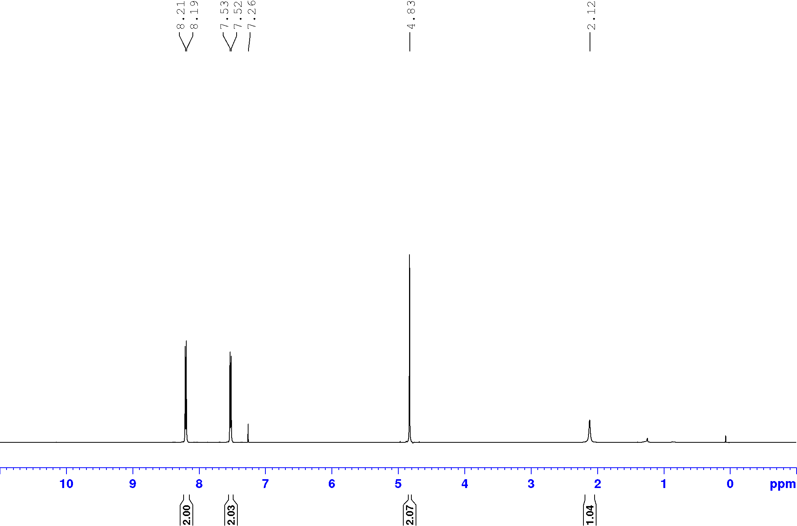

**Figure S16:** 1H NMR of extracted 4-nitrobenzyl alcohol [CDCl3, 500 MHz]

**Entry 6:** 100 mg (0.027 mmol) of [Fe4L6] cage, 36 mg (0.3 mmol) of phenylacetaldehyde and 19 mg (0.3 mmol) of NaCNBH3 were taken in 5 mL distilled water under a nitrogen atmosphere and stirred for 6 hours at 50 °C. Yield: 43% (15 mg, 0.12 mmol). 1H NMR (500 MHz, CDCl3) δ = 7.35-7.24 (m, 5H), 3.89 (t, *J* = 6.6 Hz, 2H), 2.90 (t, *J* = 6.6 Hz, 2H), 1.43 (br s, 1H). 13C NMR (126 MHz, CDCl3) δ = 138.64, 129.22, 128.78, 126.67, 63.88, 39.39. Mass spectroscopy (ESI): mass calculated for C8H10NaO ([M+Na]+)­­: 145.0629; Mass found: 145.0607.

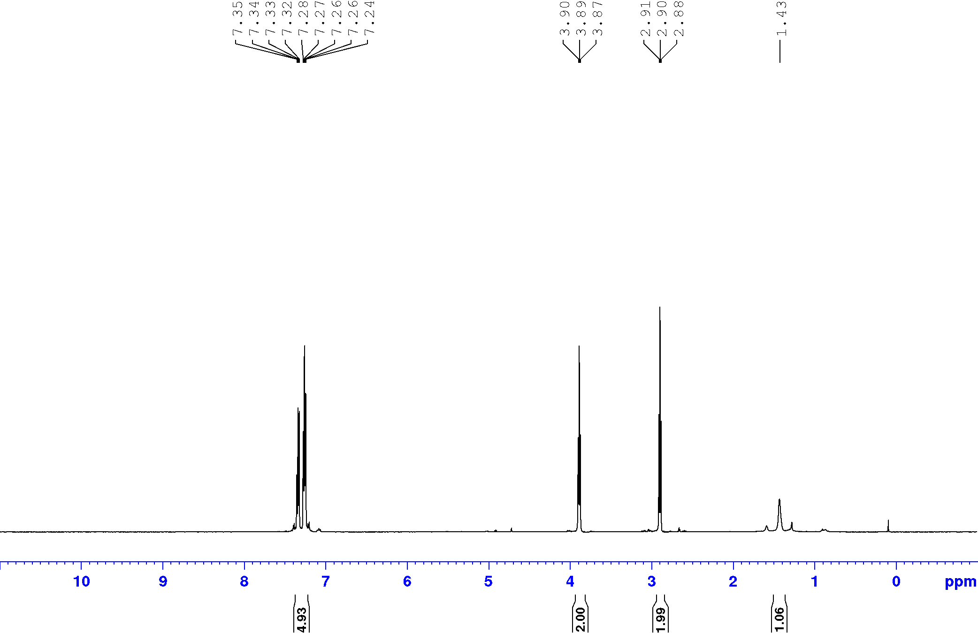

**Figure S17:** 1H NMR of extracted 2-phenylethyl alcohol [CDCl3, 500 MHz]



**Entry 7:** 100 mg (0.027 mmol) of [Fe4L6] cage, 42 mg (0.3 mmol) of 4-chlorobenzaldehyde and 19 mg (0.3 mmol) of NaCNBH3 were taken in 5 mL distilled water under a nitrogen atmosphere and stirred for 6 hours at 50 °C. Yield: 52% (22 mg, 0.15 mmol). 1H NMR (500 MHz, CDCl3) δ = 7.33-7.28 (m, 4H), 4.66 (s, 2H), 1.85 (br s, 1H). 13C NMR (126 MHz, CDCl3) δ = 139.40, 133.50, 128.82, 128.41, 64.68. Mass spectroscopy (ESI): mass calculated for C7H7ClNaO ([M+Na]+)­­: 165.0083; Mass found: 165.0068.

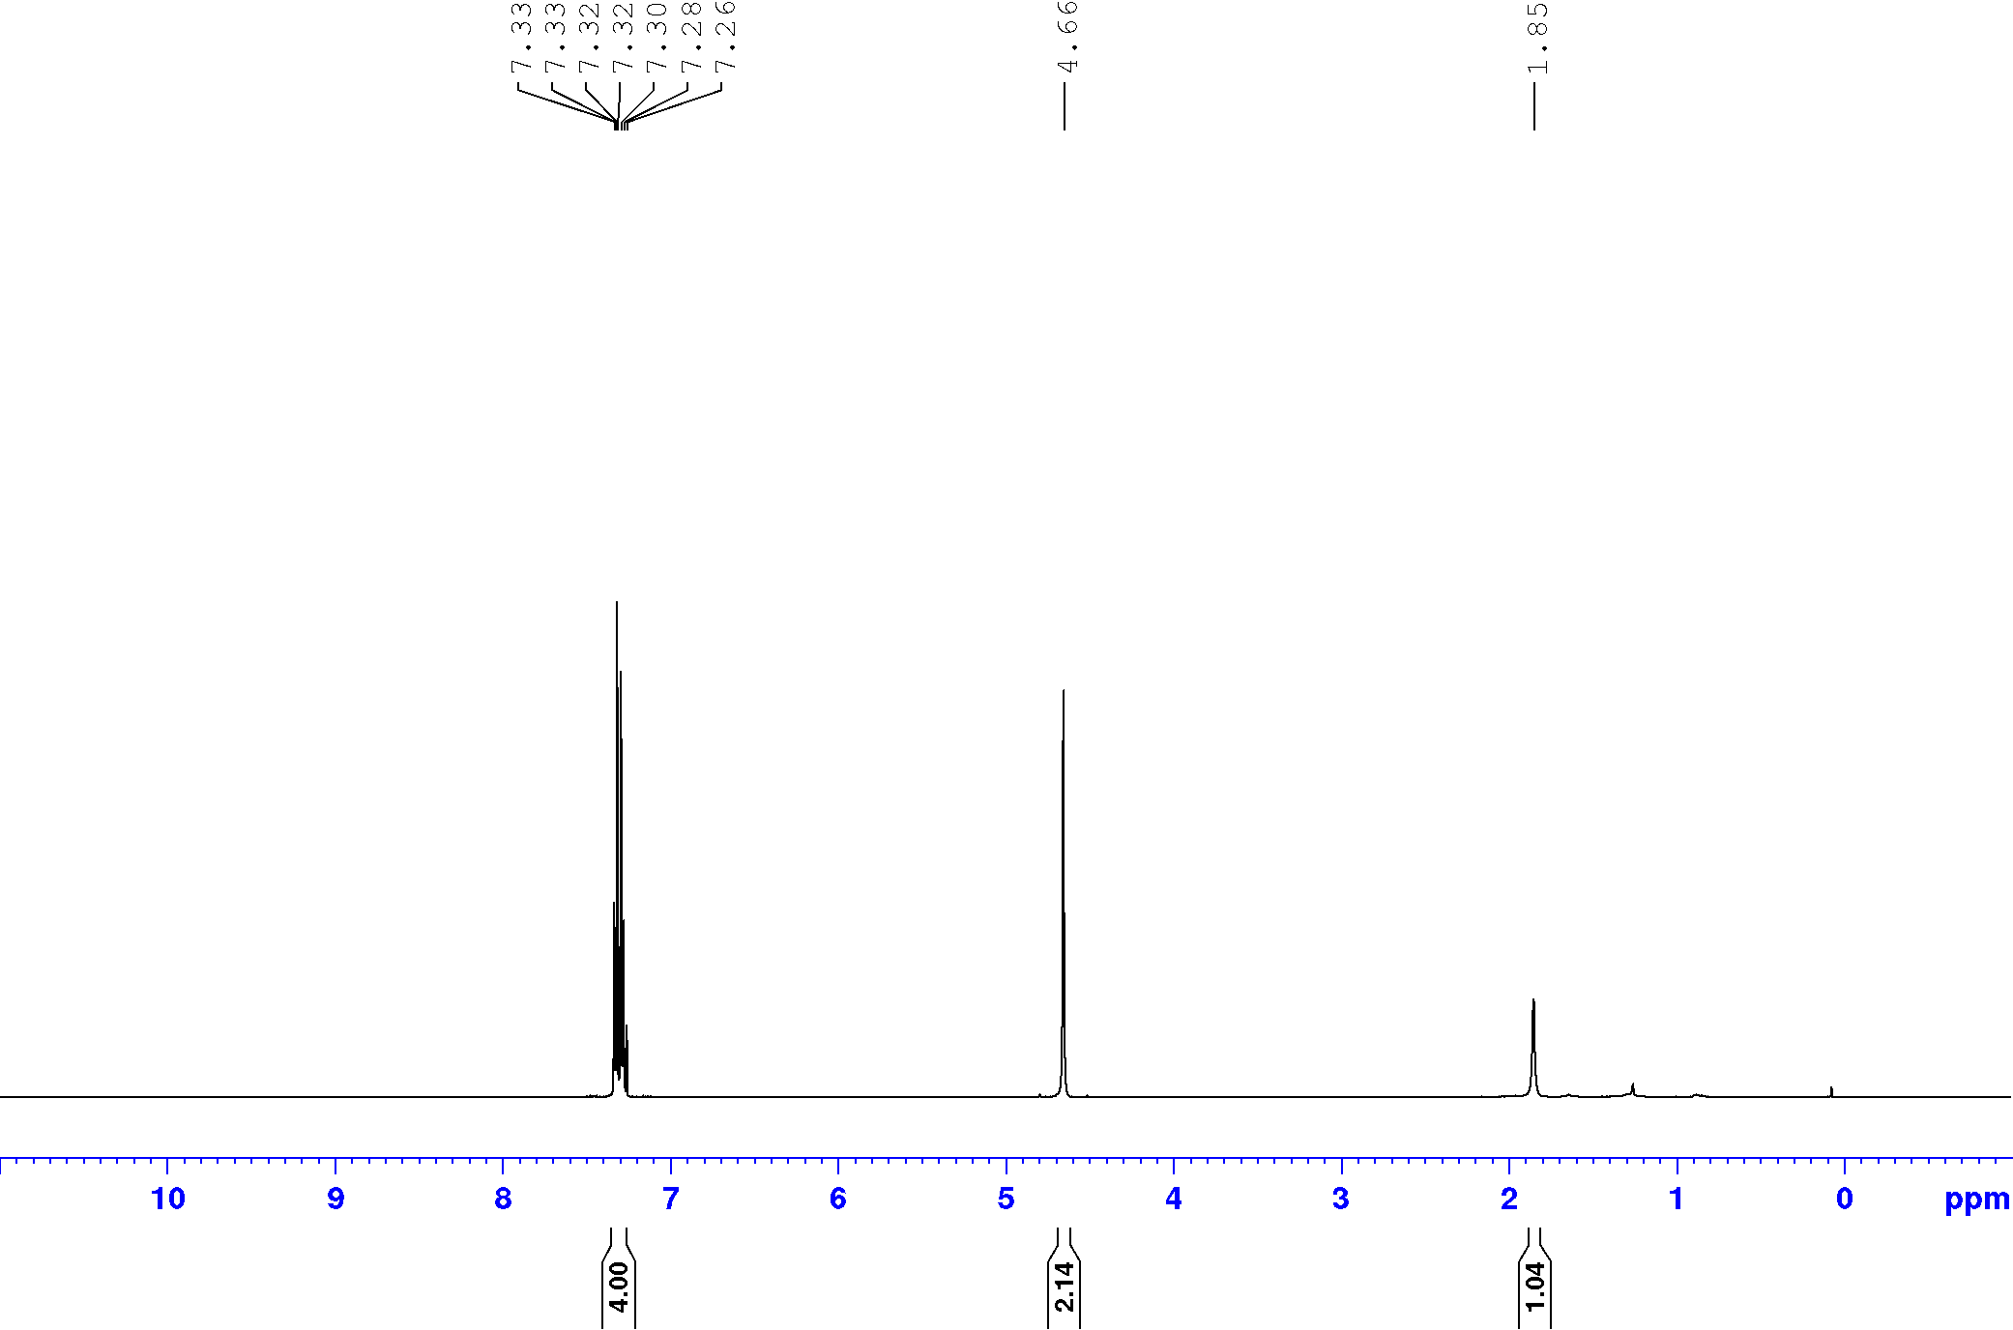

**Figure S18:** 1H NMR of extracted 4-chlorobenzyl alcohol [CDCl3, 500 MHz]

**Entry 8:** 100 mg (0.027 mmol) of [Fe4L6] cage, 36 mg (0.3 mmol) of 4-methylbenzaldehyde and 19 mg (0.3 mmol) of NaCNBH3 were taken in 5 mL distilled water under a nitrogen atmosphere and stirred for 6 hours at 50 °C. Yield: 39% (14 mg, 0.12 mmol). 1H NMR (500 MHz, CDCl3) δ = 7.27 (d, *J* = 7.8 Hz, 2H), 7.18 (d, *J* = 7.8 Hz, 2H), 4.64 (s, 2H), 2.36 (s, 3H), 1.69 (br s, 1H). 13C NMR (126 MHz, CDCl3) δ = 138.09, 137.57, 129.41, 127.29, 65.44, 21.31. Mass spectroscopy (ESI): mass calculated for C8H10NaO ([M+Na]+)­­: 145.0629; Mass found: 145.0609.

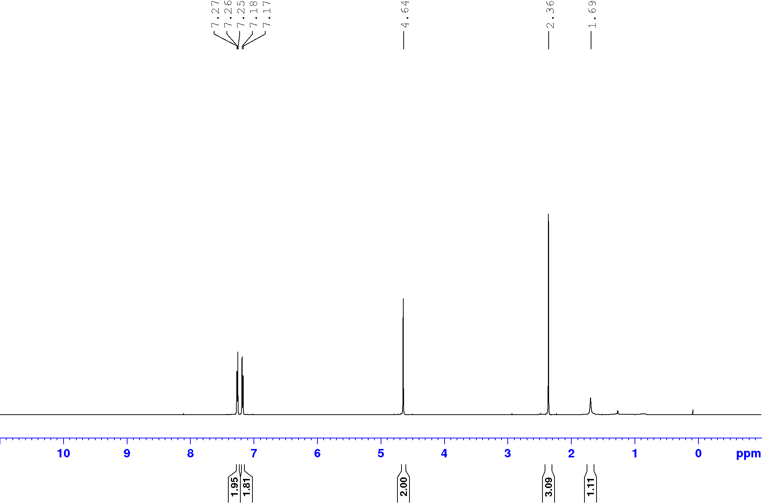

**Figure S19:** 1H NMR of extracted 4-methylbenzyl alcohol [CDCl3, 500 MHz]

**Entry 9:** 100 mg (0.027 mmol) of [Fe4L6] cage, 45 mg (0.3 mmol) of 4-acetylbenzaldehyde and 19 mg (0.3 mmol) of NaCNBH3 were taken in 5 mL distilled water under a nitrogen atmosphere and stirred for 6 hours at 50 °C. Yield: 60% (27 mg, 0.18 mmol). 1H NMR (400 MHz, CDCl3) δ = 7.97 (d, *J* = 8.3 Hz, 2H), 7.45 (d, *J* = 8.3 Hz, 2H), 4.79 (s, 2H), 2.61 (s, 3H), 1.56 (br s, 1H). 13C NMR (101 MHz, CDCl3) δ = 197.8, 146.1, 136.5, 128.6, 126.6, 64.7, 26.6. Mass spectroscopy (ESI): mass calculated for C9H10NaO2 ([M+Na]+)­­: 173.0579; Mass found: 173.0571.

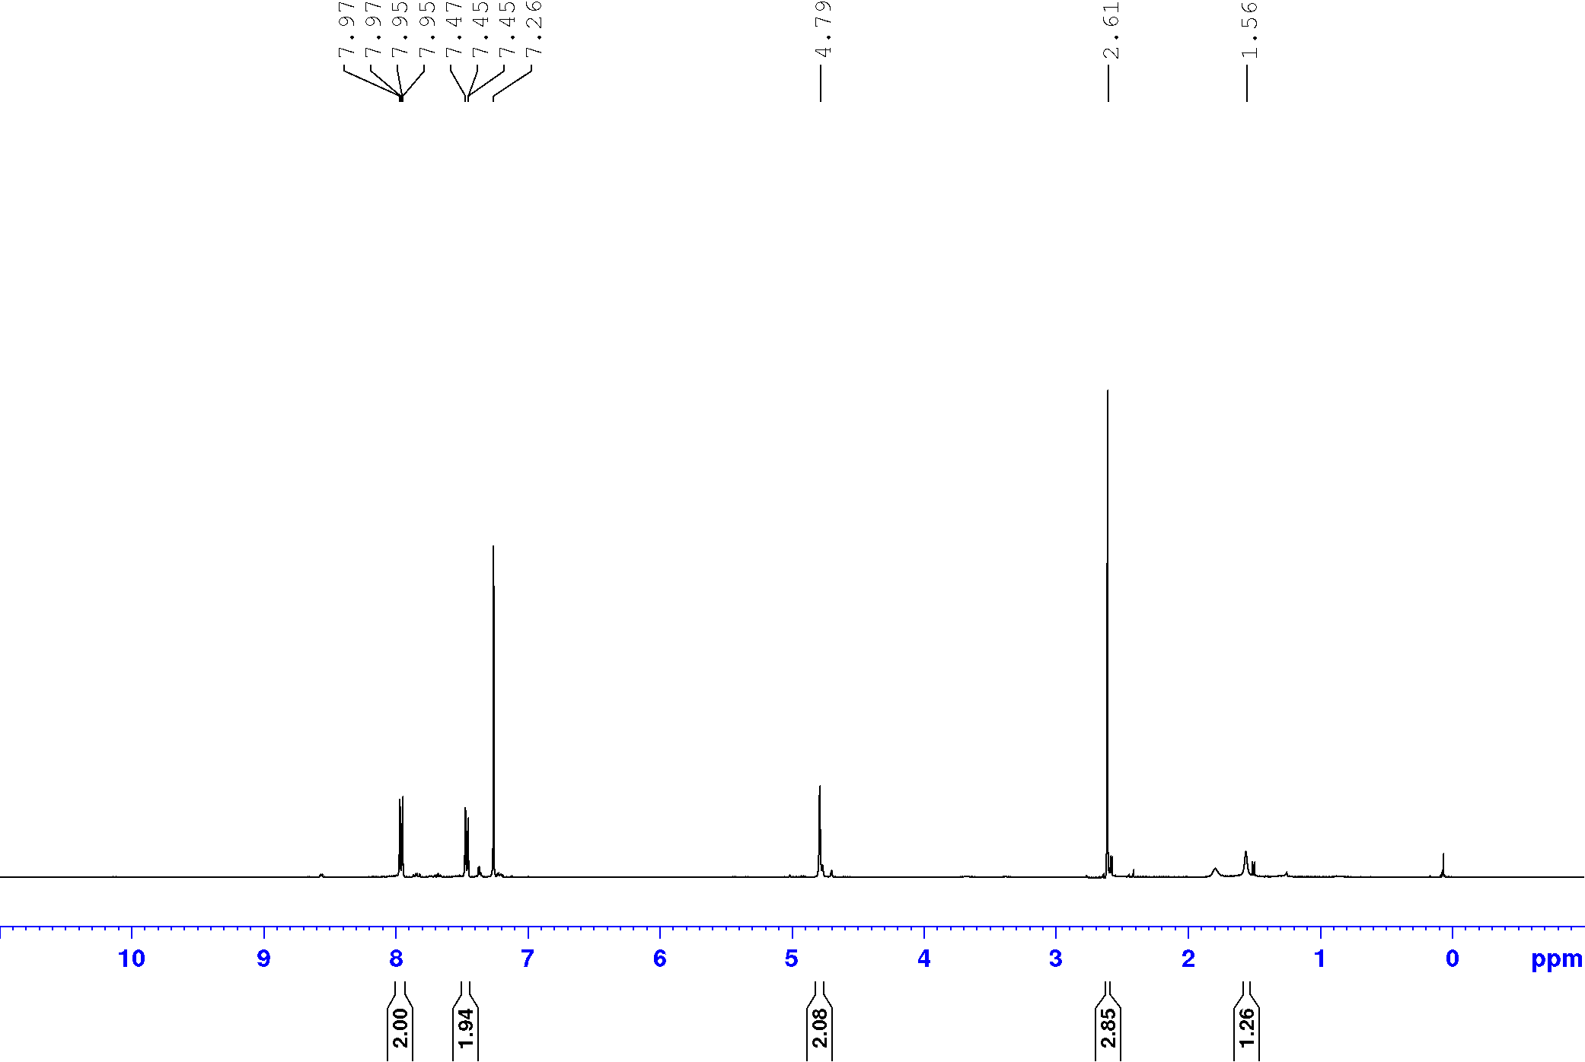

**Figure S20:** 1H NMR of extracted 1-​[4-​(hydroxymethyl)​phenyl]​ethanone [CDCl3, 400 MHz]

**Entry 10:** 100 mg (0.027 mmol) of [Fe4L6] cage, 49 mg (0.3 mmol) of methyl 4-formylbenzoate and 19 mg (0.3 mmol) of NaCNBH3 were taken in 5 mL distilled water under a nitrogen atmosphere and stirred for 6 hours at 50 °C. Yield: 63% (31 mg, 0.19 mmol). 1H NMR (400 MHz, CDCl3) δ = 8.05 (d, *J* = 8.4 Hz, 2H), 7.43 (d, *J* = 8.4 Hz, 2H), 4.78 (s, 2H), 3.92 (s, 3H), 1.55 (br s, 1H). 13C NMR (101 MHz, CDCl3) δ = 166.9, 145.9, 129.9, 129.4, 126.5, 64.8, 52.1. Mass spectroscopy (ESI): mass calculated for C9H10NaO3 ([M+Na]+)­­: 189.0528; Mass found: 189.0518.

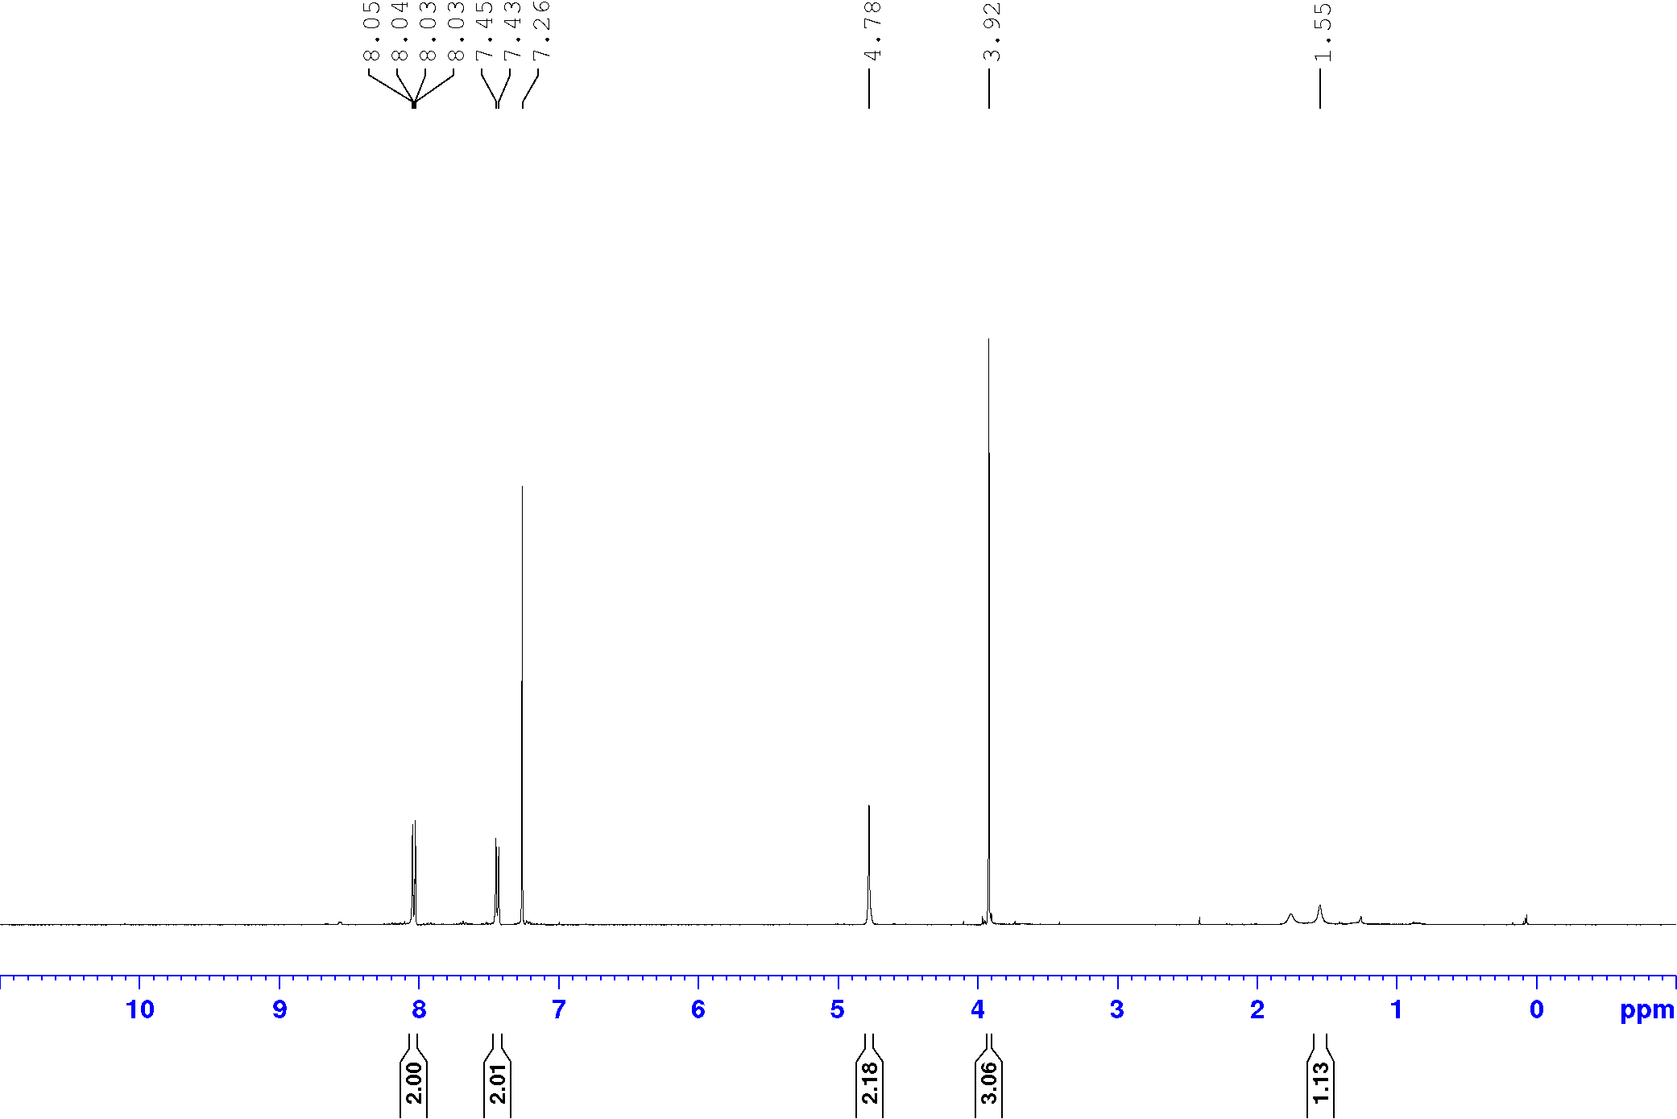

**Figure S21:** 1H NMR of extracted methyl 4-​(hydroxymethyl)​benzoate [CDCl3, 400 MHz]

**Entry 11:** 100 mg (0.027 mmol) of [Fe4L6] cage, 37 mg (0.3 mmol) of 4-hydroxybenzaldehyde and 19 mg (0.3 mmol) of NaCNBH3 were taken in 5 mL distilled water under a nitrogen atmosphere and stirred for 6 hours at 50 °C. Yield: 67% (25 mg, 0.20 mmol). 1H NMR (500 MHz, DMSO-d6) δ = δ 9.22 (s, 1H), 7.09 (d, J = 8.4 Hz, 2H), 6.69 (d, J = 8.4 Hz, 2H), 4.93 (t, J = 5.7 Hz, 1H), 4.35 (d, J = 5.7 Hz, 2H). 13C NMR (126 MHz, DMSO-d6) δ = 156.1, 132.7, 128.0, 114.7, 62.7. Mass spectroscopy (ESI): mass calculated for C7H8NaO2 ([M+Na]+)­­: 147.0422; Mass found: 147.0409.

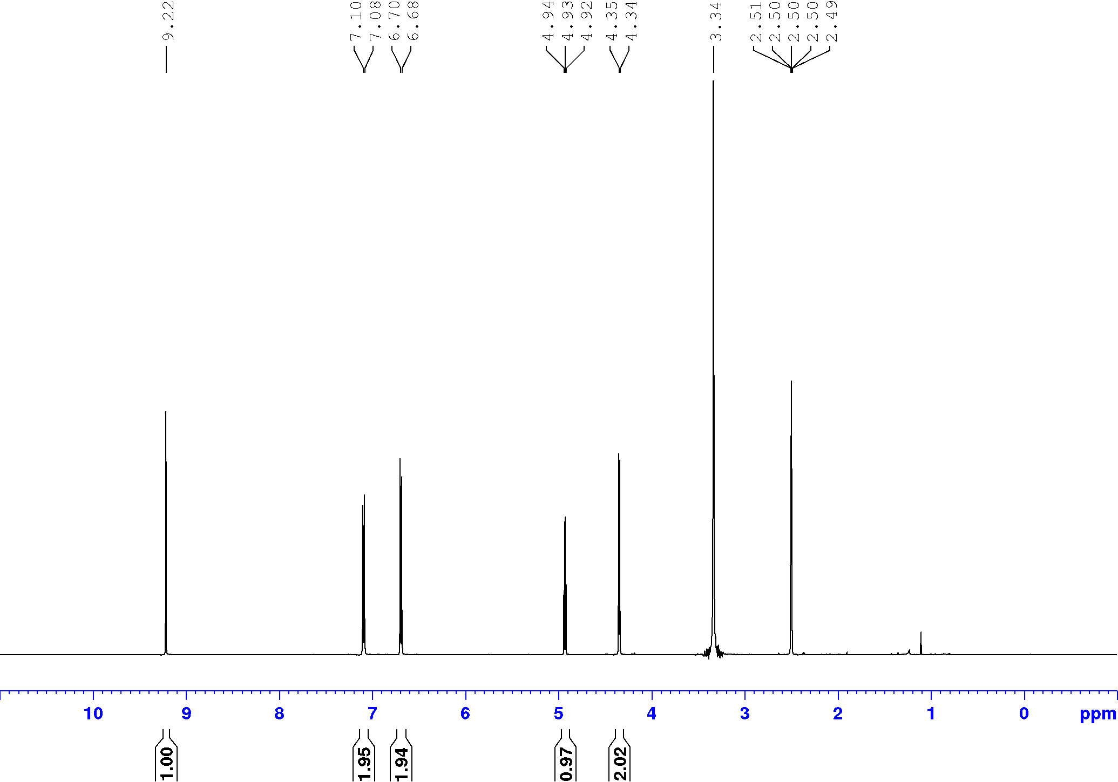

**Figure S22:** 1H NMR of extracted 4-​hydroxybenzyl alcohol [DMSO-d6, 500 MHz].

**Entry 12:** 100 mg (0.027 mmol) of [Fe4L6] cage, 49 mg (0.3 mmol) of 4-tertbutylbenzaldehyde and 19 mg (0.3 mmol) of NaCNBH3 were taken in 5 mL distilled water under a nitrogen atmosphere and stirred for 6 hours at 50 °C. Yield: 27% (13.3 mg, 0.08 mmol). 1H NMR (400 MHz, CDCl3) δ = 7.41 (d, J = 8.4 Hz, 2H), 7.32 (d, J = 8.4 Hz, 2H), 4.68 (d, J = 5.7 Hz, 2H), 1.61 (t, J = 5.7 Hz, 1H), 1.33 (s, 9H). 13C NMR (101 MHz, CDCl3) δ = 150.8, 137.9, 126.9, 125.5, 65.2, 34.6, 31.3. Mass spectroscopy (ESI): mass calculated for C11H16NaO3 ([M+Na]+)­­: 187.1099; Mass found: 187.1098.

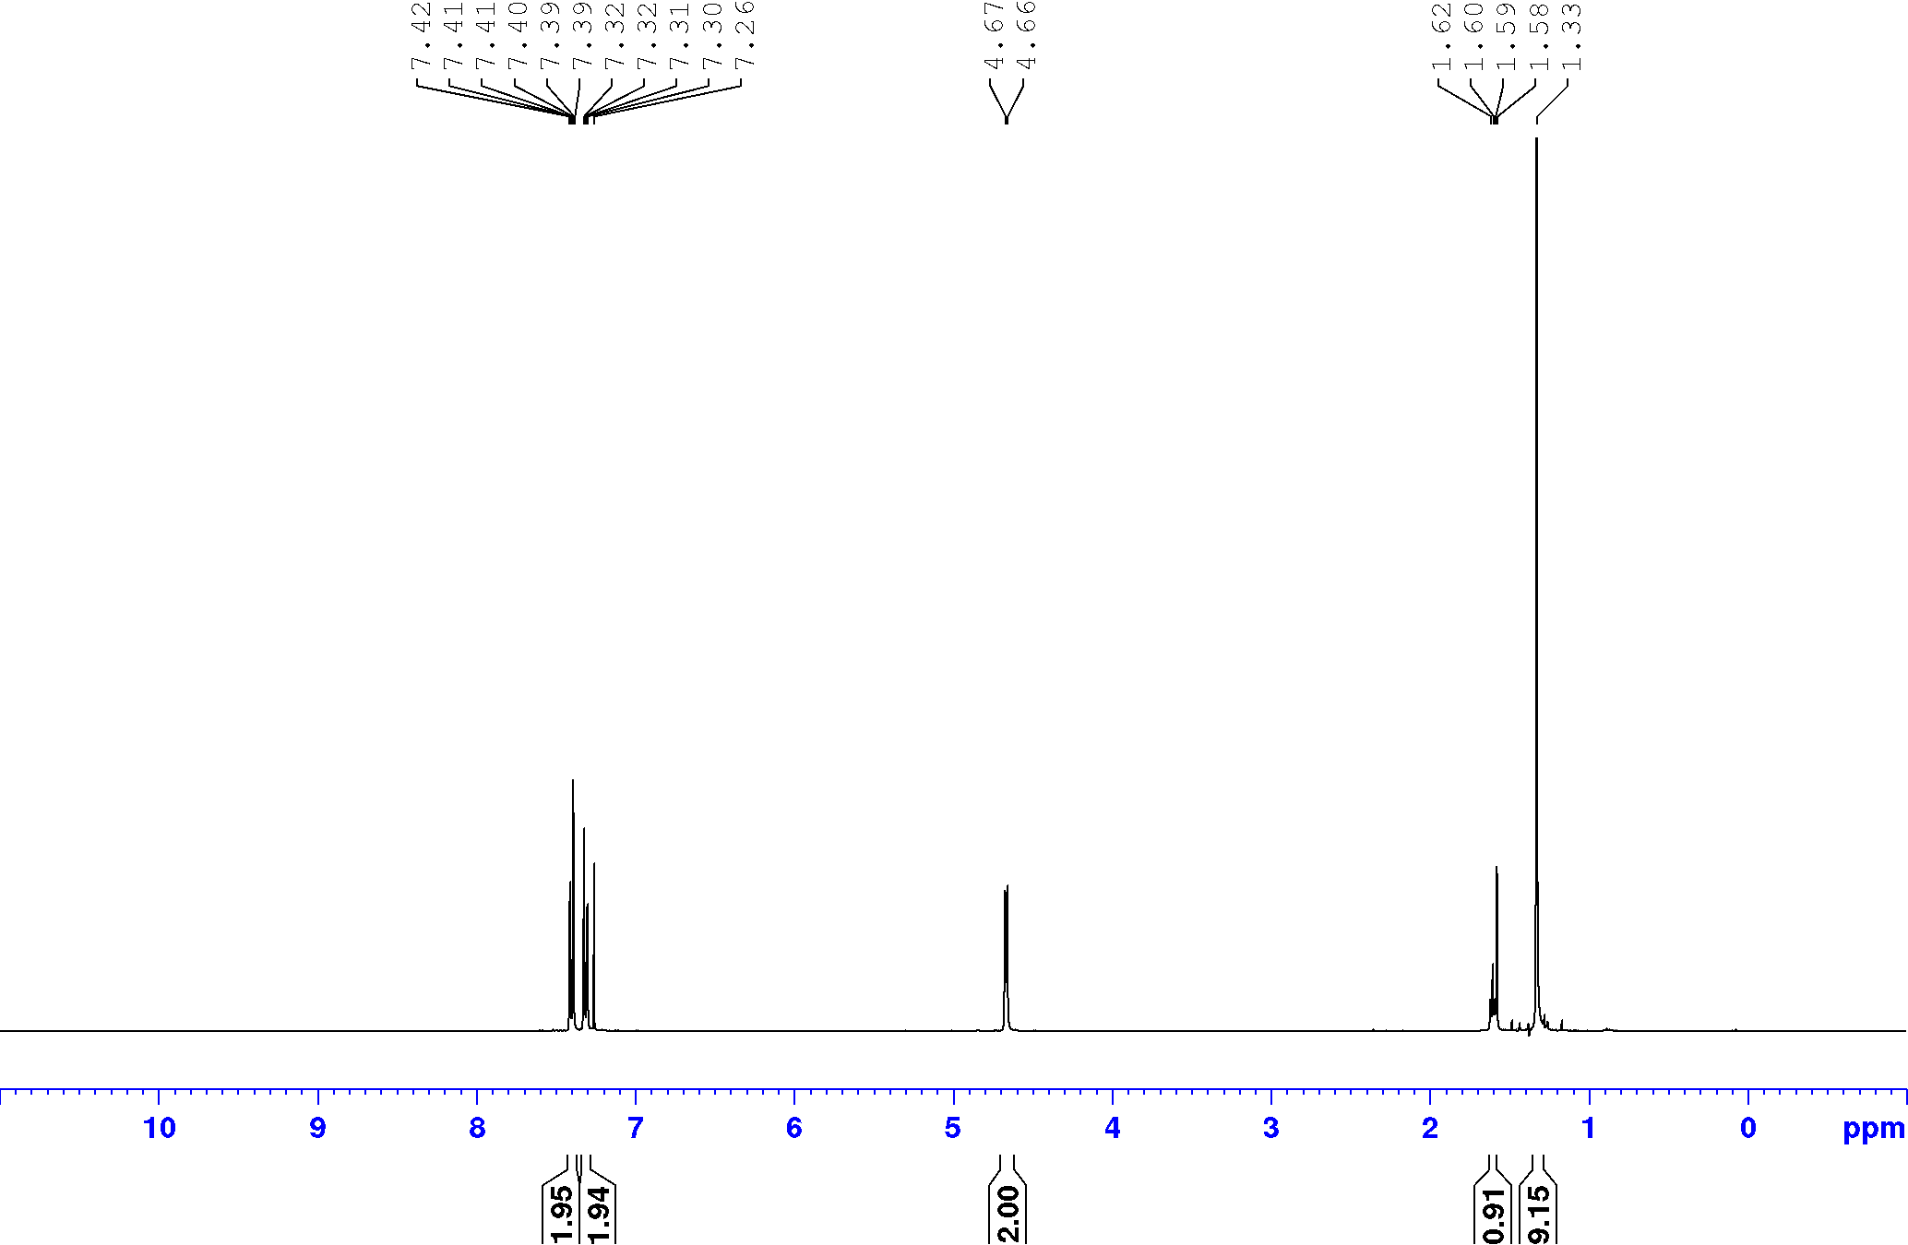

**Figure S23:** 1H NMR of extracted methyl 4-​tertbutylbenzyl alcohol [CDCl3, 400 MHz]

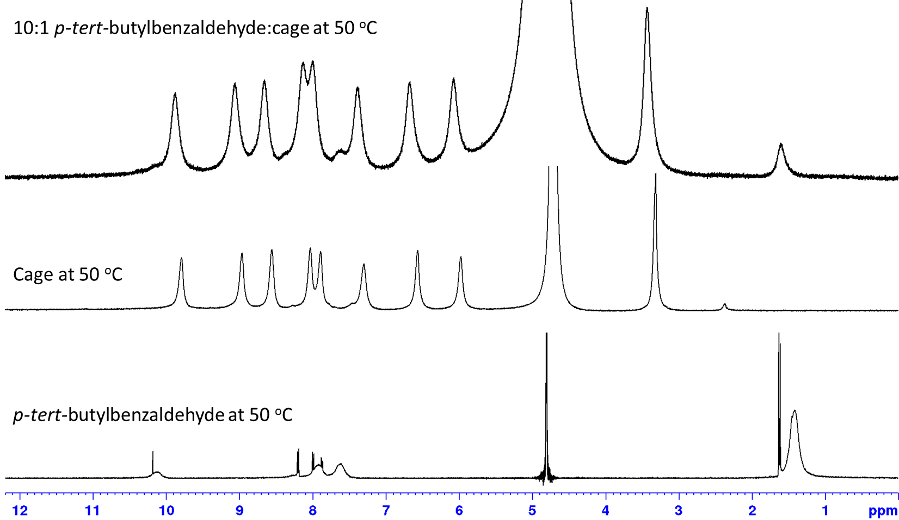

**Figure S24:** Stacked 1H NMR spectra (500 MHz) in D2O at 323 K of *p-tert-*butylbenzaldehyde on its own (bottom), FeII4L6 cage on its own (middle) and a 1:10 mixture of cage and *p-tert-*butylbenzaldehyde (top). Upon addition of the *p-tert-*butylbenzaldehyde to the cage, both sets of peaks broaden considerably, consistent with an intermediate rate of exchange on the NMR timescale.

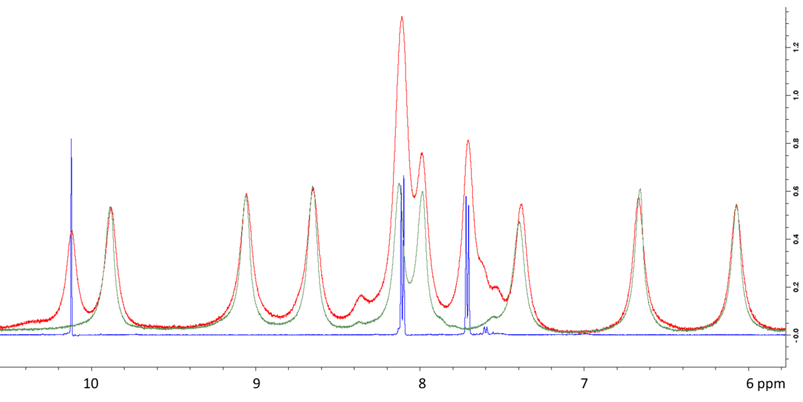

**Figure S25:** Overlaid 1H NMR spectra (500 MHz) in D2O at 323 K of *p-*tolualdehyde on its own (blue), FeII4L6 cage on its own (green) and a 1:10 mixture of cage and *p-*tolualdehyde (red). Upon addition of the *p-*tolualdehyde to the cage, both sets of peaks broaden considerably, consistent with an intermediate rate of exchange on the NMR timescale.

**References**

S1. P. Mal, D. Schultz, K. Beyeh, K. Rissanen, J. R. Nitschke, *Angew. Chem. Int. Ed.* **2008**, *47*, 8297.

S2. F. Neese, *WIREs Comput. Molec. Sci.* **2012**, *2*, 73.

S3. M. Thompson, 2005 *ArgusLab 4.01*. PlanariaSoftware LLC, Seattle, WA, USA. See http://www.ArgusLab.com.

S4. a) A. D. Becke, *Phys. Rev. A* **1988**, *38*, 3098; b) J. P. Perdew, *Phys. Rev. B* **1986**, *33*, 8822.

S5. A. Klamt, G. Schüürmann, *J. Chem. Soc., Perkin Trans. 2***1993**, 799.

S6. a) A. Schäfer, H. Horn, R. Ahlrichs, *J. Chem. Phys.* **1992**, *97*, 2571; b) A. Schäfer, C. Huber, R. Ahlrichs, *J. Chem. Phys.* **1994**, *100*, 5829; c) F. Weigend, R. Ahlrichs, *Phys. Chem. Chem. Phys.* **2005**, *7*, 3297.

S7. F. Weigend, R. Ahlrichs, *Phys. Chem. Chem. Phys.* **2005**, *7*, 3297.

S8. a) S. Grimme, J. Antony, S. Ehrlich, H. Krieg, *J. Chem. Phys.* **2010**, *132*, 154104; b) S. Grimme, S. Ehrlich, L. Goerigk, *J. Comput. Chem.* **2011**, *32*, 1456.

S9. a) E. van Lenthe, J. G. Snijders, E. J. Baerends, *J. Chem. Phys.* **1996**, *105*, 6505; b) E. van Lenthe, A. van der Avoird, P. E. S. Wormer, *J. Chem. Phys.* **1998**, *108*, 4783; c) J. H. van Lenthe, S. Faas, J. G. Snijders, *Chem. Phys. Lett.* **2000**, *328*, 107.

S10. C. J. van Wüllen, *J. Chem. Phys.* **1998**, *109*, 392.

S11. F. Neese, *J. Comput. Chem.* **2003**, *24*, 1740.

S12. a) P. Pulay, *Chem. Phys. Lett.* **1980**, *73*, 393; b) P. Pulay, *J. Comput. Chem.* **1982**, *3*, 556.

S13. *Molekel*, Advanced Interactive 3D-Graphics for Molecular Sciences, Swiss National Supercomputing Center. https://ugovaretto.github.io/molekel/