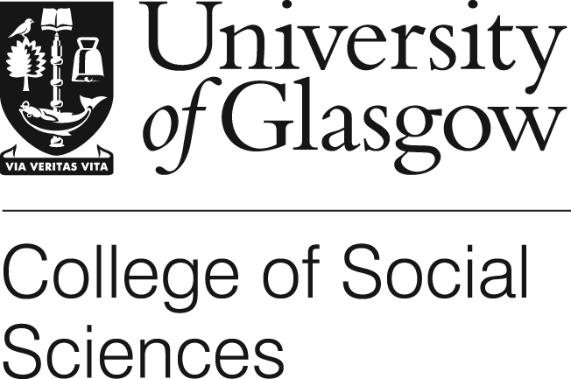 Consent Form

Title of Project: International transfer and translation of end of life care interventions: the case of the Liverpool Care Pathway for the Dying Patient

Name of Researcher: Hamilton Inbadas, Shahaduz Zaman, Alexander Whitelaw, David Clark

I confirm that I have read and understood the Participant Information Sheet for the above study and have had the opportunity to ask questions.

I understand that my participation is voluntary and that I am free to withdraw at any time, without giving any reason.

- I consent / do not consent (delete as applicable) to interviews being audio-recorded.

- I consent / do not consent to reveal my identity in any publication arising from this research.

- I consent / do not consent to anonymise my role or substitute with a cognate role

- The material will be treated as confidential and kept in secure storage at all times.
- The material will be retained in secure storage for use in future academic research
- The material may be used in future publications, both print and online.
- I agree to waive my copyright to any data collected as part of this project.
- Reports and publications resulting from this study will be available to interviewees on request.

I agree to take part in this research study

I do not agree to take part in this research study

Name of Participant ………………………………………… Signature …………………………………………………….

Date ……………………………………

Name of Researcher ………………………………………………… Signature …………………………………………………….

Date ……………………………………

End of consent form ……………………………………………………………………………………………………………………………………………

