Decoupled Electrolysis using a Silicotungstic Acid Electron-Coupled-Proton Buffer in a Proton Exchange Membrane Cell
Greig Chisholm, Leroy Cronin* and Mark D. Symes*
WestCHEM, School of Chemistry, University of Glasgow, Glasgow. G12 8QQ, United Kingdom
*Email: mark.symes@glasgow.ac.uk; lee.cronin@glasgow.ac.uk

Materials and Methods
1. Materials and General Methods: Sodium bicarbonate, potassium sulfate, calcium nitrate and magnesium chloride were purchased from Sigma Aldrich. All chemical reagents were used as purchased. All aqueous solutions were prepared with ultrapure grade water (18.2 MΩ-cm resistivity), unless otherwise stated. All other materials were obtained as stated in the text. All electrochemical data were collected using a BioLogic SP-150 potentiostat coupled to a BioLogic VMP-3B 20A booster. Data were collected and analysed using the EC-Lab software (BioLogic, version 10.40).

2. Electrolysis System Design and Construction: A general schematic of the set-up used in this work is shown in Figure 1.
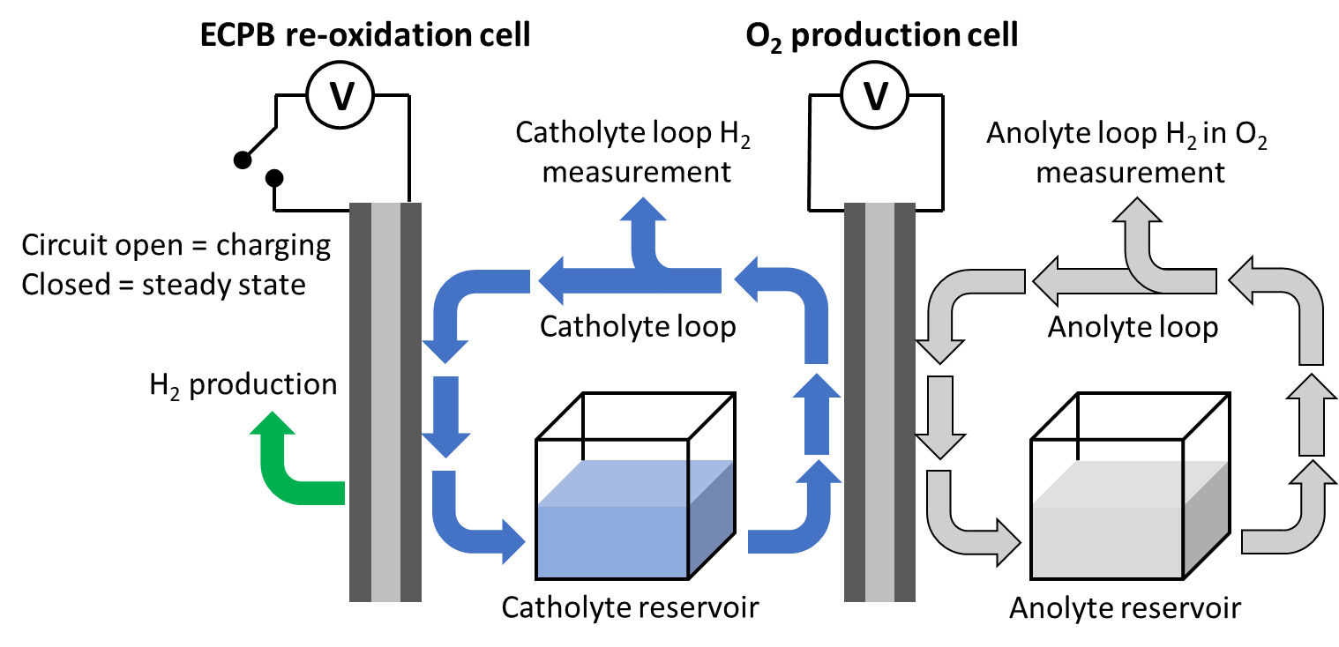
Figure 1: A schematic of the device set-up used in this work. A full description of materials and construction is given in the text.

The oxygen-producing electrochemical cell was constructed as follows: the anode of this cell consisted of a 10 mm-thick titanium serpentine flow field utilising 6 parallel flow channels of 1 mm² cross-section and a platinised titanium mesh (supplied by Fuelcellsetc). These elements were sealed using a 0.1 mm-thick polytetrafluoroethylene (PTFE) gasket (Labtex). The cathode consisted of a 10 mm-thick titanium serpentine flow field as described above and a layer of TGP-H60 carbon paper (Alfa Aesar). Prior to insertion of the cathodic flow plate into the cell, the flow fields of the plate were immersed in Aqua Regia for 90 minutes. This ensured a completely clean surface and minimised any parasitic cathodic hydrogen generation. These elements were sealed using a 0.15 mm-thick cellulose fibre gasket (Klinger, AE5057613). The anode and cathode were separated by a Nafion 117-based catalyst-coated membrane supplied by Ion Power. This membrane was coated with IrO₂ (1 mg/cm²) (anode side, producing oxygen). No catalyst was applied to the cathode side (reducing the Electron-Coupled-Proton Buffer, ECPB). The active area of the membrane was 12.96 cm². The anode and cathode were compressed against the membrane via 10 mm-thick PTFE insulating plates and 10 mm-thick aluminium end plates. The bolts fastening the cells were tightened to a torque of 5 Nm. Prior to all experiments, the catholyte loop and reservoir were sparged with argon for 30 minutes at a flow rate of 300 mL/min.
The electrochemical cell for re-oxidation of the reduced ECPB was constructed from similar components to those used for the oxygen-generating cell as follows. The anode of this cell consisted of a 3 mm-thick titanium serpentine flow field, and a layer of TGP-H60 carbon paper. These elements were sealed using a 0.15 mm-thick cellulose fibre gasket. The cathode consisted of a 3 mm-thick titanium serpentine flow field and a layer of TGP-H60 carbon paper. These elements were sealed using a 0.15 mm-thick cellulose fibre gasket. The anode and cathode were separated by a Nafion 117-based catalyst-coated membrane supplied by Ion Power. This membrane was coated with Pt (0.3 mg/cm²) (cathode side, for hydrogen generation). No catalyst was applied to the anode side (ECPB re-oxidation). The active electrode area of this membrane electrode assembly was 12.96 cm². The anode and cathode were compressed against the membrane via 10 mm-thick PTFE insulating plates and 10 mm-thick aluminium end plates. The bolts fastening the cells were tightened to a torque of 5 Nm.

3. Configuration of Standard PEM Electrolyser: For comparison between coupled and decoupled electrolysis, a conventional Proton Exchange Membrane (PEM) electrolyser was constructed as follows. The anode of this cell consisted of a 3 mm-thick titanium serpentine flow field and a platinised titanium mesh. These elements were sealed using a 0.1 mm-thick PTFE gasket. The cathode consisted of a 3 mm-thick titanium serpentine flow field and a layer of TGP-H60 carbon paper. These elements were sealed using a 0.15 mm-thick cellulose fibre gasket. The anode and cathode were separated by a Nafion 117-based catalyst-coated membrane supplied by Ion Power. This membrane was coated with IrO₂ (1 mg/cm²) (anode side) and platinum (0.3 mg/cm²) (cathode side). The active area of the membrane was 12.96 cm². The anode and cathode were compressed against the membrane via 10 mm-thick PTFE insulating plates and 10 mm-thick aluminium end plates. The bolts fastening the cells were tightened to a torque of 5 Nm. Unless stated otherwise, ultra-pure water (18.2 MΩ-cm resistivity) was pumped through the anode of this electrochemical cell at a rate of 40 mL min^{–1}. The temperature of the water reservoir was maintained using an oil bath such that the temperature of the water entering the cell was 30 °C. A gas outlet from this anolyte reservoir was connected to the auto-sampling port of the gas chromatography machine (see below) to monitor gas compositions as a function of operational parameters. A current potential curve was obtained for this cell to test its operation (Figure 2). This curve was obtained by stepping the voltage in 100 mV steps at 10 minute intervals. The average current was measured across the last 5 minutes of each interval. The performance of the electrolyser was comparable to that of proton exchange membrane electrolysers of similar construction at similar temperatures reported in the literature [-].
Figure 2: Current-potential curve for the conventional proton exchange membrane electrolyser used as a comparison to the ECPB-mediated system.

4. Quantifying Decoupling of the Oxygen and Hydrogen Evolution Reactions: The extent of parasitic hydrogen evolution on the cathode side of the cell during reduction of the ECPB was gauged by collecting the hydrogen gas generated in a gas burette. The number of moles of hydrogen to which this volume equated was then calculated by taking the volume of 1 mole of an ideal gas at room temperature and pressure to be 24.5 L. This number of moles was then compared to the number of moles of hydrogen that could theoretically have been produced if all the charge passed during the reduction reaction had been used in driving the hydrogen evolution reaction (instead of ECPB reduction). This theoretical (0% decoupling) number of moles of hydrogen was obtained by dividing the charge passed during the electrolysis by 2F (where F is the Faraday constant). The efficiency of decoupling (as a %) is then obtained by applying the formula:
$$Decoupling Efficiency = 1- \frac{moles of hydrogen detected}{theoretical max. moles hydrogen } × 100$$

5. Quantifying Hydrogen Levels in the Oxygen Stream: The oxygen stream from the anode side of the cells was routed through an Agilent Technologies 7890A gas chromatography (GC) system (equipped with a thermal conductivity detector) via a pneumatically-operated automatic gas sampling valve. The cells were connected to the GC system using 316 stainless steel tubing of ⅛ inch internal diameter. An Agilent 19041P-MS4 column was used (dimensions = 30 m × 320 μm × 12 μm) at a flow rate of 0.45108 mL min^{–1}, and a pressure of 2.8504 psi. The GC oven temperature was set to 27 °C and no carrier gas was used. The GC system was calibrated for H₂ using certified standards of hydrogen at a range of volume % in argon supplied by CK Gas Products Limited (UK). Linear fits of volume % vs. peak area were obtained, which allowed peak areas to be converted into volume % of H₂ in the measured gas.

6. Determination of Electrolyte Fluoride Content: Electrolyte fluoride content was measured using a perfectION™ ion specific fluoride electrode from Mettler Toledo. Calibration of the electrode was carried out using a low level “Total Ionic Strength Adjustment Buffer” (TISAB) prepared as follows: 500 mL of deionised water was added to a 1 L beaker. 57 mL of glacial acetic acid was added followed by 58 g of sodium chloride. The pH of this solution was adjusted to 5.0 – 5.5 using an aqueous 5 M NaOH solution. 25 mL of a standard fluoride solution was prepared using 250 μL of 1000 mg/mL fluoride standard (supplied by Mettler Toledo) and 18.2 MΩ-cm water. A calibration standard solution was then prepared using 18.2 MΩ-cm water (25 mL) and low level TISAB solution (25 mL). Volumes were measured accurately using a graduated pipette. The electrode potential was then plotted versus the log of the fluoride concentration for each calibration standard. The resulting calibration curve gave a linear relationship between the log of the fluoride concentration and the electrode potential. The R² for this calibration was typically >0.98.

References

N. Mamaca, E. Mayousse, S. Arrii-Clacens, T. W. Napporn, K. Servat, N. Guillet, K. B. Kokoh, Electrochemical activity of ruthenium and iridium based catalysts for oxygen evolution reaction, Appl. Catal. B 111–112 (2012) 376–380.
S. Siracusano, V. Baglio, N. Briguglio, G. Brunaccini, A. Di Blasi, A. Stassi, R. Ornelas, E. Trifoni, V. Antonucci, A. S. Aricò, An electrochemical study of a PEM stack for water electrolysis, Int. J. Hydrogen Energy 37 (2012) 1939–1946.
P. Millet, R. Ngameni, S. A. Grigoriev, N. Mbemba, F. Brisset, A. Ranjbari, C. Etiévant, PEM water electrolyzers: From electrocatalysis to stack development, Int. J. Hydrogen Energy 35 (2010) 5043–5052.

