PARTICIPANT INFORMATION FORM

Animal health interventions used for sheep and cattle on Islay: Livestock treatments and wildlife

Date: 15/08/2016
Version 2

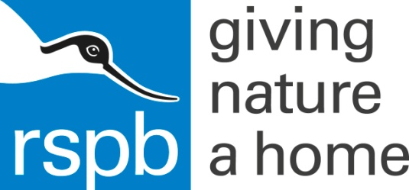
Invitation
You are being invited to take part in a research study. Before you decide it is important for you to understand why the research is being done and what it will involve. Please take time to read the following information carefully and discuss it with others if you wish. Ask us if there is anything that is not clear or if you would like more information. Take time to decide whether or not you wish to take part.
Background
Priority bird species that forage for dung and soil dwelling invertebrates are the conservation focus of this project. The species of focus is primarily chough, but other species (such as starling, lapwing, curlew and snipe) might also be affected by the issues raised. There are proven toxic effects, particularly on beetle species, of some livestock parasiticides of the macrocyclic lactone family, including doramectin and ivermectin. These parasiticides are widely used throughout the UK and the rest of the world. There is also a range of other treatments used as internal and external parasiticides, some of which are recommended as alternatives to ivermectin and as being relatively safe for invertebrates. However, many (including those recommended) have had little appropriate testing as to their wider environmental effects on invertebrates and other wildlife. In 2014 random block experiments on the effects of commonly used (non-ivermectin) cattle treatments on the abundance of invertebrates in cattle dung were conducted by RSPB staff. The results showed significant negative effects on dipteran larvae, resulting from commonly combined administration of drench and pour-on treatments. These are widely applied to cattle, sheep and lambs as pour-on endectocides and orally administered anthelmintic drenches. We intend to further investigate the direct and indirect effects of these treatments, both on dung and soil invertebrates and wider wildlife including birds, in particular chough. This will involve investigating the direct effect of parasiticides such as Ivermectin on birds as well as further investigating the effects of other treatments. For the development and planning of the most effective possible research studies, it is important to understand which products are being used by farmers, when they are used and how they are applied. This survey is intended to provide this information.
Purpose of this study
- This study is intended to identify
  - The livestock health problems that concern farmers in the coastal areas where chough are found
  - The methods that farmers currently use to manage these problems
  - The pharmaceutical products that they use to treat their livestock
  - The time of year when livestock are treated
  - The location of animals when they are treated (particularly whether they are housed or in the field.
How have you been chosen?
You have been chosen for invitation to participate in this study because you own/operate/manage a farm on Islay.
Participation in this study is entirely voluntary and you may terminate the interview at any time you wish.
It is up to you to decide whether or not to take part. If you do decide to take part, you will be given this information sheet to keep and be asked to sign a consent form. If you decide to take part, you are still free to withdraw at any time and without giving a reason
What will happen to you if you do take part in the study?
You will be asked a series of questions about your farming operation, in particular about the management of any livestock you have. Your opinion will also be sought in relation to changes in farming practices and wildlife over time. We expect the discussion to take 30 to 60 minutes.
Use of results
The results from this study will be used by the RSPB to design future research studies; to inform animal treatment management decisions on their own landholdings/management agreement areas on Islay, Colonsay and Oronsay; and to develop advice packages for other landowners where chough are found across the UK. The results of the research will be relevant to all those responsible for giving advice on all species that prey on dung and soil dwelling invertebrates. All participants will be provided with a summary of the results of the study.
Confidentiality
The data collected in the course of this project are confidential and will not be published in the public domain in a way that enables identification of individual land-owners or managers. All information which is collected about you, or responses that you provide, during the course of the research will be kept strictly confidential. You will be identified by an ID number, and any information about you will have your name and address removed so that you cannot be recognised from it.
Funding and organisation
This project is funded and organised by RSPB and The University of Glasgow.
Contact for further information
Nick Jonsson
Professor of Production Animal and Public Health
University of Glasgow
nicholas.jonsson@glasgow.ac.uk
07432 683 770

Ethics
This survey has been reviewed by the University of Glasgow MVLS Research Ethics Committee.
Thanks for your participation in this study.

