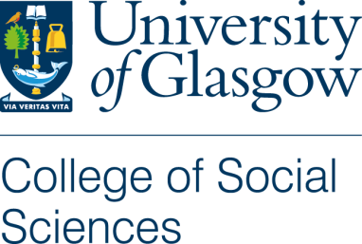

Participant Information Sheet

International transfer and translation of end of life care interventions: the case of the Liverpool Care Pathway for the Dying Patient
Hamilton Inbadas, Shahaduz Zaman, Alexander Whitelaw, David Clark
School of Interdisciplinary Studies, University of Glasgow, Dumfries campus, Dumfries, Scotland

We would like to invite you to take part in the above research study. Before you decide it is important for you to understand why the research is being done and what it will involve. Please take time to read the following information carefully and discuss it with others if you wish. Ask us if there is anything that is not clear or if you would like more information. Take time to decide whether or not you wish to take part.
Thank you for reading this.

The purpose of the study is to explore the international spread of the Liverpool Care Pathway (LCP) beyond the United Kingdom; to understand why, how and when LCP was implemented in other countries than UK and its impact and implications for end of life care in the respective countries.
Participation in this study is voluntary. Your participation will involve an interview (approx. 40 min) over telephone, skype or in person, where this is possible.
Due to the aim and the design of the study, the confidentiality of the person interviewed may not be guaranteed, we propose to conduct interviews ‘on the record’ in such a way that interviewees may be identified by their role in our resulting reports and publications. We hope this will be acceptable to you, but if not we can discuss alternative options, such as anonymising your role or substituting with a cognate role.
All interviews will be audio recorded, transcribed, and subject to a content analysis. Data files will be stored at the University of Glasgow for a period of 10 years in a locked facility or in computers secured by passwords.
The reports and/or publications from this study will be made available to you on request.
Confidentiality will be respected subject to legal constraints and professional guidelines. Any personal data collected (name and contact details) will be stored in a university computer secured by passwords.
This study is part of the Glasgow End of Life Studies Group’s ‘Global Interventions at the End of Life project’ funded by the Wellcome Trust. The Wellcome Trust Grant Number is 103319/Z/13/Z.
This project has been considered and approved by the Research Ethics Committee of the College of Social Sciences, University of Glasgow.

- For further information, please email Revd Dr Hamilton Inbadas Email: Hamilton.Inbadas@glasgow.ac.uk or call +44 (0) 1387 702008

- To pursue any complaint: please contact the College of Social Sciences Ethics Officer, Dr Muir Houston, email: Muir.Houston@glasgow.ac.uk Tel: Tel. 044 141 3304699. College of Social Sciences, Florentine House, 53 Hillhead Street. Glasgow G12 8QF

